Campus Network Design
and Routing Simulation
Cisco Packet Tracer | VLSM | RIPv2 | Static Routing | Network Services
A structured technical report based on the university temporary-campus network scenario, the original device configuration notes, and the simulation topology.

5  building networks | 6  routers incl. backup | 2,955  planned users

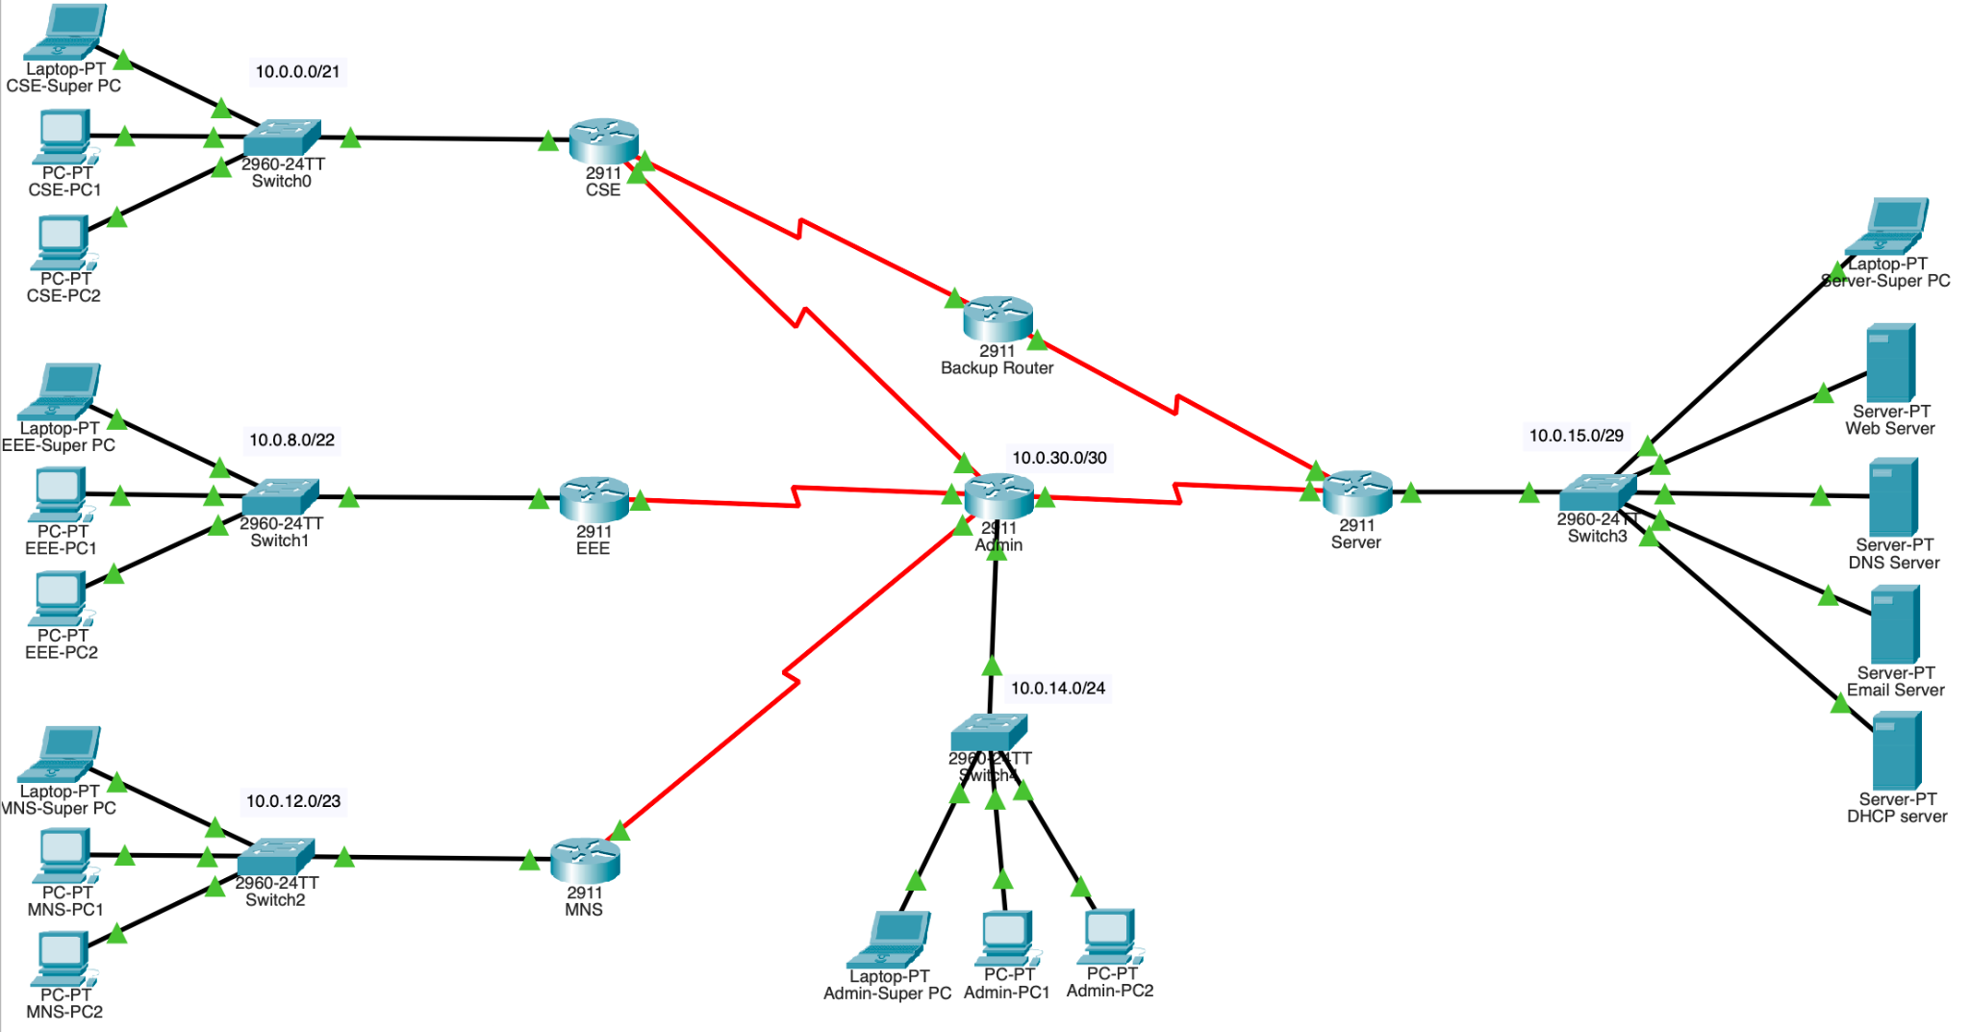
Figure 1. Original Cisco Packet Tracer topology (user-provided screenshot).
REPORT SCOPE
This document records the designed network, address allocations, router configuration commands, and network service settings. It describes the intended routing and failover behavior, but does not present unrecorded runtime tests as successful results.
Document status: professionally edited from the original project documentation. Configuration excerpts are source records and must be checked against the .pkt device settings before use.

1 Project overview
The fictional brief asks for a temporary campus network supporting five buildings—CSE, EEE, MNS, Administration, and Server—following the disruption of the main university campus. The implementation uses a routed topology with departmental LANs, a centralized service network, and a secondary CSE-to-Server path through a backup router.

1.1 Requirements captured from the brief
- Allocate IPv4 addresses through VLSM to minimize unused host addresses across building LANs.
- Place web, DNS, email, and DHCP services in the Server building and configure these servers manually.
- Use static IP addresses for the designated Super PCs; each occupies the last usable host address in its building subnet.
- Provide DHCP addresses to CSE, EEE, and MNS clients using the centralized DHCP server and router relay configuration.
- Use RIPv2 for CSE, EEE, MNS, and Admin routers, while keeping the Server router on static routes.
- Use Administration as the intended central route to Server, and provide a separate backup path for CSE.
- Avoid direct links between the CSE, EEE, and MNS departmental networks.
- Make the local university website accessible through www.bracu.com with the supplied welcome message.

1.2 Physical and logical architecture
Six Cisco 2911 routers represent the five building gateways and the intermediary backup router. Each building LAN connects through a Cisco 2960 switch. The Server LAN groups HTTP, DNS, email and DHCP server devices plus its Super PC. Point-to-point router connections use /30 networks.
Normal intended server access is via the Admin router. The additional CSE → Backup → Server path is intended for continuity when the CSE–Admin connection is unavailable. Link presence alone is not proof that the routing tables will select the desired path during failure; this behavior needs direct testing.

1.3 Scope and assumptions
The brief allows representative end devices instead of physically simulating every planned campus user. The written source also assumes CSE, EEE and MNS have no direct interconnection but may exchange traffic via Admin. This is an architectural assumption, not evidence of security filtering or access controls.

2 Addressing design
The documented base address space is 10.0.0.0/16. VLSM was used to allocate different-sized subnets according to the planned client populations.
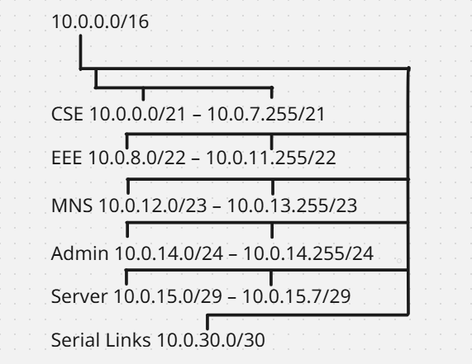
Figure 2. Original VLSM allocation diagram from the project notes.
Building | Planned users | Network | Usable hosts | Gateway
CSE | 1,500 | 10.0.0.0/21 | 2,046 | 10.0.0.1
EEE | 700 | 10.0.8.0/22 | 1,022 | 10.0.8.1
MNS | 500 | 10.0.12.0/23 | 510 | 10.0.12.1
Admin | 250 | 10.0.14.0/24 | 254 | 10.0.14.1
Server | 5 | 10.0.15.0/29 | 6 | 10.0.15.1

The planned population totals 2,955 users; the Packet Tracer file uses representative endpoint devices rather than modeling all users individually.

2.1 WAN interconnections
Link | Point-to-point subnet | Router A IP | Router B IP
CSE ↔ Admin | 10.0.30.0/30 | CSE: 10.0.30.1 | Admin: 10.0.30.2
EEE ↔ Admin | 10.0.30.4/30 | EEE: 10.0.30.5 | Admin: 10.0.30.6
MNS ↔ Admin | 10.0.30.8/30 | MNS: 10.0.30.9 | Admin: 10.0.30.10
Admin ↔ Server | 10.0.30.12/30 | Admin: 10.0.30.13 | Server: 10.0.30.14
CSE ↔ Backup | 10.0.30.20/30 | CSE: 10.0.30.21 | Backup: 10.0.30.22
Backup ↔ Server | 10.0.30.24/30 | Backup: 10.0.30.25 | Server: 10.0.30.26

3 Interface and endpoint inventory
The following addressing entries are reproduced from the original IP address table. They should be interpreted as documented configuration values rather than independently tested device states.

3.1 Router interface addressing
Router | Interface / Connection | IPv4 address | Subnet mask
R-CSE | G0/0 (LAN) | 10.0.0.1 | 255.255.248.0
R-CSE | S0/0/0 (to Admin) | 10.0.30.1 | 255.255.255.252
R-CSE | S0/0/1 (to Backup) | 10.0.30.21 | 255.255.255.252
R-EEE | G0/0 (LAN) | 10.0.8.1 | 255.255.252.0
R-EEE | S0/0/0 (to Admin) | 10.0.30.5 | 255.255.255.252
R-MNS | G0/0 (LAN) | 10.0.12.1 | 255.255.254.0
R-MNS | S0/0/0 (to Admin) | 10.0.30.9 | 255.255.255.252
R-Admin | G0/0 (LAN) | 10.0.14.1 | 255.255.255.0
R-Admin | S0/0/0 (to CSE) | 10.0.30.2 | 255.255.255.252
R-Admin | S0/0/1 (to EEE) | 10.0.30.6 | 255.255.255.252
R-Admin | S0/1/0 (to MNS) | 10.0.30.10 | 255.255.255.252
R-Admin | S0/1/1 (to Server) | 10.0.30.13 | 255.255.255.252
R-Server | G0/0 (LAN) | 10.0.15.1 | 255.255.255.248
R-Server | S0/0/0 (to Admin) | 10.0.30.14 | 255.255.255.252
R-Server | S0/0/1 (to Backup) | 10.0.30.26 | 255.255.255.252
R-Backup | S0/0/0 (to CSE) | 10.0.30.22 | 255.255.255.252
R-Backup | S0/0/1 (to Server) | 10.0.30.25 | 255.255.255.252

3.2 Servers and statically addressed endpoints
Device | IPv4 address | Subnet mask | Gateway
Web Server | 10.0.15.2 | 255.255.255.248 | 10.0.15.1
DNS Server | 10.0.15.3 | 255.255.255.248 | 10.0.15.1
Email Server | 10.0.15.4 | 255.255.255.248 | 10.0.15.1
DHCP Server | 10.0.15.5 | 255.255.255.248 | 10.0.15.1
Super PC (CSE) | 10.0.7.254 | 255.255.248.0 | 10.0.0.1
Super PC (EEE) | 10.0.11.254 | 255.255.252.0 | 10.0.8.1
Super PC (MNS) | 10.0.13.254 | 255.255.254.0 | 10.0.12.1
Super PC (Admin) | 10.0.14.254 | 255.255.255.0 | 10.0.14.1
Super PC (Server) | 10.0.15.6 | 255.255.255.248 | 10.0.15.1
Admin PC 1 | 10.0.14.2 | 255.255.255.0 | 10.0.14.1
Admin PC 2 | 10.0.14.3 | 255.255.255.0 | 10.0.14.1

3.3 DHCP clients
CSE PC 1/2, EEE PC 1/2 and MNS PC 1/2 are recorded as DHCP clients. Their lease addresses were not included in the submitted address inventory.

4 Centralized network services
The Server LAN uses the 10.0.15.0/29 network. All four service servers were assigned static addresses and a common gateway (10.0.15.1).
Service | Address | Documented configuration
HTTP / Web | 10.0.15.2 | HTTP enabled; homepage text: “Welcome To Brac University”
DNS | 10.0.15.3 | DNS enabled; www.bracu.com resolves to 10.0.15.2
Email | 10.0.15.4 | Dedicated email server address recorded; user accounts and delivery tests not documented
DHCP | 10.0.15.5 | DHCP enabled; separate address pools for CSE, EEE and MNS

4.1 DHCP pool inventory
Pool | Start address | Gateway | Subnet mask | Max. users
CSE_LAN | 10.0.0.2 | 10.0.0.1 | 255.255.248.0 | 2,040
EEE_LAN | 10.0.8.2 | 10.0.8.1 | 255.255.252.0 | 1,020
MNS_LAN | 10.0.12.2 | 10.0.12.1 | 255.255.254.0 | 510

All three DHCP pools point clients to DNS server 10.0.15.3. Because the DHCP server is located on a different subnet, the documented building LAN interfaces use DHCP relay.

Documented DHCP relay (each departmental LAN interface)
interface g0/0
ip helper-address 10.0.15.5

4.2 Static Super PC addressing
Building | Static Super PC address | Default gateway
CSE | 10.0.7.254 | 10.0.0.1
EEE | 10.0.11.254 | 10.0.8.1
MNS | 10.0.13.254 | 10.0.12.1
Admin | 10.0.14.254 | 10.0.14.1
Server | 10.0.15.6 | 10.0.15.1

Review item: the documented MNS DHCP pool starts at 10.0.12.2 with 510 users; depending on the Packet Tracer pool behavior, it can reach the statically reserved 10.0.13.254 address. The running pool and reservations should be checked before claiming collision-free DHCP.

4.3 Website name and email scenario
The original notes record www.bracu.com → 10.0.15.2 and mention a CNAME entry for bracu.com without providing its target. The assignment also specifies departmental mail addresses; the documentation does not include mailbox configuration or successful message-delivery evidence.

5 Routing approach

5.1 Dynamic and static routing
CSE, EEE, MNS and Admin are documented as RIPv2 participants with no auto-summary. Their LAN-facing interfaces are marked passive. The Server router uses manually entered routes and a default route toward Admin. The backup router uses static routes toward the CSE and Server LANs.
Router group | Documented protocol / route policy
CSE, EEE, MNS, Admin | RIPv2 (`version 2`, `no auto-summary`), plus selected static routes
Server | Static routes to building LANs, default route via Admin, alternate CSE route via Backup
Backup | Static routes toward CSE LAN and Server LAN

5.2 Key route entries from the original notes

CSE — backup next-hop route
ip route 0.0.0.0 0.0.0.0 10.0.30.22 120

Admin — Server LAN route
ip route 10.0.15.0 255.255.255.248 10.0.30.14

Server — primary and alternate CSE routes
ip route 10.0.0.0 255.255.248.0 10.0.30.13
ip route 10.0.0.0 255.255.248.0 10.0.30.25 10
ip route 0.0.0.0 0.0.0.0 10.0.30.13

The source assigns the CSE alternate route administrative distance 10 and the CSE default route toward Backup distance 120. These values and the resulting forward/return route selection must be verified in Packet Tracer. The recorded commands alone do not demonstrate working automatic failover or recursive next-hop resolution.

5.3 Security boundary of the design
The layout does not connect CSE, EEE and MNS directly to one another. However, the absence of direct cables is not equivalent to interdepartmental traffic isolation: routers can forward between reachable networks. No ACL, firewall policy or traffic-monitoring configuration is provided as proof of enforced segmentation or monitoring.

6 Verification plan and evidence status
The original submission contains addressing, setup commands and topology documentation but no retained command output or screenshot sequence that establishes results for all required checks. The following checklist is provided for anyone reproducing or evaluating the simulation.
Test | Suggested evidence | Status from supplied materials
Link/interface status | show ip interface brief on each router | Not independently verified
RIPv2 and static routes | show ip route; show ip protocols | Not independently verified
DHCP lease and gateway | ipconfig on CSE/EEE/MNS clients | Not independently verified
DNS + HTTP | Browser visit to http://www.bracu.com | Settings documented; test not included
Email messaging | Mail client send/receive between assigned accounts | Configuration evidence incomplete
Primary path | tracert from CSE client to Server | Not independently verified
Failover / recovery | Disable CSE–Admin link, traceroute + ping, then restore | Not independently verified

7 Configuration record
The commands below are organized from the original Word notes. They are included for transparency and reproducibility, not presented as sanitized or freshly verified running-config exports. The original preparation steps include device resets; do not execute those steps on an existing or production network.

7.1 Base router/interface commands as recorded

CSE
en
erase startup-config
reload
en
conf t
hostname R-CSE
no ip domain-lookup
int g0/0
ip address 10.0.0.1 255.255.248.0
int s0/0/0
ip address 10.0.30.1 255.255.255.252
interface s0/0/1
ip address 10.0.30.21 255.255.255.252
no shut
copy running-config startup-config

EEE
en
erase startup-config
reload
en
conf t
hostname R-EEE
no ip domain-lookup
interface g0/0
ip address 10.0.8.1 255.255.252.0
interface s0/0/0
ip address 10.0.30.5 255.255.255.252
no shut
copy running-config startup-config

MNS
en
erase startup-config
reload
en
conf t
hostname R-MNS
no ip domain-lookup
interface g0/0
ip address 10.0.12.1 255.255.254.0
interface s0/0/0
ip address 10.0.30.9 255.255.255.252
no shut
copy running-config startup-config

Admin
en
erase startup-config
reload
en
conf t
hostname R-CSE
no ip domain-lookup
interface g0/0
ip address 10.0.14.1 255.255.255.0
interface s0/0/0
ip address 10.0.30.2 255.255.255.252
clock rate 64000
interface s0/0/1
ip address 10.0.30.6 255.255.255.252
clock rate 64000
interface s0/1/0
ip address 10.0.30.10 255.255.255.252
clock rate 64000
interface s0/1/1
ip address 10.0.30.13 255.255.255.252
clock rate 64000
no shut
copy running-config startup-config

Server
en
erase startup-config
reload
en
conf t
hostname R-CSE
no ip domain-lookup
interface g0/0
ip address 10.0.15.1 255.255.255.248
interface s0/0/0
ip address 10.0.30.14 255.255.255.252
interface s0/0/1
ip address 10.0.30.26 255.255.255.252
no shut
copy running-config startup-config

Backup Router
en
erase startup-config
reload
en
conf t
hostname R-CSE
no ip domain-lookup
interface s0/0/0
ip address 10.0.30.22 255.255.255.252
clock rate 64000
interface s0/0/1
ip address 10.0.30.25 255.255.255.252
clock rate 64000
no shut
copy running-config startup-config

7.2 Dynamic and static route commands as recorded

CSE routing
ip route 0.0.0.0 0.0.0.0 10.0.30.22 120
router rip
version 2
no auto-summary
network 10.0.0.0
network 10.0.30.0
passive-interface g0/0
end
copy run start

EEE routing
router rip
version 2
no auto-summary
network 10.0.8.0
network 10.0.30.0
passive-interface g0/0
end
copy run start

MNS routing
router rip
version 2
no auto-summary
network 10.0.12.0
network 10.0.30.0
passive-interface g0/0
end
copy run start

Admin routing
ip route 10.0.15.0 255.255.255.248 10.0.30.14
router rip
version 2
no auto-summary
network 10.0.14.0
network 10.0.30.0
passive-interface g0/0
end
copy run start

Server routing
ip route 10.0.0.0 255.255.248.0 10.0.30.13
ip route 10.0.8.0 255.255.252.0 10.0.30.13
ip route 10.0.12.0 255.255.254.0 10.0.30.13
ip route 10.0.14.0 255.255.255.0 10.0.30.13
ip route 0.0.0.0 0.0.0.0 10.0.30.13
ip route 10.0.0.0 255.255.248.0 10.0.30.25 10

Backup routing
ip route 10.0.15.0 255.255.255.248 10.0.30.26
ip route 10.0.0.0 255.255.248.0 10.0.30.21
end
copy run start

8 Review notes before publication
- Hostname discrepancy: the original base-command notes use “hostname R-CSE” under Admin, Server and Backup sections. Compare these text entries against each actual router hostname before treating the notes as exact exports.
- Interface enablement: some baseline command snippets show “no shut” only once after multiple interface sections. Verify the operational state of every configured LAN and serial interface.
- DHCP reservation: check whether the MNS pool allocates the last usable host address reserved for its Super PC.
- Routing behavior: verify route preference and the Server-to-CSE return path after disabling the CSE–Admin link.
- Documentation vs implementation: the supplied notes do not prove that department traffic is actively monitored or blocked by access-control policies.
- Email service: the original notes specify an email server address but do not record user/mailbox setup or delivery-test evidence.
Source references: “A Network Problem Scenario_Brac University Under Attack.pdf”, “Project documentation.docx”, and “project.pkt”, provided by the project owner. This report does not claim an external audit or live-network deployment.

