FWD, Embedded Systems

On-demand Traffic light control

Author: Omar Elmasri

Table of Contents
1. System Description 1
2. System Design 1
3. State-machine 2

System Description
System implements a state machine to manage different behavior and implement an iterator like pattern to manage state timed transition, taking benefit of the sequential nature of the system physical state representation (i.e. green → yellow → red → yellow → green). Timed transition is implemented using a 16-bit hardware timer. The system is based on AVR core, ATmega32 MCU. System utilize AVR-GCC toolchain and AVR-Development libraries hosted on Fedora 36. System was simulated using Simulide on Ubuntu 22.04.

System Design
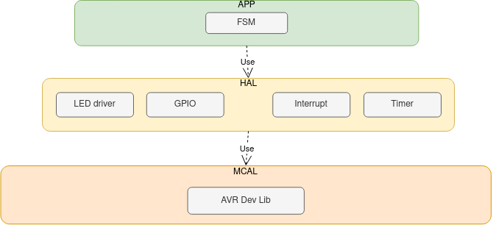Figure 1: Layeres

State-machine
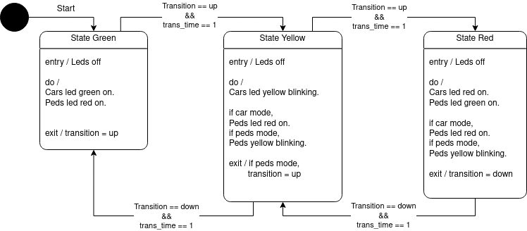Figure 2: State-machine

