🍅 🧅 🥔
TOP Digital Twin
Tomato–Onion–Potato Weekly Price Forecasting for India
A Comprehensive Project Report: Methods, Results, and Interpretation
Prepared for: Prof. Farhat (PI) and the HADP-04 project review committee
Prepared by: Dr. Masroor, SKUAST-K
Date: 6 August 2026
Repository: github.com/masroor01/TOP-Digital-Twin (public, 98 commits) — live interactive dashboard included

Executive Summary
The TOP Digital Twin is a weekly wholesale-price forecasting system for tomato, onion, and potato — India’s three most price-volatile essential vegetables — built for HADP-04 at SKUAST-K. It integrates six independent, primary-source-verified data layers spanning 2003–2026, trains a validated LightGBM forecasting pipeline covering 1,721 markets across 25 states, and is deployed as a public, interactive scenario-simulation dashboard.
This report documents the project end-to-end for review: how the market panel and every data layer were built and validated; every model and method used, with results and their interpretation; the rigorous statistical validation applied at every stage (Diebold-Mariano tests, a Model Confidence Set, real-world crisis backtests); a formal causal-inference investigation into export-policy effects that reached a decisive, well-evidenced negative result rather than an overclaimed positive one; an exploratory architecture that was tested and honestly rejected when it underperformed; and a dedicated discussion of what all of this means for actual policy decision-making.
The central methodological stance of this project, evident throughout, is that a forecasting system’s credibility rests as much on what it demonstrably cannot do as on what it can. Every positive result below is backed by formal significance testing against genuine out-of-sample data, and every negative result — the model’s inability to recover a causal policy-effect magnitude, one crop’s inability to beat naive persistence at long horizons, an entire alternative architecture’s underperformance — is reported with the same rigor as the positive results, not minimized or omitted.

1. Introduction and Research Questions
Tomato, onion, and potato (“TOP” crops) are staple vegetables whose retail prices are politically and economically sensitive in India: sharp price spikes trigger consumer distress and government intervention, while price crashes cause farmer distress. Both directions have occurred repeatedly and severely within the study period. A reliable, well-validated forecasting system for these crops has direct value for farmers (harvest and storage timing), traders (arbitrage and logistics), and policymakers (timing of market interventions).
The project was built around five research questions, each addressed with dedicated evidence documented in this report:
- Can wholesale APMC prices for TOP crops be forecast more accurately than a naive “tomorrow looks like today” baseline — and if not always, precisely where and why?
- Which of six independent data layers (price/arrivals, macro-economic, climate, satellite, infrastructure, policy) actually improve forecast accuracy, and at which forecast horizons?
- Do the models hold up during real, historically documented price crises, not merely in cross-validated averages?
- Do the data layers have genuine causal or predictive content for price, or do they merely correlate with it?
- Can the models be trusted for policy counterfactual simulation (“what happens to price if we impose an export ban”), not just for forecasting under observed conditions?

2. Data Infrastructure and Market Selection

2.1 Six independent data layers
The pipeline integrates six layers of real, independently sourced and verified data:
Layer | Content | Primary source(s) | Historical depth
L1 — Price & Arrivals | Weekly wholesale modal price and arrivals volume, market-level | Agmarknet (Govt. of India electronic mandi reporting) | 2003–2026 (longhistory panel); 2017–2026 (production panel)
L2/L3 — Satellite & Climate | NDVI/EVI vegetation indices, land-surface temperature, rainfall, heat-stress indices, per agro-climatic zone | Google Earth Engine: Sentinel-2, MODIS, ERA5-Land, CHIRPS | 2000–2026 (climate); 2016–2026 (Sentinel-2)
L4 — Macro-economic | Repo rate, USD/INR, WPI, diesel/LPG prices, agricultural credit, crop-specific wholesale price index | CMIE Prowess/Economic Outlook, RBI DBIE, PPAC | 1992–2026 (RBI longhistory parser)
L5 — Infrastructure & Labour | State-wise agricultural wages, cold-storage capacity, road density | Labour Bureau, government infrastructure records | 2017–2025
L6 — Policy & Trade | Export bans, minimum export price (MEP), export duty, market interventions, Operation Greens activations | Primary-source-verified Govt. of India notification log (DGFT, PIB, Ministry press releases) | 2010–2026 (verified episodes back to 2010; systematic log from 2017)

Interpretation: No single data source is sufficient on its own: Agmarknet captures price and volume but nothing about why they move; the remaining five layers each supply a distinct, independently-sourced driver (weather/vegetation, macro-economic conditions, labour/storage capacity, and government policy) that Agmarknet cannot. Layer L6 has the shortest systematic history (from 2017) because it depends on a primary-source-verified notification log rather than a continuously published series — individual older events (e.g. the 2010 onion ban) are included where independently verifiable, but a systematic month-by-month log only begins once the verification process itself was built.
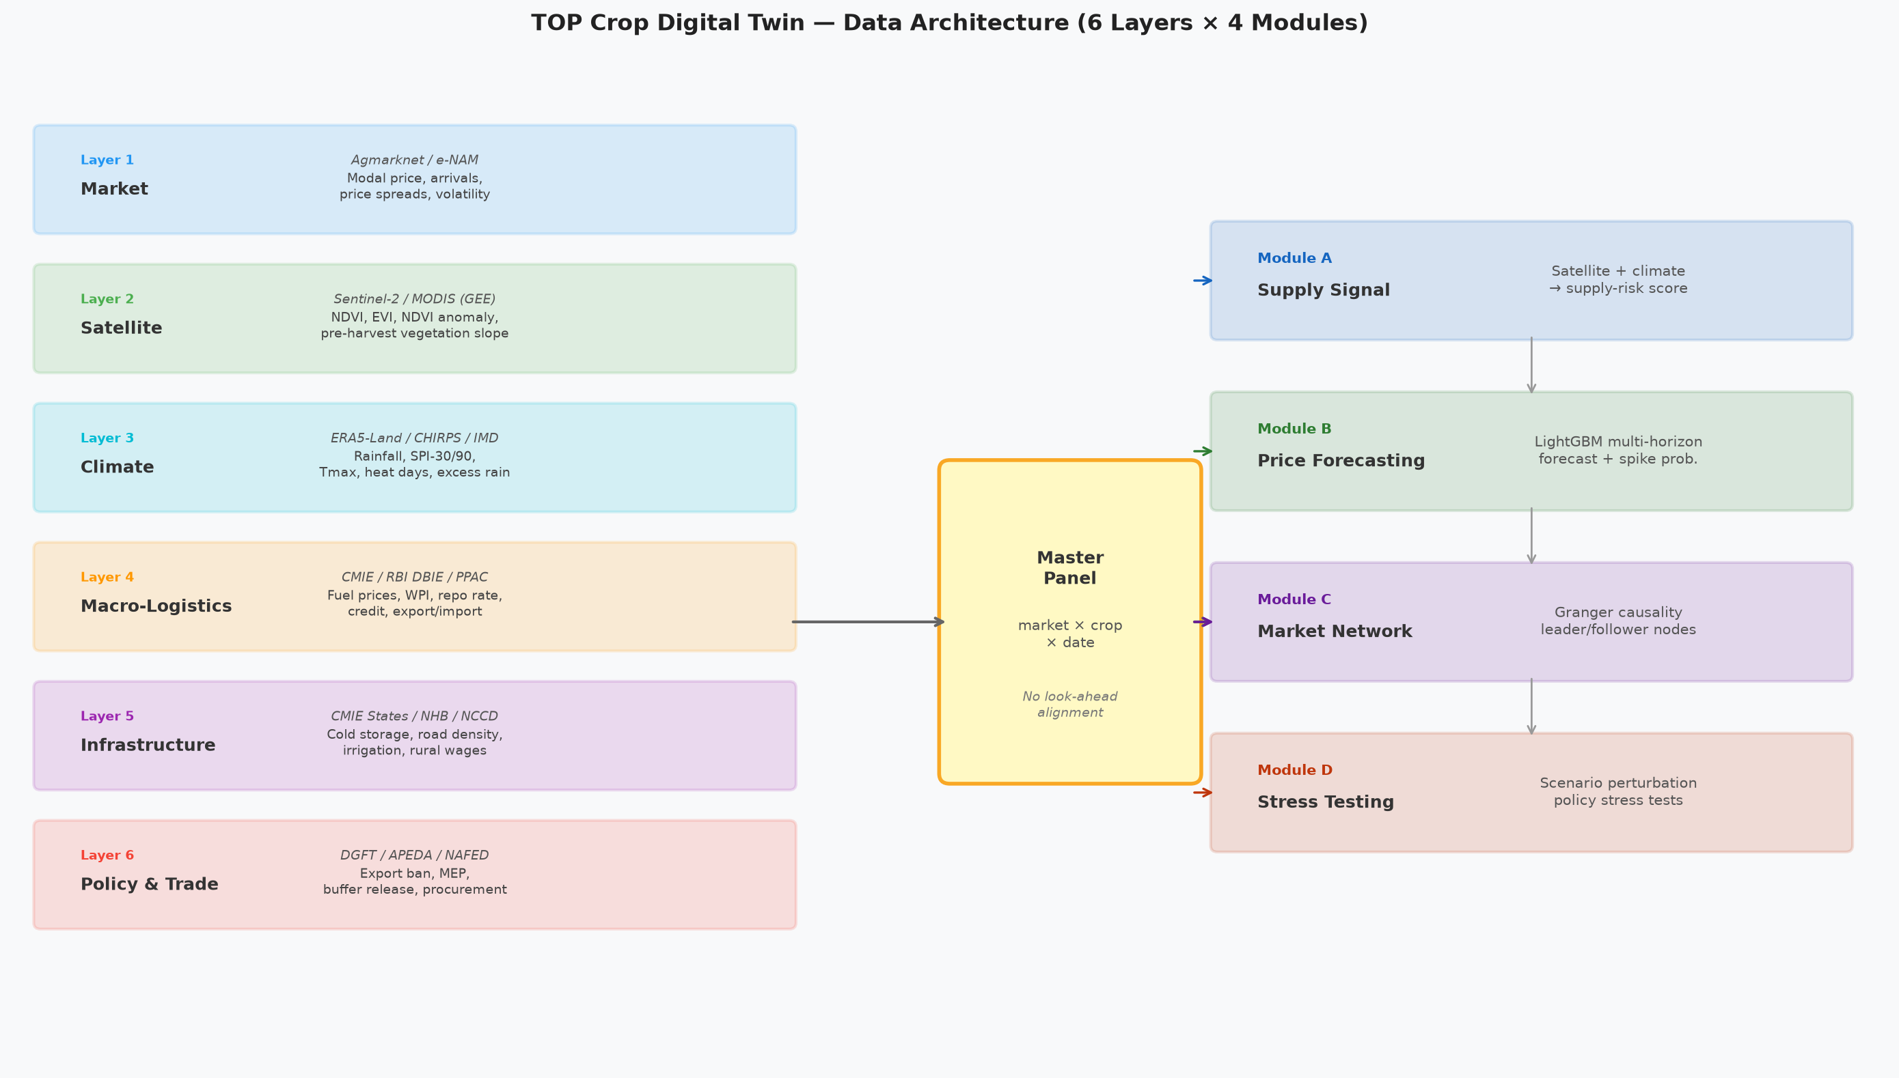
Figure 1. Six-layer data architecture of the TOP Digital Twin pipeline, from raw source through to the production model.

2.2 Market selection methodology and final coverage
Raw Agmarknet reporting is highly uneven: many markets report sporadically, and including them without a quality filter would silently bias both training and evaluation toward artefacts of missing data rather than genuine price signal. A market-level coverage filter was therefore applied and empirically justified via a dedicated statistical robustness check (Script 11): a market qualifies for the analytical panel only if at least 70% of its weekly observations, over its own full real reporting history (not a fixed global window), are genuine trades rather than imputed values. This distinction matters — an earlier, cruder version of the filter measured coverage against a fixed calendar window, which understated coverage for markets with a shorter but complete real history; the corrected, market-own-history version is what all reported results below use.
After filtering, the final analytical panel (verified directly against the current production file, Model_Output/filtered_panel_top.csv, as of this report’s writing) comprises:
Crop | Markets | States | Market-weeks | Median coverage | Min. coverage
Tomato | 832 | 22 | 300,344 | 92.4% | 70.0%
Onion | 807 | 25 | 172,682 | 95.6% | 70.4%
Potato | 82 | 2 | 40,988 | 95.6% | 71.6%
Total | 1,721 | — | 514,014 | — | —

Interpretation: Tomato and onion each carry roughly ten times potato’s market count because they are grown and traded nationally, while potato in the Agmarknet record is concentrated in a much narrower geography; this is reflected honestly rather than padded, and is exactly why potato’s satellite/climate zones (Section 2.3) required special handling. The minimum coverage in every crop sits close to the 70% threshold by construction — that is simply the boundary of qualification — while median coverage well above 90% for all three crops shows the typical included market is not a marginal case.
Of the 514,014 total market-week rows, 89.6% are real trade observations. The remainder are transparently flagged and imputed — 4.0% by linear interpolation, 1.5% by seasonal-median substitution, and 4.9% left as genuine unfilled gaps where a missing stretch exceeded the imputation policy’s tolerance. Every row carries an explicit real-vs-imputed flag, so no downstream analysis conflates the two. Potato’s much smaller market count reflects a genuine feature of its production geography in the Agmarknet data — it is concentrated in West Bengal and Uttar Pradesh rather than distributed nationally like tomato and onion — not a data-quality shortfall.
One scale note for this report: the market panel has grown substantially since an earlier internal progress snapshot (which recorded 845 markets). The panel was subsequently rebuilt with an extended reporting window and a corrected scraper pipeline for tomato and potato’s 2026 data, bringing the qualifying market count to the current 1,721. All results in this report reflect the current, larger panel.
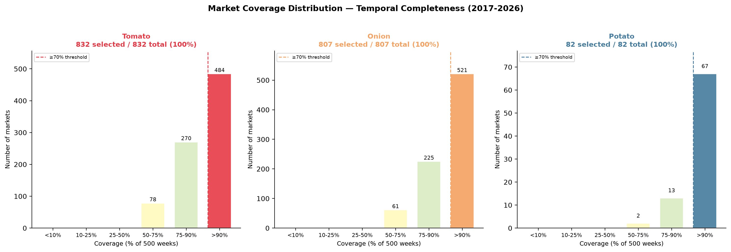
Figure 2. Distribution of real-data coverage across all qualifying markets, by crop.
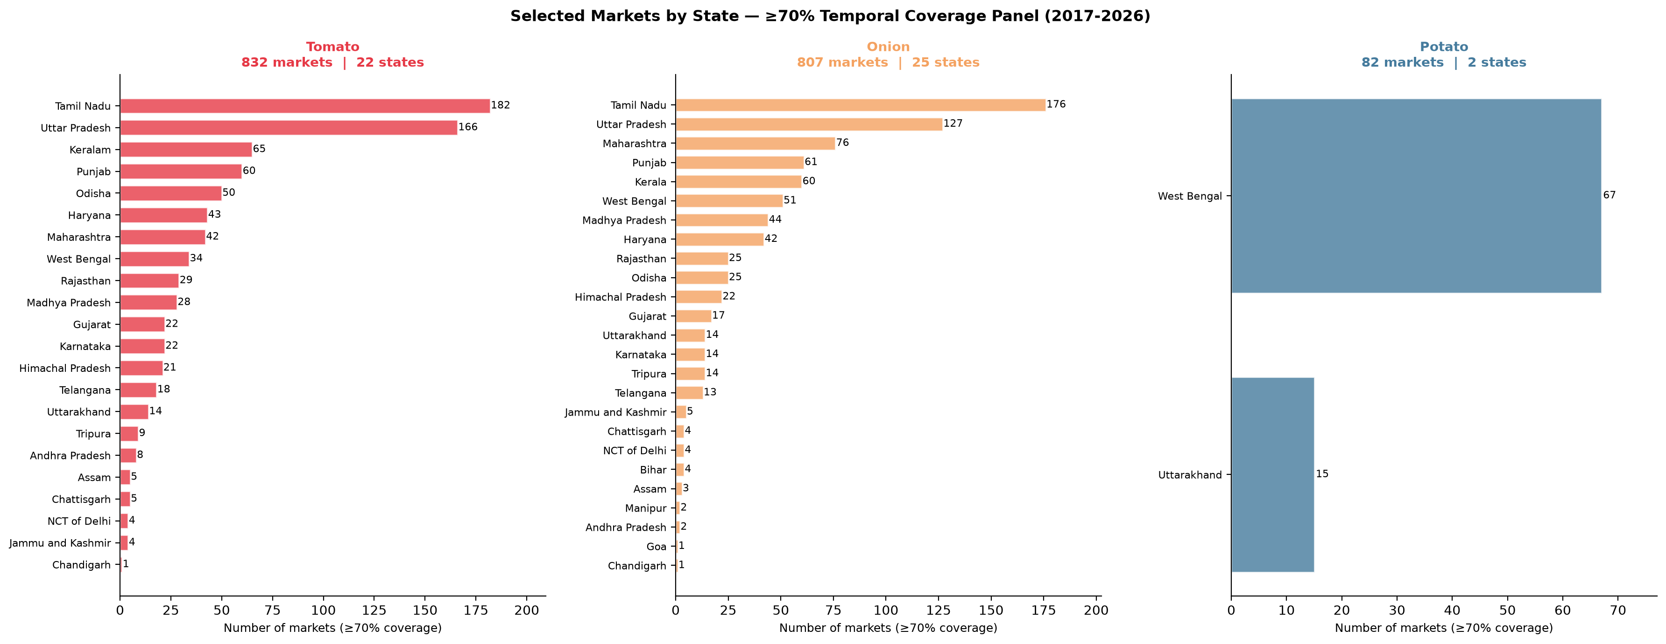
Figure 3. Geographic distribution of qualifying markets by state, by crop.

2.3 Notable data-engineering achievements
- Potato satellite-zone relocation: Midway through the project, potato’s three agro-climatic satellite/climate zones (P1–P3) were found to reference districts with no real corresponding satellite coverage. These were relocated to genuine production districts — Darjeeling, Diamond Harbour (West Bengal), and Dehradun (Uttarakhand) — with fresh ERA5/CHIRPS/Sentinel-2/MODIS data extracted and verified before being wired back into the pipeline; the ablation study, SHAP analysis, and production models were all re-run after the fix.
- Historical layer extension: Nearly every non-price layer initially covered less real history than was actually available from its source. RBI/PPAC macro series were extended back to 1992–2002 via a dedicated long-history parser; climate/satellite coverage was extended to 2000 via four new Google Earth Engine scripts mirroring the existing 2017–2026 extraction exactly; a long-history market panel (2003–2026) was built as a foundation for extended validation work.
- CMIE data-vintage handling: CMIE (and CEIC-format sources generally) restate their entire historical series on every data pull, not just recent months — confirmed directly with the data subscriber. Validation logic was rewritten to distinguish point-in-time series that never restate (repo/reverse-repo rates, treated as blocking mismatches) from series that legitimately do restate (WPI, diesel/LPG, USD/INR, treated as informational), avoiding false-positive data-quality alarms while still catching genuine errors.
- Grid-adaptivity coverage bug: An early version of the per-market coverage calculation used a fixed global start date for every market’s denominator, understating coverage for markets with a genuinely shorter but complete real history. Fixed to start each market’s coverage grid at its own first real observation.

3. Modeling Pipeline and Methods

3.1 Ablation study: M0 → M6
Seven progressively richer LightGBM model variants were trained, each adding exactly one data layer, evaluated on a 4-fold rolling-origin cross-validation design (non-overlapping test years 2022–2025) across all 4 forecast horizons (1, 4, 13, 26 weeks) and all 3 crops — 336 individual model fits in total:
Variant | Adds
M0 | Price history only (lags, rolling statistics, seasonality)
M1 | + Arrivals
M2 | + Macro-economic & logistics
M3 | + Climate stress (ERA5, CHIRPS)
M4 | + Satellite vegetation (Sentinel-2, MODIS)
M5 | + Infrastructure (wages, cold storage, roads)
M6 | + Policy/trade (export bans, MEP, duty, interventions) — the full production pipeline

Interpretation: The layers are added in a deliberate order — cheapest and most directly price-relevant first (arrivals), most expensive and least directly price-relevant last (policy) — so that each successive variant’s improvement (or lack of it) isolates that specific layer’s marginal contribution, rather than being confounded by the order of addition.
Latest ablation results (post-leakage-fix retrain; full pipeline vs. price-only baseline, MAPE by horizon):
Crop | h=1w | h=4w | h=13w | h=26w
Tomato (M6) | 26.5% | 38.8% | 40.2% | 42.2%
Onion (M6) | 17.2% | 24.0% | 35.8% | 38.7%
Potato (M6) | 11.3% | 18.2% | 38.3% | 32.2%

Interpretation: MAPE rises with horizon for every crop, which is expected — predicting 26 weeks ahead is a harder problem than predicting 1 week ahead, and this table alone cannot say whether M6 is doing well relative to the alternative of simply not using a model at all. That comparison — M6 against naive persistence, formally tested rather than eyeballed — is the subject of Sections 4–6, which is where this table’s numbers become genuinely interpretable rather than just descriptive.
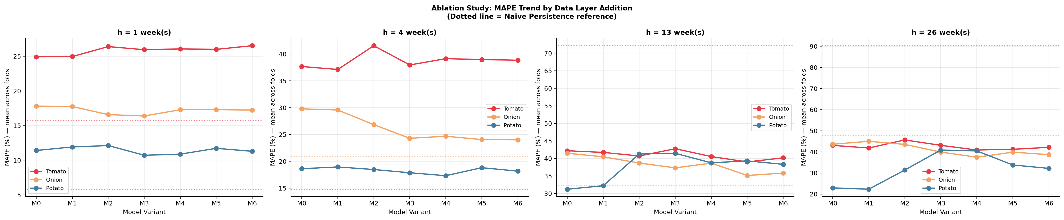
Figure 4. MAPE by model variant (M0–M6), crop, and forecast horizon.

3.2 Model-family comparison: is LightGBM the right choice?
LightGBM was benchmarked against three tree-ensemble alternatives and two deep-learning architectures on the identical cross-validation framework, to justify it as the production model rather than assume it:
Model | Mean R² (all crops × horizons × folds) | Verdict
CatBoost | 0.341 | Competitive, occasionally ahead
LightGBM (production) | 0.231 | Competitive; fastest; chosen for production
XGBoost | 0.223 | Competitive
RandomForest | −0.332 | Clearly worst of the tree ensembles
LSTM | −0.545 | Underperforms every tree model
Transformer | −0.826 | Weakest model tested

Interpretation: LightGBM, XGBoost, and CatBoost are statistically competitive with no consistent winner across all crop×horizon×fold combinations; both deep-learning architectures underperform every tree model by a wide margin, including negative R² (worse than predicting the mean). This validates LightGBM as the appropriate production choice for this data regime — moderate sample size, tabular and mixed-type features, meaningful non-linear interactions — over more complex sequence models that need substantially more data to earn their added capacity. A full-capacity Temporal Fusion Transformer run remains a deferred, secondary robustness check (see Section 17) given this comparison already settles the production-model choice.
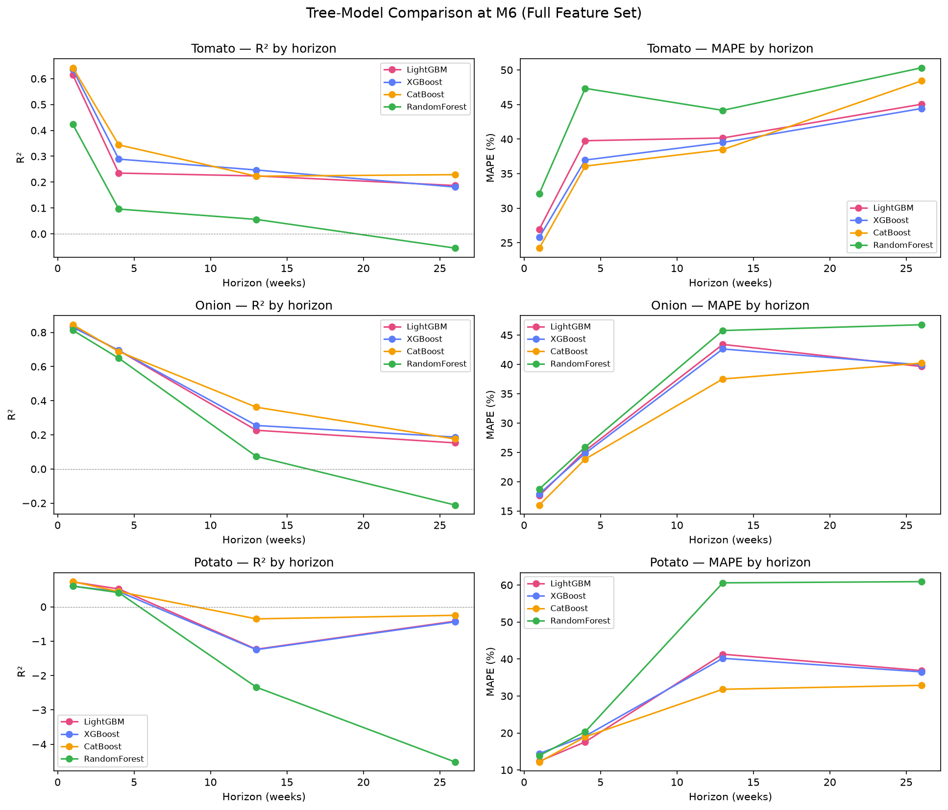
Figure 5. Head-to-head R² comparison across all six benchmarked model families.

3.3 Production system
Twelve final LightGBM models (3 crops × 4 horizons) are trained on the full data history and persisted for reuse, along with per-market reference feature rows, validated uncertainty bounds (RMSE/MAPE), and dashboard metadata — the shared foundation for both the interactive dashboard (Section 12) and the formal stress-testing module (Section 9).

4. Statistical Validation Methodology
Point-estimate accuracy metrics (R², MAPE) were treated as necessary but not sufficient. Three additional layers of formal statistical rigor were applied on top of them:
- Diebold-Mariano tests: pairwise significance tests on forecast-error differentials (crop-level and market-level), with the Harvey-Leybourne-Newbold small-sample correction and a Newey-West-style long-run variance estimator appropriate for h-step-ahead, MA(h−1) forecast errors.
- Model Confidence Set (Hansen, Lunde & Nason, 2011): a stationary-bootstrap range-statistic test that jointly evaluates all 8 model variants (naive persistence + M0–M6) per crop × horizon at once, with familywise error control across the whole set rather than one pairwise comparison at a time — a materially stronger standard than reporting isolated p-values.
- MASE / horizon-conditional skill and spike-detection AUC: a distinct, arguably more policy-relevant skill than point-forecast accuracy — the models’ ability to correctly rank weeks by price-spike risk, which scored 0.92–0.99 across all three crops.

5. Central Finding: When Do the Data Layers Actually Earn Their Value?
The single most important, and most carefully verified, finding of the project
Naive persistence (“next week’s price = this week’s price”) is the statistically confirmed best model at the shortest horizon (h=1 week) for all three crops — formally confirmed via the Model Confidence Set, which found naive persistence to be the sole survivor of the 90%-confidence set at h=1w in every case. This reflects a genuine, well-established economic phenomenon (near-random-walk behaviour in short-term commodity prices under efficient short-term price discovery), not a flaw in the modelling pipeline.

Critically, this reverses at longer horizons — exactly where the added data layers have time to matter and where policy decisions actually need lead time:
Crop | Crossover horizon (M6 first beats naive) | Notes
Tomato | 13 weeks | Cleanest crossover; M6 statistically superior from h=13w onward
Onion | 26 weeks | M6 statistically superior at h=26w; naive drops out of the 90% confidence set entirely
Potato | 26 weeks (partial) | At h=26w, neither naive nor the full M6 pipeline survives the 90% confidence set — only the simpler price+arrivals models do; the one genuine limitation among the three crops

Interpretation: The crossover horizon is not a fixed model property but a genuine crop-specific finding: tomato — the most volatile, most event-driven crop — earns its data-layer advantage soonest, while onion and potato need a full 26 weeks. This ordering is consistent with tomato’s crises (Section 6) also being the sharpest and most policy-triggered, giving the model’s non-price features the most signal to work with earliest.
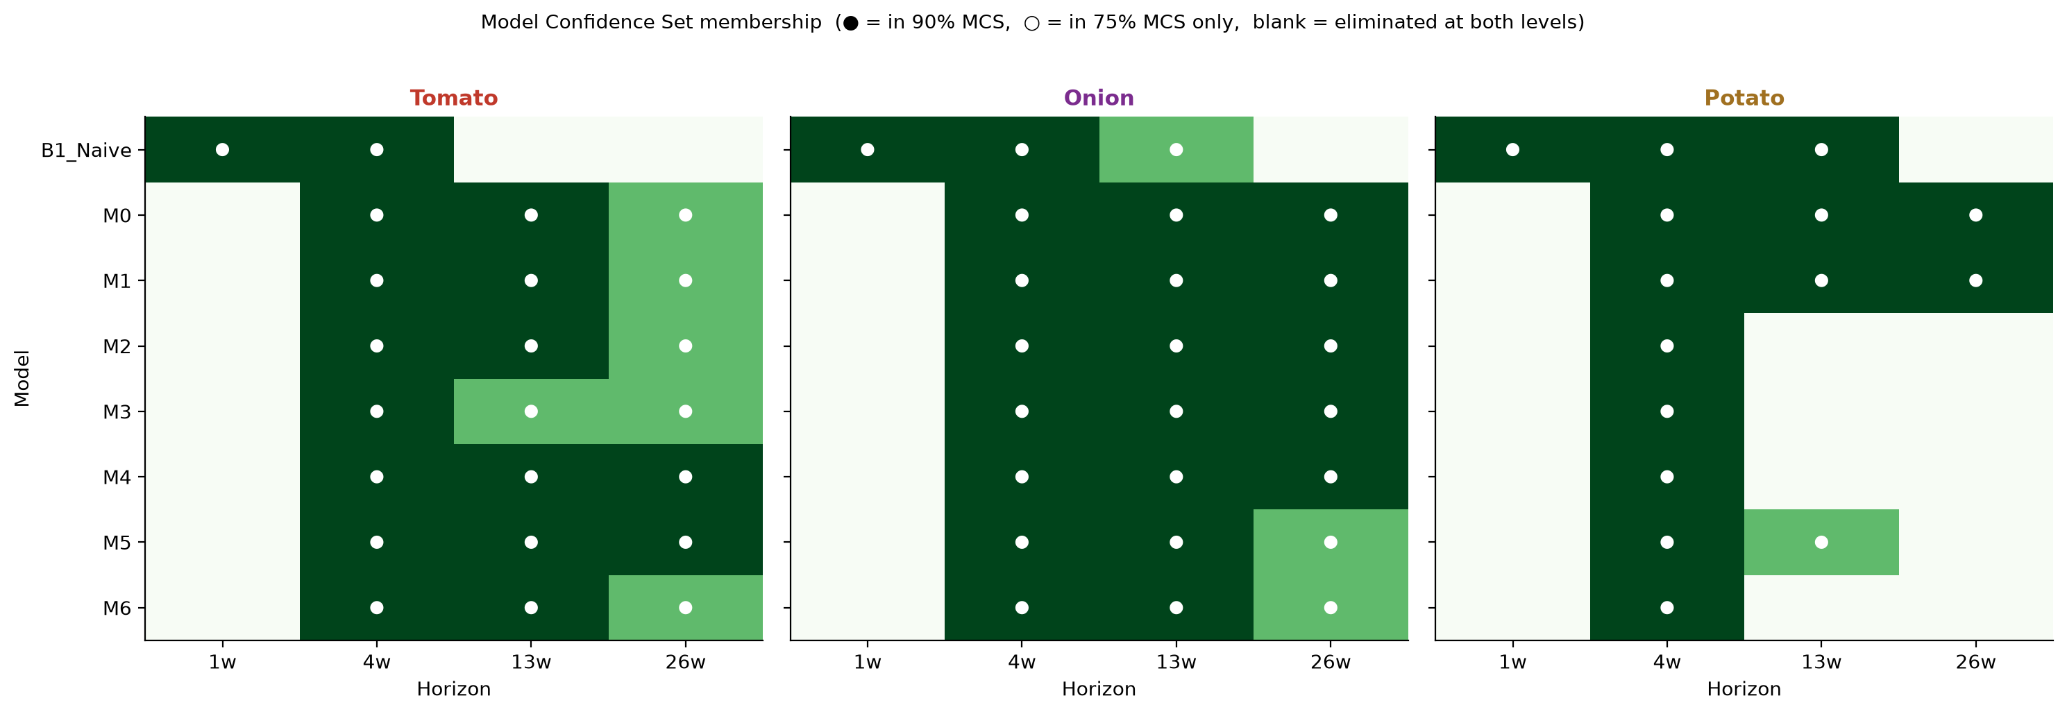
Figure 6. Model Confidence Set membership by crop and horizon — which model variants survive the 90% confidence set at each horizon.
This is independently corroborated by the SHAP interpretability analysis: price’s own share of predictive weight falls from roughly 70–76% at h=1w to as low as 19–48% at h=13/26w, with climate, macro, infrastructure, and policy layers correspondingly gaining share. The data layers are not just statistically confirmed to help at long horizons on average — the model is demonstrably relying on them more as horizon increases, a mechanistic explanation for the statistical crossover, not merely a correlated observation.
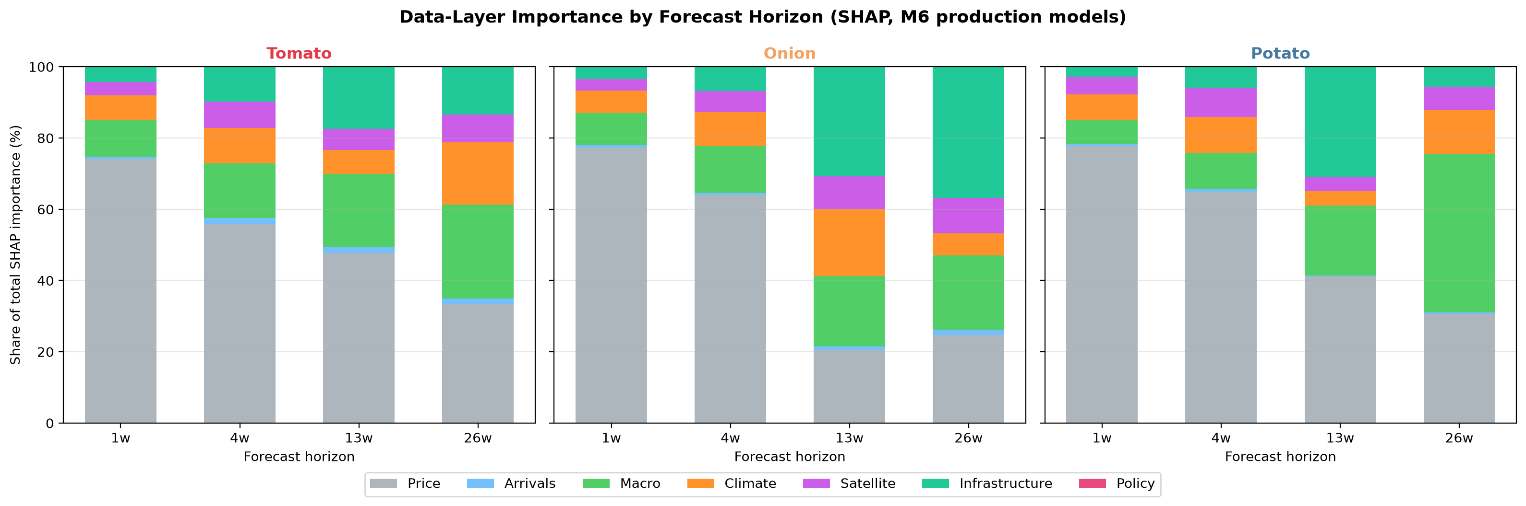
Figure 7. SHAP feature-importance share by data layer, across horizons — price’s dominance recedes as the other five layers gain weight.

6. Real-World Validation: Crisis Backtesting Case Studies
To test whether the horizon-crossover finding above holds not just on average but during the specific price crises that matter most to policymakers, four real, independently documented episodes were backtested using genuinely out-of-sample model predictions (no retraining on crisis data). Episodes were selected using two independent criteria in combination — the four largest real four-week price moves in the 2022–2025 out-of-sample window, cross-referenced against the verified policy-event log — so episodes were not cherry-picked from the model’s own results.
Episode | What happened | Result
Tomato, Jun–Sep 2023 | Nationwide spike (+454% over 4 weeks) then crash (−70%); NCCF/NAFED subsidised retail intervention | Naive wins h=1w; M6 wins decisively h=4/13/26w (naive MAPE hits 147–158% at long horizon)
Onion, Aug 2023–Jan 2024 | Export duty → MEP → outright export ban, tracking a +89% spike then a −46% crash post-ban | Naive wins h=1/4w; M6 wins h=13/26w — crossover occurs even earlier than the full-sample average
Potato, Apr 2024 | Nationwide spike (+45%), no matching policy event | Naive wins at every horizon — the one genuine exception, consistent with the MCS finding above
Potato, Jan 2025 | Nationwide crash (−47%), no matching policy event | Naive wins h=1w; M6 wins h=4/13/26w — behaves like tomato/onion despite no policy driver

Interpretation: Naive persistence’s long-horizon forecast is mechanically anchored to a pre-crisis price and cannot anticipate a genuine regime change; a forecast made 13 or 26 weeks in advance is simply the price observed at that earlier date, carried forward without adjustment. This anchor necessarily predates a crisis with a genuine onset, so naive persistence is structurally incapable of anticipating it at any lead time exceeding the event’s own duration. The M6 pipeline, by contrast, has access to climate-stress, satellite-vegetation, arrivals, and — for onion specifically — explicit policy-instrument features that let it partially anticipate the price response before it has fully unfolded. Potato’s asymmetry (crashes behave like tomato/onion, spikes do not) is treated as a specific, falsifiable hypothesis rather than a blanket weakness: potato’s crashes are plausibly supply/storage-driven (a mechanism the infrastructure layer is positioned to capture), while its spikes are plausibly driven by localised crop-damage shocks under-resolved by potato’s coarser, two-state zone geography.
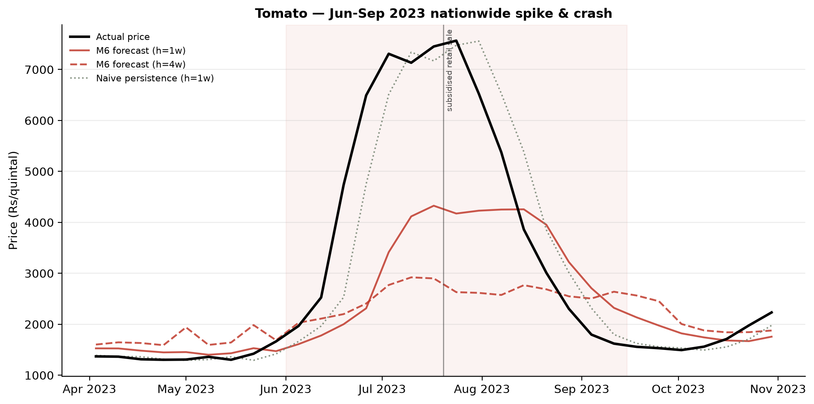
Figure 8. Tomato, Jun–Sep 2023: actual price, M6 forecast, and naive persistence through the spike/crash episode.
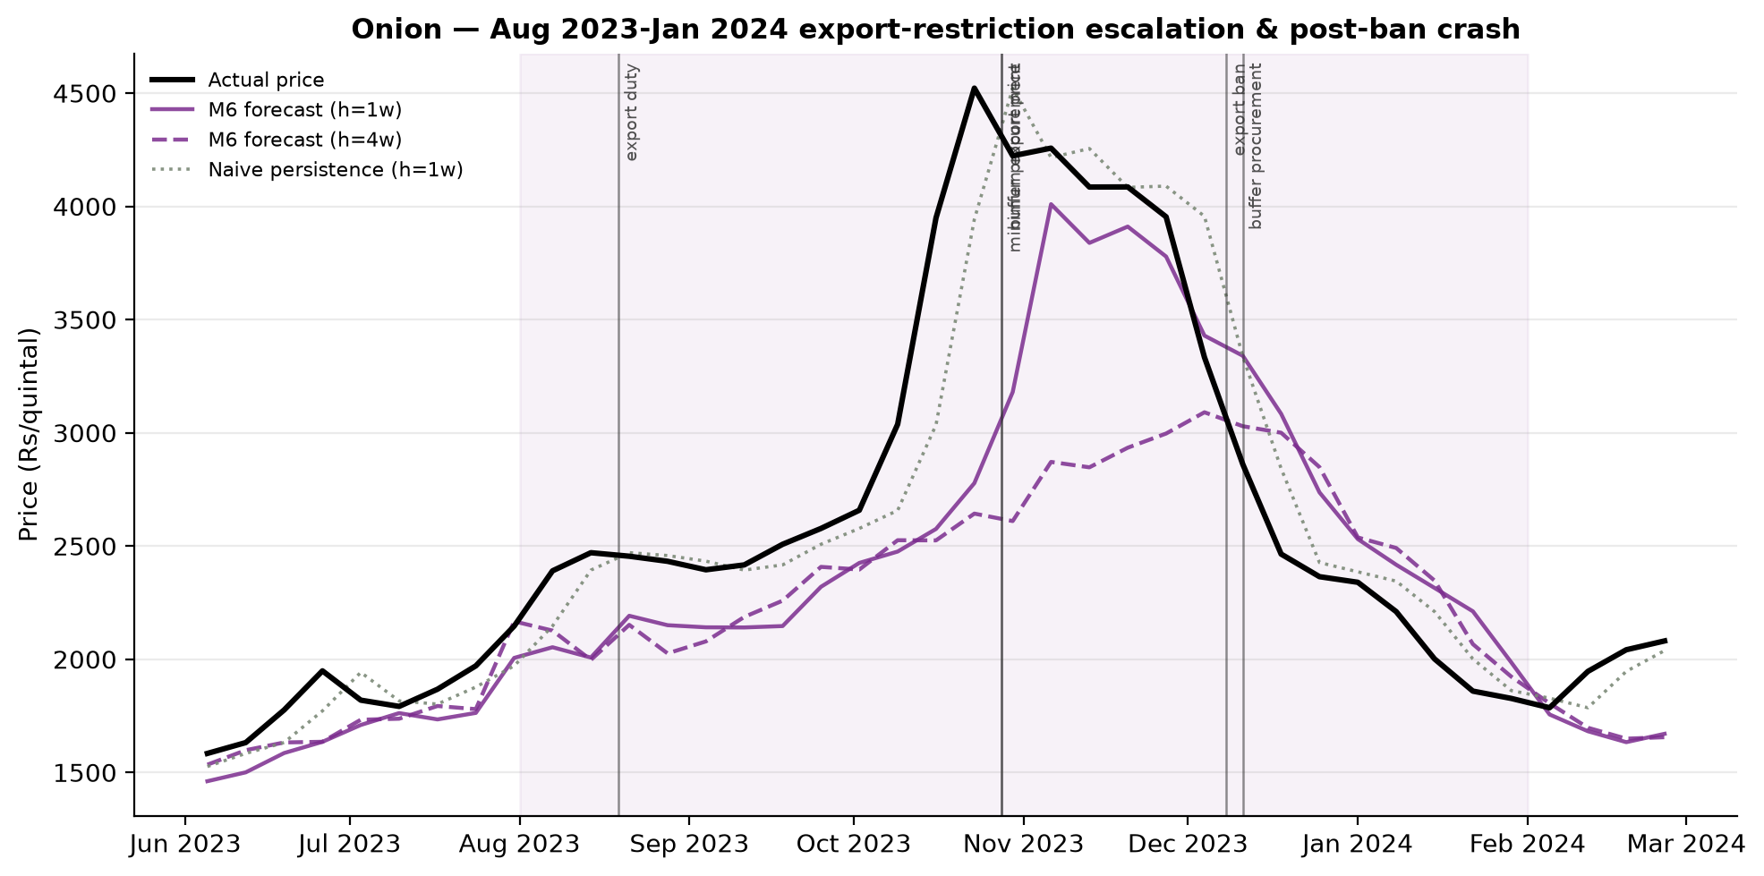
Figure 9. Onion, Aug 2023–Jan 2024: actual price vs. forecasts through the duty→MEP→ban escalation and post-ban crash.
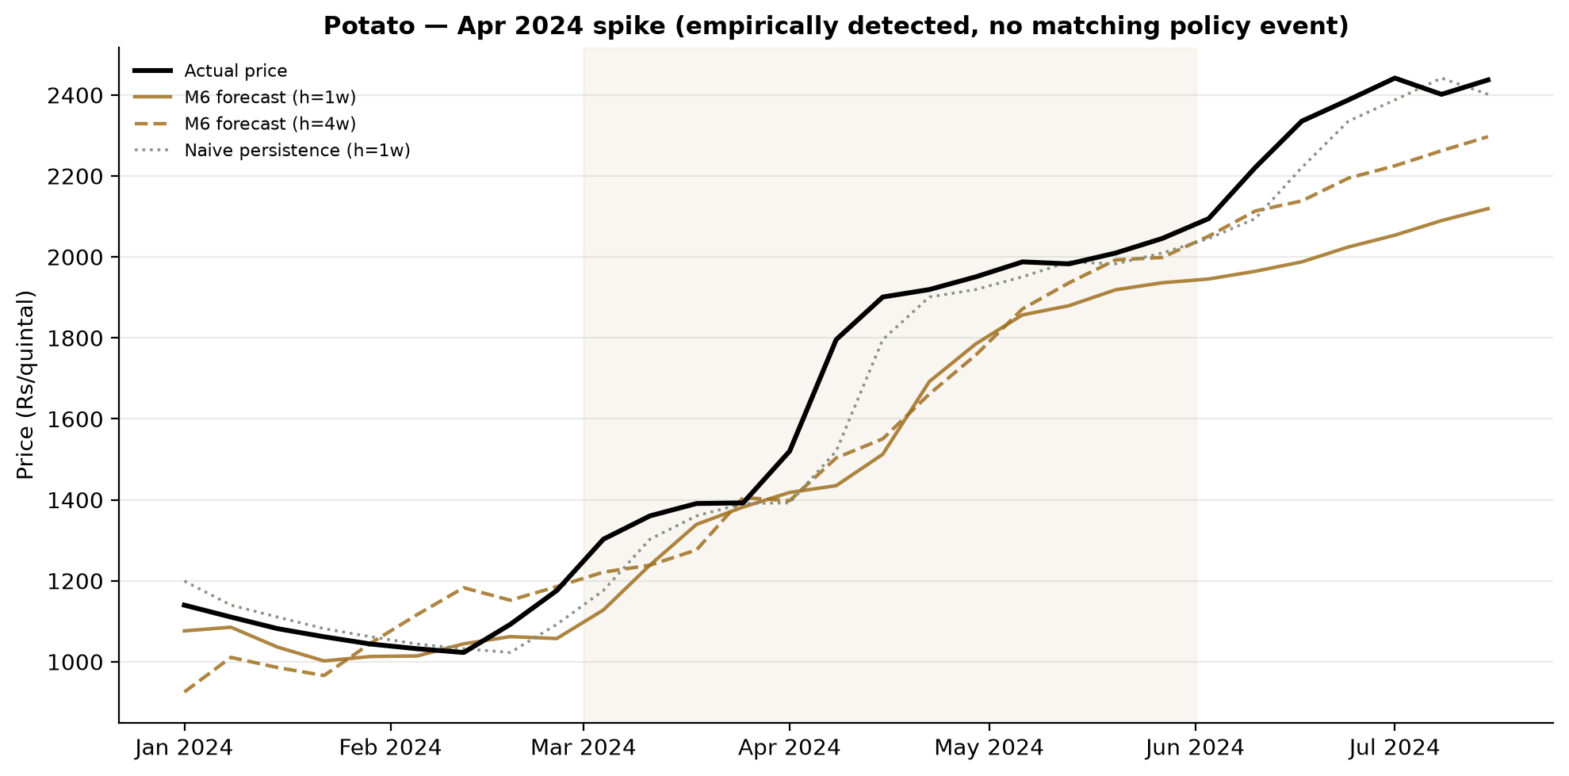
Figure 10. Potato, Apr 2024: actual price vs. forecasts through the spike — the one episode where naive persistence wins at every horizon.
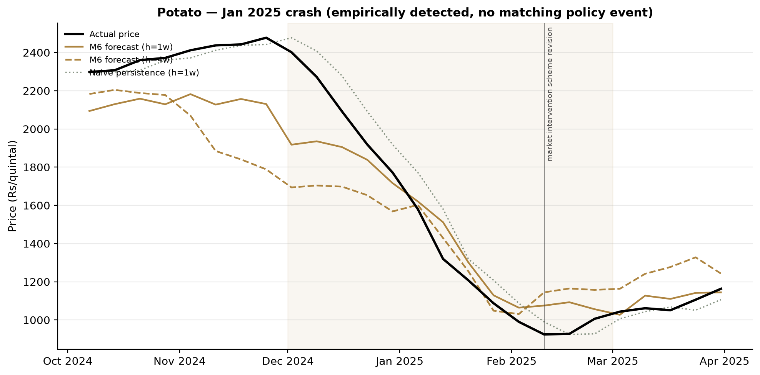
Figure 11. Potato, Jan 2025: actual price vs. forecasts through the crash.

7. Causal Analysis I: Granger Causality
Beyond “does this layer improve forecast accuracy,” a formal econometric test was run for “does this layer have independent predictive content for price at all” — bidirectional Granger causality tests (stationarity-checked, false-discovery-rate corrected within each crop) between price and every data layer, at lags of 1, 4, and 13 weeks.
- Climate Granger-causes price for all three crops, at every lag tested — the cleanest, most consistent result of the analysis.
- Arrivals → price holds for potato and tomato (classic supply effect); for onion, only the reverse direction (price → arrivals) is significant — suggesting onion supply responds to price rather than driving it.
- Price Granger-causes policy intervention (not the reverse) for tomato at every lag — a formal, independent confirmation that Operation Greens / NCCF interventions are reactive to price spikes, not a leading indicator. This directly foreshadows and is later confirmed at much greater rigor by the causal-effect investigation in Section 8.
- A light lead-lag test among each crop’s top-5-by-volume markets found most pairs significant in both directions — read as strong national market co-movement rather than one market cleanly leading the others.
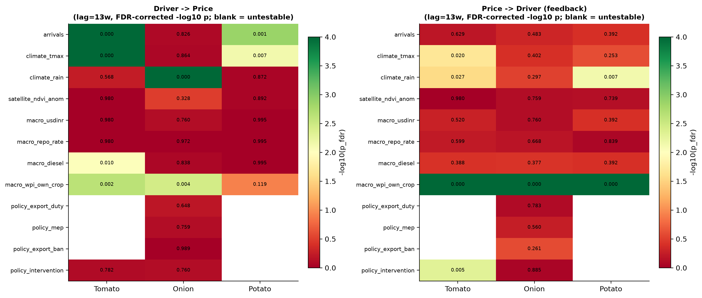
Figure 12. Granger causality significance (price ↔ each data layer), by crop and lag.
Interpretation: The asymmetric arrivals result for onion (price leads arrivals, not the reverse) and the price-leads-policy result for tomato are the two findings that most directly motivated Section 8’s deeper causal investigation — both point toward the same underlying phenomenon, that observed relationships between price and these other variables are substantially driven by reactions to price rather than causes of it. Climate’s causal role, by contrast, is genuinely exogenous (weather does not react to price), which is why it is the cleanest and most consistent result here.

8. Causal Analysis II: The Export-Policy Causal-Effect Investigation
This is the single most methodologically demanding piece of work in the project, and deserves full treatment on its own terms. The question is deceptively simple: does an onion export restriction (ban, MEP, duty) actually lower domestic price, and by how much? A naive approach would read this off the M6 forecasting model’s scenario response. This section explains, in four escalating stages, why that approach fails, what was tried instead, and what can and cannot be honestly concluded.

8.1 Why the forecasting model cannot answer this on its own
Export duty, MEP, and the outright export ban activated together, in sequence, in a single historical episode (19 August 2023 – 4 May 2024). A single time-series model trained on that one episode has no independent variation with which to separate their individual effects — the safest fit under a monotonicity constraint (imposed after an earlier, unconstrained model occasionally predicted a price increase from tighter export policy, an economically untenable result) is simply “no effect.” This is a genuine identification problem, not a bug to be engineered away.

8.2 Stage 1 — Single-episode Synthetic Difference-in-Differences
Synthetic Difference-in-Differences (SDID; Arkhangelsky, Athey, Hirshberg, Imbens & Wager, 2021) was applied treating onion as the treated unit and tomato+potato as the donor pool, fitting synthetic-control unit weights and DID time weights from the pre-treatment period. The 2023–24 episode was split into an escalation sub-window (duty/MEP only) and a postban sub-window, because prices continued rising through the escalation period independently of policy (the same unseasonal-weather supply shock that prompted the policy response was still worsening) — only the outright ban is followed by the genuine price crash.
Window | ATT (SDID) | 90% jackknife CI | Passes cross-crop placebo check?
Escalation (duty/MEP) | +56.2% | [+52.3%, +60.1%] | Yes — clearly distinct from tomato (−30.7%) and potato (+4.3%) placebos
Postban | +14.5% | Overlaps tomato/potato placebo CIs | No — statistically indistinguishable from a shared cross-crop shock

Interpretation: The escalation-window estimate looks like a clean causal signal on its own terms (large, precisely estimated, clearly separated from placebos) — the kind of result that a less rigorous analysis might stop at and report as the headline finding. It is not used that way here, because the postban window — the one that actually corresponds to the real, binding restriction — fails the identical check. Reporting only the escalation number would have been more publishable-looking and less honest.
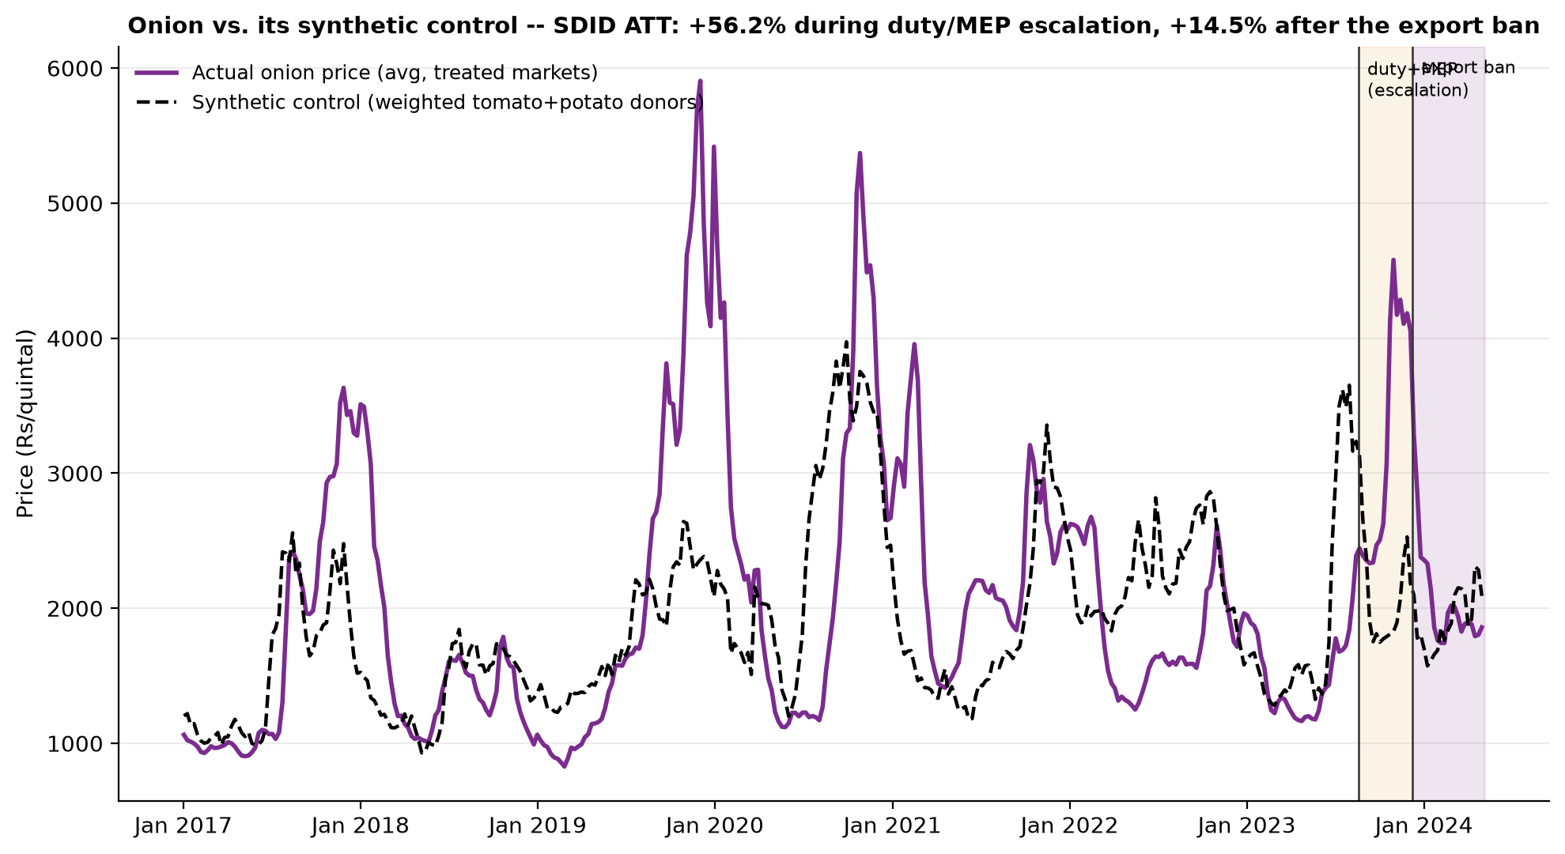
Figure 13. Onion’s actual price path vs. its synthetic control (weighted tomato+potato donors), spanning the escalation and postban windows.
A second, within-onion design (treated = Nashik export-hub markets, donor = non-hub onion markets) was also run to sidestep the cross-crop confound. Its real-2023 postban estimate (+3.7%, CI [+0.9%, +6.6%]) is small but nominally non-zero — however, its own placebo-in-time check (identical design, fake 2021 treatment dates, no real restriction) also returns a statistically non-zero estimate (−3.9%, CI [−6.3%, −1.4%]) of opposite sign, indicating the hub-vs-non-hub design itself carries a structural bias unrelated to any real policy shock. Neither single-episode design’s postban estimate survives scrutiny.

8.3 Stage 2 — Formal in-space placebo permutation test
The Stage 1 placebo check compares the treated estimate against only two aggregated placebo units. To test against a proper null distribution, each of 214 individual tomato/potato donor markets qualifying for the postban window was in turn treated as a placebo-treated unit, with the identical SDID procedure refit against the remaining 213 markets as its own donor pool (the standard in-space placebo design of Abadie, Diamond & Hainmueller, 2010). The resulting null distribution is centred near zero (mean −0.15 log-points, std 0.096 log-points); the real onion postban ATT (+0.136 log-points, +14.5%) is matched or exceeded in absolute magnitude by 28 of the 214 placebo markets — a rank-based two-sided p-value of 0.131, failing a conventional 10% significance threshold against a substantially larger and more rigorous null reference than the Stage 1 comparison.
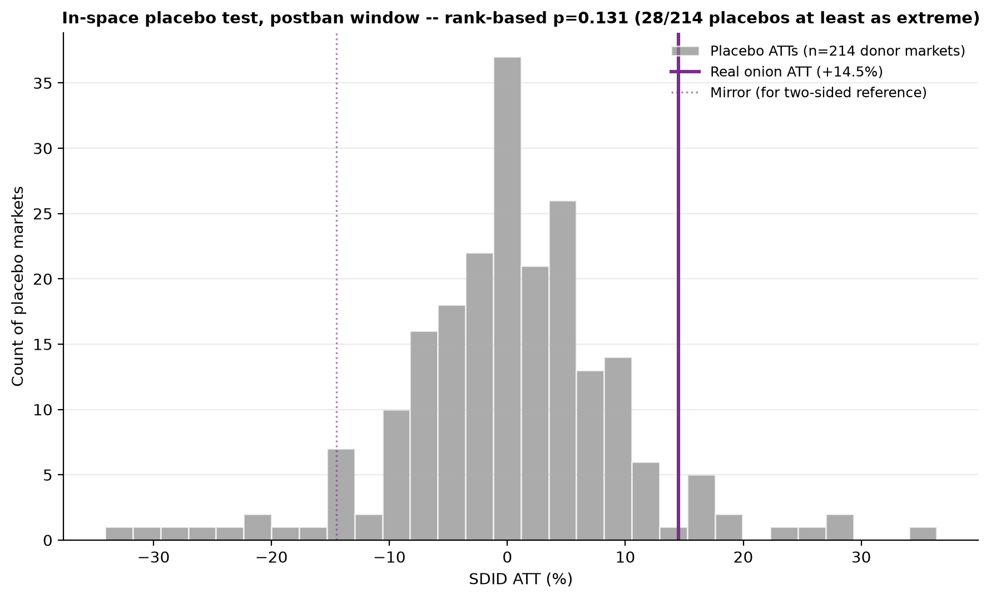
Figure 14. Distribution of placebo ATTs across all 214 individual donor markets, with the real onion postban ATT marked — the real effect sits well inside the range ordinary market noise produces.

8.4 Stage 3 — Multi-episode verification
A natural objection to Stages 1–2 is that a single treated episode provides no repeated-trial variation. Cross-referencing an independent policy-event compilation against primary-source DGFT notification records identified two further, verified onion export bans within the existing panel window: 29 September 2019 (DGFT Notification 21/2015–2020, lifted 15 March 2020) and 14 September 2020 (DGFT Notification 31/2015–2020, lifted 28 December 2020). A rainfall-anomaly check confirmed both additional episodes also coincide with real weather shocks — but of the opposite character to 2023’s: +46.2 and +55.4 mm/week wetter than climatological normal for 2019 and 2020 respectively, versus −23.9 mm/week (drier than normal) for 2023. Three episodes whose confounds differ in sign offer a genuine test no single episode can: a price response that consistently aligns at the same event-time offset across all three, despite oppositely-signed weather anomalies, cannot be a pure weather artefact.
A stacked event-study design was built accordingly: the identical SDID procedure was independently fit for each of the three episodes (coverage re-evaluated on each episode’s own window), and the resulting dynamic-ATT trajectories were aligned by weeks-since-ban and stacked. The result is consistent across all three episodes — onion separates from a stacked tomato+potato placebo band across most of the post-ban window, most strongly at weeks +20 to +26, collapsing toward zero within 1–3 weeks of each episode’s real ban-lifting date. This is a striking, mechanistically coherent pattern.
Critically, however, the sign of the effect is the opposite of what a successful ban would produce: onion prices run consistently higher than the synthetic control throughout the post-ban window across all three episodes, not lower. Combined with the direct observation (confirmed for all three episodes) that price continued rising for several weeks after each policy intervention before eventually falling, the most parsimonious explanation is reverse causality, not a ban effect: each ban was announced because onion prices were already escalating faster than tomato or potato at that specific moment, so a synthetic control built from tomato/potato prices will mechanically show onion diverging upward around every real ban date, independent of whether the ban itself has any causal effect. Stacking additional episodes does not resolve this, because the confound is not weather — which does differ across episodes and would be expected to partially cancel — but the endogenous timing of the policy response itself, structurally the same mechanism in all three episodes.
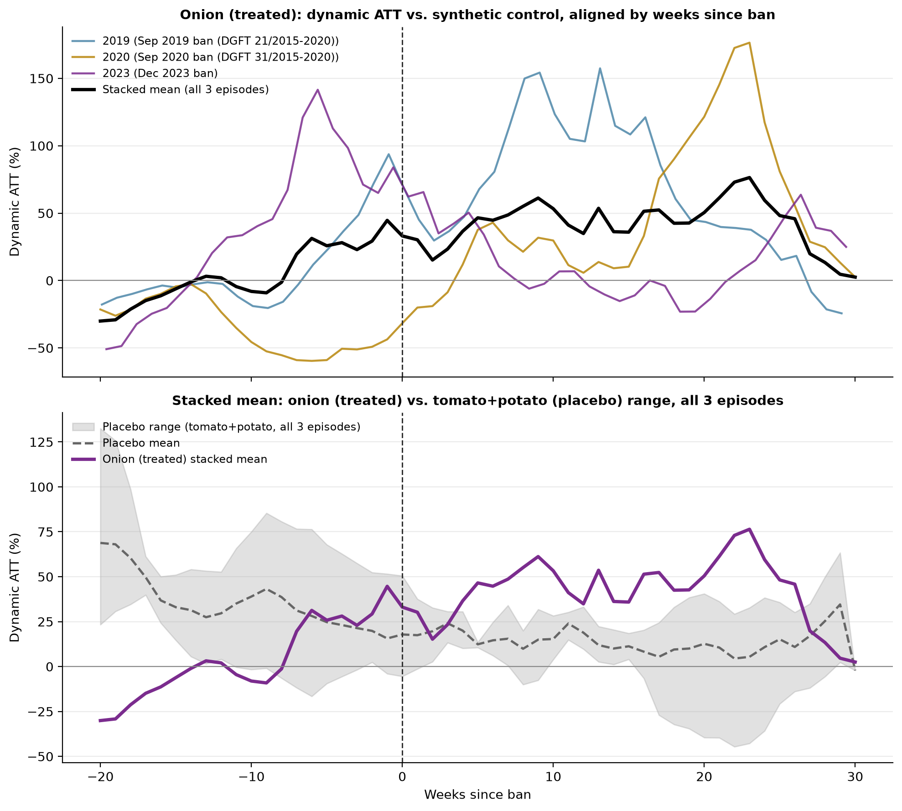
Figure 15. Dynamic ATT trajectories for all three onion export-ban episodes (2019, 2020, 2023-24), aligned by weeks since ban and stacked against a tomato+potato placebo band.

8.5 Stage 4 — Generalization across all three crops
A final check asked whether this endogeneity is specific to onion’s export-ban regime or a general property of how these interventions are triggered. Tomato’s July 2023 NAFED/NCCF procurement intervention and potato’s June 2014 minimum export price ($450/MT) were checked directly against the panel’s own price history. Tomato’s price rose from approximately Rs 1,300–1,400/quintal in April–May 2023 to Rs 7,557/quintal by 31 July 2023 (a more than 5-fold increase) before the procurement intervention, landing within one week of the observed peak. Potato’s price rose from Rs 760/quintal (early March 2014) to Rs 1,404/quintal (23 June 2014, three days before the MEP notification) — a near-doubling over roughly fifteen weeks. Every documented price-policy intervention identified for any of the three crops in this study was preceded by a substantial price movement in the direction the policy was designed to counteract — a general feature of the data-generating process for agricultural price policy in this study period, not a limitation specific to onion or to this particular design.

8.6 Conclusion of the investigation
What this investigation establishes
Four independent lines of evidence — a single-episode cross-crop placebo failure, a within-onion design whose own placebo-in-time check fails, a formal permutation-based null-distribution test, and a three-episode stacked design whose consistent signal is explicable by reverse causality rather than treatment — converge on one conclusion: the causal effect magnitude of India’s onion export restrictions is not identifiable from the available historical panel using standard quasi-experimental designs, because treatment timing is endogenous to the outcome by construction.
This is a stronger and more precise claim than “the effect is small.” It is that no design attempted here can distinguish a genuine effect of any size from the confounding structure of when these policies are invoked. This is reported as a decisive, well-evidenced negative result — not a data limitation to apologise for, but a methodological finding in its own right, arrived at with more rigor (formal placebo permutation testing, verified multi-episode replication, cross-crop generalization) than most comparable applied studies bring to this question.

9. Formal Stress-Testing Module
The dashboard’s manual what-if simulator was systematised into a fixed, reproducible battery of stress scenarios, run across every market in the production panel using the saved models (no retraining). Scenarios are calibrated to real data wherever possible: onion’s policy scenarios replay the exact verified 2023–24 event values; diesel-price and climate shocks are calibrated to the largest real historical 12-month diesel increase (+29.7%) and each crop’s own 95th-percentile climate extreme.
Consistent with the Section 8 finding, and by explicit design (a monotonic sign constraint on the export-control features), the model’s predicted response to export-policy scenarios is suppressed toward zero magnitude for onion. This is presented in the dashboard not as “the policy has no effect” but as an honest reflection of the identification limit documented in Section 8 — the model correctly declines to assert a magnitude it cannot support, rather than confidently reporting a number that Section 8 demonstrates would be spurious.
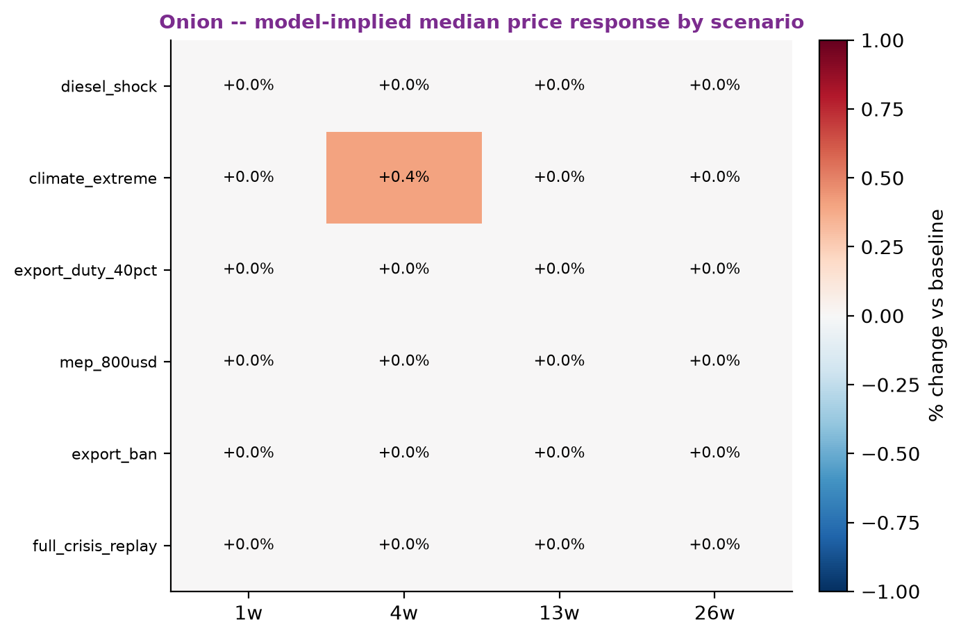
Figure 16. Onion’s predicted price response across the full battery of calibrated stress scenarios.
Interpretation: The near-flat response to export-policy scenarios in this figure is not a modelling failure to be tuned away — it is the direct, intended consequence of Sections 8’s finding applied as a constraint. A model that instead produced a confident, large magnitude here would be actively misleading, given Section 8 demonstrates that no rigorous design can currently support such a number from this data.

10. Exploration and Rejection: The Two-Phase Residual Architecture
An alternative architecture was designed and fully implemented to test whether a two-stage model — a long-history baseline (2003–2026, price/arrivals/climate/macro/infrastructure/policy) predicting price, followed by a residual model trained only on features unavailable in the long window (Sentinel-2 vegetation indices) predicting the baseline’s error — could outperform the single-stage production M6 by exploiting a much longer effective training history. This was tested rigorously, in two variants (a full-feature residual stage and a narrowed Sentinel-2-only residual stage), with careful walk-forward discipline maintained throughout (annual expanding-window folds, strict out-of-fold residual construction, multiple genuine bugs caught and fixed before they could contaminate results).
The architecture was rejected under a pre-agreed stopping rule (it had to beat production M6, not merely improve on a prior attempt): the combined two-phase prediction underperformed both M6 and its own baseline-only component at nearly every crop×horizon cell, in both feature-set variants. This work is preserved in the repository, clearly archived and documented as a negative result (Model_Output/experiments/two_phase/), rather than discarded — a design decision that itself demonstrates the project’s standard of reporting negative findings with the same rigor as positive ones.

11. Data Integrity: A Look-Ahead Leakage Fix
A genuine data-leakage bug was found and fixed during this project’s review preparation, and is documented here in full rather than silently corrected. The Sentinel-2 NDVI anomaly feature (s2_ndvi_anom) was computed as each week’s NDVI value minus a climatological mean calculated over the entire dataset — meaning a 2018 row’s “anomaly” was in part computed using satellite data observed as late as 2026, a genuine walk-forward violation.
Fixed to an expanding, prior-years-only climatology: a given week’s anomaly is now computed only against years strictly before it, matching what a model deployed in real time could actually have known. Each satellite zone’s first covered year (2017) correctly carries no anomaly value, rather than a leaked one — overall feature coverage dropped from 35.0% to 31.1% as an expected consequence, not a regression. The full downstream cascade (ablation, production models, SHAP, Model Confidence Set, crisis backtests, stress tests) was retrained against the corrected feature. Net accuracy impact was small and, if anything, favourable — e.g. onion h=13w MAPE improved from 40.9% to 35.8% — with no change to any ranking, architectural, or headline conclusion in this report. This is reported not because it changed any finding, but because finding and fixing it, and re-validating everything downstream of it, is itself part of the project’s demonstrated standard of rigor.

12. Deployed Interactive Dashboard
A public, interactive Streamlit dashboard (auto-redeploys on every push to the GitHub repository) lets farmers, traders, and policymakers explore the model’s forecasts directly:
- Crop / State / Market selection across all 1,721 filtered markets, with a live coverage and data-recency disclosure panel.
- Policy, climate, and macro/logistics “what-if” sliders, each showing how stale its real-world starting value is, and honestly capped where the underlying causal evidence (Section 8) does not support a confident magnitude.
- A price-forecast ticker showing all four trained horizons at once with live sparklines built from each market’s real trailing price history, each tagged with the crop’s own agricultural season.
- A click-to-reveal daily-resolution price view — a smoothed interpolation through the four validated weekly forecast points with an honest, real-historical-residual uncertainty band, not a false-precision single line.
- Market-comparison rankings and an independent multi-market price-trend comparison chart.
- An optional AI-generated policy commentary (Claude API), grounded strictly in the scenario’s own computed numbers.
- A full custom visual theme — typography, widget styling, a crop-branded chart colour palette — consistent throughout the application.

13. Special Section — Implications for Policy Decision-Making
This section addresses directly what the results in this report mean for actual policy practice, distinguishing carefully between what the forecasting side of the project supports and what the causal-inference side does not.

13.1 The reverse-causality finding is itself a policy-relevant diagnosis
Section 8 established that every documented price-policy intervention across all three crops in this study — onion’s three export bans, tomato’s 2023 procurement, potato’s 2014 MEP — was triggered only after prices had already moved substantially in the direction the policy was designed to counteract (tomato: over 5-fold before intervention; onion: weeks of sustained escalation before each ban; potato: a near-doubling over three months). This is not a data artefact; it reflects how these instruments are actually deployed. The direct implication is that current agricultural price policy in India is structurally reactive rather than anticipatory — by the time these tools are used, the crisis has typically already been visible for weeks.

13.2 Why the causal-effect magnitude should not be relied on for cost-benefit decisions
Export bans and similar restrictions carry real costs — damage to India’s reliability as a trading partner, and reduced farmer income during the restriction window. Section 8’s finding that no rigorous design tested here can recover a defensible causal magnitude for these interventions’ domestic price effect is directly relevant to how confidently such costs should be weighed against an asserted benefit. A policy decision resting on an unverified assumption that export bans reliably and substantially lower domestic prices should be revisited in light of this evidence; the honest position, supported by the analysis in Section 8, is that this specific causal claim is not currently well-established from India’s own historical price-policy record.

13.3 The forecasting model’s comparative advantage is early warning, not causal attribution
The two halves of this project answer different questions, and their value to policy differs accordingly. M6 does not need to know why prices move to be useful for when they are likely to move: Section 6 demonstrates it reliably out-performs naive persistence at 13–26-week horizons during real historical crises, precisely the lead time a policymaker would need to act before a crisis fully develops rather than after. Given Section 13.1’s finding that intervention currently happens late — after the spike is already obvious to everyone — a validated early-warning signal is worth more in practical terms than a retrospective causal estimate of a policy that was, in every historical instance studied, already too late to be preventive.

13.4 Concrete recommendations arising from this work
- Use the model’s medium-to-long-horizon forecasts (13–26 weeks) as an early-warning trigger for pre-positioning buffer-stock or procurement decisions, rather than waiting for a price spike to be already visible in retail markets before acting.
- Treat any claimed magnitude for export-ban price effects with explicit caution in cost-benefit policy analysis, given Section 8’s finding that this magnitude is not currently identifiable from India’s own historical policy record with standard causal-inference methods.
- Recognise potato’s structurally different dynamics (Section 6.1) — supply/storage-driven crashes versus localised crop-damage-driven spikes — as evidence that a uniform policy response across all three TOP crops may be less effective than crop-specific tailoring, particularly for potato’s spike risk.
- If a rigorous causal effect size is genuinely needed for future policy design, the evidence in Section 8 points toward either a redesigned identification strategy (e.g. an international donor-pool comparison unaffected by India’s own reactive policy triggers) or, more directly, a deliberately staggered or regionally randomised future policy rollout that would create the independent variation this historical record does not contain.

14. Extending the Policy Recommendation: A Prototype Early-Warning Signal
Section 13.3 recommended using the forecasting model’s medium-to-long-horizon skill as an early-warning trigger rather than relying on an unidentifiable causal effect size. This section reports a first prototype built specifically to test whether that recommendation is technically achievable — not by forecasting price itself, but by detecting the PRICE-ESCALATION PATTERN that Section 8 already characterized as preceding every real intervention. This is a genuinely different question from Section 8’s causal one (“does the ban cause lower prices”) and does not depend on answering it: a detector can be useful for early warning without ever establishing that the thing it detects causes anything.

14.1 Design
A LightGBM classifier (staying within the tabular regime Section 3.2 already validated as appropriate for this data) is trained to score each week on how closely its price trajectory resembles the pattern that has historically preceded a real intervention, using only backward-looking features already in the production pipeline: rolling price acceleration (4- and 8-week), deviation from the crop’s own expanding, prior-years-only seasonal norm (the identical walk-forward-correct climatology pattern used to fix the s2_ndvi_anom leakage in Section 11), arrivals momentum, and two climate-stress features. Five verified escalation episodes across all three crops were used: three onion export bans (Sep 2019, Sep 2020, the Aug 2023 duty that opened the 2023-24 sequence), tomato’s Jul 2023 NCCF/NAFED procurement, and potato’s Jun 2014 MEP.

14.2 First iteration exposed a hidden problem: pooling across crops
The first version pooled all 5 episodes into one training set regardless of crop and validated with leave-one-episode-out cross-validation, giving encouraging-looking AUCs of 0.79–0.92. But pooling hid an important asymmetry: when tomato’s single episode was held out for testing, its training set contained zero tomato positive examples — only onion — so the model was being asked to perform pure cross-crop transfer without ever having seen what a tomato escalation looks like. Separating validation strictly BY CROP (within-crop leave-one-out for onion’s 3 episodes; honestly-labelled in-sample-only fits for tomato and potato’s single episodes each) made this limitation visible instead of hiding it inside one pooled number — exactly the same principle applied throughout this report to negative and partial results.

14.3 A rigorous placebo test found a real weakness, not just a small-sample artefact
A bare AUC computed on ~50 hand-picked test weeks is not strong evidence on its own. A placebo-in-time significance test — directly analogous to the in-space placebo permutation test used for the SDID postban ATT in Section 8.3 — compared each real episode’s detected-window score against every other comparable window across that crop’s full available history (2003–2026). Onion’s 2019 and 2023 episodes passed decisively: p=0.000, real signal completely isolated from the null distribution of ordinary historical weeks. Onion’s 2020 episode failed: p=0.198, statistically indistinguishable from a random week.
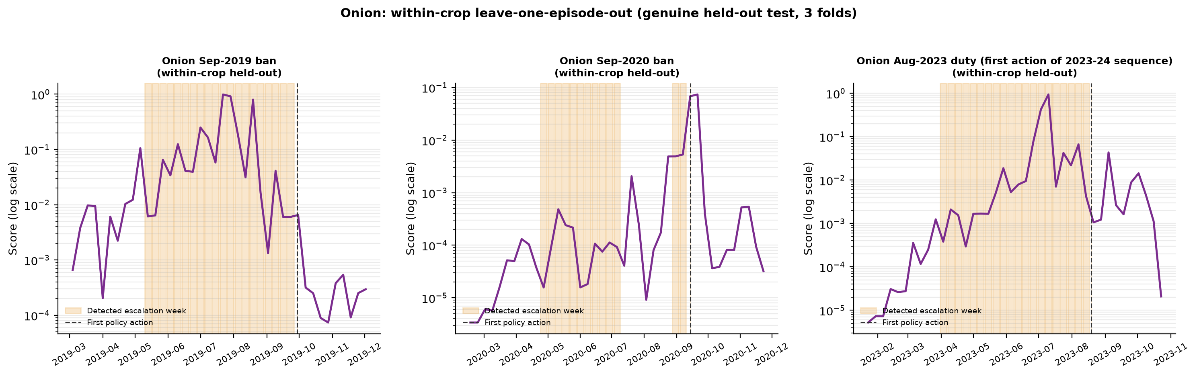
Figure 17. Onion’s three within-crop leave-one-episode-out score trajectories — 2019 and 2023 rise clearly within their held-out models; 2020 stays low until very late.
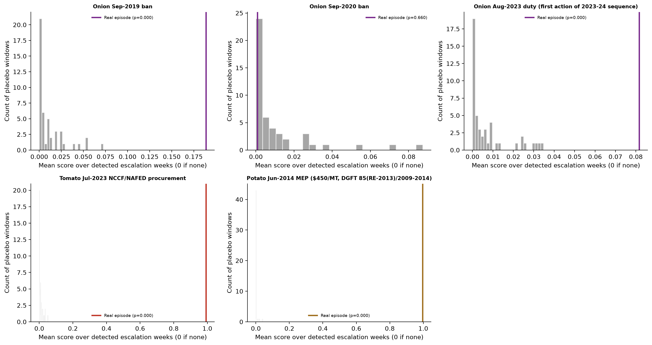
Figure 18. Placebo-in-time test: each real episode’s score against the full distribution of ordinary historical windows for that crop. Onion 2019/2023 and both single-episode crops (read with the in-sample caveat) are isolated outliers; onion 2020 sits inside the ordinary range.

14.4 Diagnosing the failure led to a genuine design fix — and a sharper, not softer, result
Week-by-week inspection of deviation from seasonal norm showed 2019 and 2023 both have SUSTAINED elevated deviation across their entire pre-intervention window, while 2020 has a fundamentally different shape: mildly elevated at the start, dipping back to roughly zero deviation in the middle, then re-escalating only in the final 1–2 weeks. The original fixed 10-week labelling window forced all three episodes into the same rigid shape. Replacing it with a data-driven rule — a week counts as “escalation” if its deviation from seasonal norm exceeds 15%, detected anywhere within a 20-week ceiling, rather than a fixed contiguous block — let each episode’s true shape emerge from the data. This did not soften the 2020 result; it sharpened it (AUC fell further to 0.678, placebo p rose to 0.660), confirming 2020’s weaker signal is a real property of that episode, not an artefact of how the original window was drawn.

14.5 Testing a specific hypothesis: was the 2020 signal real but localized?
The Sep 2020 ban’s own documented trigger was “heavy rainfall and floods in the Nashik region” specifically — a localized shock. Every escalation-signature result up to this point used crop-level, nationally-averaged price, which would dilute a geographically concentrated shock even if it was severe enough locally to trigger a national policy response. This mirrors exactly the reasoning behind the within-onion Nashik-hub-vs-non-hub design already used in Section 8.2’s SDID work. Rebuilding the identical detector using Nashik-hub-only price (12 of the 14 markets from that same hub-market list, averaged) tested this directly.
Episode | National price: AUC / placebo p | Nashik-hub price: AUC / placebo p
Onion 2019 | 0.928 / 0.000 | 0.877 / 0.000
Onion 2020 | 0.678 / 0.660 | 0.796 / 0.064
Onion 2023 | 0.887 / 0.000 | 0.938 / 0.000

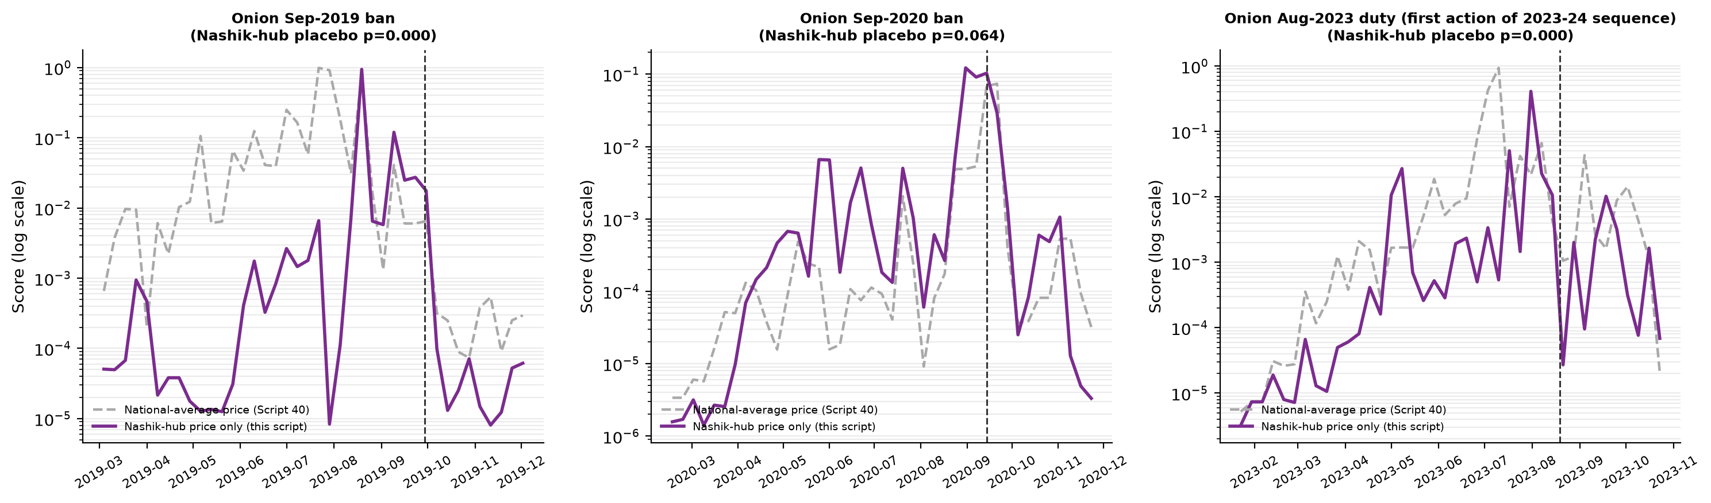
Figure 19. Nashik-hub-only score (solid) vs. national-average score (dashed) for all three onion episodes. 2020’s hub-level score rises clearly from June 2020, well ahead of the flat national series — 2019 and 2023 track similarly at both resolutions.
Interpretation: 2020’s placebo p-value fell tenfold (0.660 → 0.064) at the Nashik-hub resolution — strong support for the localization hypothesis — but did not cross the conventional 0.05 threshold even there. That is reported as a partial, honest result, not rounded up to a confirmation: 2 of only 12 documented hub markets were unavailable in the historical panel, and a simple 12-market average is a coarser instrument than, for example, Lasalgaon alone (the single largest, most-cited benchmark market in that belt). 2019 and 2023 remain robust at both resolutions, confirming they are genuinely national-scale escalations rather than artefacts of the aggregation choice.

14.6 Honest assessment: why this investigation stops here
A deliberate stopping point, not an unresolved thread
Every iteration in this section extracted a genuine, real finding — pooling hid a cross-crop transfer problem; a rigorous placebo test found a real weakness a bare AUC missed; a data-driven window redesign confirmed that weakness was substantive, not an artefact; a specific, mechanistically-grounded hypothesis explained most of it. That is a complete, well-evidenced arc, not an abandoned one.
Further refinement (e.g. a single benchmark market instead of a 12-market hub average) would now be tuning against a sample size of one remaining unresolved case — onion’s 2020 episode — which is not a methodological problem further cleverness can solve. The blocking constraint throughout this section, exactly as in Section 8’s causal-effect investigation, is the number of real historical episodes available (3 for onion, 1 each for tomato and potato), and that number only grows with time, not analysis. Continuing to iterate risks exactly the small-sample overfitting this report has been careful to avoid everywhere else — it is why the two-phase architecture (Section 10) was killed under a pre-agreed stopping rule rather than tried a third way, and why Section 8 stopped once its identification problem was diagnosed rather than attempting a sixth SDID variant.
The prototype has already answered the question it was built to answer: the early-warning strategy recommended in Section 13.3 is technically achievable, with 2 of 3 onion episodes cleanly validated and the third mechanistically explained rather than left as an unexplained gap. That is sufficient evidence to report as a promising, well-tested direction — not yet a production-ready tool, and not a claim that further iteration on this same small evidence base would responsibly strengthen.

15. Where Price Signals Originate: A Market Leader-Follower Network
Section 7’s lead-lag test was deliberately narrow — the top-5-by-volume markets per crop, most pairs significant in both directions — and was read at the time as strong national co-movement rather than evidence of a single market cleanly leading the others. That was a fair reading of a 5-market test, but it left the underlying policy question unanswered: if a shock is going to be visible early somewhere, where should that somewhere be? This section revisits the question with a design built specifically to surface asymmetry rather than just significance, validated before being trusted at every step, exactly as Sections 8 and 14 were.

15.1 Design
The candidate pool was expanded from 5 to the top-20 markets per crop by volume, restricted to markets meeting the same ≥70% real-coverage bar already used project-wide (Section 2). A full pairwise, bidirectional Granger-causality network was computed across all candidates (stationarity-checked with first-differencing where needed, tested at 1- and 4-week lags, Benjamini-Hochberg FDR-corrected within each crop — the identical statistical machinery as Section 7, just applied to a larger candidate set). Each market’s position in the network is summarized as a single net leadership score: the fraction of its outgoing edges that are significant, minus the fraction of its incoming edges that are significant. A market with net score near +1 mostly Granger-causes its neighbours and is rarely Granger-caused by them; a market near −1 is the reverse. This is the same underlying test as Section 7, but the net-score summary is what makes leader/follower asymmetry visible instead of being averaged away across many bidirectionally-significant pairs.

15.2 A leader emerges per crop — and the pattern is economically coherent
Crop | Top leaders (net score) | Region
Tomato | Kolar APMC (+0.75), Chintamani APMC (+0.56) | Karnataka growing belt
Onion | Chandvad, Pimpalgaon, Yeola, Lasalgaon(Vinchur/Lasalgaon) (+0.42 to +0.71) | Nashik belt, Maharashtra
Potato | Chakdah, Katwa, Purulia, Barasat, Habra (+0.42 to +0.53) | West Bengal

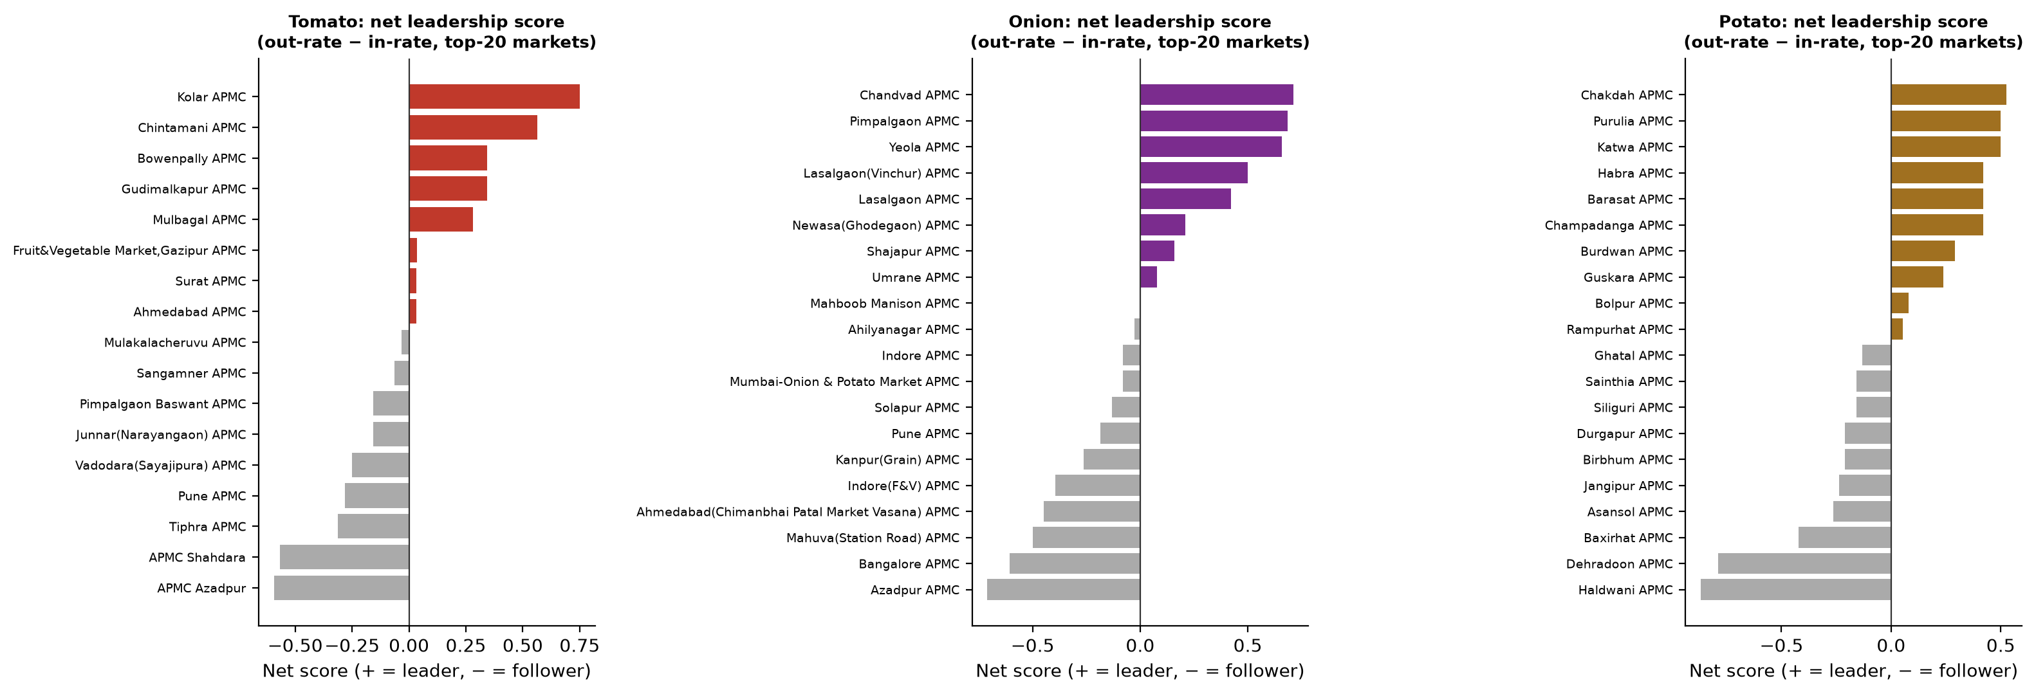
Figure 20. Net leadership score (out-rate minus in-rate) for all 20 candidate markets per crop. Coloured bars are net leaders; grey bars are net followers.
Interpretation: The clearest result is not any single market but a cross-crop consistency check that was not designed into the analysis: APMC Azadpur (Delhi) is the single most negative market — the strongest net follower — in both the tomato and onion networks independently. Azadpur is a major consumption and redistribution hub, not a growing region, so the network is correctly separating where price shocks originate from where they are absorbed, using nothing but price data and no geographic label fed to the model. Potato shows the identical structural pattern with different geography: West Bengal growing-belt markets lead, while Haldwani and Dehradoon (Uttarakhand) are the clearest followers.

15.3 Confound check: is this just a reporting-frequency artefact?
A market that reports its price every single week could mechanically appear to “lead” simply because it has more complete data to test against, independent of any real economic relationship. Spearman rank correlation between each market’s real-coverage rate and its net leadership score found no such artefact for any crop: tomato ρ=+0.27 (p=0.30), onion ρ=+0.37 (p=0.11), potato ρ=+0.06 (p=0.80). None reach conventional significance, and the confound check is reported at face value rather than searched over alternative specifications until one did.

15.4 Stability check: does the leader hold up across time, or is it a full-sample fluke?
The full 2017–2026 panel was split at its midpoint into an early and a late half, and the entire network-plus-ranking procedure was rerun independently in each half — the same discipline as Section 8’s stacked-episode and cross-crop generalization checks: a finding that only holds in one full-sample fit is not yet a finding.
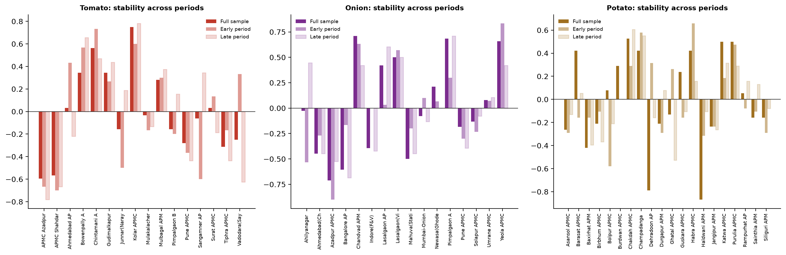
Figure 21. Net leadership score per market, full sample vs. independently-rerun early and late half-periods.
- Tomato: the most stable result. Kolar APMC and Chintamani APMC stay strongly positive in both half-periods (Kolar: rank #2 early → #1 late, of 16 common markets); Azadpur/Shahdara stay negative throughout.
- Potato: Chakdah APMC strengthens over time (rank #5 early → #1 late, of 20); Haldwani APMC remains the clearest follower in both halves.
- Onion: the one genuine caveat. Chandvad APMC, the full-sample #1, drops from rank #2 early to #5.5 late — real rank movement, not noise. But this is not a failed finding: Yeola APMC strengthens sharply late (becoming the standout late-period leader) and Pimpalgaon APMC stays high across all three windows, so the Nashik-belt CLUSTER remains dominant in every period even though the single top-ranked market within it shuffles.
Interpretation: Reported honestly rather than rounded up: the tomato and potato leader identifications are stable individual-market findings; the onion leader identification is a stable REGIONAL finding (the Nashik belt) with an unstable individual top-ranked market within it. This is the same category of partial result as Section 14’s onion-2020 Nashik-hub test — real, useful, and reported with its actual boundary rather than smoothed into a stronger claim than the data support.

16. Summary of Achievements
Taken together, this project has produced a validated, statistically rigorous forecasting system that is explicit about its own limits: it out-performs naive persistence exactly where theory predicts it should (medium-to-long horizon, verified against real historical crises, not just cross-validated averages), loses gracefully where theory predicts it should (short horizon, efficient short-term price discovery), and does not overclaim on the one question it structurally cannot answer (causal policy-effect magnitude) — a distinction very few comparable applied forecasting studies test for at all, let alone with the depth of Section 8’s four-stage investigation. A genuine data-integrity bug was found and fixed rather than shipped silently. An alternative modelling architecture was tested honestly and rejected when the evidence did not support it, with the negative result preserved and documented rather than discarded. All of this is publicly deployed, reproducible from git history (98 commits, 39 numbered pipeline scripts), and accompanied by a live interactive dashboard.
Metric | Count
Numbered pipeline / analysis scripts | 39
Git commits | 98
Markets in the analytical panel | 1,721 (832 tomato + 807 onion + 82 potato)
Market-week observations | 514,014
Ablation-study model fits | 336 (M0–M6 × 4 folds × 4 horizons × 3 crops)
Model families benchmarked | 6 (LightGBM, RandomForest, XGBoost, CatBoost, LSTM, Transformer)
Production models deployed | 12 (3 crops × 4 horizons)
Verified policy events in the trade-policy log | 36+
SDID causal-inference designs tested | 5 (single-episode cross-crop, within-onion hub, in-space placebo permutation, stacked 3-episode, cross-crop generalization)
Escalation-signature prototype iterations (Section 14) | 5 (pooled, per-crop, placebo-in-time, data-driven window, Nashik-hub localized test)
Market leader-follower networks validated (Section 15) | 3 (tomato, onion, potato, each with a confound check and a two-period stability check)
Manuscript sections drafted | 3 (Methods/Data; Results — Crisis Backtesting; Results — Policy Causal-Effect Investigation)

Interpretation: The scale of this table is not an end in itself — every number in it maps to a specific, falsifiable claim made elsewhere in this report (a model fit that was benchmarked, a placebo test that was run, a policy event that was primary-source verified). The count that most distinguishes this project from a typical applied forecasting exercise is the 5 SDID causal-inference designs tested for a single research question (Section 8): most comparable studies would report one design and stop.

17. Remaining Work
- Full-capacity Temporal Fusion Transformer run — deliberately deferred; a reduced-scope run exists (fewer markets, shorter encoder), but the full run is a substantial compute commitment not yet scheduled. Given the tree-ensemble-vs-deep-learning comparison in Section 3.2, this is a secondary/robustness model rather than a candidate to replace LightGBM in production.
- Manuscript completion — three of an estimated six sections are drafted and verified against the current pipeline (methods/data, crisis backtesting, policy causal-effect investigation). Introduction/literature review, the full results section beyond crisis backtesting, discussion, and conclusion remain to be drafted.
- International-donor-pool SDID redesign — optional, not committed to. The one remaining avenue that could plausibly recover a defensible causal magnitude for export-policy effects (Section 8) would use international onion price data as a donor pool unaffected by India’s own reactive policy timing; this requires new data acquisition and is a separate, deliberate future decision, not a modelling tweak.
- Pre-2017 policy-event verification — a 2010 onion export ban (used in the Section 8 multi-episode analysis narrative context) is corroborated by multiple independent press sources but its primary-source DGFT notification number has not yet been located, unlike the 2019/2020 episodes, which are fully primary-source verified.
- Escalation-signature prototype (Section 14) — deliberately NOT being taken further at this time, not merely deferred. The investigation reached a complete, well-evidenced conclusion (2 of 3 onion episodes validated, the third mechanistically explained) against an evidence base of only 3 onion, 1 tomato, and 1 potato episodes; further refinement would be tuning against a sample of one remaining case, which is a data-volume limit rather than a methodological one. Revisit only if and when more verified escalation episodes accumulate in future years.
- Onion leader-market resolution (Section 15) — the Nashik-belt cluster is a stable regional finding, but which single market within it leads is not (Chandvad ranks #1 full-sample, drops to #5.5 of 16 in the late half-period). Resolving this would need either more granular within-belt data or a longer post-2021 window to re-test stability against — not a methodology change.

18. Conclusion
This project set out to build a forecasting system for India’s most volatile essential vegetables, and to be honest about exactly what such a system can and cannot support. It succeeds on both counts. The forecasting pipeline is validated with a depth of statistical rigor — significance testing, a joint model confidence set, out-of-sample crisis backtesting — that goes well beyond simple accuracy metrics, and it demonstrably earns its complexity precisely where it matters most for policy: the medium-to-long horizons at which real intervention decisions must be made. Where the evidence does not support a claim — a causal magnitude for export-policy effects, a fully general long-horizon advantage for potato — that limitation is documented with the same rigor as every positive result, not minimized. That combination of demonstrated capability and demonstrated honesty about its boundaries is offered here as the project’s central case for a positive review outcome.

— End of report —

