<html>  
<head><title>Currency Converter</title></head>  
  
<%-- Load the CurrencyConverter bean --%>  
<jsp:useBean id="converter" scope='session'  
class='converter.CurrencyConverter' />  
  
  
<body>  
<h1>Currency Converter</h1>  
<p>  
Enter the amount in US dollars:  
<p>  
<form method=get>  
   <input type=text name=amount>  
   <input type=submit value="Convert">  
   <%-- Set the amount by associating all properties with the  
      input parameter --%>  
   <jsp:setProperty name="converter" property="*"/>  
</form>  
     
<% if (converter.hasAmount()) { %>  
  
   The amount in Euros is:  
   <%-- Return the converted amount --%>  
   <jsp:getProperty name="converter" property="amount"/>  
   <p>  
   <hr>  
     
<% } %>  
  
</body>  
</html>

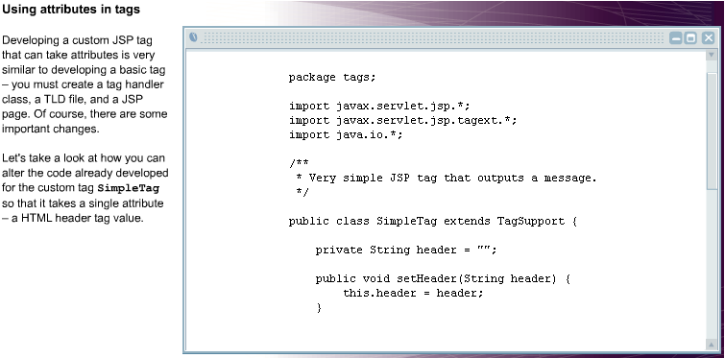

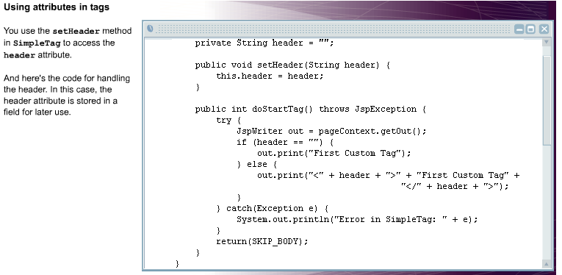

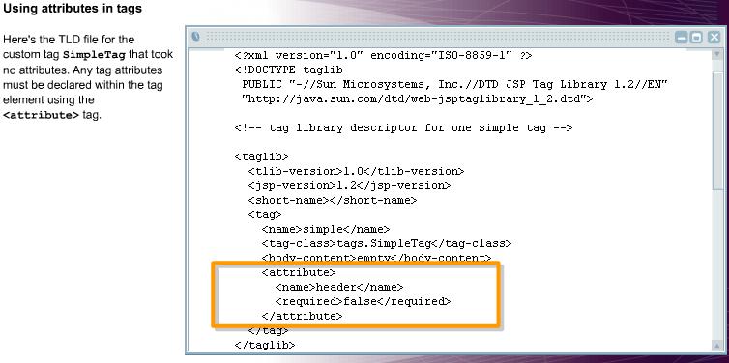

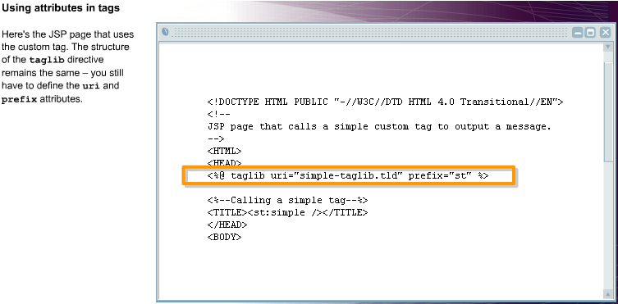

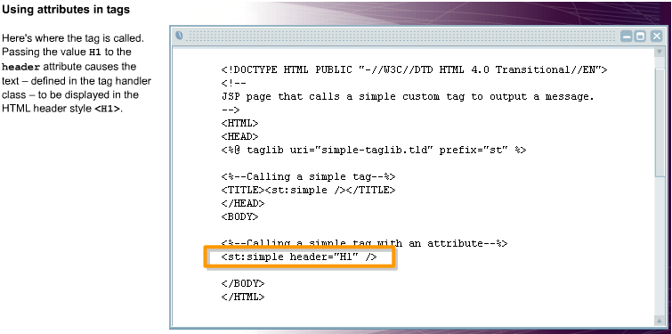

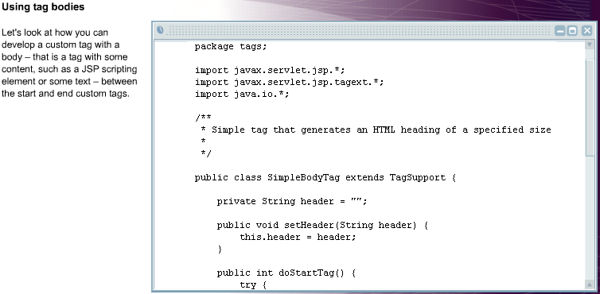

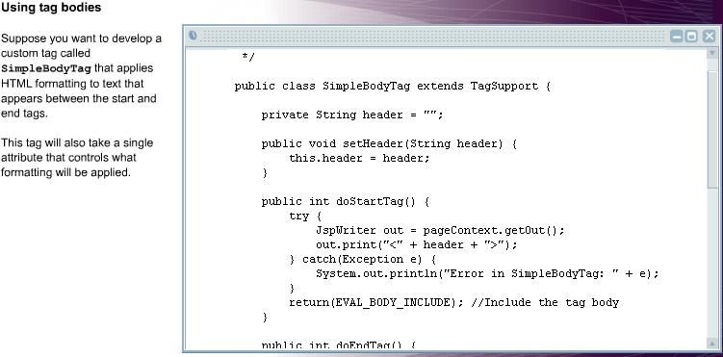

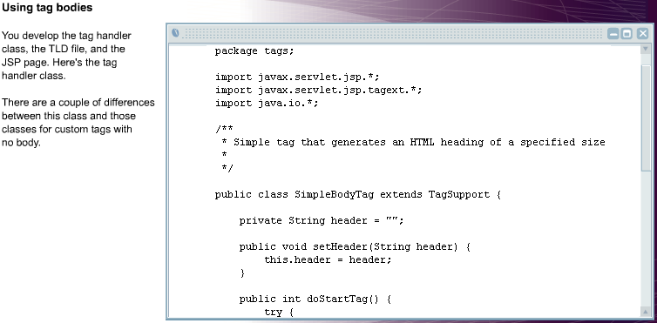

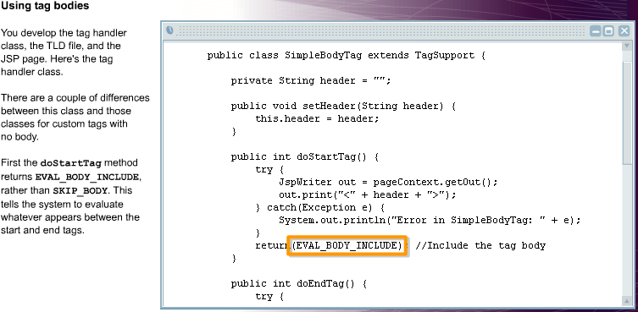

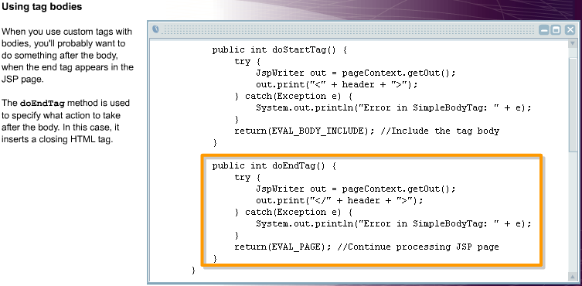

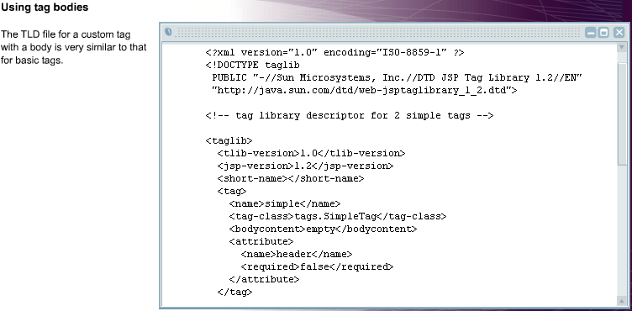

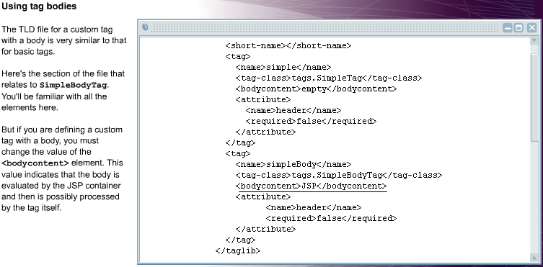

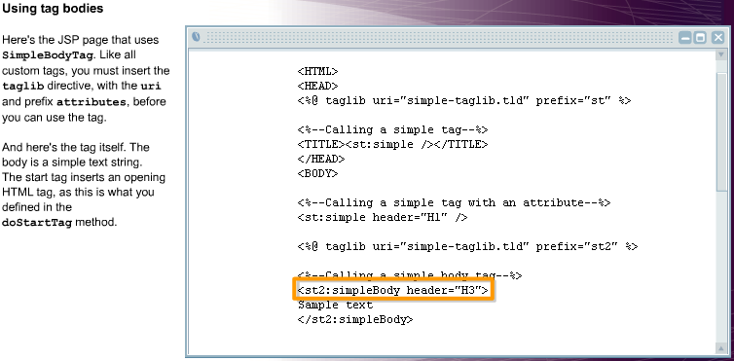

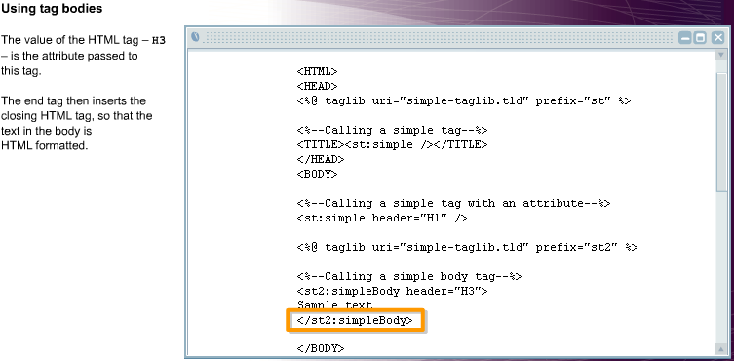

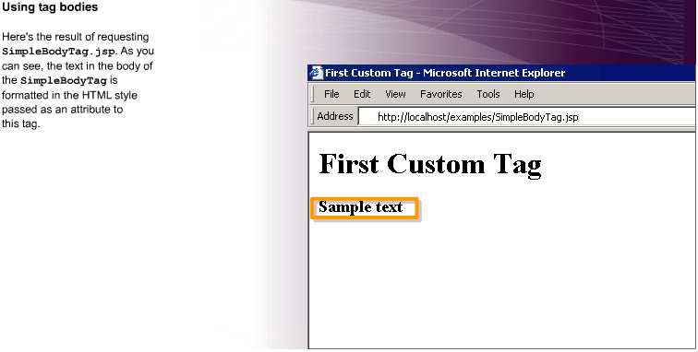

**CurrencyConverterTag.java**

package tags;

import javax.servlet.jsp.*;

import javax.servlet.jsp.tagext.*;

import java.io.*;

/** * JSP custom tag that converts from US Dollars to Euros. */

public class CurrencyConverterTag extends TagSupport {

private double amount = 0; //conversion rate as of 04 Nov, 2002

private final static double rate = 1.0056;

public void setAmount(String strAmount) {

try { this.amount = (Double.valueOf(strAmount)).doubleValue();

} catch (Exception ne) {

amount = 0; }

}

public int doStartTag() throws JspException {

try {

JspWriter out = pageContext.getOut();

this.amount = amount * rate; out.print("The amount in Euros is: " + amount);

} catch(Exception e){ System.out.println("Error in ConverterTag: " + e); }

return(SKIP_BODY); }

}

Tld file

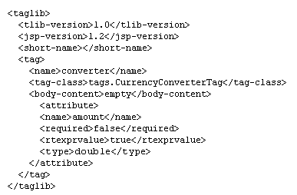

**JSP file**

<html>

<head>

<title>Currency Converter</title>

</head>

<%-- Import the CurrencyConverter tag --%>

<%@ taglib uri="converter-taglib.tld" prefix="ct" %>

<body>

<h1>Currency Converter</h1>

<p> Enter the amount in US dollars: <p>

<form method=post>

<input type=text name=amount>

<input type=submit value="Convert">

</form>

<%! String amt = null; %>

<% amt = request.getParameter("amount"); %>

<% if (amt != "" && amt != null) { %>

<ct:converter amount="<%=amt%>" /> <% }

%>

</body>

</html>