**Oracle Database Architecture**

**The Oracle relational database management system (RDBMS) provides an open, comprehensive, integrated approach to information management.**

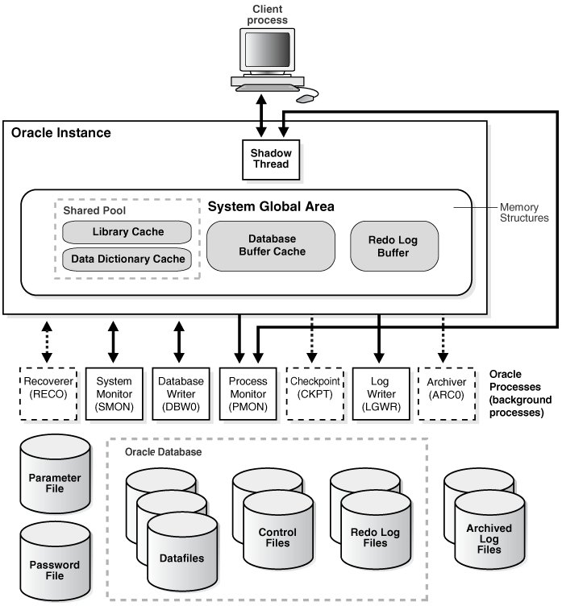

**Oracle Database Architecture**

Oracle Database Memory Architecture

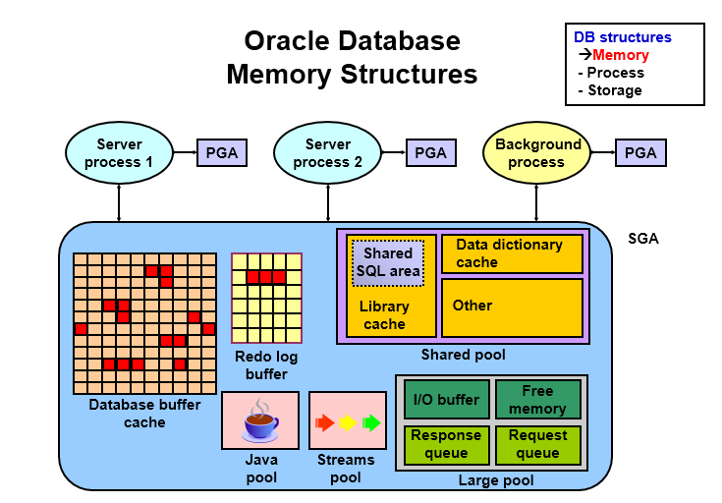

1. **Database Buffer Cache**
   * **Is part of the SGA**
   * **Holds copies of data blocks that are read from data file**
   * **Is shared by all concurrent users.**
2. **Shared Pool**
   1. **Is a portion of the SGA**
   2. **Contains:**
      1. **Library cache:** contains Shared SQL area and has already pasrsed SQL and PL/SQL statements. So when a user executes a query then database checks for already parsed SQL or PL/SQL for the user query. If present then that query is executed. This is called soft parse. Else it parses the SQL and builds a new parse tree for the SQL or SQL statement executed.

Server process checks the shared pool to see if a shared SQL area already exists for an identical statement.

Server process allocates a private SQL area on behalf of the session.

* + 1. **Data dictionary cache:** contains the Table schema, user name, role and privileges
    2. **Control structures**

1. **Large Pool**

**Provides large memory allocations for:**

* + **Session memory for the shared server and the Oracle XA interface**
  + **I/O server processes**
  + **Oracle Database backup and restore operations.**

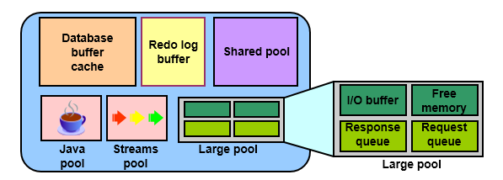

**Process Architecture**

* + **User process**
    - **Is started when a database user or a batch process connects to Oracle Database**
  + **Database processes**
    - **Server process: Connects to the Oracle instance and is started when a user establishes a session**
    - **Background processes: Are started when an Oracle instance is started**

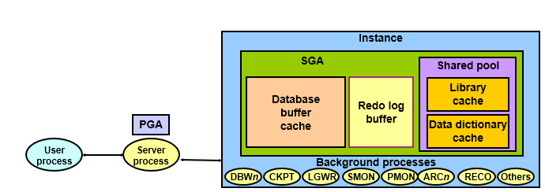

**Database Background Process**

* 1. **Database Writer Process (DBWr):**

**Writes modified (dirty) buffers in the database buffer cache to disk:**

* + **Asynchronously while performing other processing**
  + **Periodically to advance the checkpoint.**
  1. **LogWriter Process (LGWR):**
  + **Writes the redo log buffer to a redo log file on disk**
  + **Writes:**
    - **When a user process commits a transaction**
    - **When the redo log buffer is one-third full**
    - **Before a DBW*n* process writes modified buffers to disk**
  1. **Checkpoint Process (CKPT)**
  + **Records checkpoint information in**
    - **Control file**
    - **Each data file header**
  1. **System Monitor Process (SMON)**
  + **Performs recovery at instance startup**
  + **Cleans up unused temporary segments**
  1. **Process Monitor Process (PMON)**
  + **Performs process recovery when a user process fails**
    - **Cleans up the database buffer cache**
    - **Frees resources that are used by the user process**
  + **Monitors sessions for idle session timeout**
  + **Dynamically registers database services with listeners**
  1. **Recoverer Process(RECO)**
  + **Used with the distributed database configuration**
  + **Automatically connects to other databases involved in in-doubt distributed transactions**
  + **Automatically resolves all in-doubt transactions**
  + **Removes any rows that correspond to in-doubt transactions**
  1. **Archiver Processes (ARC*n*)**
  + **Copy redo log files to a designated storage device after a log switch has occurred**
  + **Can collect transaction redo data and transmit that data to standby destinations**
  1. **MMON: Performs manageability-related background tasks**
  2. **MMNL: Performs frequent and lightweight manageability-related tasks**
  3. **MMAN: Performs automatic memory management tasks**
  4. **CJQ0: Runs user jobs used in batch processing**
  5. **QMNx: Monitors the Streams Advanced Queuing message queues**

**Server Process and Database Buffer Cache**

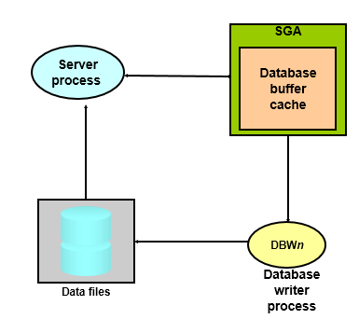

**Database Buffer contains three types of DATA**

• **Free buffers:** These are buffers that do not contain any useful data, and, thus, the database can reuse them to hold new data it reads from disk.

• **Dirty buffers:** These contain data that was read from disk and then modified, but hasn’t yet been written to the datafiles on disk.

• **Pinned buffers:** These are data buffers that are currently in active use by user sessions.

**Database Storage Architecture**

**Divided into two storage Types**

1. Physical Storage

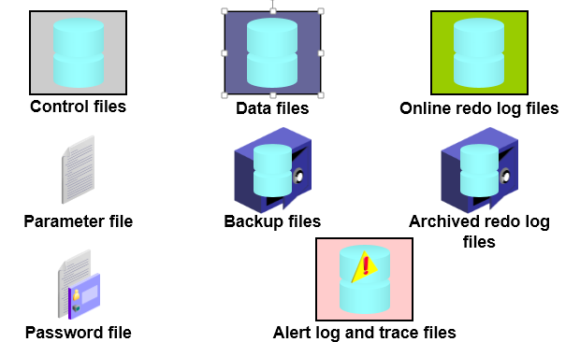

The **Oracle database** consists of the following three main types of files:

* **Datafiles**: These files store the table and index data.

• **Control files**: These files record changes to all database structures.

• **Redo log files**: These online files contain the changes made to table data.

1. Logical Storage:

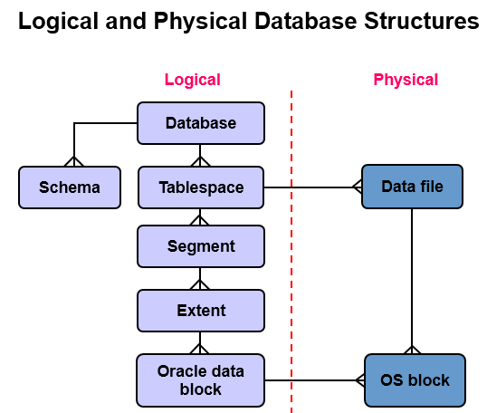

Relationship between datafiles and tablespace

* + **Tablespaces consist of one or more data files.**
  + **Data files belong to only one tablespace.**

**SYSTEM and SYSAUX Tablespaces**

* + **The SYSTEM and SYSAUX tablespaces are mandatory tablespaces that are created at the time of database creation. They must be online.**
  + **The SYSTEM tablespace is used for core functionality (for example, data dictionary tables).**
  + **The auxiliary SYSAUX tablespace is used for additional database components (such as the Enterprise Manager Repository).**

**Segments, Extents, and Blocks**

* + **Segments exist in a tablespace.**
  + **Segments are collections of extents.**
  + **Extents are collections of data blocks.**
  + **Data blocks are mapped to disk blocks.**

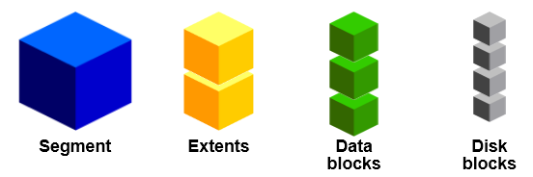

Bibliography

1. docs.oracle.com