|  |  |  |
| --- | --- | --- |
| G:\nsu-logo.png  **North South University**  Department of Electrical & Computer Engineering    **LAB REPORT**  Course Name: **CSE231L**  Experiment No: 01     |  | | --- | | Experiment Name: **Digital Logic Gates and Boolean Functions** |   Experiment Date: 10 November 2020  Report Submission Date: 16 November 2020  Section: 05 | |
| Student Name:Md. Masruf Jaman | Score |
| Student ID: **1813625642** |  |
| Remarks: |

**LAB-01: Digital Logic Gates and Boolean Functions**

**Objectives:**

1. To learn about the basic logic gates – AND, OR, NOT, NAND, NOR, XOR.
2. To learn about the representation of Boolean functions using truth tables, logic diagrams and Boolean Algebra.
3. To prove the extension of inputs of AND and OR gates using the associate law.
4. To familiarized with combinational logic circuits.

**Apparatus:**

* IC 7400 Quadruple 2-input NAND gates
* IC 7402 Quadruple 2-input NOR gates
* IC 7404 Hex Inverters (NOT gates)
* IC 7408 Quadruple 2-input AND gates
* IC 7432 Quadruple 2-input OR gates
* IC 7486 Quadruple 2-input XOR gates

**Theory:**

**Logic gates:** Logic gates are used to carry out logical operations on single or multiple binary inputs and give one binary output. In simple terms, logic gates are the electronic circuits in a computerized framework or digital system. The positive supply voltage +Vs represents true or binary 1 (ON) and 0v represent false or binary 0 (OFF). There are several basic logic gates used in performing operations in digital systems – OR, AND, NOT, XOR, NAND, NOR.

**Truth Table:** Truth Table is used to show the result of the logical operation of a function. These operations comprise Boolean algebra or Boolean functions. It is used to check whether the propositional expression is true or false, according to the input values. This is based on Boolean algebra.

**Boolean algebra:** Boolean algebra is the category of algebra where the variable’s values are the truth values, true and false, meant 1 and 0. It is used to analyze and simplify digital circuits. It is also called as Binary Algebra or logical algebra. It has been essential in the advancement of digital electronics and is provided for in all modern programming language.

**Integrated Circuit (IC):** An integrated circuit is a small chip of a semiconductor material that mounts an entire circuit on itself. An IC can function as an amplifier, oscillator, timer, counter, computer memory, or microprocessor. A particular IC is categorized as either linear or digital, depending on its intended application.

**Circuit Diagram:**

**Experiment-01:**

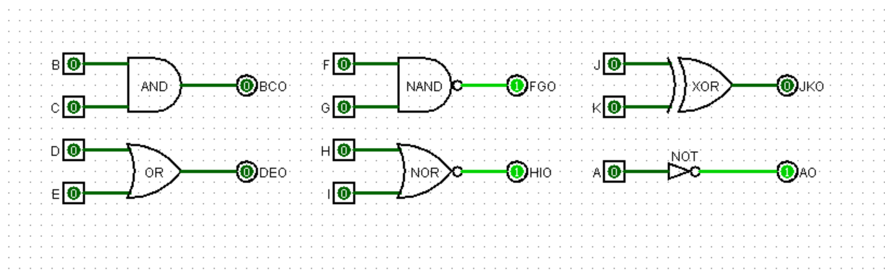

**Experiment-02:**

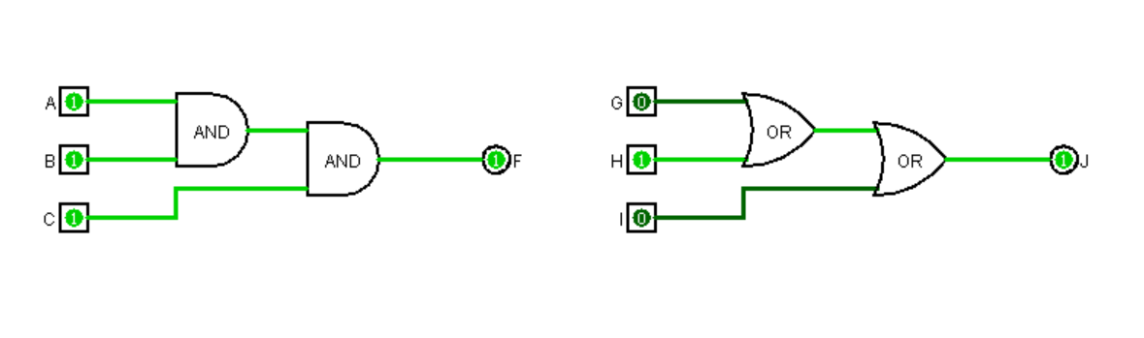

**~~Experiment-03:~~**

**Data Table:**

**Experiment-01:**

Truth table of Logic Gates.

|  |  |  |  |  |  |  |
| --- | --- | --- | --- | --- | --- | --- |
| **Input** | | **AND**  **F = A. B** | **OR**  **F = A + B** | **NAND**  **F = A. B** | **NOR**  **F = A + B** | **XOR**  **F = A ⊕ B** |
| **A** | **B** |
| **0** | **0** | **0** | **0** | **1** | **1** | **0** |
| **0** | **1** | **0** | **1** | **1** | **0** | **1** |
| **1** | **0** | **0** | **1** | **1** | **0** | **1** |
| **1** | **1** | **1** | **1** | **0** | **0** | **0** |

|  |  |
| --- | --- |
| **Input**  **A** | **NOT**  **F = A** |
| **0** | **1** |
| **1** | **0** |

**Experiment-02:**

Truth Table for 3-input AND OR.

|  |  |  |  |  |
| --- | --- | --- | --- | --- |
| **A** | **B** | **C** | **F = ABC** | **F = A + B + C** |
| **0** | **0** | **0** | **0** | **0** |
| **0** | **0** | **1** | **0** | **1** |
| **0** | **1** | **0** | **0** | **1** |
| **0** | **1** | **1** | **0** | **1** |
| **1** | **0** | **0** | **0** | **1** |
| **1** | **0** | **1** | **0** | **1** |
| **1** | **1** | **0** | **0** | **1** |
| **1** | **1** | **1** | **1** | **1** |

Expressing 3-input gates as 2-input gates using associative law.

|  |
| --- |
| **F = ABC = A.(B.C) = (A.B).C** |
| **F = A+B+C = A+(B+C) = (A+B)+C** |

***~~Experiment-03:~~***

*~~Truth table for the given Boolean function F = A’C + AB’ + BC.~~*

|  |  |  |  |  |  |  |
| --- | --- | --- | --- | --- | --- | --- |
| ***~~A~~*** | ***~~B~~*** | ***~~C~~*** | ***~~I~~~~1~~ ~~= A’C~~*** | ***~~I~~~~2~~ ~~= AB’~~*** | ***~~I~~~~3~~ ~~= BC~~*** | ***~~F = I~~~~1~~ ~~+ I~~~~2~~ ~~+ I~~~~3~~*** |
| ***~~0~~*** | ***~~0~~*** | ***~~0~~*** |  |  |  |  |
| ***~~0~~*** | ***~~0~~*** | ***~~1~~*** |  |  |  |  |
| ***~~0~~*** | ***~~1~~*** | ***~~0~~*** |  |  |  |  |
| ***~~0~~*** | ***~~1~~*** | ***~~1~~*** |  |  |  |  |
| ***~~1~~*** | ***~~0~~*** | ***~~0~~*** |  |  |  |  |
| ***~~1~~*** | ***~~0~~*** | ***~~1~~*** |  |  |  |  |
| ***~~1~~*** | ***~~1~~*** | ***~~0~~*** |  |  |  |  |
| ***~~1~~*** | ***~~1~~*** | ***~~1~~*** |  |  |  |  |

**Question and Answer:**

**Experiment-01:**

1. The names and the numbers of the ICs that we need for:
2. 13 AND gates – IC 7408 (have 4 gates) – 4 IC
3. 12 NOT gates – IC 7404 (have 6 gates) – 2 IC
4. 15 NOR gates – IC 7402 (have 4 gates) – 4 IC
5. Your Answer

**Experiment-02:**

Simulation of 6-input AND gate in Logisim using only 2-input AND gates. (Circuit)

|  |
| --- |
|  |

**~~Experiment-03:~~**

~~Simulation for the given Boolean function F = A’C + AB’ + BC when the input ABC =010~~

|  |
| --- |
|  |

**~~IC diagram for the first implicant I~~~~1~~~~= AC’~~** ~~(Circuit)~~

**Discussion:** First of all, we focused on the theory part. We learned about the basic logic gates, truth table, Boolean algebra, and ICs (IC 7400, IC 7402, IC 7404, IC 4708, etc.).

For our first experiment, we build the basic logic gates - AND, OR, NOT, NAND, NOR, XOR on Logisim. We observe the outputs, collected the data in the truth table for all combinational input.

Then We came into our second experiment and constructed 3-input AND & OR gates from 2-input AND & OR gates. Then we took all the output for different input in the truth table and expressed it using associative law. We also Simulate 6-input AND gates in Logisim using only 2-input AND gates. (Circuit)