MIRAZ Luxury Eyewear - Website Documentation Report
Project: MIRAZ Luxury Eyewear E-Commerce Website
Subject: IICT LAB

1. Project Overview
MIRAZ is a luxury eyewear e-commerce website designed to showcase and sell premium quality eyeglasses and sunglasses for both adults and children. The website features a modern, elegant design with an emerald and gold color scheme that reflects luxury and sophistication. The platform includes product browsing, shopping cart functionality, checkout process, and an AI-powered stylist assistant to help customers find the perfect eyewear.

2. Chosen Niche

Luxury Eyewear for Adults and Children
MIRAZ is positioned as a premium eyewear brand specializing in high-quality, stylish glasses for both adults and children. The niche focuses on:
- Premium Quality: Offering eyewear that rivals international standards at competitive local prices
- Family-Focused: Catering to both adult and children's eyewear needs
- Style & Durability: Combining fashionable designs with long-lasting materials
- Local Pakistani Brand: Growing from the heart of Pakistan, providing accessible luxury
- Three Main Categories:
  - Eye Glasses (prescription and reading glasses)
  - Sun Glasses (fashion and protective eyewear)
  - Kids Glasses (durable, safe, and fun designs for children)

3. Design Color Palette
The website uses an elegant emerald and gold color scheme that conveys luxury and sophistication:
Color Name | Hex Code | Usage
Primary Gold | #d4af37 | Primary accent color, buttons, highlights, borders
Dark Emerald Background | #011f18 | Main page background, primary dark background
Card Background | #00332a | Product cards, secondary background elements
Header/Footer Background | #002b24 | Header bar, footer background
Light Text | #f0fdf4 | Primary text color on dark backgrounds
Footer Text | #a0c0b0 | Secondary text in footer sections
Gradient Orange | #FF7300 to #FFEF00 | Luxury button gradients
Sidebar Dark | #111 | Sidebar navigation background

4. Font Choices
Font Name | Usage | Source | Characteristics
Playfair Display | Headings (H1, H2, H3, H4) | Google Fonts | Elegant serif font with italic variants, weights: 400 (regular), 700 (bold)
Poppins | Body text, buttons, navigation | Google Fonts | Modern sans-serif, clean and readable, weights: 300 (light), 400 (regular), 500 (medium), 600 (semi-bold)
Font Awesome Icons | Icons throughout the site | FontAwesome 6.4.0 | Icon font library for social media, shopping cart, navigation, etc.

5. Page Layouts and Features

5.1 Home Page
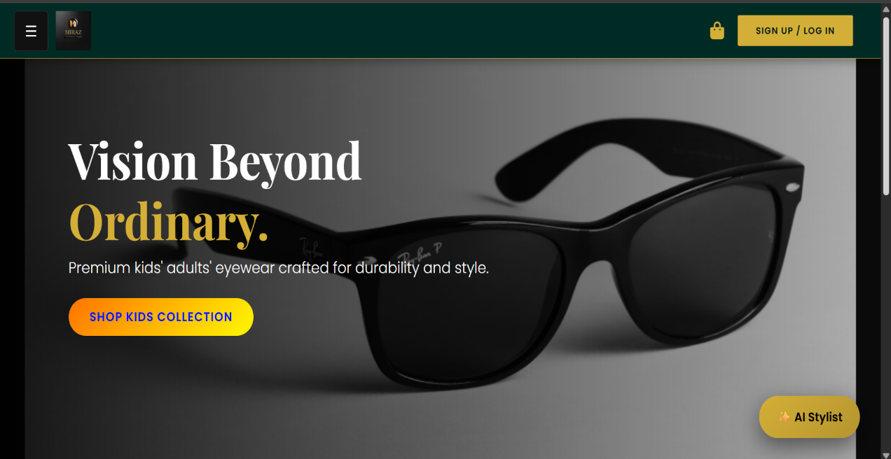

Layout Description:
The home page features a full-screen hero banner with a background image, overlaid with a dark gradient for text readability. The main heading "Vision Beyond Ordinary" is displayed prominently with the word "Ordinary" highlighted in gold. Below the hero, three circular category icons allow quick navigation to Eye Glasses, Sun Glasses, and Kids Glasses. A promotional banner at the bottom announces the summer sale.

Key Features:
- Full-viewport hero banner with background image
- Gradient overlay for text contrast
- Call-to-action button "Shop Kids Collection"
- Interactive category circle menu with hover effects
- Promotional sale banner at the bottom

Design Elements:
- Dark emerald background (#011f18)
- Gold accent color for highlights
- Smooth hover animations on category icons
- Responsive design using Bootstrap grid system

5.2 Products/Categories Page
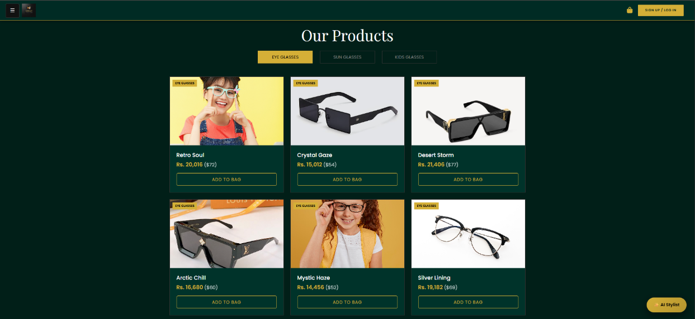]

Layout Description:
The products page displays a centered heading "Our Products" with three filter buttons (Eye Glasses, Sun Glasses, Kids Glasses) at the top. Products are displayed in a responsive grid layout (3 columns on desktop, 2 on tablet, 1 on mobile). Each product card shows an image, category badge, product name, price in PKR (with USD equivalent), and an "Add to Bag" button. A "Load More" button appears at the bottom for pagination.

Key Features:
- Dynamic product filtering by category
- Active button state indication
- Product cards with hover effects (lift and zoom)
- Category badge tags on product images
- Dual currency display (PKR primary, USD secondary)
- Add to cart functionality
- Load more pagination (simulated)

Design Elements:
- Product cards with dark emerald background (#00332a)
- Gold border on hover
- Image zoom effect on card hover
- Category badges in gold color
- Clean, organized grid layout

5.3 Top Sellers Page
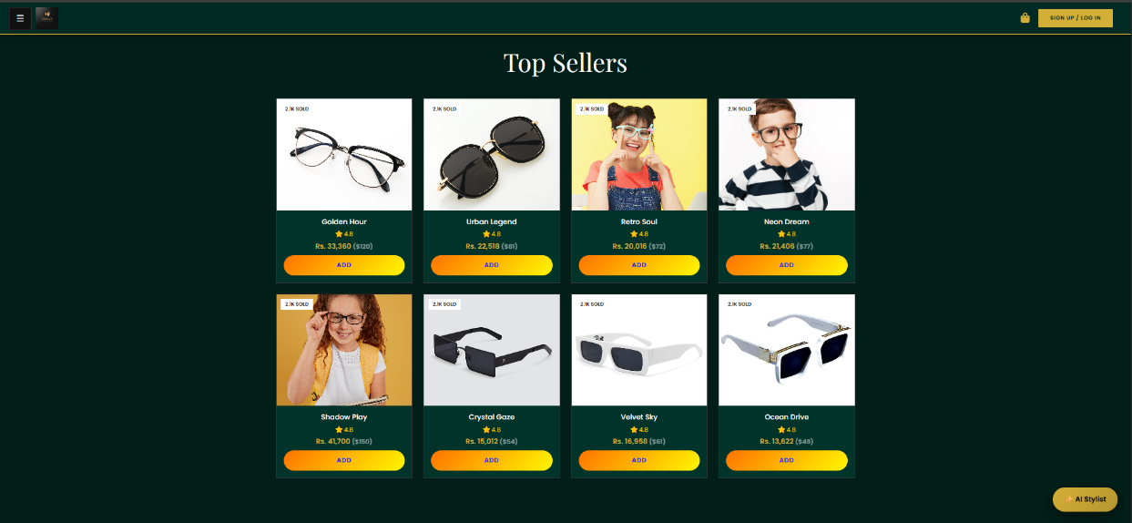

Layout Description:
The top sellers page showcases the 8 most popular products in a grid layout. Each product displays with a "2.1k Sold" badge, star rating (4.8), product name, price, and a compact "Add" button. The layout is optimized to highlight best-selling items with social proof.

Key Features:
- Featured products display
- Sales badge showing popularity ("2.1k Sold")
- Star ratings for social proof
- Quick add to cart functionality
- Compact card design for maximum visibility

Design Elements:
- White sales badges for contrast
- Star rating display with gold/yellow stars
- Smaller card format for featured items
- Emphasis on best-selling products

5.4 Shopping Cart Page
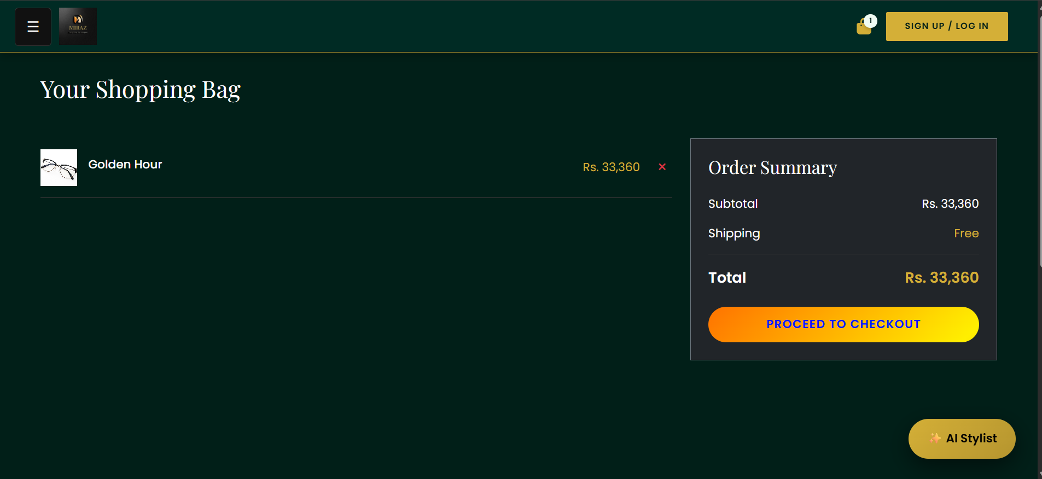

Layout Description:
The shopping cart page is divided into two columns: the left column (8/12 width) displays cart items with product images, names, prices, and remove buttons. The right column (4/12 width) shows the order summary with subtotal, shipping (free), total, and a "Proceed to Checkout" button. When empty, a message is displayed indicating the cart is empty.

Key Features:
- Dynamic cart item list
- Remove item functionality
- Real-time price calculation
- Free shipping indicator
- Total price display in PKR
- Empty cart state handling
- Cart badge in header showing item count

Design Elements:
- Two-column responsive layout
- Cart items with thumbnail images
- Dark card background for order summary
- Gold accent for pricing and totals
- Clear visual separation between items

5.5 Checkout Page
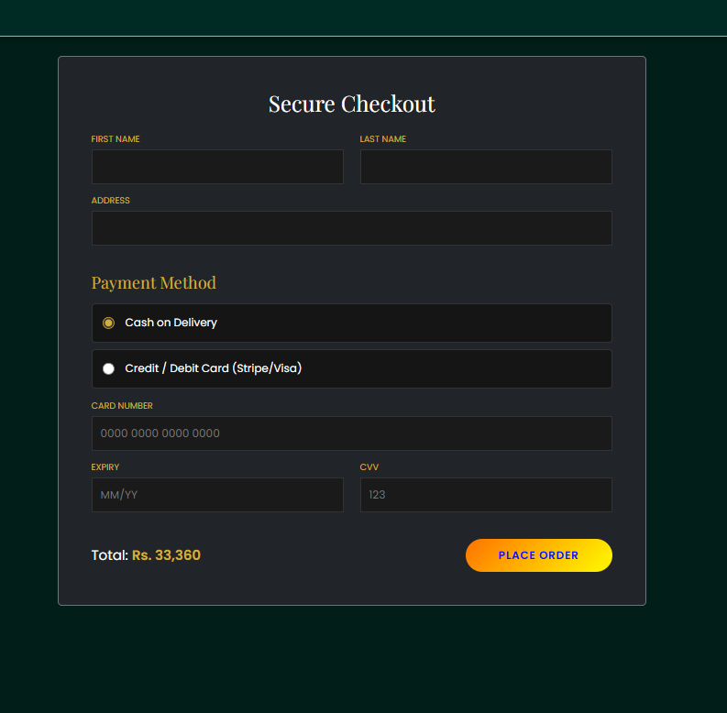

Layout Description:
The checkout page features a centered form container with customer information fields (First Name, Last Name, Address) and payment method selection. Users can choose between Cash on Delivery or Credit/Debit Card payment. When card payment is selected, additional fields appear for card number, expiry date, and CVV. The total amount is displayed at the bottom with a "Place Order" button.

Key Features:
- Customer information form
- Dual payment options (COD and Card)
- Dynamic credit card form (shows/hides based on selection)
- Form validation (required fields)
- Order total display
- Order placement with success notification
- Automatic redirect to home after order

Design Elements:
- Centered form layout
- Dark form container with gold border
- Payment option boxes with radio buttons
- Clean input field styling
- Gold accent for labels and totals
- Professional checkout experience

5.6 Contact Us Page
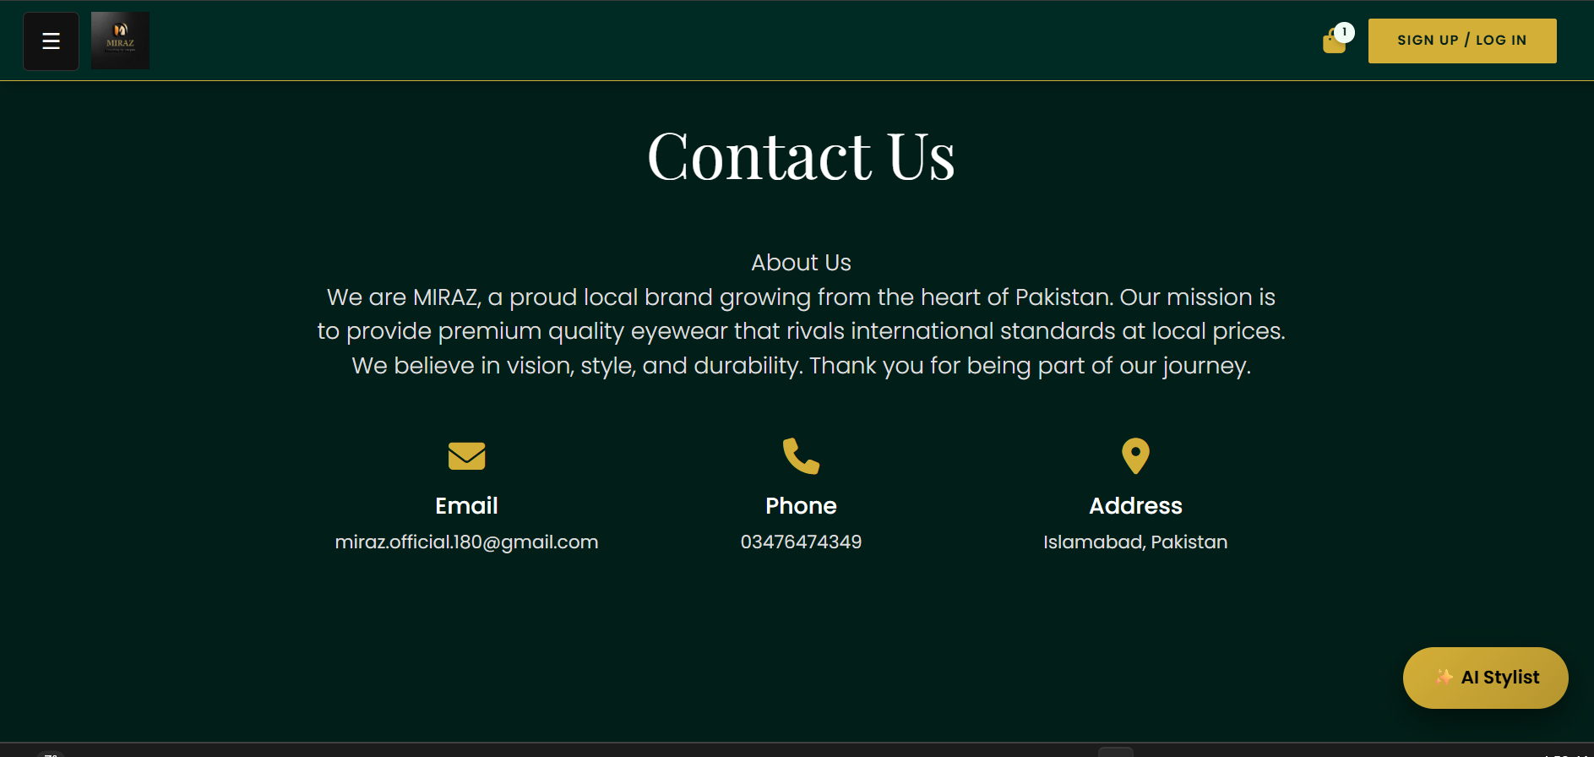

Layout Description:
The contact page displays the company's "About Us" section with a description of MIRAZ as a local Pakistani brand. Below, three contact cards are arranged horizontally showing Email, Phone, and Address information with respective icons. The layout is centered and uses a clean, professional design.

Key Features:
- Company story and mission
- Contact information cards
- Icon-based contact categories
- Email: miraz.official.180@gmail.com
- Phone: 03476474349
- Address: Islamabad, Pakistan

Design Elements:
- Centered content layout
- Three-column grid for contact info
- Gold icons for visual interest
- Clear typography hierarchy
- Professional presentation

5.7 Authentication Modal
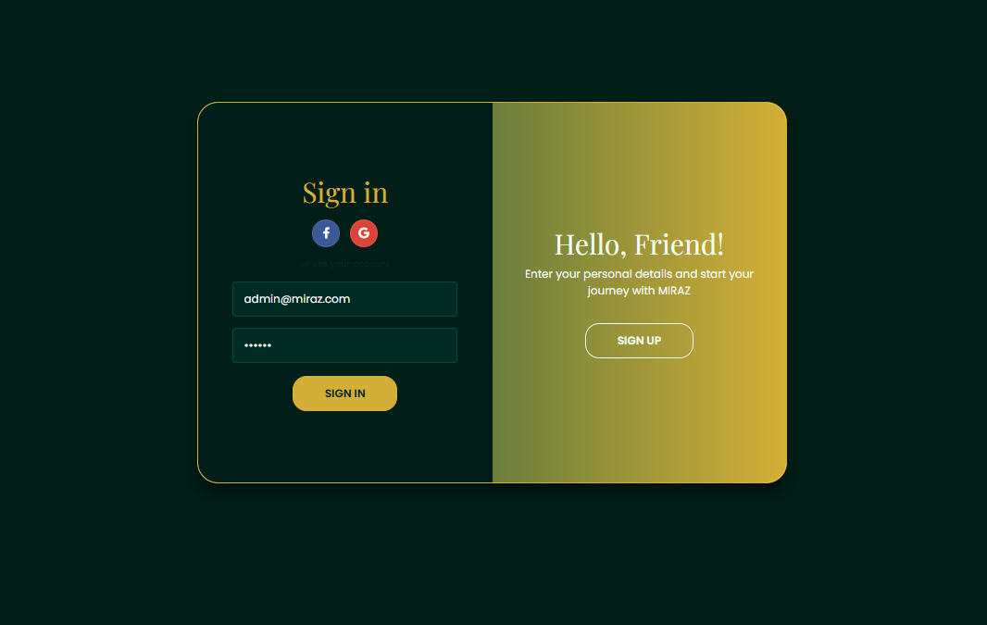

Layout Description:
The authentication modal features a split-screen design that slides between Sign In and Sign Up forms. The modal includes social login buttons (Facebook and Google), email/password fields, and an animated overlay panel that switches sides when toggling between sign-in and sign-up modes. The design uses the emerald and gold color scheme throughout.

Key Features:
- Dual form system (Sign In / Sign Up)
- Smooth sliding animation between forms
- Social media login options
- Email/password authentication
- Form validation
- Animated overlay with welcome messages
- Close button to dismiss modal

Design Elements:
- White modal container with rounded corners
- Dark emerald form backgrounds
- Gold accent buttons and borders
- Gradient overlay panel
- Smooth CSS transitions
- Professional login experience

6. Additional Features and Components

6.1 Fixed Header Bar
- Logo: Clickable MIRAZ logo on the left
- Shopping Bag Icon: Navigates to cart with item count badge
- Auth Button: Opens authentication modal
- Background: Dark emerald (#002b24) with gold bottom border
- Position: Fixed at top, stays visible while scrolling

6.2 Sidebar Navigation
- Toggle Button: Hamburger menu (☰) in top-left corner
- Logo Display: MIRAZ logo with "EST. 2025" tag
- Navigation Links: Home, Products, Top Sellers, My Bag, Contact Us, Log Out
- Animation: Slides in from left, pushes main content to the right
- Background: Dark (#111) with gold hover effects

6.3 AI Stylist Widget
- Floating Button: Fixed position at bottom-right
- Chat Window: Popup modal with conversation interface
- Features: Keyword-based product recommendations
- Categories: Recognizes kid, sun, beach, outdoor keywords
- Design: Gold-themed chat interface with AI/user message distinction

6.4 Footer
- Three Columns: Contact Info, Useful Links, Store Locations
- Social Media: Facebook, Instagram, GitHub icons with hover effects
- Copyright: "Copyright © 2025, MIRAZ. All Rights Reserved."
- Design: Dark emerald background with gold accents

6.5 Notification System
- Toast Notification: Appears after order placement
- Message: "Order placed. Thank you for shopping."
- Animation: Fade in/out with slide up effect
- Design: Gold background with bold text

7. Technical Implementation

7.1 Technologies Used
- HTML5: Semantic markup and structure
- CSS3: Custom styling with CSS variables, animations, and transitions
- JavaScript: Vanilla JS for interactivity and dynamic content
- Bootstrap 5.3.0: Responsive grid system and utilities
- Font Awesome 6.4.0: Icon library
- Google Fonts: Playfair Display and Poppins typefaces

7.2 Key Functionality
- Single-Page Application (SPA): Page navigation without full reloads
- Dynamic Product Rendering: Products generated and displayed dynamically
- Shopping Cart: Client-side cart management with localStorage potential
- Currency Conversion: PKR/USD dual currency display (278:1 rate)
- Form Handling: Checkout and authentication form processing
- Responsive Design: Mobile-first approach with Bootstrap grid

7.3 User Experience Features
- Smooth page transitions and animations
- Hover effects on interactive elements
- Loading states for buttons
- Empty state handling (empty cart)
- Visual feedback on user actions
- Accessible navigation and forms

8. Design Philosophy
The MIRAZ website design philosophy centers around luxury, elegance, and accessibility. The emerald and gold color scheme was chosen to convey premium quality while maintaining a warm, approachable feel. The typography pairing of Playfair Display (elegant serif) for headings and Poppins (modern sans-serif) for body text creates a sophisticated yet readable experience.
The layout emphasizes clarity and ease of navigation, with prominent calls-to-action and intuitive user flows. The dark background reduces eye strain during extended browsing sessions, while the gold accents draw attention to important elements and create visual hierarchy. The responsive design ensures a consistent experience across all devices, from mobile phones to desktop computers.

9. Conclusion
The MIRAZ Luxury Eyewear website successfully combines elegant design with functional e-commerce features to create a premium shopping experience. The emerald and gold color palette, combined with thoughtful typography and smooth animations, establishes a strong brand identity. The website's single-page application architecture ensures fast navigation and a seamless user experience, while the comprehensive feature set (product browsing, shopping cart, checkout, and AI stylist) provides all necessary functionality for an online eyewear store.
The design effectively communicates the brand's mission of providing premium quality eyewear at accessible prices, with particular attention to both adult and children's needs. The local Pakistani branding adds authenticity and connection with the target market, while maintaining international quality standards in design and user experience.

