PRIME MINISTER’S OFFICE
REGIONAL ADMINISTRATION AND LOCAL GOVERNMENT
ARUSHA REGION
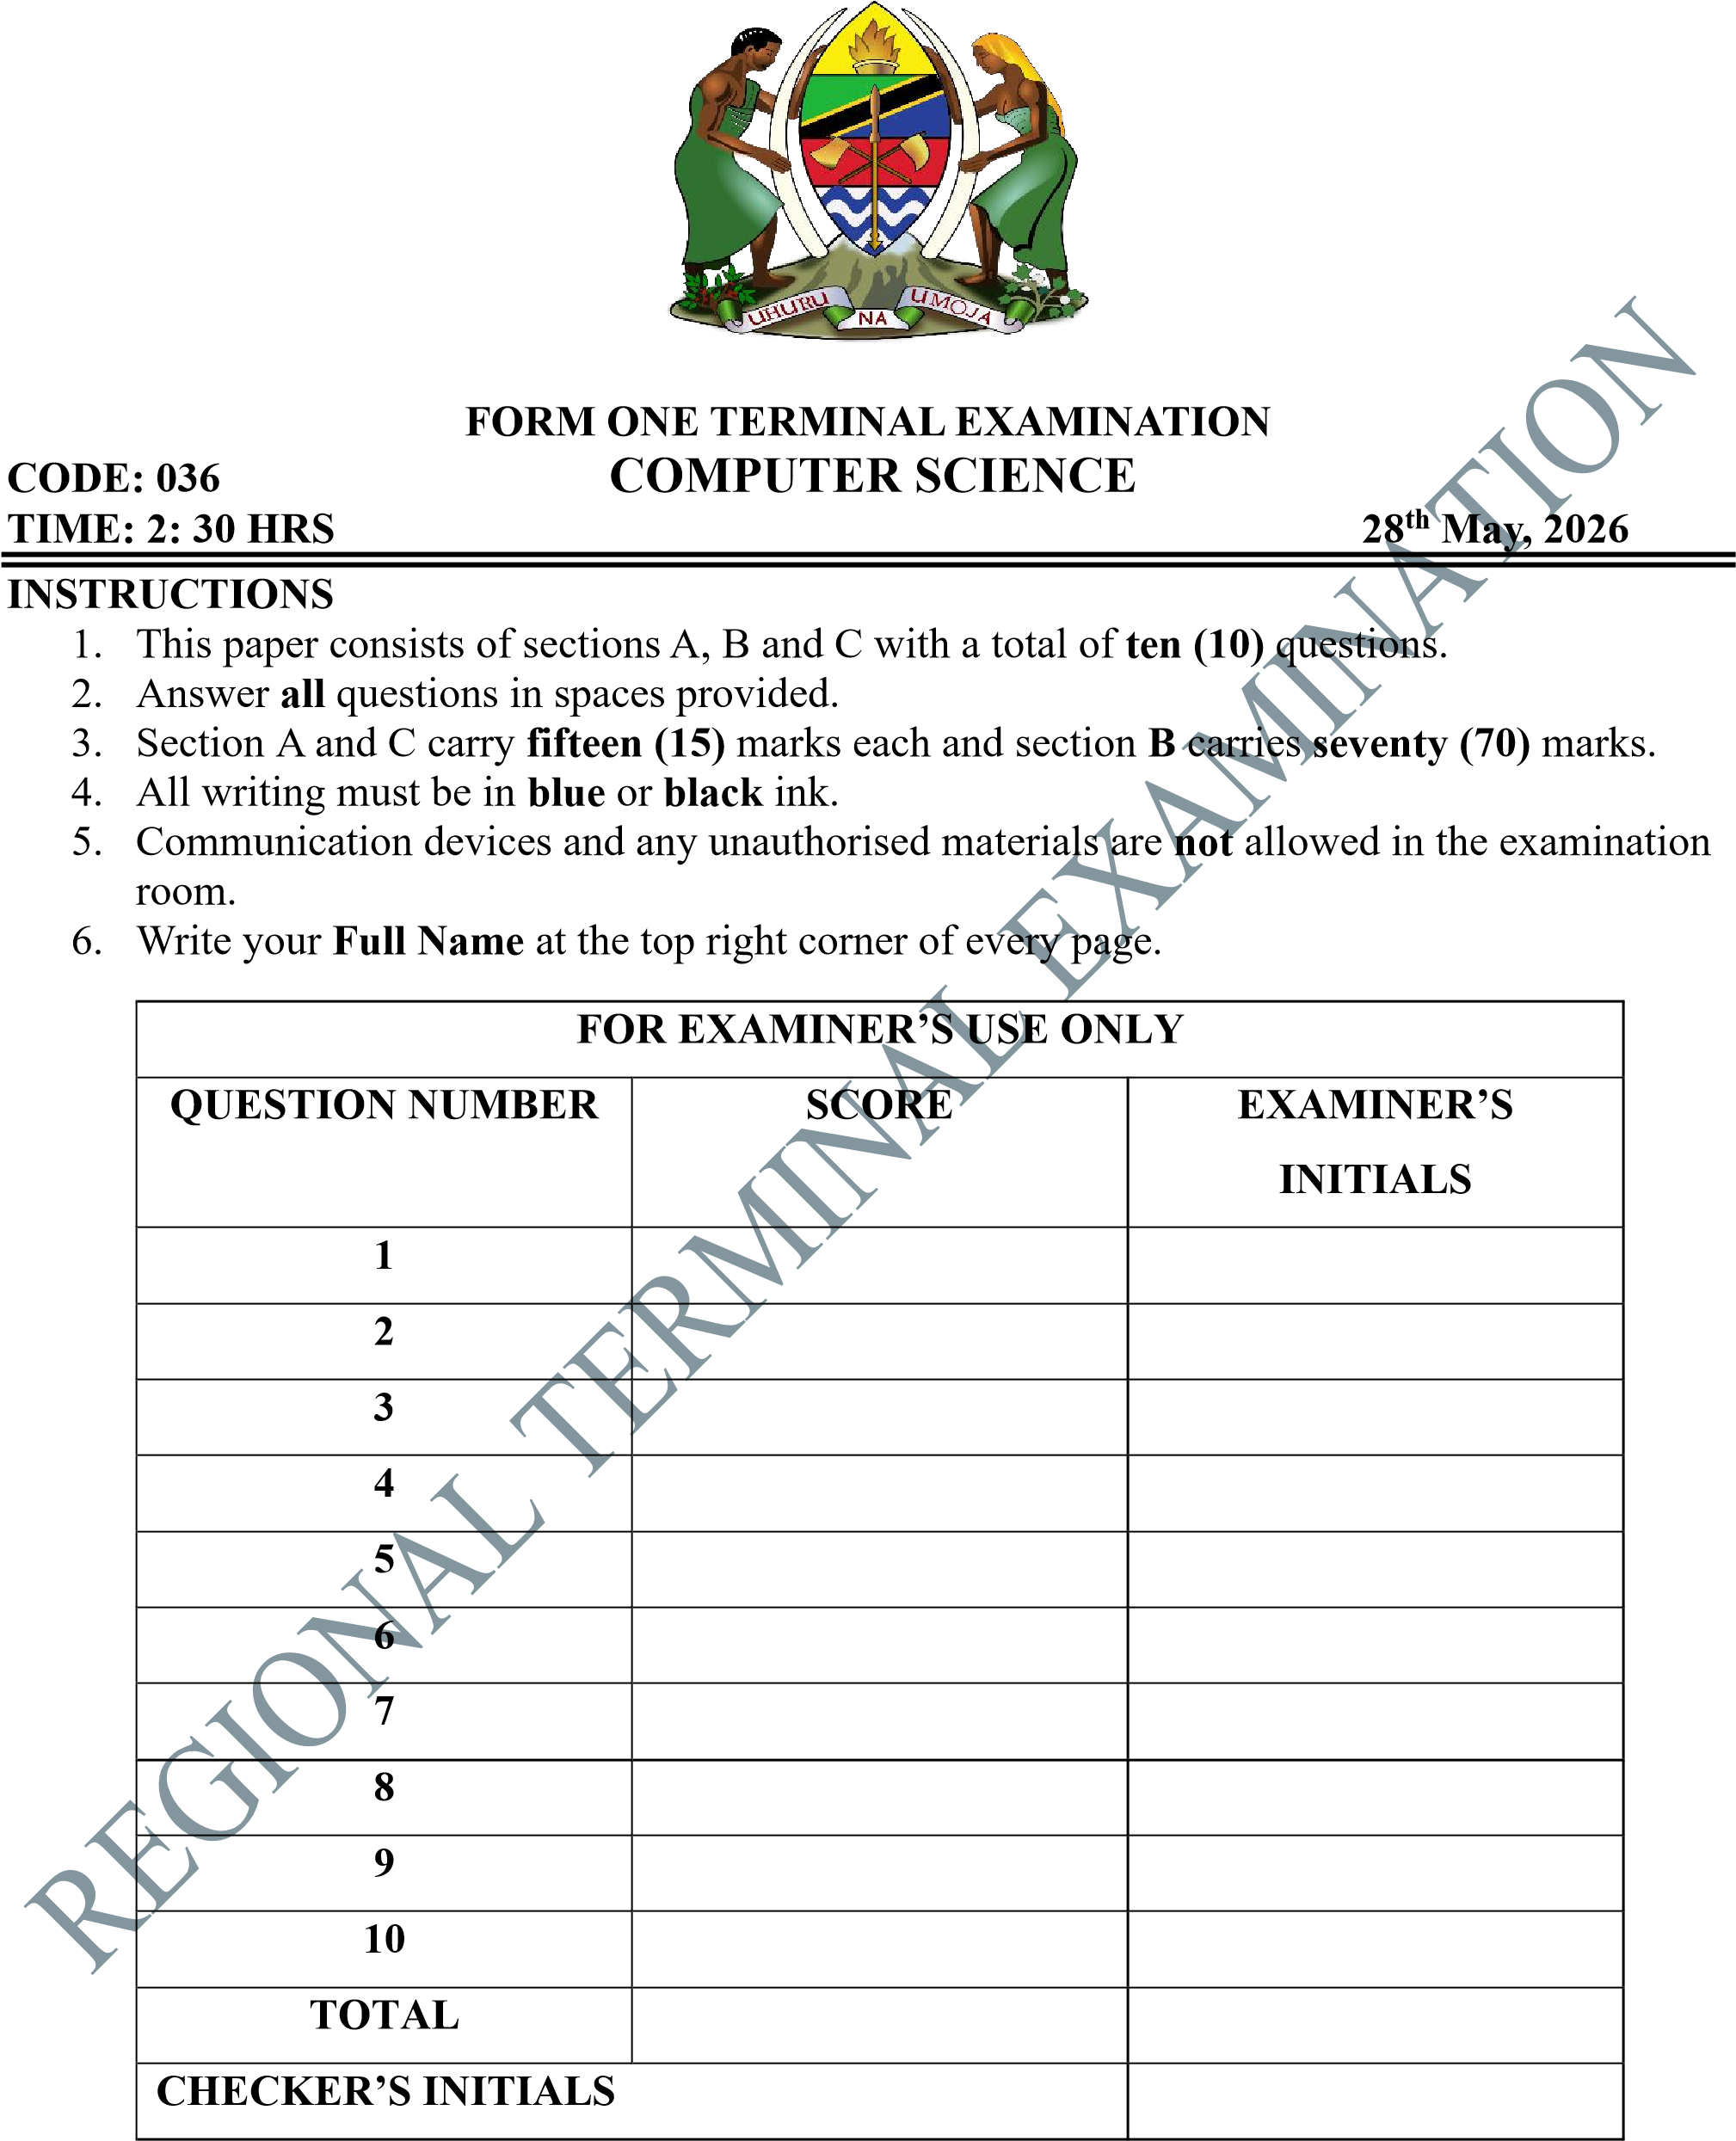
Page 1 of 8

SECTION A (15 Marks)
Answer all questions in this section.

1. For each of the items (i) – (x), choose the correct answer from the given alternatives and write its letter in the box provided.

- While typing, a user presses Shift + a and gets a capital letter. What type of key is Shift?
  - Function key C Modifier key
  - Cursor movement key D Special key

- A user wants to close an active window using the keyboard. Which combination is correct?
  - Ctrl + W C Shift + F4
  - Alt + F4 D Ctrl + F4

- A student switches between open applications quickly. Which shortcut is used?
  - Ctrl + Tab C Shift + Tab B Alt + Tab D Ctrl + Alt

- A user presses a key to move the cursor to the beginning of a line.
Which key is used?
  - End key C Page Up key B Home key D Tab key

- A typist inserts space between words while typing.
Which key is used?
  - Enter key C Tab key
  - Spacebar key D Shift key

- A computer technician is explaining how keyboard input is processed. He mentions that when a key is pressed, the data is first held temporarily before being processed by the system.
Where is this data temporarily stored?
  - Central processing unit (CPU) C Monitor
  - Hard disk D Keyboard buffer

- During document preparation, a symbol “!” is required. Which key combination produces this symbol?
  - Ctrl + 1 C Alt + 1
  - Shift + 1 D Tab + 1
- Movement of cursor up, down, left, and right is required during editing. Which keys are used?
  - Function keys C Modifier keys B Arrow keys D Special keys

- During document editing, a student needs to remove characters from both sides of the cursor position. The student uses different keyboard keys depending on the direction of deletion. Which keys are correctly used to delete characters to the left and to the right of the cursor respectively?
  - Delete and Backspace C Ctrl and Alt
  - Backspace and Delete D Shift and Tab

- A data entry clerk notices that the numeric keypad is not entering numbers but is instead behaving like navigation keys. To restore its normal function of entering numbers, a specific key must be activated. Which key is used to enable the numeric keypad to input numbers?
  - Caps Lock C Num Lock
  - Shift Key D Scroll Lock

(i) | (ii) | (iv) | (v) | (vi) | (vii) | (viii) | (ix) | (x) | (x)

- Match the generations of computers in List A with their corresponding technologies used in List B by writing the letter of the correct answer below the corresponding item number in the table provided

List A List B

(i) Second generation A Input devices for input data
B Very large-scale Integration
(ii) Fifth generation
C Vacuum tube technology
(iii) Fourth generation D Transistor technology
E Microprocessor design technology
(iv) First generation
F Integrated circuits technology
(v) Third generation computers G Output devices for displaying data

Answers

List A (i) (ii) (iii) (iv) (v)
List B

SECTION B (70 Marks)
Answer all questions in this section.

- Computers are widely used in different sectors of the economy to improve efficiency and service delivery. Describe the application of computers in the following areas

  - Agriculture.
    - ......................................................................................................................... .........................................................................................................................
.........................................................................................................................
    - ......................................................................................................................... .........................................................................................................................
.........................................................................................................................
    - ......................................................................................................................... .........................................................................................................................
.........................................................................................................................

  - Banking.
    - ......................................................................................................................... .........................................................................................................................
.........................................................................................................................
    - ......................................................................................................................... .........................................................................................................................
.........................................................................................................................

    - .........................................................................................................................
......................................................................................................................... ........................................................................................................................

  - Transportation.
    - ......................................................................................................................... .........................................................................................................................
.........................................................................................................................
    - ......................................................................................................................... .........................................................................................................................
..........................................................................................................................
    - ................................................................................................................. .......
......................................................................................................................... ..................................................................................................

- A student is learning about the physical components of a computer system and how they work together to perform tasks.

  - What is the meaning of computer system.
.................................................................................................................................
.................................................................................................................................
.................................................................................................................................

  - Explain four (4) components of computer system.

    - ......................................................................................................................... .........................................................................................................................
.........................................................................................................................
    - .........................................................................................................................
.........................................................................................................................
.........................................................................................................................
    - .........................................................................................................................
.........................................................................................................................
.........................................................................................................................
    - ......................................................................................................................... .........................................................................................................................
.........................................................................................................................

  - A computer hardware is grouped into different categories. Explain four (4) types of computer hardware.
    - ......................................................................................................................... .........................................................................................................................
.........................................................................................................................
    - ......................................................................................................................... .........................................................................................................................
.........................................................................................................................
    - ......................................................................................................................... .........................................................................................................................
.........................................................................................................................
    - .........................................................................................................................
.........................................................................................................................
.........................................................................................................................

- A desktop computer is experiencing slow performance and occasional freezing when opening applications. Inside the system unit, different internal components are responsible for processing and storing data.

  - Define the term system unit.
................................................................................................................................ .................................................................................................................................
.................................................................................................................................
  - Identify four internal components found inside the system unit.
    - .................................................................................................................
    - .................................................................................................................
    - ................................................................................................................. (iv) .................................................................................................................

  - Explain the function of each internal components of system unit identified above in 4 (b)
    - ......................................................................................................................... .........................................................................................................................
.........................................................................................................................
    - ......................................................................................................................... .........................................................................................................................
.........................................................................................................................
    - ......................................................................................................................... .........................................................................................................................
.........................................................................................................................
    - ......................................................................................................................... .........................................................................................................................
.........................................................................................................................

- A computer system uses different devices to produce output, including printers that produce information on paper.

  - Explain two types of printers used in computer systems.
(i) ......................................................................................................................... .........................................................................................................................
........................................................................................................................ (ii) ......................................................................................................................... .........................................................................................................................
.........................................................................................................................

  - Identify the type of printer commonly used in modern offices and explain three (3) advantages of using it.

    - ......................................................................................................................... .........................................................................................................................
.........................................................................................................................
    - ......................................................................................................................... .........................................................................................................................
.........................................................................................................................
    - ......................................................................................................................... ......................................................................................................................... .........................................................................................................................
.........................................................................................................................

  - State three disadvantages of the printer identified above in 5 (b).
    - ......................................................................................................................... .........................................................................................................................
.........................................................................................................................
    - .........................................................................................................................
.........................................................................................................................
.........................................................................................................................
    - ......................................................................................................................... .........................................................................................................................
.........................................................................................................................

- A school is replacing old computer display devices with modern ones for use in its computer laboratory.
  - State the two types of monitors based on display technology
    - .................................................................................................................
    - .................................................................................................................

  - Identify and explain the type of monitor commonly used in modern computer.

................................................................................................................................. .................................................................................................................................
................................................................................................................................

  - Explain three advantages of the monitor identified above in 6 (b).

(i) .........................................................................................................................
......................................................................................................................... (ii) .........................................................................................................................
.........................................................................................................................
(iii) .........................................................................................................................
........................................................................................................................

- A computer uses both fast memory for processing and permanent storage for saving data. (a) With examples explain the meaning of secondary memory.
.................................................................................................................................
.................................................................................................................................
..................................................................................................................................

(b) State three (3) types of secondary storage devices.
    - .................................................................................................................
    - ................................................................................................................. (iii) .................................................................................................................

(c) Explain three (3) advantages of hard disk storage device.
    - ......................................................................................................................... .........................................................................................................................
.........................................................................................................................
    - ......................................................................................................................... .........................................................................................................................
.........................................................................................................................
    - ......................................................................................................................... .........................................................................................................................
.........................................................................................................................

- Some computers allow users to control the system by directly touching the screen.
  - What is a touch screen?
................................................................................................................................. ................................................................................................................................. .................................................................................................................................
.................................................................................................................................

  - Explain how touch screen work?
.................................................................................................................................
.................................................................................................................................
.................................................................................................................................
.................................................................................................................................
.................................................................................................................................
  - State three (3) functions of a touch screen.
(i) .......................................................................................................................... .......................................................................................................................... (ii) .........................................................................................................................
..........................................................................................................................
(iii) .......................................................................................................................... ..........................................................................................................................

  - give five (5) devices that use touch screen
    - .................................................................................................................
    - .................................................................................................................
    - .................................................................................................................
    - ................................................................................................................. (v) .................................................................................................................
SECTION A (15 Marks)
Answer question ten (10).

- Modern society depends on computers due to its ability to perform tasks efficiently and reliably. Discuss the characteristics of a computer. Give five (5) points
......................................................................................................................................... ......................................................................................................................................... ......................................................................................................................................... ......................................................................................................................................... ......................................................................................................................................... ........................................................................................................................................ .........................................................................................................................................
.........................................................................................................................................
..........................................................................................................................................
......................................................................................................................................... .........................................................................................................................................
.........................................................................................................................................
......................................................................................................................................... .........................................................................................................................................
.........................................................................................................................................
......................................................................................................................................... .........................................................................................................................................
.........................................................................................................................................
......................................................................................................................................... .........................................................................................................................................
.........................................................................................................................................
......................................................................................................................................... .........................................................................................................................................
.........................................................................................................................................
......................................................................................................................................... .........................................................................................................................................
.........................................................................................................................................
......................................................................................................................................... .........................................................................................................................................
.........................................................................................................................................
......................................................................................................................................... .........................................................................................................................................
.........................................................................................................................................
......................................................................................................................................... .........................................................................................................................................
.........................................................................................................................................

