PRESIDENT OFFICE
REGIONAL ADMINISTRATION AND LOCAL GOVERNMENT
FORM ONE MID-TERM EXAMS
INFORMATION AND COMPUTER STUDIES
FORM ONE

TIME: 2.30 Hours AUGUST ,2023
INSTRUCTIONS
- This paper consists of three sections A, B and C with a total of TEN (10) questions
- Answer All questions
SECTION :A (15 Marks)
- For each of the items (i) – (x), choose the correct answer from the given alternatives and write its letter in the box provided.
- A computer can be defined as:
- An electronic device that can process data into information
- A device that can solve problem by executing a special set of instructions
- A time keeping device
- None of the above
- Element of information dissemination are:
- Source, message, medium, receiver, and feedback
- Source message, data and feedback
- Message, medium, information, and feedback
- Source, medium, receiver, and feedback
- A two-way traffic of receiving and sending and receiving information
- The following are the characteristics of computer except
- Computer perform much faster than human being or manual
- Computer perform task according to the instruction
- Computer become tired when perform many tasks
- Computer never tired when perform many task
- Small letter in the keyboard is knowns as
- Icon
- Mice
- Lower case letter
- Cross-endnote letter
- To boot computer means to
- Service a computer
- Install a computer
- Switch off a computer
- Start/restating a computer

- The first six letter of the keyboard form the word ?
- ABCD
- QWARTY
- QWERTY
- ZXCVBN
- The part f the computer used to produced hardcopy (paper) information is called ?
- Printer
- Speaker
- Scanner
- Monitor
- Output device used to display information to the user, example of it is
- Keyboard
- Mouse
- Joystick
- Speaker
- Disadvantage of modern form of information dissemination is
- Large amount of information can be sent at a time
- It is fast
- It is accurate
- It promote hacking
- Which term represent the results of processing raw facts like numbers, symbols, letter, picture and sound in a computer
- Data
- Program
- Information
- website

- Match the functions of different types of operating system in List A with their corresponding types of operating systems in List B by writing the letter of the correct answer below the items number in the table provided

COLUMN A | COLUMN B
- first generation  - second generation  - third generation  - fourth generation  - A device that is used to enter data in form of speech in the computer | - transistor  - thermionic valves (vacuum tube)  - very large integrated circuit  - integrated circuit  - monitor  - Wireless  - Mouse  - Microphone

SECTION: B (70 Marks)
- (a) Write the use of each of the following hardware:
- Monitor …………………………………………………………………………
- Hard disk ………………………………………………………………………
- Mouse …………………………………………………………………………..
- Keyboard ………………………………………………………………………
  - Draw the diagram of computer Block

- a) Define the term information Dessermination

b) Give four differences between traditional and modern way of information dessermination
c) Mention the missing element of information desserminaton so as to make
communication completely.

SENDER

E
MDIUM

- a)Msambweni auto mechanics intends to purchase an output device to produce their engineering drawings. Which device would you advice them to purchase……………………….
b) Name the two types available of the above mentioned device

- a)Write the long of the following abbreviations as used in computer studies.
- CPU ………………………………………………………………………..
- PCB ……………………………………………………………………………….
- CU …………………………………………………………………….................
- ALU ……………………………………………………………………………….
- HDMI. ....................................................................................
vi)VGA
- Label the parts of the instrument shown below:

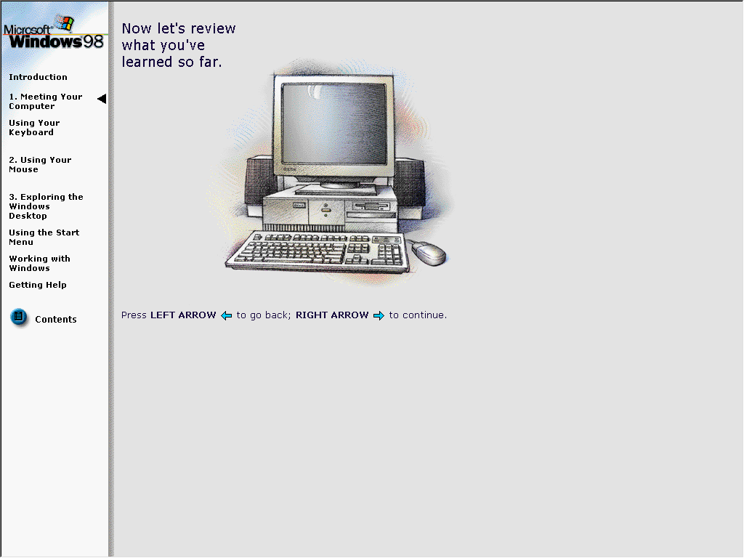

- Most of schools now days prefer the use of computers in performing their activities.
- Explain three uses of computers in a school
- What are the two weaknesses of computers can school experience?
- a) give three reason why a mobile phone is regarded to be a computer

b) Name the following devices as they used in ICS studies
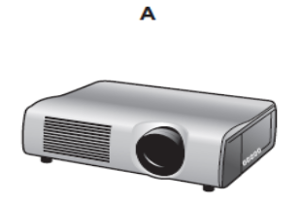

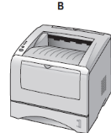

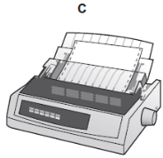

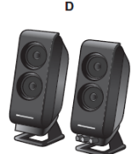

- a) what are the meaning of following
- CPU
- Peripherical devices
b) mention 5 function of CPU

SECTION: C (20 Marks )
- Information dissemination is very important in a society as it help to spread/distribute information quickly. Explain 5 advantage of information dissemination

