

THE PRESIDENT’S OFFICE
REGIONAL ADMINISTRATION AND LOCAL GOVERNMENT
LONGIDO DISTRICT

FORM ONE ANNUAL EXAMINATION
COMPUTER SCIENCE
MARKING SCHEME NOVEMBER 2025
SECTION A (15 MARKS)
- (10 Marks)
B | C | C | B | C | B | D | B | B | B

- (05 Marks)
C | D | A | B | E

SECTION B (70 MARKS)
- (a). Definition
A computer system is a complete setup that includes hardware, software, and users working together to process data. (2 marks)
- Components:
- Hardware, (2 marks)
- Software, (2 marks)
- Users (2 marks)
- Diagram of computer system (6 marks)
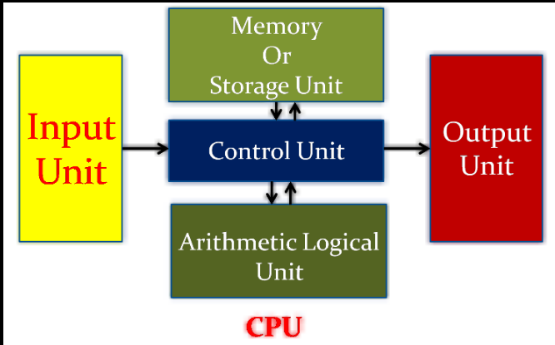
- Different between hardware and software (6 marks)
Feature | Hardware | Software
Tangibility | Physical, can be touched | Intangible, cannot be touched
Function | Performs actual tasks | Gives instructions
- i) Directly turning off power (3 marks)
ii) Data loss, system corruption (3 marks)
iii) Use Start > Shut down; Close all programs first (3 marks)

- i) Downloading unsafe files (3 marks)
ii) Malware, slow performance (3 marks)
iii) Use antivirus, download from trusted sources (3 marks)

- i) Good: Lab exists, Bad: Drinking near computers (3 marks)
ii) Spills may damage machines, attract pests (3 marks)
iii) Ban food/drinks in lab (3 marks)

- i) System and Application software (3 marks)
ii) System: Windows, Application: MS Word (3 marks)
iii) System software manages hardware (3 marks)

- (a)
- Microcomputer. (3 marks)
- Minicomputer. (3 marks)
- Main Frame computer. (3 marks)
- Super computer. (3 marks)
(b)
- Microcomputer: Is a small, relatively inexpensive computer with a microprocessor as its central processing unit (CPU). It includes a microprocessor, memory, and minimal input/output (I/O) circuitry mounted on a single printed circuit board (Mother board). Microcomputer are can process less amount of data compared than minicomputer, mainframe and supercomputer.
- The Micro-computers are specially designed for general usage like entertainment, education and work purposes. Example or categories of microcomputer are Desk top or personal computer (PC), Laptops, handled computer Personal Digital Assistants (PDAs), Notebook, Tabulates, and Smartphone’s.
- Minicomputer: Is a kind of computer that contains more than one processor and support multiprocessing and fills the space between the mainframe and microcomputer. Minicomputers are generally resilient to high workloads. Although they are smaller than mainframe or supercomputers, minicomputers are more powerful than personal computers and workstations in processing data. Minicomputers are used by small businesses and firms. Minicomputers are also called as “Midrange Computers”. These computers are not designed for a single user. A large company or organizations use Mini-computers for specific purposes. For example, a production department can use Mini-computers for monitoring certain production process.
- Mainframe computer: This is a kind of computer which is more powerful expensive than microcomputer and minicomputer and can be used primarily by large organizations for critical applications, bulk data processing, such as census, industry and consumer statistics, enterprise resource planning, and transaction processing.
- Supercomputer: Is a kind of computer that is most powerful, highest speed in processing data and is the most expensive computer compared with microcomputer, minicomputer and mainframe computer. A super computer is used in large organization on scientific research, Space Exploration, earthquake studies, weather forecasting, and nuclear weapons testing

SECTION C: ESSAY (15 MARKS)

Component | Marks
Definitions (hardware & software) | 3
Explanation of working together | 3
Examples (2 hardware, 2 software) | 3
Good practices (e.g. cleaning, shutdown) | 3
Conclusion and grammar | 3
TOTAL | 15

