

THE PRESIDENT’S OFFICE
REGIONAL ADMINISTRATION AND LOCAL GOVERNMENT
LONGIDO DISTRICT

FORM ONE TERMINAL EXAMINATION
COMPUTER SCIENCE
Time: 2½ Hours Thursday, 29th May 2025 a.m.
Instructions
- This paper consists of sections A, B and C with a total of ten (10) questions.
- Answer all questions.
- Write your answer in the spaces provided.
- All answers must be written in black or blue ink.
- Cellular phones, calculators and any unauthorized materials are not allowed in the

Assessment Room.
- Write for Assessment Number at the top right corner of every page.

QUESTION # | MARKS | INITIALS OF EXAMINER
1
2
3
4
5
6
7
8
9
10
Total

SECTION A (15 MARKS)
- For each of the following items (i-x), choose the best answer from among the given alternatives and write its letter in the space given below.
- Which of the following best describes a supercomputer?
- A portable computer for basic tasks
- A computer used in homes and offices
- A powerful computer used for scientific research
- A small device with touch screen features
- Which generation of computers introduced the microprocessor?

- First generation
- Second generation
- Third generation
- Fourth generation

- Which of the following options describe why software is important in a computer system:
- It powers the CPU directly
- It provides electricity to the system

- It enables the hardware to perform specific tasks
- It cools the internal parts

- Which part of the computer holds data temporarily for quick access by the CPU?:

- Hard disk
- ROM
- RAM
- Monitor

- What is the main difference between hardware and software?
- Hardware is downloaded, software is physical
- Hardware is internal, software is external
- Hardware is touchable, software is intangible
- Hardware performs tasks, software stores data
- In the evolution of computers, the second generation used:

- Vacuum tubes
- Transistors
- Integrated circuits
- Artificial intelligence
- A computer system consists of:
- Only hardware
- Only software
- Hardware and people
- Hardware, software, data, and users
- Which of the following is a characteristic of mini computers?

- Smallest in size
- Highest processing power
- Supports multiple users
- Used only in mobile devices

- The study of Computer Science is mainly important because:

- It teaches how to watch videos
- It improves musical skills
- It enables solving problems using technology
- It increases physical strength

- The input component of a computer system includes:

- Monitor and speakers
- CPU and memory
- Keyboard and mouse
- Printer and projector

i | ii | iii | iv | v | vi | vii | viii | ix | x
Answers

- Match the following computer generation in LIST A with its associated technology in LIST B
LIST A | LIST B
- Second generation computers | - Very Large- scale Technology  - Vacuum Tube Technology  - Transistor Technology  - Microprocessor design Technology  - Integrated circuit technology  - Designed for complex simulations  - Microcomputer
- Fifth generation computers
- Fourth generation computers
- First generation computers
- Third generation computers
Answers
LIST A | i | ii | iii | iv | v
LIST B
SECTION B (70 MARKS)
- (a) Describe five types of computer classifications based on size. Give one example of each.
- ……………………………………………………………………………………..
- ……………………………………………………………………………………..
- …………………………………………………………………………………….
- ……………………………………………………………………………………..
- ……………………………………………………………………………………..
(b) By referring to question 3(a) above, arrange them to the order of increasing power of processing.
- ………………………………………………………………………………………
- ………………………………………………………………………………………
- ………………………………………………………………………………………
- ………………………………………………………………………………………
- State the long form and one function in each of the following abbreviations as used in computer science
- HDD……………………………………………………………………………………………………………………………………………………………………
- SSD……………………………………………………………………………………………………………………………………………………………………….
- PSU………………………………………………………………………………………………………………………………………………………………………...
- CPU………………………………………………………………………………………………………………………………………………………………………..
- ALU……………………………………………………………………………………………………………………………………………………………………
- RAM…………………………………………………………………………………………………………………………………………………………………….
- ROM…………………………………………………………………………………………………………………………………………………………………….
- VGA………………………………………………………………………………………………………………………………………………………………………
- CAD…………………………………………………………………………………………………………………………………………………………………….
- CAM……………………………………………………………………………………………………………………………………………………………………
- Imagine that a school with a tight budget is planning to buy computers for its computer laboratory. As an advisor, recommend suitable computers they should buy and give reasons to explain your selections.
……………………………………………………………………………………………………………………………………………………………………………………………………………………………………………………………………………………………………………………………………………………………………………………………………………………………………………………………………………………………………………………………………………………………………………………………………………………………………………………………………………
- Explain why the development of microprocessors was a major development in computer technology. Give five points
- …………………………………………………………………………………….
- ……………………………………………………………………………………
- …………………………………………………………………………………….
- …………………………………………………………………………………….
- …………………………………………………………………………………….
- How can you differentiate System software from Application software? Give five points
- ………………………………………………………………………………………………………………………………………………………………………………
- ………………………………………………………………………………………………………………………………………………………………………………
- ………………………………………………………………………………………………………………………………………………………………………………
- ………………………………………………………………………………………………………………………………………………………………………………
- ………………………………………………………………………………………………………………………………………………………………………………
- (a) Librarian at a Seypalm Secondary School uses computer system to manage book borrows and book returns. Outline three (3) advantages of using a computer rather than doing this job manually.
  - .......................................................................................................................................
  - .......................................................................................................................................
  - ..........................................................................................................................................
- i. The diagram below shows a simple computer system with its data flow. Identify the six
components marked as A,B,C, D, E and F.
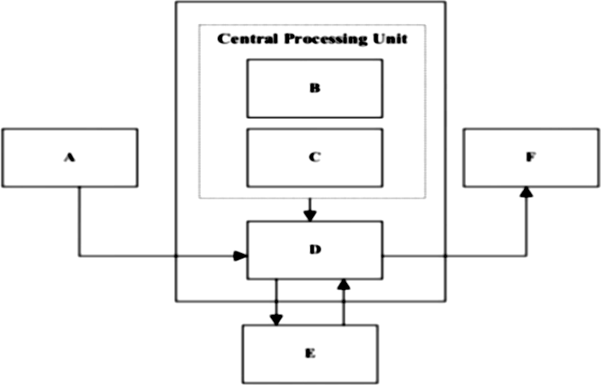
A
E
D
F
Central Processing Unit
C
B
  - .........................................................................................................................................
  - ........................................................................................................................................
  - .........................................................................................................................................
  - .........................................................................................................................................
  - ..........................................................................................................................................

F …………………………….

- List two functions of Central Processing Unit.
  - ................................................................................................................................................
  - ................................................................................................................................................
- Give any four devices which act as part A above. (02 marks)
  - ……………………………………….........................................................................……
  - ……………………………………………………..............................................................
  - ………………………………………………......................................................................
- Explain how Robotics are used in manufacturing industries is important. Use five points
- ……………………………………………………………………………………………………………………………………………………………………………………
- ……………………………………………………………………………………………………………………………………………………………………………………
- ……………………………………………………………………………………………………………………………………………………………………………………
- ……………………………………………………………………………………………………………………………………………………………………………………

SECTION C (15 MARKS)
- Using the knowledge of Computer Science, explain how Computer Science improves teaching and learning and give examples of software or platforms that support education delivery.
…………………………………………………………………………………………………………………………………………………………………………………………………………………………………………………………………………………………………………………………………………………………………………………………………………
…………………………………………………………………………………………………………………………………………………………………………………………………………………………………………………………………………………………………………………………………………………………………………………………………………
…………………………………………………………………………………………………………………………………………………………………………………………………………………………………………………………………………………………………………………………………………………………………………………………………………
…………………………………………………………………………………………………………………………………………………………………………………………………………………………………………………………………………………………………………………………………………………………………………………………………………
…………………………………………………………………………………………………………………………………………………………………………………………………………………………………………………………………………………………………………………………………………………………………………………………………………
…………………………………………………………………………………………………………………………………………………………………………………………………………………………………………………………………………………………………………………………………………………………………………………………………………

