THE UNITED REPUBLIC OF TANZANIA
PRESIDENT’S OFFICE
REGIONAL ADMINISTRATION AND LOCAL GOVERNMENT
MATALE SECONDARY SCHOOL
FORM ONE TERMINAL EXAMINATION
INFORMATION AND COMPUTER STUDIES
MARKING SCHEME 2024

SECTION A

C | B | D | C | B | B | D | D | C | C

D | B | A | F | C

SECTION B

- Hard disk drive
- Flash disk
- Digital Versatile Disks
- Compact Disk
- Floppy Disk

- RAM –Random Access Memory
- TV – Television
- CPU – Centra Processing Unit
- ALU – Arithematic and Logic Unit
- HD – Hard Disk
- Give five uses of computer at home
- Typing
- Watching movies
- Play games
- Charting
- Store documents
- (a)
- Mouse
- Monitor
- System unit
- Power cable
- VGA
- Keyboard
(b) function of hardware labeled 1,2,4 and 6
- Select text, icons or files, folder and menu items
- Display information in form of text, pictures and video
- Supply electricity to the electronic device
- Typing text
(c)
Input devices
- Mouse
- Keyboard
Output devices
- Monitor
(d) Hardware housing Central Processing Unit is System unit – 3
(e) CPU BLOCK diagram
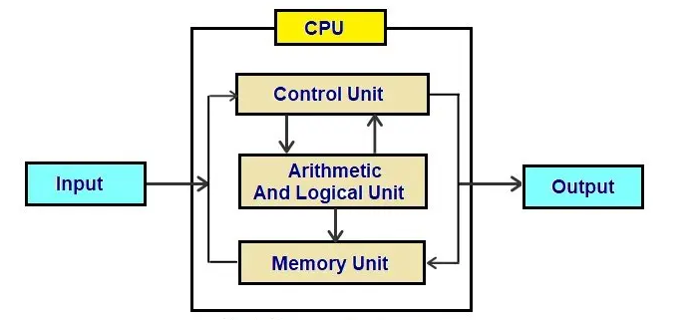
- (a) Operating system is a system software that carries out the computer’s essential functions.
(b) Resources managed by operating system
- Computer Memory
- Monitor
- Disk drive
- Printers
- Programs
(c) Single-user operating systems provide access to computer systems by a single user at a time.e.g windows OS while Multi – user operating systems allow more than one user to access the computer system at once e.g UNIX

- Primary source of information
- Primary source of information is a source from which first hand information has been collected by investigator.

- Long time memory
- Correct information
- Increase level of understanding
9.
Traditional Way | Modern Way
- It is slow in disseminating information. | - It is very fast in disseminating information.
- Uses poor and manual equipment. | - Uses more advanced electronic equipment.
- Its coverage area is small. | - Its coverage area is big.
- It is less expensive than modern. | - It is high expensive.
- It is locally wise. | - It is gobble wise.
- Few people are aware with this | - Many people are aware.

SECTION C
- Important of studying ICS
- in education computer are used in teaching and learning process.
- In schools are used to communicate, create, disseminate, store and manage information.
- ICS make relevant decisions about different aspects of life such as;
-Development activities.
-Providing social services.
-Doing business.
- Computer can be used to simulate experiments in chemistry, physics, Biology and other subjects.
- Students can use the internet to search and organise various educational materials such as notes and books for different subjects.

