THE UNITED REPUBLIC OF TANZANIA
THE PRESIDENT’S OFFICE
REGIONAL ADMINISTRATION AND LOCAL GOVERNMENT

NAMANGA FORM ONE PRE-MIDTERM EXAMINATION

INFORMATION AND COMPUTER STUDIES
Time: 2 ½ Hours August 2024

Instructions
- Answer all questions in section A and B.
- All writings must be in the black or blue ink except diagrams, which must be in pencil.

SECTION A (15 marks)
- For each of the following terms (i)-(x), choose the correct answer among the given alternatives and write its letter beside the item number in your answer booklet provided.
  - This is the stage where data or instructions are put into a computer system
A. Information B. Input C. Process D. Output

  - These are raw facts, figures, values or instructions with no specific meaning by themselves.
- Information B. Data C. meaning D. Knowledge

  - This is processed information that comes out of a computer system
- Information B. Output C. Process D. Output

  - Which among these is not an example of a hardware?
- A printer B. Motherboard C. Operating system D. Monitor
- Processed data is called
  - Field B. Information C. Record D. File
- Keyboard key to leave space between characters
  - Backspace B. Spacebar C. Delete D. ESC
- What is raw fact?
  - Number only B. Alphabets only C. Processed data D. Unprocessed data
- The fastest memory devices is
  - CPU B. Register C. Read only Memory D. Random Access memory

- The following are parts of mouse except
  - Right click button B. Left click button C. Monitor D. scroll Wheel
- which of the following is data processing sequence
  - Output, main memory, CPU, Input B. Input, Output, main memory, CPU
C. Input, main memory, CPU, Output D. main memory, Input, Output, CPU

- Match the items between Column A and the correct response in Column B
COLUMN A | COLUMN B
- Memory storage whose content can be accessed and read but cannot be changed.  - Working storage that is used to hold instructions and data needed by the currently application.  - Memory storage which are suitable for recording motion pictures.  - A special temporary storage available in the ALU.  - The main memory in a virtual memory system. | - Digital Versatile Disks  - RAM storage  - Real storage  - ROM storage  - Optical storage  - Register  - Floppy disks  - Flash disk

LIST A | i | ii | iii | iv | v
LIST B

SECTION B (70 marks)
- Write five (5) four secondary storage devices in electronic devices.

i.
ii.
iii.
iv.
v.

- Give the long term of these.
  - RAM
  - TV
  - CPU_
  - ALU
  - HD
- Give five (5) uses of computer at Home.
i. ii.
iii. iv. v.
- Study the following computer hardware given and answer the questions that follow:
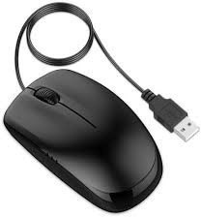

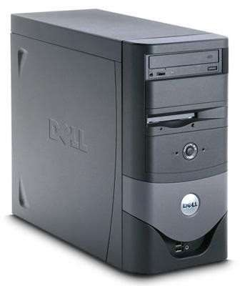
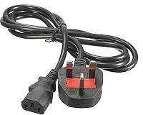
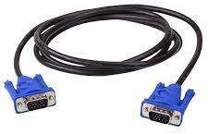
1
2
3
4
5

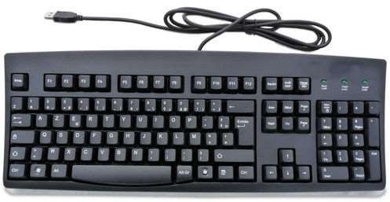
6

- Name the computer hardware accessories labeled 1-6.

1-
2-
3-
4-
5-
6-

- State the function of each hardware labeled 1, 2,4 and 6.
1
2
4
6
- List two input devices and one output device from hardware labeled 1-6 above.
Input devices | Output devices
i. | i.
ii.

- Which hardware labeled 1- is housing Central Processing Unit of computer?

- Draw well-labeled CPU BLOCK diagram by using pencil.

- (a) Define Operating system(1mark)
________________________________________________________________________________________________________________________________________________________
- Describe five resources managed by an operating system. (5marks)
- __________________________________________________
- __________________________________________________
- __________________________________________________
- __________________________________________________
- ___________________________________________________
- With one example briefly explain the difference between single-user operating system and multi-user operating system. (2 marks)
_________________________________________________________________________________________________________________________________________________________________________________________________________________________________________________

- Latiya went to Mkapa Stadium to watch simba and Yanga match day. Next day after match Latiya asked by her teacher Mwanyole some questions about match. Suppose you have appointed to help Latiya to answer her teacher as following.
- What source of information you used to collect data?

- Define source of information mentioned in 8(a) above.

- Give three advantages of using that source of information in 8(a) above.

- List the traditional and modern ways of disseminating information
Tradition way | Modern way
i. | i.
ii. | ii.
iii. | iii.
iv. | iv.
v. | v.

SECTION C (15 MARKS)
- Why is it important to study ICS? Explain by giving four points.
____________________________________________________________________________________________________________________________________________________________________________________________________________________________________________________________________________________________________________________________________________________________________________________________________________________________________________________________________________________________________________________________________________________________________________________________________________________________________________________________________________________________________________________________________________________________________________________________________________________________________________________________________________________________________________________________________________________________________________________________________________________________________________________________________________________________________________________________________________________________________________________________________________________________________________________________________________________________________________________________________________________________________________________________________________________________________________________________________________________________________________________________________________________________________________________________________________________________________________________________________________________________________________________________________________________________________________________________________________________________________________________________________________________________________________________________________________________________________________________________________________________________________________________________________________________________________________________________________________________________________________________________________________________________________________________________________________________________________________________________________________________________________________________________________________________________________________________________________________________________________________________________________________________________________________________________________________________________________________________________________________________________________________________________________________________________________________________________________________________________________________________________________________________

