PRESIDENT OFFICE
REGIONAL ADMINISTRATION AND LOCAL GOVERNMENT
NAMANGA SECONDARY SCHOOL
FORM ONE MID-TERM EXAMS

INFORMATION AND COMPUTER STUDIES

TIME: 2.30 Hours AUGUST ,2024
INSTRUCTIONS
- This paper consists of three sections A, B and C with a total of TEN (10) questions
- Answer All questions
SECTION: A (15 Marks)
- For each of the items (i) – (x), choose the correct answer from the given alternatives and write its letter in the box provided.

- A computer can be defined as:
- An electronic device that can process data into information
- A device that can solve problem by executing a special set of instructions
- A time keeping device
- None of the above
- Element of information dissemination are:
- Source, message, medium, receiver, and feedback
- Source message, data and feedback
- Message, medium, information, and feedback
- Source, medium, receiver, and feedback
- A two-way traffic of receiving and sending and receiving information

- The following are the characteristics of computer except
- Computer perform much faster than human being or manual
- Computer perform task according to the instruction
- Computer become tired when perform many tasks
- Computer never tired when perform many task

- Small letter in the keyboard is knowns as
- Icon
- Mice
- Lower case letter
- Cross-endnote letter
- To boot computer means to
- Service a computer
- Install a computer
- Switch off a computer
- Start/restating a computer

- The first six letter of the keyboard form the word ?
- ABCD
- QWARTY
- QWERTY
- ZXCVBN
- The part f the computer used to produced hardcopy (paper) information is called ?
- Printer
- Speaker
- Scanner
- Monitor
- Output device used to display information to the user, example of it is
- Keyboard
- Mouse
- Joystick
- Speaker
- Disadvantage of modern form of information dissemination is
- Large amount of information can be sent at a time
- It is fast
- It is accurate
- It promote hacking
- Which term represent the results of processing raw facts like numbers, symbols, letter, picture and sound in a computer
- Data
- Program
- Information
- Website
i | ii | Iii | iv | v | vi | vii | viii | ix | X

- Match the functions of different types of operating system in List A with their corresponding types of operating systems in List B by writing the letter of the correct answer below the items number in the table provided

COLUMN A | COLUMN B
- first generation  - second generation  - third generation  - fourth generation  - A device that is used to enter data in form of speech in the computer | - transistor  - thermionic valves (vacuum tube)  - very large integrated circuit  - integrated circuit  - monitor  - Wireless  - Mouse  - Microphone

COLUMN A | i | ii | iii | iv | v
COLUMN B

SECTION: B (70 Marks)
- (a) Write the use of each of the following hardware:
- Monitor …………………………………………………………………………………………………….
- Hard disk …………………………………………………………………………………………………..
- Mouse ……………………………………………………………………………………………………….
- Keyboard …………………………………………………………………………………………………..

  - Draw the diagram of computer Block

4. a) Define the term information Dessermination .................................................................................................................................................................................................................................................................................................................................................................................

b) Give four differences between traditional and modern way of information dessermination
Taditional way | Modern way

c) Fill the missing element of information desserminaton so as to make
communication completely.

SENDER

E
MEDIUM

- (a) Msambweni auto mechanics intends to purchase an output device to produce their engineering drawings. Which device would you advice them to purchase?...........................................
(b) Name the two types available of the above mentioned device
(i) ………………………………………………
(ii) …………………………………………….

- (a)Write the long of the following abbreviations as used in computer studies.
- HDD ………………………………………………………………………..
- VGA……………………………………………………………………………….
- CU …………………………………………………………………….................
- ALU ……………………………………………………………………………….
- HDMI. ....................................................................................
- Label the parts of the instrument shown below:

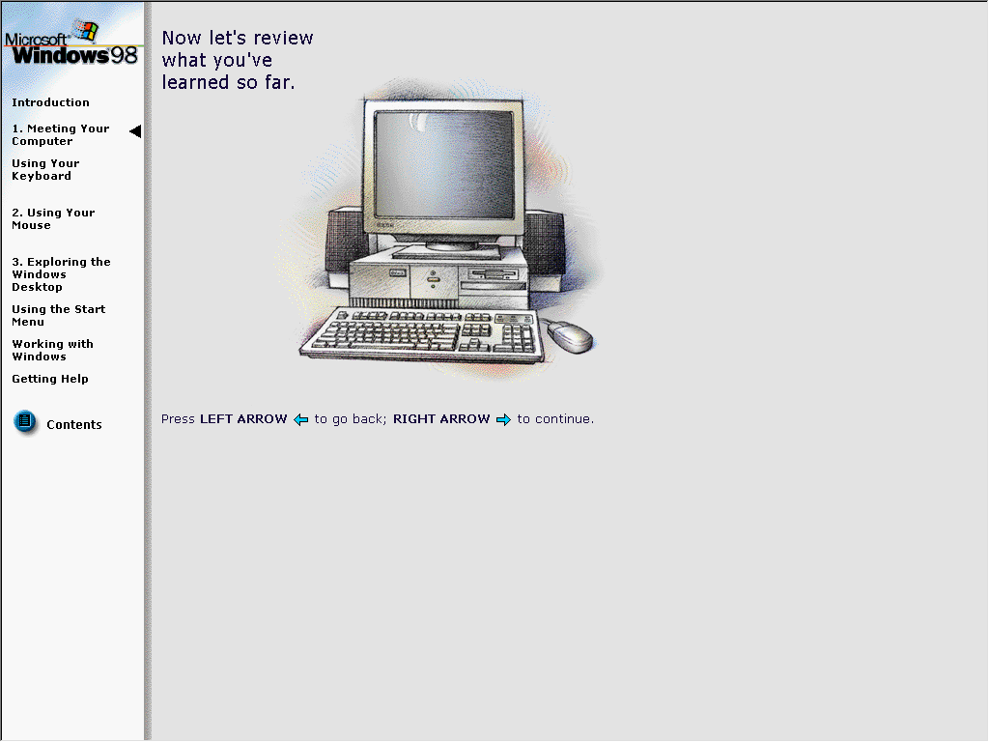
…………………..

…………………

………………………

……………….

- Most of schools now days prefer the use of computers in performing their activities.
- Explain three uses of computers in a school
- …………………………………………………………………………………
- ………………………………………………………………………………….
- …………………………………………………………………………………..
- What are the two weaknesses of computers can school experience?
- ……………………………………………………………………………………
- ……………………………………………………………………………………
- a) give three reason why a mobile phone is regarded to be a computer

- ……………………………………………………………………………..
- ……………………………………………………………………………..
- ……………………………………………………………………………..

(b) Name the following devices as they used in ICS studies
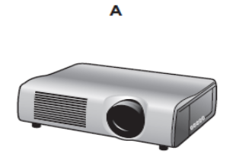

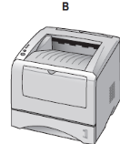

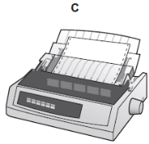

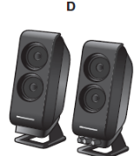

- a) what are the meaning of following
- CPU …………………………………………………………………………………………………………………………………………………………………………
- Peripherical devices ………………………………………………………………………………………………………………………………………………………………………..

(b) mention 2 function of CPU

- ………………………………………………………………………………………
- ………………………………………………………………………………………

SECTION: C (20 Marks )
- Information dissemination is very important in a society as it help to spread/distribute information quickly. Explain 5 advantage of information dissemination

……………………………………………………………………………………………………………………………………………………………………………………………………
……………………………………………………………………………………………………………………………………………………………………………………………………
……………………………………………………………………………………………………………………………………………………………………………………………………
……………………………………………………………………………………………………………………………………………………………………………………………………
……………………………………………………………………………………………………………………………………………………………………………………………………
……………………………………………………………………………………………………………………………………………………………………………………………………
……………………………………………………………………………………………………………………………………………………………………………………………………
……………………………………………………………………………………………………………………………………………………………………………………………………
……………………………………………………………………………………………………………………………………………………………………………………………………
……………………………………………………………………………………………………………………………………………………………………………………………………
……………………………………………………………………………………………………………………………………………………………………………………………………
……………………………………………………………………………………………………………………………………………………………………………………………………
……………………………………………………………………………………………………………………………………………………………………………………………………
……………………………………………………………………………………………………………………………………………………………………………………………………
……………………………………………………………………………………………………………………………………………………………………………………………………
……………………………………………………………………………………………………………………………………………………………………………………………………
…………………………………………………………………………………………………

