THE UNITED REPUBLIC OF TANZANIA
PRESIDENT’S OFFICE
REGIONAL ADMINISTRATION AND LOCAL GOVERNMENT
NAMANGA SECONDARY SCHOOL
FORM ONE TERMINAL EXAMINATION
INFORMATION AND COMPUTER STUDIES

Time: 2:30 Hours 2024
Instructions

- Answer all questions in section A and B.
- All writings must be in the black or blue ink except diagrams, which must be in pencil.

SECTION A (15 marks)
- For each of the following terms (i)-(x), choose the correct answer among the given alternatives and write its letter beside the item number in the space provided.
- This is the stage where data or instructions are put into a computer system.
  - Information B. Input C. Process D. Output

- These are raw facts, figures, values or instructions with no specific meaning by themselves.
  - Information B. Data C. Meaning D. Knowledge
iii. This is processed information that comes out of a computer system.
A. Input
B. Process C. Feedback D. Output.
- Which among of these is not an example of hardware?
A. Printer B. Motherboard C. Operating system D. Monitor
- Processed data is called
  - Field B. Information C. Record D. File
- Keyboard key to leave space between characters
  - Backspace B. Spacebar C. Delete D. ESC
- What is raw fact?
  - Number only B. Alphabets only C. Processed data D. Unprocessed data
- The fastest memory devices is
  - CPU B. Register C. Read only Memory D. Random Access memory

- The following are parts of mouse except
  - Right click button B. Left click button C. Monitor D. scroll Wheel

- which of the following is data processing sequence
  - Output, main memory, CPU, Input B. Input, Output, main memory, CPU
C. Input, main memory, CPU, Output D. main memory, Input, Output, CPU

- Match the items between Column A and the correct response in Column B
COLUMN A | COLUMN B
- Memory storage whose content can be accessed and read but cannot be changed.  - Working storage that is used to hold instructions and data needed by the currently application.  - Memory storage that are suitable for recording motion pictures.  - A special temporary storage available in the ALU.  - The main memory in a virtual memory system. | - Digital Versatile Disks  - RAM storage  - Real storage  - ROM storage  - Optical storage  - Register  - Floppy disks  - Flash disk

LIST’A’

LIST’B’

SECTION B (70 marks)
- Write five (5) four secondary storage devices in electronic devices.

i.
ii.
iii.
iv.
v.

- Give the long term of these.
  - RAM
  - TV
  - CPU_
  - ALU
  - HD
- Give five (5) uses of computer at Home.
i. ii.
iii. iv. v.
- Study the following computer hardware given and answer the questions that follows:
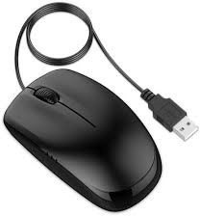


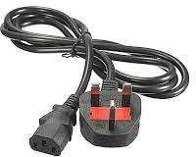
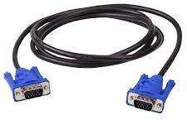
1
2
3
4
5
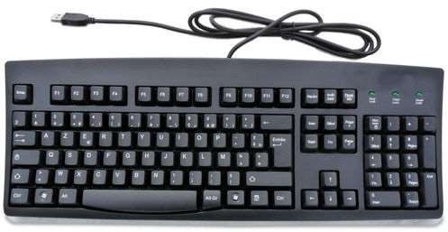
6

- Name the computer hardware accessories labeled 1-6.

1-
2-
3-
4-
5-
6-

- State the function of each hardware labeled 1, 2,4 and 6.
1
2
4
6

- List two input devices and one output device from hardware labeled 1-6 above.
Input devices | Output devices
i. | i.
ii.

- Which hardware labeled 1- is housing Central Processing Unit of computer?

- Draw well-labeled CPU BLOCK diagram by using pencil.

- (a) Define Operating system(1mark)
________________________________________________________________________________________________________________________________________________________
- Describe five resources managed by an operating system. (5marks)
- __________________________________________________
- __________________________________________________
- __________________________________________________
- __________________________________________________
- ___________________________________________________
- With one example briefly explain the difference between single-user operating system and multi-user operating system. (2 marks)

- Latiya went to Mkapa Stadium to watch Simba and Yanga match today. Next day after the match, Latiya was asked by her teacher Mwanyole some questions about the match. Help Latiya to answer her to answer following questions from her teacher:
- What source of information you used to collect data?

- Define source of information mentioned in 8(a) above.

___________________________________________________________________________

- Give three advantages of using that source of information in 8(a) above.

- List the traditional and modern ways of disseminating information
Tradition way | Modern way
i. | i.
ii. | ii.
iii. | iii.
iv. | iv.
v. | v.

SECTION C (15 MARKS)
- Why is it important to study ICS? Explain by giving four points.
________________________________________________________________________________________________________________________________________________________________________________________________________________________________________________________________________________________________________________________________________________________________________________________________________________________________________________________________________________________________________________________________________________________________________________________________________________________________________________________________________________________________________________________________________________________________________________________________________________________________________________________________________________________________________________________________________________________________________________________________________________________________________________________________________________________________________________________________________________________________________________________________________________________________________________________________________________________________________________________________________________________________________________________________________________________________________________________________________________________________________________________________________________________________________________________________________________________________________________________________________________________________________________________________________________________________________________________________________________________________________________________________________________________________________________________________________________________________________________________________________________________________________________________________________________________________________________________________________________________________________________________________________________________________________________________________________________________________________________________________________________________________________________________________________________________________________________________________________________________________________________________________________________________________________________________________________________________________________________________________________________________________________________________________________________________________________________________________________________________________________________________________________________________________________________________________________________________________________________________________________________________________________________________________________________________________________________________________________________________________________________________________________________________________________________________________________________________________________________________________________________________________________________________________________________________________________________________________________________________________________________________________________________________________________________________________________________________________________________________________________________________________________________________________________________________________________________________________________________________________________________________________________________________________________________________________________________________________________________________________________________________________________________________________________________________________________________________________

