PRIME MINISTERS OFFICE
REGIONAL ADMINSTRATION AND LOCAL GOVERNMENT
LONGIDO DISTRICT CHEMISTRY EXAMINATION

- Avogadro’s constant6.02 X 10²³ , volume of gases 22.4 dm³/mol
Relative atomic mass;Mg= 24 , C= 12, H = 1, Mn = 55,O = 16, Ag = 108, N = 14, Na = 23, S = 32
- Faraday constant 96 500 coulombs
INSTRUCTIONS TIME: 3HRS
- This consists of section A, B and C
- Answer ALL questions from all sections
- Remember to write your examination number on every page of your answer sheet.
- Calculator may be used where necessary.

SECTION A
- Choose the correct answer from the given alternatives and write its letter in the box provided below.
- The process of distillation involves
- Filtration and decantation
- Condensation and decantation
- Evaporation and condensation
- Evaporation and filtration

- The most important of purpose of adding ashes to the soil is
- To add extra mineral
- To neutralize excess acids
- To accelerate humus formation
- To stop leaching of bases

- One faraday of electricity is associated with
- 1 mole of electron (b) 1 Ampere (c) 1 coulombs (d) 1 seconds

- Element R of atomic number 12 is found in
- Group II and period 2
- Group I and period 2
- Group II and period 3
- Group II and period 4
- When substance A and substance B reacts to produce a new substance C, the reactant A and B are said to be
- Mixture (b) Solution C (c) Undergo a physical change (d) Undergo a chemical change

- Steam and methane can react to produce hydrogen gas according to the following equation CH_{4g} + 2H₂O_{g} CO_{2g} + 4H_{2g}
- 37cm³ (b) 50 Cm³(c) 100 Cm³ (d) 150 Cm³
- Insoluble salts are generally obtained in laboratory through
- Evaporation (b) Precipitation (c) Decomposition (d) Crystallization
- Wood charcoal is prepared by heating wood in
- Unlimited supply of air
- A limited supply of air
- Open space
- A charcoal burner
- The permutit method of softening water works by chemical process called
- Ion exchange (b) Iron exchange (c) Distillation (d) Filtration
- The most abundant metal in the earth’s crust is
- Sodium (b) Calcium (c) Aluminum (d) Iron
- Match the items in list A with the responses in list B by writing the letter of the correct response in the box provided below.

LIST A | LIST B
- Favored by lowering temperature | - Electron affinity
- Miscible liquids | - Gold
- Identification of hydrogen | - Relight a glowing split
- Catalyst in Haber’s process | - Kerosene and water
- Standard solution | - Calcium
- React with steam | - Magnesium
- A liquid non – metal | - Ionization energy
- A yellow solid non-metal | - Sulphur
- Least reactive metal | - Exothermic reaction
- The energy required to remove electrons from outermost shell | - 0.1 MH₂ SO₄
 | - Vanadium (v) oxide
 | - Iron with aluminum oxide
 | - Sodium
 | - 98g of H² SO₄
 | - Alcohol and water
 | - Bromide

LIST A | i | ii | iii | iv | V | vi | vii | viii | ix | x
LIST B

SECTION B
- (a) Define the following terms
- Empirical formula
- Molecular formula
(b) Determine the empirical formula of a substance that has the following composition by mass 49.5% manganese (Mn) and 50.5% oxygen
(c) Complete and balance the following equations
- NH₄ Cl₍₂₎ + Ca (OH)₂
- Cu(NO₃)_{2(s)} +
∆

HEAT
- P(s) + O5(g)
- CuO_{(g)} + H_{2(g)}
- Fe₂O₃ + CO
- (a) Differentiate between the following terms
- Electrochemical equivalent and electrochemical sense
- Electrolytes and electrolysis
- Atom and ion
(b) State the faraday’s laws of electrolysis
(c) A current of 1.6A was passed for 10 minutes through Ag NO₃ and X in series
- How many coulumbs were passed?
- How many faradays were passed
- Calculate the mass of silver liberated
- Calculate the charge of X
- Write the cathode reaction in both voltammeter
- Given the four atom E, F, G and H. study the information given, then answer the questions that follow
ATOM | ATOMIC NUMBER | ATOMIC MASS
E | 6 | 12
F | 11 | 23
G | 12 | 24
H | 16 | 32

- (i) For each atom give the number of protons and neutrons present
(ii)For each atom, write its electronic configuration
- Which atom have similar chemical reaction
- Write down the formula of the compound formed between
- E and H
- F and H
- Which compound in (iv) above would you expect to be crystallite solid? Why?
(b) Suggest one best method for separating each of the following mixtures
- Sodium chloride and water
- Ammonium chloride and sand
- Ethanol and water
- (a) With a well-balanced chemical equation
- What will you observe when a piece of sodium is placed in cold water containing drops of P.O.P indicator
- Addition of zinc metal into a solution of copper II sulphate results into decolorization of the solution and deposition of a brown solid substance
- Covalent compound are bad conductors of heat and electricity

(b)Balance the following equation
- Ca + H₃PO₄ Ca₃(PO₄)₂+ H₂
- Cu + HNO₃ Cu(NO₃)₂ + NO₂ + H₂O
- SnCl + FeCl₃ SnCl₄ + FeCl₂

- (a) Define the following terms
- Standard solution
- Titration
(b)Name one indicator you would choose for each of the following titration of
- Na HCO₃ and HNO₃
- Ba (OH)₂ and HCl
- NH₄OH and HNO₃
- NaOH and H₂C2O₄
- KOH and HNO₃

- 26cm³of Hydrochloric acid solution which contains 4g/dm³ neutralizes 25cm³ of impure sodium carbonate which contains 7g/dm. Calculate the percentage parity of sodium carbonate

- a) Define “rate of reaction” In what unit can it be expressed?
b) i. why does an increase in temperature increase the rate of reaction?
ii. Why does an increase in concentration of reactants increase the rate of reaction?

b. Mr Ngogwe prepared four samples and put them in different beaker labeled A,B,C and D. As a chemists,classify each type of mixture and give reasons to your answer
A-contains ashes and water
B-contains ethanol and sunflower oil
C-contains groundnuts oil and water
D-contains salt and water

- (a) (i) Name any four sources of heat in the laboratory apart from Bunsen Burner
(ii)Name two types of flames produced by the Bunsen Burner

- How do the two mention flames above differ?
- Why is it necessary to include chemistry in secondary school subjects (mention four suggestions)
SECTION C
- The figure below shows the Down’s cell used in the extraction of sodium.
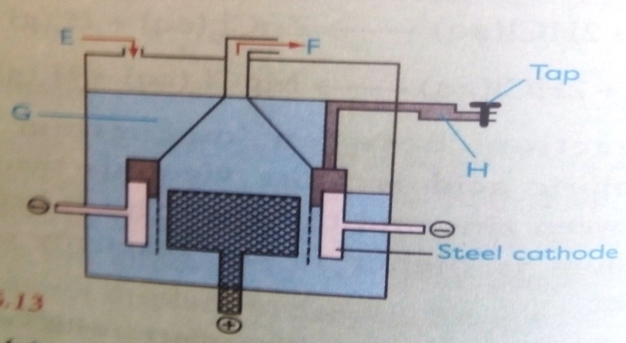
- What is the major ore from which sodium is extracted in this cell?
- Why is sodium not extracted by reduction using carbon?
- Identify the substances marked E, F, G, and H.
- What is the use of calcium chloride in the extraction of sodium from sodium chloride?

- (a) State the Le Chatelier’s principle
(b)Ammonia is synthesized by reacting nitrogen and hydrogen according to
N₂ + 3H₂ 2NH₃∆H = -92KJ/mol
- What does the word synthesized mean?
- What is the source of (i) Nitrogen (ii) Hydrogen
- What is the effect of raising the pressure on ammonia formed at equilibrium
- What is the effect of raising the temperature on the ammonia formed at equilibrium
- What is the effect of using a catalyst on ammonia formed at equilibrium
- What volume of ammonia is obtained when 1litre of nitrogen and 3 litre of of hydrogen at STP Combine together.
- What will the position of equilibrium shift if:-
- Temperature is decreased
- Pressure of the system lowered
- Volume of the container increased
- Catalyst is added
- More nitrogen is added
- A green substance AA on heating gas BB which turns lime water milk and a black residue CC was formed. When a black residue was dissolved in dilute acid,a black solution DD was formed.
When a pen knife blade was dipped DD a reddish coat was deposited on the pen knife blade.
- Identify substances AA, BB, CC and CC.
- Write a balanced chemical equation for each step outlined above
- What would be observed when sodium hydroxide solution is added in small quantity till in excess in a test tube contains little amount of substances AA?

