

THE PRESIDENT’S OFFICE
REGIONAL ADMINISTRATION AND LOCAL GOVERNMENT
LONGIDO DISTRICT

FORM THREE ANNUAL EXAMINATION
032 CHEMISTRY
MARKING SCHEME NOVEMBER 2025

SECTION A (16 MARKS)
- (10 marks)
(i) | (ii) | (iii) | (iv) | (v) | (vi) | (vii) | (viii) | (ix) | (x)
B | C | A | C | A | C | A | B | A | C

- (05 marks)
List A | i | ii | iii | iv | v | vii
List B | D | B | A | C | F | E

SECTION B (54 MARKS)
- (a)
(i) Atomic number: The number of protons in the nucleus of an atom of an element. It determines the element's identity.
(ii) Mass number: The total number of protons and neutrons in the nucleus of an atom.
(b) The electronic configuration is 2, 8, 2.
(i) Element: The sum of electrons is 12, which is the atomic number of Magnesium (𝑀𝑔).
(ii) Group and Period: The element is in Period 3 (because it has three electron shells) and Group II (because it has two valence electrons).
(c) Formula with Chlorine: Magnesium (𝑀𝑔) is in Group II, forming Mg²⁺ions. Chlorine (𝐶𝑙) is in Group VII, forming 𝐶𝑙⁻ ions. The charges balance out to form 𝑀𝑔𝐶𝑙₂

- (a)
(i) 2NaOH+H₂SO₄ → Na₂SO₄ + 2H₂O₂
(ii) 𝐹𝑒₂𝑂₃+3𝐶𝑂→2𝐹𝑒+3𝐶𝑂₂
(b)
Step 1: Write the balanced chemical equation.
2𝑁𝑎+2𝐻2𝑂→2𝑁𝑎𝑂𝐻+𝐻2
Step 2: Calculate moles of Sodium (𝑁𝑎).
Molar mass of 𝑁𝑎=23g/mol.
Moles of 𝑁𝑎=46 g/23 g/mol=2 moles
.
Step 3: Use the mole ratio from the equation.
From the equation, 2 moles of 𝑁𝑎 produce 2 moles of 𝑁𝑎𝑂𝐻. Therefore, 2 moles of 𝑁𝑎 will produce 2 moles of 𝑁𝑎𝑂𝐻
Step 4: Calculate the mass of Sodium Hydroxide (𝑁𝑎𝑂𝐻).
Molar mass of 𝑁𝑎𝑂𝐻=23+16+1=40g/mol.
Mass of 𝑁𝑎𝑂𝐻=2 moles×40 g/mol=80 g
Mass of NaOH = 80 g.
- (a) Salt: A salt is an ionic compound formed when the hydrogen ion of an acid is partially or completely replaced by a metallic ion or an ammonium radical. Examples: Sodium chloride (𝑁𝑎𝐶𝑙), Copper (II) sulphate (𝐶𝑢𝑆𝑂4).
(b) Difference between strong and weak acid:
Strong acid: Ionizes completely in an aqueous solution, meaning all its molecules dissociate into ions. Example: Hydrochloric acid (𝐻𝐶𝑙).
Weak acid: Ionizes partially in an aqueous solution, meaning only a fraction of its molecules dissociate into ions. Example: Ethanoic acid (𝐶𝐻3𝐶𝑂𝑂𝐻).
(c) Three methods for preparing soluble salts:
Reaction of an acid with a metal (e.g., 𝑀𝑔+𝐻2𝑆𝑂4→𝑀𝑔𝑆𝑂4+𝐻2).
Reaction of an acid with a base/alkali (e.g., 𝐻𝐶𝑙+𝑁𝑎𝑂𝐻→𝑁𝑎𝐶𝑙+𝐻2𝑂).
Reaction of an acid with a metal carbonate (e.g., 𝐶𝑎𝐶𝑂₃+2𝐻𝐶𝑙→𝐶𝑎𝐶𝑙₂+𝐶𝑂₂+𝐻₂𝑂).
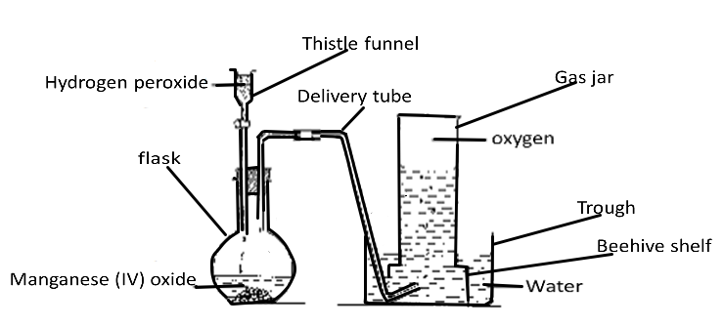
- (a) Apparatus for laboratory preparation of gas Y (oxygen) from hydrogen peroxide solution

(Gas Y = Oxygen: 0½ Mark
Diagram: 01½ Marks
Labels: Any eight @½ = 4 marks)

(b)Uses of oxygen in daily life includes:
- The oxygen in the air and that dissolved in water and soil is used for respiration.
- It is also needed for burning.
(Any three 01@ = 03 Marks)
- It is used in the oxyacetylene (oxygen–ethyne) flame for welding and cutting steel.
- It is extensively used for removing impurities from pig iron in order to produce steel. Oxygen is blown into molten iron to remove impurities such as carbon or phosphorus, which are expelled in the form of gases.
- Oxygen is used as an aid to breathing in hospitals, high altitude climbing or flying, and in deep sea diving.
- Liquid oxygen is used in supporting burning of fuels such as hydrogen in rockets.
- (a) Electrolysis: The process of using a direct electric current to drive an otherwise non-spontaneous chemical reaction. It involves the decomposition of an electrolyte by the passage of an electric current.
(b) Three applications of electrolysis:
- Electroplating: Coating a metallic object with a thin layer of another metal for protection or decoration.
- Electrolytic refining: Purifying metals, such as copper.
- Extraction of reactive metals: Extracting metals like sodium and aluminium from their molten salts.
(c) Electrolysis of concentrated sodium chloride using carbon electrodes:
At the Anode (+): Chloride ions (𝐶𝑙⁻) are discharged in preference to hydroxide ions (𝑂𝐻−) due to their high concentration.
2𝐶𝑙⁻_{(𝑎𝑞)} →𝐶𝑙_{2(𝑔)}+2𝑒⁻ (Chlorine gas is produced)
At the Cathode (-): Hydrogen ions (𝐻⁺) from the dissociation of water are discharged in preference to sodium ions (𝑁𝑎⁺) because they are lower in the electrochemical series.
2𝐻⁺_{(𝑎𝑞)} +2𝑒⁻→𝐻_{2(𝑔)} (Hydrogen gas is produced)
In the solution: The sodium ions (𝑁𝑎+) and hydroxide ions (𝑂𝐻⁻) left behind combine to form sodium hydroxide (𝑁𝑎𝑂𝐻) solution.
- (a)
  - There was an increase in mass due to absorption of water by the substance in the container. (02 marks)
- Deliquescence (01 Mark)
- The rate of reaction would be fast, because of the increase in surface area of the particles. Calcium carbonate powder has a large surface area compared to marble chips. (02 Marks)
(b)
(i) Exothermic reaction because heat is given out to the surrounding. (02 Marks).
(ii) In order to favor forward reaction, the temperature should be lowered because the reaction does not require high temperature for completion.
(02 Mark)

SECTION C (30 MARKS)
- (a)
- Oxidation: Loss of electrons.
- Reduction: Gain of electrons
(b) Differentiate between oxidizing and reducing agents:
- Oxidizing agent: A substance that causes oxidation by accepting electrons. It gets reduced in the process. Example: Copper (II) sulphate (𝐶𝑢𝑆𝑂₄) in the given reaction.
- Reducing agent: A substance that causes reduction by donating electrons. It gets oxidized in the process. Example: Iron (𝐹𝑒) in the given reaction.
(c) For the reaction:
𝐹𝑒+𝐶𝑢𝑆𝑂₄→𝐹𝑒𝑆𝑂₄+𝐶𝑢:
- Oxidized substance: Iron (𝐹𝑒) is oxidized, as it loses two electrons to become 𝐹𝑒²⁺ (𝐹𝑒→𝐹𝑒²⁺ + 2𝑒⁻).
- Reduced substance: Copper (𝐶𝑢²⁺) is reduced, as it gains two electrons to become copper metal. (𝐶𝑢²⁺+2𝑒⁻→𝐶𝑢).
- Oxidizing agent: 𝐶𝑢𝑆𝑂4 (or 𝐶𝑢²⁺) is the oxidizing agent, as it accepts electrons.
- Reducing agent: 𝐹𝑒 is the reducing agent, as it donates electrons.
(08 marks)
- (a) Factors affecting the rate of a chemical reaction:
- Concentration: Increasing the concentration of reactants increases the frequency of collisions, leading to a faster reaction rate.
- Temperature: Increasing the temperature increases the kinetic energy of particles, leading to more frequent and energetic collisions, and a faster reaction rate.
- Surface area: Increasing the surface area of a solid reactant increases the area exposed for reaction, leading to a faster reaction rate.
- Catalyst: A catalyst speeds up a reaction by providing an alternative reaction pathway with a lower activation energy.
(b) Chemical equilibrium: A state in a reversible reaction where the rate of the forward reaction is equal to the rate of the backward reaction, and the concentrations of reactants and products remain constant.
(02 marks)
(c) Effect of pressure on Haber process:
Equation: N_{2(g)} + 3H_{2(g)} ⇌2NH₃
Effect: An increase in pressure will shift the equilibrium to the right, favoring the production of ammonia (𝑁𝐻₃).
- Reason: The forward reaction involves a decrease in the number of gaseous moles (4 moles of reactants to 2 moles of products). According to Le Chatelier's principle, the system will counteract the pressure increase by shifting in the direction that reduces the number of moles of gas.
(05 marks)
Total: 15 marks

- (a) Electronic configuration:
(02 marks)
- Magnesium (Mg, Z=12): 2, 8, 2
(02 marks)
- Chlorine (C l, Z=17): 2, 8, 7
(b) Formation of ionic bond between Mg and Cl:
Magnesium (Mg) is in Group 2, with 2 valence electrons. Chlorine (Cl) is in Group 7, with 7 valence electrons.
Magnesium donates its two valence electrons to two chlorine atoms, forming a positive magnesium ion (Mg²⁺).
Each chlorine atom accepts one electron, forming a negative chloride ion (Cl⁻).
The oppositely charged ions attract each other through strong electrostatic forces to form the ionic compound MgCl₂
(03 marks)
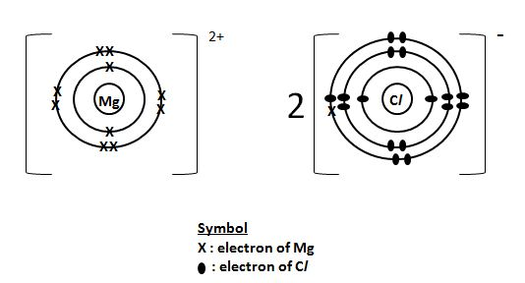
Diagram: A labelled diagram showing the transfer of electrons and the resulting ions is required.
(03 marks)

(c) Trend in reactivity of group I elements:
Reactivity increases down the group.
(05 marks)
Reason: As you go down the group, the atoms get larger, and the outermost electron is further from the nucleus. This reduces the attraction of the nucleus for the valence electron, making it easier for the atom to lose its electron and form a positive ion.

(Total 15 marks)

