PRESIDENT’S OFFICE
REGIONAL ADMINISTRATION AND LOCAL GOVERNMENT
MKALAMA DISTRICT COUNCIL

FORM THREE TERMINAL EXAMINATION MARKING SCHEME

032 CHEMISTRY

SECTION A (16 Marks)
1.
i | ii | iii | iv | v | vi | vii | viii | ix | x
D | D | B | C | B | A | B | E | C | A

1mark@ = 10 marks
2.
 | i |  | ii | iii |  | iv |  | v |  | vi
C |  | B |  | A | I |  | F |  | D
1mark@ = 06 marks

3. In laboratory
- Reaction of dilute hydrochloric acid with Zinc metal 1 ½ mark
Zn_{(s)} + 2HCl_{(aq)} ZnCl_{2(s)} + HCl_{2(g)} ½ mark

In industry
- By steam reforming mark
Steam reacts with methane to produce carbon monoxide and hydrogen gas
- H₂O_{(g)} + CH_{4(g)} CO_{(g)} + 3H_{2(g)} mark b) Copper (ii) oxide is reduced to copper metal as shown below:-
CuO_{(s)} + H_{2(g)} Cu₍₂₎ + H₂O_{(g)} 1 mark

c) i. Hydrogen does not cause environmental pollution

Page 1 of 5

ii. Hydrogen can be produced from renewable resources eg. Water
1mark@ = 02 marks

d)
Property | Uses
i) Reducing agent | Manufacturing margarine
ii) Lighter than air | Filling weather balloons
iii) Highly flammable | Preparation of water gas
iv) Readily react with other substances | Manufacturing of ammonia

1mark@ = 04marks
4.a) i. Data given
Mass of M(OH)₂, m= 5.8g
Molarity of HCl, M= 0.2M_{T.}
- Required, atomic mass of metal M, Mr.
- Consider the following equation
M(OH)2(aq) + 2HCl(aq) MCl2(aq) + 2H2O(I)

1mol of M (OH)₂ ≡ 2mol of HCl
X? ≡ 0.2mol of HCl

X = 0.2mol = 0.1mol 00 mark
2

Moles of M (OH)₂ = 0.1mol
From
Moles = mass
Molar mass

0.1mol = 5.8g
Mr

00 mark
Mr. 58g/mol
Molar mass = 58g/mol

- In magnitude molar mass is equal to relative atomic mass

Hence
Atomic mass of M (OH)₂ = 58
M(OH)₂ = 58
M + 32 + 2 = 58 00 mark
M= 58 – 34 =24
= 24
Atomic mass of M (OH)₂ = 24 00 mark

ii. The name of metal M is magnesium 01 mark
4b) | Data given
 | Volume of acid , Va = 25cm3

Molarity of base, Mb = 1M 01 mark
Molarity of acid, Ma = 1M
Consider the following equation
X (OH)_{2(aq)} + 2HA_{(aq)} XA_{2(aq)} + 2H₂O_{(I)} 01 mark na = 2 nb = 1

From
Ma Va = na 01 mark
MbVb nb

1 x 25 = 2
- x vb 1

2vb = 25
- 2

Vb = 12.5cm³


The volume capacity of the pipette used = 12.5cm³ 01 mark

c) The burette should be cleaned and rinsed in order to avoid contaminations that may interfere with the reaction. 2 marks

5 . a) water sample C is hardest, because it remains hard even after boiling.
2marks
- water sample D behave as distilled water because it use Little volume of
soap solution. 2 marks
It means that water contains no soluble substances.
- (i) Calcium hydrogen carbonate or magnesium hydrogen carbonate. 1marks
(ii) Calcium sulphate or magnesium sulphate 2 marks d) - using more soap during washing
- destruction of boilers, hot water pipes and kettles.
Any 3 points, 1 mark @ = 2marks
6. a) Laboratory rules should be obeyed by everyone because laboratory rules help;
    - To have successful practical activities
    - To ensure safety
    - To protect equipments/apparatii in the laboratory
    - To avoid contaminations (Any 3points,1mark@=3marks)

b) i. A laboratory should be equipped with fire extinguisher so as to extinguish harmful fire in case there is fire accident.
ii. A laboratory should have large windows for proper and good ventilation iii. A laboratory should have fume chamber for preparing poisonous gases

(1mark@=3marks)

c) i. - In hospital
- In petrol filling station
- In chemical industries

(Any 3points, 00^{𝟏}mark@=𝟏 ^{𝟏} 𝒎𝒂𝒓𝒌𝒔)
ii. This is because safety signs ensure safety in the laboratory during practical
activities. Hence safety signs warn laboratory users on the hazards of chemical and advice laboratory users to handle chemicals carefully
(1 marks)

7. a) given data.
Mass = 0.65g
Molar mass = 98g/mol.
Volume = needed ½ marks
Firstly, calculate number of moles then convert into volume
mass
𝑛 = ½ marks
Molar mass
0.65
𝑛 =
65.5𝑔/𝑚𝑜𝑙
= 0.0099mol.
From the eqn.
Zn + 2HCl ------> ZnCl2 + H2 ½ marks
This means
1mol.(Zn) -------> 1mol. (H)
0.0099 ----------> ?
? = 0.0099 x 1
1
= 0.0099mol(H) ½ marks
Convert the obtained moles of hydrogen into volume.
From.
n = volume Molar gas volume
Volume = n x molar gas volume ½ marks
= 0.0099 x 22.4
= 0.222dm³. ½ marks

(b) given data.
Molarity = 0.1M
Volume = 400cm^3
Mass = needed
Molar mass = 98 ½ marks
Firstly find the number of moles in 400cm^3 then convert moles into mass.
Remember that Molarity means the number of moles of solute that dissolved to make one litre of the solution.
0.1mol. -------> 1000cm³
? <----------- 400 cm³
?= 0.1 x 400
1000
0.04mol(in 400cm³) ½ marks
Convert 0.04mol. Into mass.
mass
𝑛 =
Molar mass
Mass = n x molar mass
= 0.04 x 98
= 3.92g. ½ marks
(c) (i) data given. Volume = 100cm³
Mass = 5.3g
Molarity = required
Molar mass = 106g/mol. ½ marks
But molarity = number of mole in one litre of the solution.
Also
concentration(g/dm3)
𝑚𝑜𝑙𝑎𝑟𝑖𝑡𝑦 = ½ marks
Molar mass g/mol
Convert 5.3g in 100cm^3 into g/L(litre)
5.3g ---------> 100cm³ ? <----------- 1000cm³
? = 5.3 x 1000
100
= 53g/dm³ ½ marks
concentration(g/dm3)
𝑚𝑜𝑙𝑎𝑟𝑖𝑡𝑦 =
Molar mass g/mol 𝑚𝑜𝑙𝑎𝑟𝑖𝑡𝑦
53
(
g
/
dm
3
)
106
(
𝑔
)
𝑚𝑜𝑙
= 0.5M ½ marks
(ii)
data given.
Volume = 2L (2000cm³)
Mass = 80g
Molarity = required
Molar mass = 40g/mol. ½ marks
But molarity = number of moles in one litre of the solution. Also =
concentration(g/dm3)
𝑚𝑜𝑙𝑎𝑟𝑖𝑡𝑦 =
Molar mass g/mol
s Convert 80g in 2000cm³ into g/L(litre) or dm³
80g ---------> 2000cm³
? <----------- 1000cm³
? = 80 x 1000
2000
= 40g/dm³ ½ marks
26
Molarity = concentration
Molar mass
= 40
40
= 1M ½ marks
Total 8 marks
8a) i. Conical flask/Flat = bottomed flask
- Filter funnel
- Retort stand and clamp
- Filter paper (Any 3points, ^{𝟏}mark@=𝟏 ^{𝟏}marks)
𝟐 𝟐

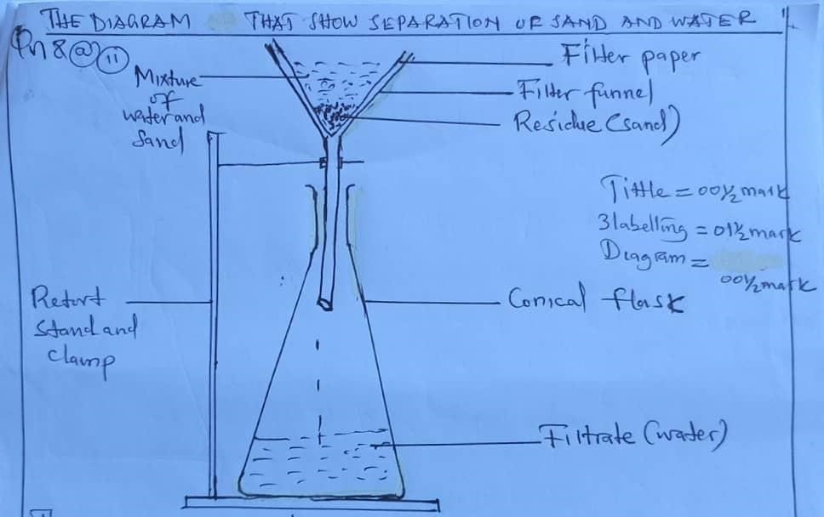

The sand is separated from the liquid using a porous filter such as filter paper. The sand will remain in the filter paper as residue and water will pass through filter into the conical flask.
00 Mark

8b) - Solution used in cleaning eg. Soap solution

- Suspensions Used as drug for treatment of diseases
- Emulsion Used in decoration eg. Paint

½ mark@=1^{𝟏}marks

c) - Used in drying crops
- Used in drying clothes
- Used in drying mopped areas
- Used in drying washed hairs

Any 3points, 𝟏mark@=𝟎𝟑marks

SECTION C: (30 Marks)
9.a) This is because the antacids will neutralize excess acid in the stomach, hence the problem of excess acid will be overcome. 02 marks

- Mg(OH)_{2(aq)} + 2HCl_{(aq)} MgCl_{2(aq)} + 2H₂O_{(I)} 02marks

- Data given
Normal acid content = 160 millmolar
Abnormal acid content = 210millimolar
Excess stomach acid = 210 – 160
Excess acid = 50millimolar

Converting millimolar to molarity

1mM | ≡ | 0.001mol/dm³
50mM | ≡ | X?
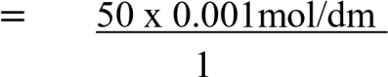
X? ³

- | = 0.05M  Molarity of excess acid = 0.05M  Determining number of moles of excess acid, From Molarity = moles (n)  Volume (dm3)  0.05M = Moles(n)  0.5litres  Moles = 0.025mol  Moles of excess acid = 0.025mol |  | 01mark  00 mark  00 mark
  - Determine the number of moles of antacid that will neutralize excess acid - consider the following equation.

Mg (OH)_{2(aq)} + 2HCl_{(aq)} MgCl_{2(aq)} + 2H₂O
1mol of Mg(OH)₂ | ≡ 2mols of HCl | 00 mark
X? | ≡ 0.025mol of HCl
X = | 0.025 x 1
2
= 0.0125mol 00 mark

Moles of antacid that will neutralize excess acid = 0.0125mol
  - 0.0125mol of Mg (OH)2 will neutralize 0.025mol of HCl Then
Moles = Mass
Molar mass
0.0125 = Mass 1mark
58

Mass = 0.725g

Mass of tablet to be given is 0.725g 1mark

- Mass of tablet = 0.725g = 725mg
1tablet ≡145mg 2mark
X? ≡725mg
X = 1tablet x 725mg
145mg
= 5tablets 2mark
The student will be given 5 tablets.

- 2 days (02mark)

10a) i. Neutralization reaction (1mark)
ii. – Used in relieving indigestion
- Used in controlling soil PH
- Used in treating factory wastes (Any 4points,𝟏mark@=𝟒marks)
- Preventing formation of acid rain
- Manufacturing of fertilizers

b) i. Lead (II) sulphate
It is prepared by precipitation reaction (1mark)
Pb(NO3)2(aq) + Na2SO4(aq) PbSO4(s) + 2NaNO3(aq) (1mark) ii. Copper (II) nitrate
It is prepared by reacting dilute HNO₃ with metal carbonate
(1mark)
CuCO3(s) + 2HNO3(aq) CU(NO3)2(aq) + CO2(g) + H2O(s) (01mark)

iii. Calcium Chloride
It is prepared by reacting dilute HCl with metal carbonate (01mark)
CaCO3(s) + 2HCl(aq) CaCl2(aq) + H2O(q) + CO2(g) (01mark)

iv. Calcium Carbonate
It is prepared by precipitation reaction (01mark)
Ca(NO3)2(_{aq)} + Na2CO3(_{aq)} CaCO3(_{s)} + 2NaNO3(_{aq)} (01mark) v. Barium sulphate
It is prepared by precipitation reaction (01mark)
BaCl₂(aq) + Na₂SO₄(aq) BaSO₄(aq) + 2NaCl(aq) (01mark)

11. i. Introduction
  - Meaning of chemistry (1mark)
  - Meaning of Agriculture (1mark)

- Main body
    - It helps to make fertilizers
    - It helps to produce pesticides (Any 5points,𝟐mark@=𝟏𝟎marks)
    - It helps to produce animal vaccine
    - It helps to produce weed killers
    - It helps to make insecticides
- Conclusion (2mark)

