CATHOLIC DIOCESE OF MOSHI
USSERI SECONDARY SCHOOL
MID TERM TEST MARCH 2025
BIOLOGY FORM ONE
TIME: 2:00HRS
Instructions
- Answer all questions in each section
- write your name in any page
- All drawing should be in pencil.
Section A
1. Mr. Matoboki taught form one students that (i) _______________ is the branch of science deals with the study of life. Also according to this subject there are three main branches of biology which are (ii)____________________, (iii)_________________,and (iv) ________________ further more he said that. A person who studies Biology is called (v)___________________. Living things are also called organisms. They include animals and plant other microorganism which are very small living things such as bacteria and some protozoan which can not be seen with the naked eyes. Those very small organisms can be seen by using instrument called (vi) __________________ Also he said that living organisms are made up of (vii)________________ which is the basic unit of life. A person who is specialized in the study of animals is called (viii) ______________ the term biology originates from two Greek words which are (ix) ___________ and(x) ___________ Bios that means(xi) _______________ and logos that means (xii)_______________ he taught us also that Biology is not an isolated field of study. This means that Biology is related to many other fields of study such as veterinary, (xiii)___________________, medicine,(xiv)_____________, pharmacy, (xv)_______________, he provides also to us the importance of studying biology by telling us that biology is very important because it helps us to understand our self better.
2. Form one student they are debating that the study of biology is like wastage of time by using five points opposes this statement.
- ___________________________________________________________ _____
- _________________________________________________________________
- _________________________________________________________________
- _________________________________________________________________
- _________________________________________________________________
03. Kingwendu and joti performing an experiment in the laboratory to observe the very small specimens by using microscope the magnification of the specimen show that, the size or length of drawing is 8cm and the actual length of object is 2cm.
(a) Calculate the magnification of the specimen.

(b) Give out the name of the apparatus used to
- catch small flying organisms such as butterflies ________________________________
- Magnifying specimens that are under observation._______________________________
- Used to catching fish and other aquatic organisms.________________________________
- Measure the temperature. ________________________________

4. Draw and label atleast five parts of light microscope.

5. Observation is one of the methods of studying biology or living things by using sense organs foristance have a coconut, you can use your sense organs to determine that.
- it is round by ____________________
- it contains a liquid by hearing the sound when shake by using _____________
- it has rough husk by ____________________
- it has good smell by _____________________
- it has a sweet taste by ____________________
6. Scientists use scientific procedure to solve different problems scientifically; the following are the scientific methods.
- Problem identification
- …………………………
- ………………………….
- Observation and recording
- ………………………………
- ………………………………
- ……………………………….
7. John attempted to observe plant cells using a prepared slide under a light microscope but he was unable to obtain a clear image due to the following challenges
- the slide contain specimen did not settle on the stage for observation
- he was unable to achieve sharp focus
- the image was too bright making it difficult to see the detail of specimen
Educate your friend on how to address the challenges faced in order to obtain a clear image of the plant cells.
- __________________________________________________________________________________
- __________________________________________________________________________________
- ___________________________________________________________________________________
8. Give the different between animal and plant cells five points.
PLANT CELL | ANIMAL CELL
9 give out the function of the following part of cell
- nucleus _______________________________________________________
- cytoplasm______________________________________________________
- cell membrane___________________________________________________
- cell wall _______________________________________________________
- mitochoridrion___________________________________________________
10. Draw and label animal cell

CATHOLIC DIOCESE OF MOSHI
USSERI SECONDARY SCHOOL
MID TERM TEST MARCH 2025
BIOLOGY FORM TWO
TIME: 2:00HRS
Instructions
- This paper consists of section A,B and C with a total of ten (10) questions
- Answer all questions.
- Section A and C carries Thirty (30) marks each and section B carries seventy (70) marks.
- All writings must be in blue or black ink except drawing which must be in pencil.
- Cellular phones and any unauthorized materials are not allowed in examination room.
- Write your Examination number at the top right corner of every page.
SECTION A
1. For each of items (i)- (x) choose the most correct answer among the alternatives and write its letters beside the item number in the box provided.
- Immunity is the ability of the body to defend itself against infections. Which one of the following types of immunity involves passage of antibodies from mother to unborn baby across the placenta?
a. Natural passive immunity
b. Artificial active immunity
c. Artificial passive immunity
d. Artificial active immunity
- A person picks up a telephone after hearing it ring. Which characteristics of living things is the person showing by this action?
a. Movement and locomotion
b. Movement and irritability
c. Growth and response
d. Development and response
- Which apparatii are used for heating substance in biology laboratory?
a. test tube holder and thermometer
b. spirit burner and Bunsen burner
c. Bunsen burner and thermometer
d. spirit lamp and test tube rack
- when two organisms live together for their mutual benefit the relationship is called:
a. commensalism
b. symbiosis
c. epiphytism
d. saprophytism
- conditions or factors that can change or be changed in an experiment
a. hypothesis
b. problems
c. variables
d. conclusions
- The residents of a certain village in Iringa feed on meat, beans and stiff porridge. In order for their health to improve, which of the following would you advise them to add to their present diet?
a. Fish and sweet potatoes
b. fruits and green vegetables
c. water
d. bread and green vegetable
- all of the following are found suspended in the plasma except:
a. red blood cells
b. platelets
c. capillaries
d. white blood cells
- Why bryophytes are the most primitive plants on earth?
a. they grow on wet areas
b. they do not produce seeds
c. they reproduce asexually and sexually
d. they lack vascular tissues
ix. People who are always talking while eating are most likely to be;
a. highly respective
b. express bad manner
c. express good manners
d. good role model to other

- Which of the following is among the products of an aerobic respiration in plants?
a. ethanol
b. lactic acid
c. oxygen
d. hydrogen
ANSWERS
i | ii | iii | iv | v | vi | vii | viii | ix | x

2. Match the terminologies used in kingdom plantae and kingdom fungi in list A with the response in list B by writing the letter of the correct response beside the item number.
LIST A | List B
i. Sac like structure which produce ascospore.  ii. leaflet in fern plant  iii. male reproductive structure in moss plant  iv. group of sporangia in fern plant  v. Female reproductive structures of moss plant | - Rhizopus  - Penicillium  - Asci  - Pinnae  - Frond  - Antheridia  - Archegonia  - Hyphae  - Sori

LIST A | i | ii | iii | iv | v
LIST B

SECTION B
3. (a) Briefly explain what will happen if chloroplast is removed from plant cell?
i) ______________________________________________________________
ii) _______________________________________________________________
(b) In four points, show how cheek cell and onion cell are similar.
- ___________________________________________________________
- ___________________________________________________________
- ___________________________________________________________
- ___________________________________________________________
- ___________________________________________________________
(c) Draw the diagram of plant cell as seen under light microscope and label any four parts
4. (a) Many children at Sonineka village have swollen abdomen and extremely thin arms and legs due
to deficiency supply of a particular food in their bodies.
(i) What is the nutrition deficiency do the children suffer from?
_______________________________________________________
(b) A part from swollen abdomen and thin hands and legs, what the symptoms of this nutrition deficiency (any three points)
- ___________________________________________________________
- ___________________________________________________________
- ___________________________________________________________
c) (i) Give any four natural foods that you can advise the people from Sononeko to fees their children.
- ___________________________________________________________
- ___________________________________________________________
- ___________________________________________________________
- ___________________________________________________________
(ii) Name the food substances found in the food mentioned in part (i) above and give two roles of each to human body _______________________________________________________________
____________________________________________________________________________________________________________________________________________________________________________________
5. (a) A bread was put in a wet cupboard after few days black thread like structures which ended up in bulb like shape appeared on the bread.
- Write the common name of the organism that grew on the bread surface __________________
- name the kingdom in which the organism belongs ____________________
- name the phyla in which the observed organism belongs ________________
- State two advantages of the kingdom into which the organism named in (a) above belongs……………………………………………………………………………………….……… and ……………………………………………………………………………………………………

(b) Tanzania Government has been insisting the provision of vaccine to its children under 5 years old. List four common diseases against which children are immunized.
- ………………………………………………………………………………….
- ………………………………………………………………………………….
- ………………………………………………………………………………….
- ………………………………………………………………………………….
(c) Write a word equation for aerobic respiration.
……………………………………………………………………………………
6. A group of form I students from Iliboru Secondary school had a study visit Mount Meru Hospital in Arusha. They noted a patient with sunken eyes, severe dehydration, weak pulse, deep breathing vomiting and watery diarrhea like rice water.
- What could be the possible disease that the patient was suffering from?
………………………………………………………………………..
- Briefly explain four control or preventive measures of the disease mentioned in (a) above.
- …………………………………………………………………………
- …………………………………………………………………………
- …………………………………………………………………………
- …………………………………………………………………………
7. a) Abdul – basit was talking to his friends about condition of his young brother who always attacked by diseases. His friend responds that maybe your young brother has weak immunity. How can he advice Abdul – basit so as to improve his young’s brother immunity?
- _______________________________________________________
- _______________________________________________________
- _______________________________________________________
- _______________________________________________________
b) A child complains to her mother that she had a headache and joint pain. She also feels uneasy, vomits and has abdominal pain. Her mother realizes that the child also has a fever. She takes her to the hospital.
- Which diseases do you think the child is suffering from?
______________________________________________
- What is the cause and mode of transmission of the diseases?
_________________________________________________________
_________________________________________________________
_________________________________________________________
c) How can the diseases named in 7(b) (i) be prevented?
- ____________________________________________________
- ____________________________________________________
- ____________________________________________________
8. (a) On the way to school, Naomi saw the following materials along the road; broken glasses, ripe banana peelings, syringes, old newspapers and water from bathroom.
- Name the materials from the above list that can be recycled. ………………........................
………………………………………………………………………………………………..
- Give one effect of those materials in the place where they were placed.
………………………………………………………………………………………………..
- From the above list, name one example of clinical waste …………………………………..
b) Name the parts of the microscope labelled A-E in the diagram below and state the function of each
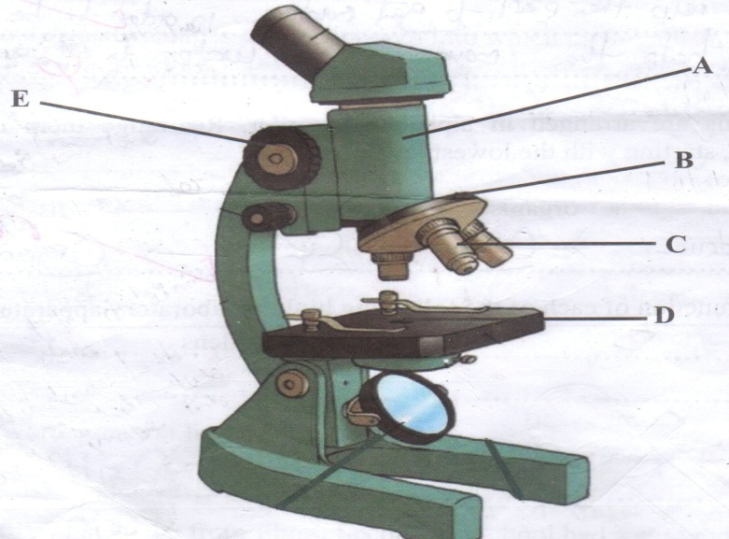

PART | NAME | FUNCTION
A
B
C
D
E

9. (a) According to the laboratory rules, what should you do it in the following?
- while boiling water alone, you realize that you need to get book from the classroom_______________________________________________________________________________________________________________________________
- you need to switch off electricity __________________________________________ _____________________________________________________________________
- One of your classmates has brought some chocolate in the laboratory.
__________________________________________________________________________________________________________________________________________
- Your classmate is bitten by a bee during learning activities.
__________________________________________________________________________________________________________________________________________

SECTION C
10. POMBESICHAI got an accident when he walking alone and when he was admitted to the hospital, he was advised by doctor to use a certain type of food for recovering and repairing his body.
(a) Suggest the food type he was advised to use.
(b) List down three natural sources of food suggested above in 10 (a)
(c) Outline three roles of the food suggested above in 10(a)
(d) Identify and explain three effects and four symptoms of the disease which results when the individuals below five years old lack the food named in 10(a) above in the diet.
ANSWERS
……………………………………………………………………………………………………………………………………………………………………………………………………………………………………………………………………………………………………………………………………………………………………………………………………………………………………………………………………………………………………………………………………………………………………………………………………………………………………………………………………………………………………………………………………………………………………………………………………………………………………………………………………………………

