PRESIDENT’S OFFEICE
REGIONAL ADMINISTRATION AND LOCAL GOVERNMENT
FORM ONE ARUSHA REGION ANNUAL EXAMINATION
BIOLOGY
TIME 2:30Hrs 2023

SECTION A (15 Marks)
Answer all questions from this section 1. Chose the most correct answer from the choices given
i) The organ that is used for hearing is called
a) The ear b) The eye
c) The nose D) The skin
ii) One of the following is not the living things characteristics
a) Movement b) Growth
c) Digestion d) Respiration
iii) A victim of poisoning should not be;
a) Forced to vomit b) Given water
c) Given milk d) given anything by mouth
iv) A decrease in supply of blood in the lead can lead into;
a) Heart attack b) Drowning
c) Fainting d) Shock
- Which of the following will not be found in a first aid box?
a) Amoxylin | b) Razor blade
b) Panadol | d) Iodine tincture
- Which of the following should not be done to a person bitten by insects such as bees?
a) Apply a cold compress b) Scrape the stings using a blunt object
c) Use fingers to remove stings d) apply baking soda in case of acid sting
vii) The following are importance of first aid except
a) Cures the person b) Give hope and encouragement
c) Reduces pain d) Reduces excessive loss of blood
viii) Which of the following is not a cause of muscles cramps?
a) Poor coordinating of muscles b) Cold weather
c) Drinking alcohol d) Excessive salts in the body
ix) What does science deals with?
a) Study of environment b) Study of medicine and car manufacturing
c) Study of microscope d) Study of nature by experiment and observation
x) Biology is the subject deals with
a) Study of cells b) Study of life
c) Study of anatomies d) Study of animals

- Match the function of parts of all in List A with the corresponding part in List B. by writing the letter of the correct response beside the item number in your answer sheet.
List A | List B
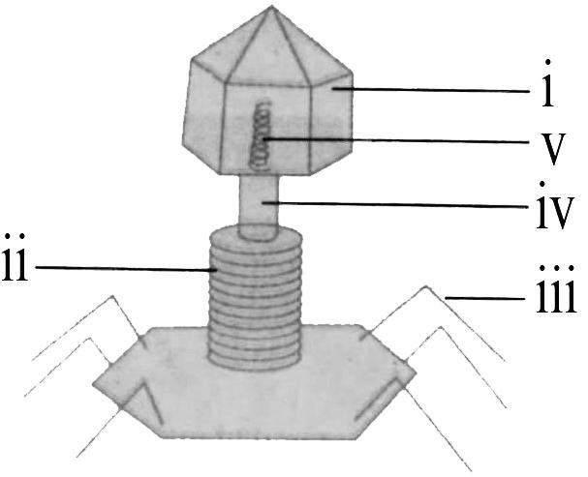 | - Tail sheath  - Nucleic acid  - Nucleus  - Collar  - Cell membrane  - Cell vacuole  - Capsid  - Tail fibers

SECTION B (70 Marks)
Answer all questions
- Using examples, explain how the following fields related to biology
(a) Agriculture
(b)Nutrition
- Forestry
- Medicine and pharmacy
4. (a) If you are deliver to talk on the qualities of a good laboratory, what qualities you will consider? (Give five points)
- Explain why most of laboratory tools are made by glass and plastics materials. (Give two reasons)
- Why we have laboratory rules in our schools especially in biology laboratory?
5. (a) State the functions of the following parts of a microscope:
i)Eye piece
ii) Mirror iii) Stage iv) Base
b) Provide the first aid to the person who has been bitten with snake (Give five procedures)
(c) As a form one student, briefly explain the common accident at home and school. (Give three points)
6 (a) Biology teacher enter the class and ordered the student to draw a well labeled diagram of animal cell and show the parts responsible for the following.
- Protects and give the cell a definite shape
- Site for chemical reaction
- Home of hereditary materials
- Allows sensitive movements of substances across the cell
- Students of Maweni secondary school were debating on the motion state that “Biology has no significance to human life” With the evidences oppose the motion
- The villagers of Maweni they likely to dispose waste in badly ways. Briefly explain the problems that are likely to happen at Maweni village. (Give five points)
7 (a) How can you maintain a good manner when you are invited for a dinner at your neighbor house?
- Puberty causes both physical and emotional changes in adolescents. With using relevant examples show the changes that occur in boys and girls during puberty.
- The family of Halima within a five years they lived without getting infections and diseases. As a form one student explain ways used by Halima family to maintain a good health. (Give three points)
8 (a) Immune system of the body it consists white blood cells, the lymphatic system, spleen, thymus, skin and the bone marrow. Through that entire component but body can get infections or diseases. Show how immunity can be affected?
- With the using of examples, show difference between the followings i) An epidemic and a pandemic ii) An endemic and a sporadic
- Why non- communicable disease are not infectious?
9 (a) State the abbreviation of the followings words
i) People living with HIV and AIDS ii) Human immunodeficiency Virus iii) Acquired Immunodeficiency Syndrome iv) Sexual Transmitted Infections v) Sexual Transmitted Diseases
SECTION C (15 Marks)
10. Why it is important to classify organisms?

