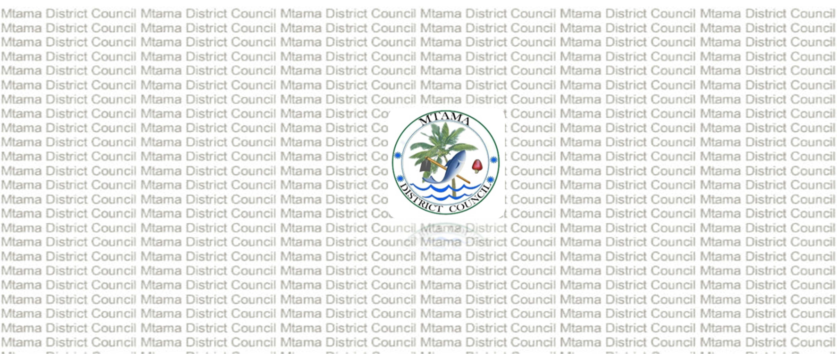
PRIME MINISTER’S OFFICE
REGIONAL ADMINISTRATION AND LOCAL GOVERNMENT MTAMA DISTRICT COUNCIL
FORM ONE TERMINAL EXAMINATION BIOLOGY
Time: 2:30 Hours
MAY, 2026

STUDENT NAME

INSTRUCTIONS
- This paper consists of section A, B and C with a total of ten (10) questions.
- Attempt all questions in each section
- All writing must be in blue or black ink except drawing which must be done in pencil.

QUESTION NUMBER | SCORE | ASSESSOR'S INITIALS
1.
2.
3.
4.
5.

6.
7.
8.
9.
10.
TOTAL
CHECKER'S INITIAL

SECTION A: (15 Marks)

Answer all questions in this section.
- For each item (i–x), choose the most correct answer from the given alternatives and write its letter in the box provided.
  - During Josiah’s study tour to Mikumi National Park, Form One students saw a pisum sativum plant, but he failed to identify the branch of Biology to which it belongs. As a Biology student, identify the correct branch of Biology.
A. Zoology B. Entomology C. Ecology D. Botany
  - are conditions or factors that can change or be changed during an experiment.
A. Hypothesis B. Variables C. Problems D. Conclusion
  - The stage in the scientific procedure that is used to compare the results with the hypothesis is known as .
A. Conclusion B. Observation C. Data collection D. Data analysis
  - If you work in a field that deals with the health of animals and treatment of their diseases, you are called a .
A. Veterinarian B. Forester C. Agriculturalist D. Pharmacist
  - A person picks up a telephone after hearing it ring. Which characteristic of living things is shown by this action?

    - Excretion and reproduction
    - Respiration and nutrition
    - Irritability and movement
    - Respiration and growth

  - Shany wanted to estimate the population of a certain species of grass in a particular area. Which instrument should be used?
A. Potter B. Quadrat C. Hand lens D. Microscope
  - If the eyepiece lens of a microscope has a magnification of 10× and the objective lens has a magnification of 20×, calculate the total magnification.
A. 25× B. 200× C. 15× D. 0.2×
  - Scientists, engineers, doctors, and geologists use a method to solve scientific problems. This method is called .

    - Project work
    - Data recording
    - Scientific procedure
    - Data collection

  - A statement that summarizes what a scientist has learned from an experiment is called .

    - Data interpretation
    - Experimentation
    - Hypothesis
    - Conclusion

  - Which part of the microscope allows the observer to move the body tube up and down in order to obtain a sharp focus of the specimen?

    - Revolving nosepiece
    - Fine adjustment knob
    - Eyepiece lens
    - Coarse adjustment knob

Items number | i | ii | iii | iv | v | vi | viii | ix | x
Answers

- Match the functions in list A with the correct part of plant cell responsible in list B by writing it's letter in the space provided.

List A |  |  |  |  | List B
- Provide rigidity and maintain the shape of the cell.  - Control movement of substances in and out of the cell.  - Site where cellular respiration occurs to release energy.  - Store cell sap and maintain turgor pressure  - Site where photosynthesis occurs |  |  |  |  | - Vacuole  - Cell membrane  - Cell wall  - Cytoplasm  - Nucleus  - Mitochondria G.Chloroplast
List A | i | ii | iii | iv |  | v
List B

SECTION B;( 70 marks)
Answer all questions from this section
- In a certain village people face diseases, low crop production and poor waste disposal,One of the biology student related these problem to what they study in class.
- From the situation in the village define biology…………………………………………………….

- State four (4) reasons how knowledge of biology is important in solving problems like those observed in the village.
i)

ii)

iii)

iv)

- A form one student tests whether fertilizer affect plant growth by using two groups of maize plants, one with fertilizer and one without.
- i. Define
variables

- Mention and explain three (03) types of variables
i)

ii)

iii)

- A scientist removed mitochondria from the muscles cells of a human and observed that the cells failed to perform their normal activities effectively.
- i. Explain the role of mitochondria in the cell.

ii. Draw a well labeled structure of mitochondria

- Draw a well labeled structure of plant cell

- Taxonomists discovered several organisms living in a forest,some organisms could mate and produce fertile offspring while others either failed to reproduce or produced infertile offspring.
- From above information construct a definition of species

- Design three(3) reasons why organisms from different species do not normally interbreed successfully
i)

ii)

iii)

- Develop three (3) characteristics used to identify members of the same species .
i)

ii)

iii)

- In a natural system of classification organisms are grouped based on many features,thus characters that show homology must be distinguished from those that exhibit analogy.
- With examples describe the meaning of;
  - Homologous characters

  - Analogous characters

- Outline four (4) reasons why natural system of classification is important in classifying organisms?
i)

ii)

iii)

iv)

- A multicellular organisms consists of a few to millions of cells,which have different functions and have features that make them better suited to carry out these functions.
- Explain the meaning of cell differentiation

- Describe functions of any three specialized plant cells
i)

ii)

iii)

- i)The following terms are arranged in alphabetical order.Rearrange them into an appropriate biological sequence,starting with the lowest level
Cell → organ → organism → system → tissue

ii)Mention five characterisrics of plant cell

- A school has decided to convert an empty classroom into a biology laboratory.
- What five(5) modification should be made to meet standard laboratory requirements?

- Write five (5) safety rules that students must obey before using the new laboratory.

SECTION C ;(15 marks)
Answer question number ten (10)
- Write an essay about photosynthesis using the following guidelines
- Meaning of photosynthesis
- Raw- materials of photosynthesis
- End – product of photosynthesis
- Importance of photosynthesis

