PRIME MINISTER’S OFFICE
REGIONAL ADMINISTRATION AND LOCAL GOVERNMENT ARUSHA REGION


CODE: 033 TIME: 2: 30 HRS

FORM ONE TERMINAL EXAMINATION

BIOLOGY

28
th

May
, 2026

SECTION A (15 MARKS)

Answer all questions in this section.

(
i
)

___________ is an organelle found in eukaryotic cells, that plays an important role of generating
energy.

A.

R
ibosome

B.

M
itochondrion

C.

P
lasma membrane

D.

G
olgi apparatus

INSTRUCTIONS 1. This Paper Consists of Section A, B and C with total of ten (10) questions.
- Answer All Questions in all sections
- Use blue or black ink to write, and HB pencil for drawings.
- Unauthorized materials are not allowed in an examination room. 5. Write your name on every page of your examination.

1. Choose the correct answer then write its letter in the space provided.

- My uncle works at Mhimbili hospital in the career that deals with microbes such as bacteria, virus and parasites. How do we call my uncle?
    - Cytologist C. Microbiologist
    - Bacteriologist D. Mycology

- When Jesca was sick the doctor asked stool and urine for diagnosis. Which instrument did he use to confirm the presence or absence of microorganisms in stool and urine?
    - Microscope C. Hand lens
    - Clinical thermometer D. Thermal detector

- Which field joins with Biology in developing varieties of fast-growing trees?
    - Sociology C. Anthropology
    - Agriculture D. Forestry
- Anania wants to do scientific investigation, which right place do you advise him to conduct his activities for better results and safety insurance?
  - Hospital C. School
  - Laboratory D. Classroom

- Which instrument can be used for picking up small organisms without hurting them?
  - Scoop net B. Specimen bottles
Page 1 of 7

C. Pooter D. Quadrat

- Which reason plains one disadvantage of using sense organs in observation?
  - It consumes time C. It needs more money
  - It needs a competent student D. It is based on personal interest

- Biology students were assigned to observe the external features of variety of preserved 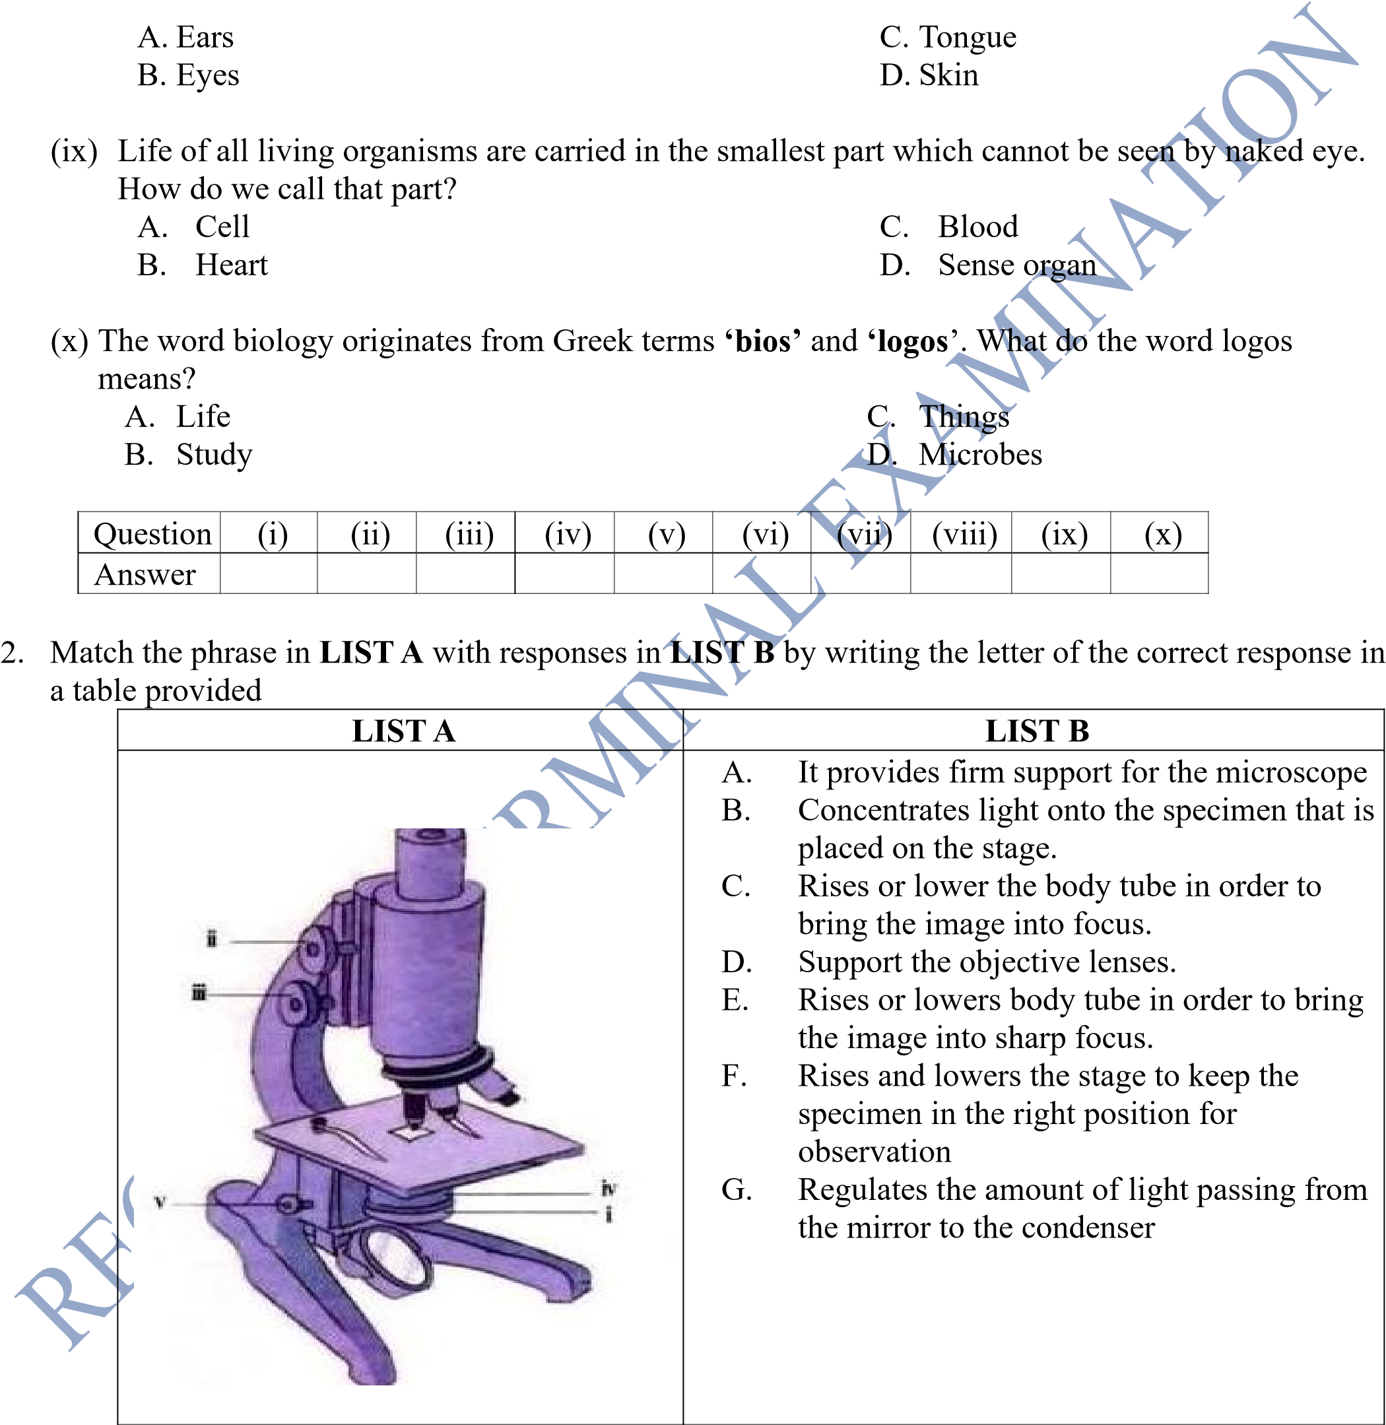specimen. Which sense organ would they use to observe?

LIST A | (i) | (ii) | (iii) | (iv) | (v)
LIST B

SECTION B (70 MARKS)
Page 2 of 7

Answer all questions in this section
- (a) What is Biology laboratory?
………………………………………………………………………………………………………
………………………………………………………………………………………………………
……………………………………………………………………………………………………… ……………………………………………………………………………………….
  - Biology laboratory is equipped to meet the needs of laboratory users especially during conducting scientific investigation. Give five qualities of a biology laboratory.
………………………………………………………………………………………………………
………………………………………………………………………………………………………
……………………………………………………………………………………………………… ……………………………………………………………………………………………………… ………………………………………………………………………………………………………
………………………………………………………………………………………………………
………………………………………………………………………………………………………

- (a) Life is the state that distinguishes living from non-living things, which characteristics that distinguish living from nonliving things?
………………………………………………………………………………………………………
………………………………………………………………………………………………………
………………………………………………………………………………………………………
………………………………………………………………………………………………………
……………………………………………………………………………………………………… ……………………………………………………………………………………………………… ……………………………….
  - Biology is more than a study of animals and plants. Explain
………………………………………………………………………………………………………
………………………………………………………………………………………………………
……………………………………………………………………………………………………… ………………………………………………………………………………………………….
- How can you compare the following terms? (a) Anatomy from Physiology
......................................................................................................................................................... .........................................................................................................................................................
.........................................................................................................................................................
  - Cytology from Microbiology
.......................................................................................................................................................
....................................................................................................................................................... .......................................................................................................................................................
  - Botany from zoology
......................................................................................................................................................... ......................................................................................................................................................... .........................................................................................................................................................
  - Unicellular from multicellular organisms
…………………………………………………………………………………………………
…………………………………………………………………………………………………
  - Prokaryotic from eukaryotic cell
……………………………………………………………………………………………………
……………………………………………………………………………………………………

- (a) Scientific research is a never-ending process, as shown in figure below. Complete the missing procedures

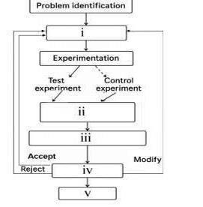

i)__________________________________________________________________________
(
(
ii)__________________________________________________________________________
iii)_________________________________________________________________________
(
(
iv)___________________
______________________________________________________
(
v)__________________________________________________________________________
(
vi)_________________________________________________________________________

(
b) If your results do not support the hypothes
is, what will you do?

…………………………………………………………………………………………………
…………………………………………………………………………………………………
…………………………………………………………………………………………………

7.

(
a) Draw a large and well labelled diagram of a plant cell. (label at least five parts
)

(
b)
Give
clear differences between an animal cell and a plant cell

- a) what do you understand about classification?
………………………………………………………………………………………………………
………………………………………………………………………………………………………
  - Why do you think most of scientists do not prefer the use of artificial classification system? (give five reasons)
............................................................................................................................................................ ............................................................................................................................................................ ............................................................................................................................................................
............................................................................................................................................................ ............................................................................................................................................................
- (a) Name the instrument you would use to measure the following and state the corresponding SI units.
(i) Mass……………………………………………………………………………………………
…………………………………………………………………………….…………………… (ii) Time……………………………………………………………………………………………
…………………………………………………………………………………………………
    - Time……………………………………………………………………………………………
…………………………………………………………………………………………………..

    - Temperature

…………………………………………………………………………………………………
…………………………………………………………………………………………………
    - Length
………………………………………………………………………………………………… …………………………………………………………………………………………………..
  - During an experiment, a scientist noticed that some of the factors can be manipulated. What is general term used to refer to such factor?
………………………………………………………………………………………………………
……………………………………………………………………………………………………….

SECTION C (15MARKS)
Answer the following question

- Biology as among the fundamental branch of science has been involved directly in solving different problems in the society. As biologist, support this statement by explaining the usefulness of studying biology.
…………………………………………………………………………………………………………
…………………………………………………………………………………………………………
…………………………………………………………………………………………………………
…………………………………………………………………………………………………………
…………………………………………………………………………………………………………
………………………………………………………………………………………………………… ………………………………………………………………………………………………………….
…………………………………………………………………………………………………………
…………………………………………………………………………………………………………
………………………………………………………………………………………………………… …………………………………………………………………………………………………………
………………………………………………………………………………………………………… ………………………………………………………………………………………………………… …………………………………………………………………………………………………………
…………………………………………………………………………………………………………
…………………………………………………………………………………………………………
…………………………………………………………………………………………………………
…………………………………………………………………………………………………………
………………………………………………………………………………………………………… ………………………………………………………………………………………………………… …………………………………………………………………………………………………………
…………………………………………………………………………………………………………
…………………………………………………………………………………………………………
…………………………………………………………………………………………………………
………………………………………………………………………………………………………… ………………………………………………………………………………………………………… …………………………………………………………………………………………………………
…………………………………………………………………………………………………………
…………………………………………………………………………………………………………
…………………………………………………………………………………………………………
………………………………………………………………………………………………………… ………………………………………………………………………………………………………… …………………………………………………………………………………………………………
…………………………………………………………………………………………………………
…………………………………………………………………………………………………………
…………………………………………………………………………………………………………
…………………………………………………………………………………………………………
………………………………………………………………………………………………………… ………………………………………………………………………………………………………… …………………………………………………………………………………………………………
…………………………………………………………………………………………………………
…………………………………………………………………………………………………………
…………………………………………………………………………………………………………
………………………………………………………………………………………………………… ………………………………………………………………………………………………………… …………………………………………………………………………………………………………
…………………………………………………………………………………………………………
…………………………………………………………………………………………………………
…………………………………………………………………………………………………………
…………………………………………………………………………………………………………
………………………………………………………………………………………………………… ………………………………………………………………………………………………………… …………………………………………………………………………………………………………
…………………………………………………………………………………………………………
…………………………………………………………………………………………………………
…………………………………………………………………………………………………………
………………………………………………………………………………………………………… ………………………………………………………………………………………………………… …………………………………………………………………………………………………………
………………………………………………………………………………………………………… …………………………………………………………………………………………………………
…………………………………………………………………………………………………………

