

THE PRIME MINISTER’S OFFICE
REGIONAL ADMINISTRATION AND LOCAL GOVERNMENT
LONGIDO DISTRICT MID TERM JOINT EXAMINATION

FORM ONE
033 BIOLOGY
MARKING SCHEME AUGUST 2026

SECTION A: 15 MARKS

10 marks
B | B | B | C | C | C | B | C | C | B

- 5 mark
C | A | D | B | E

SECTION B: 70 MARKS
- (a) Two apparatus/resources used to obtain measurements — 2 marks
Any two:
- Ruler
- Balance
- Measuring cylinder, if appropriately used
- Any other suitable measuring apparatus from the scenario

(b) Laboratory safety precautions — 2 marks
Any two:
- Handle apparatus carefully.
- Keep the working area clean.
- Do not eat or drink in the laboratory.
- Follow the teacher's instructions.
- Report accidents immediately.
- Wash hands after the experiment.

(c) Suitable hypothesis — 2 marks
Example:
Increasing the amount of water supplied to bean seedlings increases their growth up to an appropriate level.

(d) Variables — 4 marks
Variable | Expected answer
(i) Independent variable | Amount/quantity of water supplied
(ii) Dependent variable | Growth of bean seedlings, e.g. height
(iii) Controlled variable | Any one: type of seed, soil, container, amount of sunlight, temperature, etc.
(iv) Control group condition | Seedlings receiving the normal/standard amount of water for comparison

Total = 10 marks

- (a) Meaning of Biology — 2 marks
Biology is the branch of science that deals with the study of living organisms.

(b) Importance of studying Biology — 4 marks
Any four:
- Helps in understanding living organisms.
- Helps in disease prevention and control.
- Improves agricultural practices.
- Helps in environmental conservation.
- Provides knowledge about nutrition and health.
- Provides knowledge useful in medicine.
- Creates employment/career opportunities.
- Helps solve biological problems in society.

(c) Related scientific fields and contributions — 4 marks
Any two.
- Chemistry — helps explain chemical substances and reactions occurring in living organisms.
- Physics — helps explain physical processes such as movement, energy and forces in organisms.
- Geography — helps study the distribution of organisms and their relationship with the environment.
- Mathematics/Statistics — helps in collecting, analysing and interpreting biological data.
Total = 10 marks

- (a) Identification and reason — 2 marks
Specimen X: Plant cell
Reason: It contains structures such as:
- Cell wall
- Chloroplasts
- Large permanent vacuole

(b) Four differences between plant and animal cells — 4 marks

Plant cell | Animal cell
- Has a cell wall | - Lacks a cell wall
- Usually has chloroplasts | - Lacks chloroplasts
- Has a large permanent vacuole | - Vacuoles are absent or small/temporary
- Usually has a more regular/fixed shape | - Usually has an irregular/flexible shape

(c) Importance of cell differentiation — 4 marks
Any two well-explained points:
- Allows cells to become specialized for particular functions.
- Enables formation of tissues and organs.
- Improves efficiency of different body functions.
- Makes division of labour possible in multicellular organisms.
Total = 10 marks

- (a) Kingdoms — 4 marks

Organism | Kingdom
P | Monera
Q | Plantae
R | Fungi
S | Animalia

(b) Reasons for classification — 3 marks
Any three:
- Makes identification of organisms easier.
- Makes study of organisms easier.
- Shows similarities and differences among organisms.
- Shows evolutionary/relationship patterns.
- Makes communication about organisms easier.
- Organizes the large number of living organisms into manageable groups.

(c) Binomial nomenclature — 1 mark
A system of giving each organism a scientific name consisting of two names, the genus and species.

(d) Advantages of scientific names — 2 marks
Award 1 mark each for any two:
- They are universally accepted.
- Avoid confusion caused by different common names.
- Each organism has a unique scientific name.
- Facilitate communication among scientists worldwide.
Total = 10 marks

- (a) Definition of a virus — 2 marks
A virus is a microscopic infectious agent consisting mainly of genetic material surrounded by a protein coat and which can reproduce only inside a living host cell.

(b) Three characteristics of viruses — 3 marks
Any three:
- Very small/microscopic.
- Have genetic material.
- Have a protein coat/capsid.
- Cannot reproduce independently.
- Reproduce inside living host cells.
- Can cause diseases.
- Show both living and non-living characteristics.

(c) Two differences between viruses and bacteria — 2 marks
Any two valid differences.
Viruses | Bacteria
Acellular | Cellular
Cannot reproduce independently | Can reproduce independently under suitable conditions
Generally much smaller | Generally larger
Lack cytoplasm and cell membrane typical of cells | Have cellular structures including cell membrane and cytoplasm

(d) Three major groups of living organisms — 3 marks
Any three:
- Monera
- Protoctista
- Fungi
- Plantae
- Animalia
Total = 10 marks

- Characteristics of Monera (3 Marks):
- They are prokaryotic (lack a true, membrane-bound nucleus).
- They are single-celled (9unicellular) organisms.
- Their cell walls are composed of peptidoglycan/murein (not cellulose).
- They reproduce mainly by binary fission. (Any 3 points, 1 mark each)
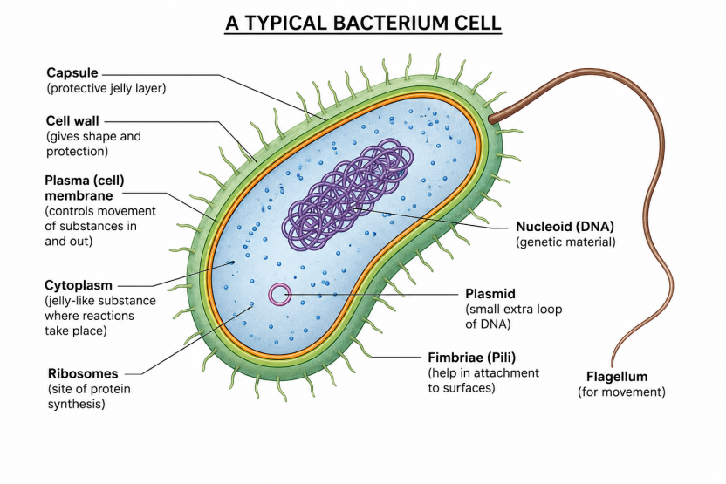
- Diagram (6 Marks):

- Roles of Bacteria (4 Marks):
- Beneficial: Used in milk fermentation (yogurt/cheese making); Act as decomposers in ecosystems; Used in sewage treatment; Nitrogen fixation in soil.
- Harmful: Cause food spoilage; Cause dangerous diseases in plants and animals.
- Disease (1 Mark): Cholera, Typhoid, Tuberculosis (TB), or Tetanus.
Total = 10 marks

- (a) Characteristics of Protoctista (4.5 Marks):
- They are eukaryotic organisms
- Most are unicellular, though some (like large algae) are multicellular.
- They live mostly in moist or aquatic environments.
(b) Examples (2 Marks): Amoeba, Paramecium, Euglena, or Algae/Plasmodium.
(c) Taxonomic Ranks (3.5 Marks):
- Kingdom
- Phylum (or Division for plants)
- Class
- Order
- Family
- Genus
- Species
Total = 10 marks

SECTION C: 15 MARKS

- Identification (1 Mark): Virus / Viral agent. (1 Mark)
- Living vs Non-living features (4 Marks):
Non-living: It lacks cellular structures (organelles, cytoplasm); It cannot carry out metabolic processes or respiration on its own; It can be crystallised. Living: It possesses genetic material (DNA or RNA); It can replicate/reproduce when inside a living host cell.
- Binomial Nomenclature Rules (4 Marks):
- The organism is given two names: the Genus name followed by the Species name.
- The Genus name must always start with a capital letter, while the species name starts with a small letter.
- When printed or typed, the scientific name must be written in italics.
- When handwritten, the Genus and Species names must be underlined separately.
- Safety Reasons (6 Marks):
- Risk of Infection: Unknown pathogens can easily enter the body through cuts, inhalation, or accidental ingestion, causing severe illness or death.
- Contamination of the Environment: Handling specimens without protection can release dangerous microbes into the air or onto laboratory counters, endangering other students.
- Lack of Immediate Treatment: Since the micro-organism is unknown, if an accidental infection occurs, there may be no immediate cure, antidote, or vaccine available in the school clinic.
Total = 15 marks

