THE PRESIDENT’S OFFICE- RALG
LONGIDO DISTRICT PRE REGIONAL MOCK 2021
FORM ONE
BIOLOGY
033
TIME: 2:30 HRS
Instruction
- This paper consist of two section A and B
- Answer all the questions in both section
- All writing should be in black or blue pen except for diagram must be drown in pencil
- Cellular phone and any unauthorized material are not allowed in Examination Room
- Write your NAME on every page of your answer sheet provided
SECTION A
Answer all the questions
- Question (i-x) is multiple choice items. Write the correct letter of the answer in each case
- Which the following will be a sequence to follow in the scientific procedure after formulation of hypothesis?
- Observation
- Problem setting
- Experimentation
- Conclusion
- Modern chemical container carry special chemical warning sign which are
- Explosive, Toxic and Cohesive
- Explosive, Additive and Toxic
- Explosive, oxidizing agent and Toxic
- Flammable, Explosive and concentrated
- Which of following is the correct definition of the word Biology
- A study of living things
- Study of plant and Animal
- Scientific study of life and living things
- All the above
- First aid is given to
- A victim of an accident
- A victim after visiting doctor
- Anyone who wants it
- Patients in the hospital
- In the microscope the eyepiece reads x10 and objective lens reads x40 the total magnification is
- 400 times
- 200 times
- 300 times
- 40 times
- Tila quickly removed his hand up touching a hot metal cup. In that case Tila exhibited
- Response
- Irritability
- Fairness
- Irresponsibility
- Incinerator is the best method for burning
- Organic waste
- Non organic state
- Gaseous waste
- All type of waste
- Are condition or factors that can change or be changed in an experiment
- Hypothesis
- Variables
- Problems
- Conclusion
- Which the following is Not the contribution of biology in the field of forestry
- Fast manufacturing plant
- Increase desertification
- Varieties of plant that do well in arid areas
- Solution to plant disease and pest
- In biology human being, lizard and Fish belong to the following brach of biology
- Mycology
- Virology
- Zoology
- Botany
i | ii | iii | iv | v | vi | vii | viii | ix | X

- In each the following statement write TRUE if the statement is correct and FALSE if the statement is not correct
- Scientific use the beam balance to measure volume______________________
- The word BIOLOGY comes from the Greek words, Bios and Logos _________________
- A hypothesis is an idea or explanation that is proposed as an answer to observe the problems _______________________
- Using Microscope , Biologist have been able to observe small organism _____________
- We use clean water salt and sugar to make a rehydration drink for the person who as vomiting _____________________________
i | ii | iii | iv | v
- Match the function of the part of the microscope in List A with their corresponding parts of microscope in LIST B by writing the letter of the correct response beside the item number of the answer sheet provided
LIST A | LIST B
- Allow the light to pass from the objective lens to the eyepiece  - Support the eyepiece, revolve nose piece  - Rise and lower the body tube in order to bring the sharp image in focus  - Rises or lower body tube in order to bring the image in focus  - Rises and lower the stage to keep the spacemen in right position for observation | - Body tube  - Course adjustment knob  - Diaphragm  - Fine adjustment knob  - Huge screw  - Mirror  - Ocular tube  - Stage clip

LIST A | i | ii | iii | iv | v
LIST B

SECTION B
Answer all questions
- (a) What is laboratory
___________________________________________________________________________________________________________________________________________________________________________
(b) According to the laboratory rules, what should do in the following situation?
- While boiling some water you realize that you need to go and get book from the class room ______________________________________________________________________
- You have finished the experiment of biology for the day _______________________________________________________________________
- Your partner is bitten by a mouse during the activity ________________________________________________________________________
- You need to perform experiment but there is no body in Laboratory ________________________________________________________________________
- (a) What is first aid ____________________________________________________________________________________________________________________________________________________________
(b) List four (4) component of the first aid
- ________________________________________________________________
- ________________________________________________________________
- ________________________________________________________________
- ________________________________________________________________
(c) State the procedure of giving first aide to a person who has been bitten by snake
- (a)Outline four (4) qualities of good laboratory
- ______________________________________________________________
- ______________________________________________________________
- ______________________________________________________________
- ______________________________________________________________
(b) Mention functions of the following apparatus
- Dropper ________________________________________________________
- Mortar and pestle ________________________________________________
- Crucible ________________________________________________________
- Sweep net ______________________________________________________
- (a)Define the term Biology and Biologist
____________________________________________________________________________________________________________________________________________________________
(b) List down four importance of studying biology
- ________________________________________________________________________
- ________________________________________________________________________
- ________________________________________________________________________
- ________________________________________________________________________

- Study the diagram below and Answer the questions that follows.
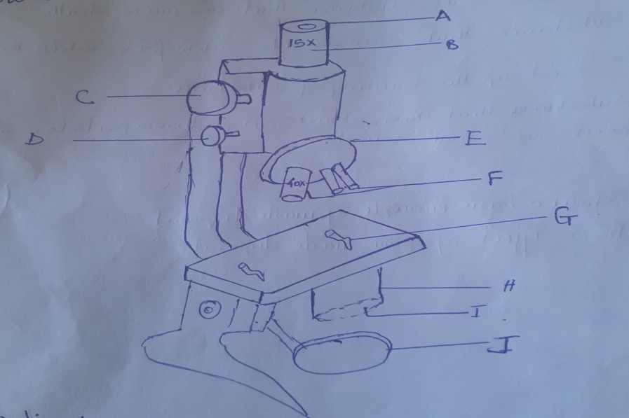
- Identify the parts labeled A-J
- If magnification is part B is 15x and F is 40x what would be total magnification of an object
- (a) What is warning sign
(b) In Biology Laboratory there are different warning sign. Draw warning sign which used to show
- Poisonous substance that can cause death
- Substance that can easily catch fire when brought near flame
- Speed the burning of substance
- Substance can bust throw particles with very high speed spread and high sound
- (a) list down basic principle of waste disposal
(b) Mention effect of poor waste disposal

