MKALAMA DISTRICT COUNCIL
FORM ONE TERMINAL EXAMS MAY 2025
BIOLOGY MARKING SCHEME
SECTION A :15 MARKS
1
i | ii | iii | iv | v | vi | vii | viii | ix | x
B | B | D | C | B | D | D | D | C | B
1marks @10 marks
2.
i | ii | iii | iv | v
E | B | F | A | C
1 Mark@ 6marks
3.i Observation
ii.Hypothesis iii.Expermentation iv.Analysis and data interpretation
v. conclusion
02marks @ 10 marks
4.(a)Prokaryotic cell – is a type of cell in which the nuclear materials are not bound with a membrane while eukaryotic cell is a type of cell whose organelles are enclosed in a membrane 05 Marks
(b) Organ a different tissue that work together to perform a certain function while Tissue is a group of cells that perform the same function 05 marks

5.(a)i) Mycology is study of fungi ii)Parasitology Is study of parasites 02@=4marks
(b) Zoology_is the study of animals 02@=6marks
Botany is the study of plants
Microbiology is the study of microbes
6 i) Guard cell -They control the opening and closing of stomata. ii)Palisade cell_-they contain chlorophyll which traps sunlight energy during photosynthesis.
iii)Root hair cells -absorb water and minerals from the soil
10marks
7(i)scoop nets ii)sweep nets iii)quadrant iv)mortar and pestle (v)Hand lens
02@ =10 marks
8.
Instruments | S I Unit
i. Stopwatch | Second
ii.Weighing balance or weighing scale | Kilogram
iii.Thermometer | Kelvin
iv.Tape measure or Ruler | Metre
2marks@=8 marks
9. Any five (5) importance of studying biology 2@=10 Marks

10.(a) >Nucleus
>Cytoplasm
>Mitochondria
>Cell membrane
Any 2 points 1.5 marks@=03 marks

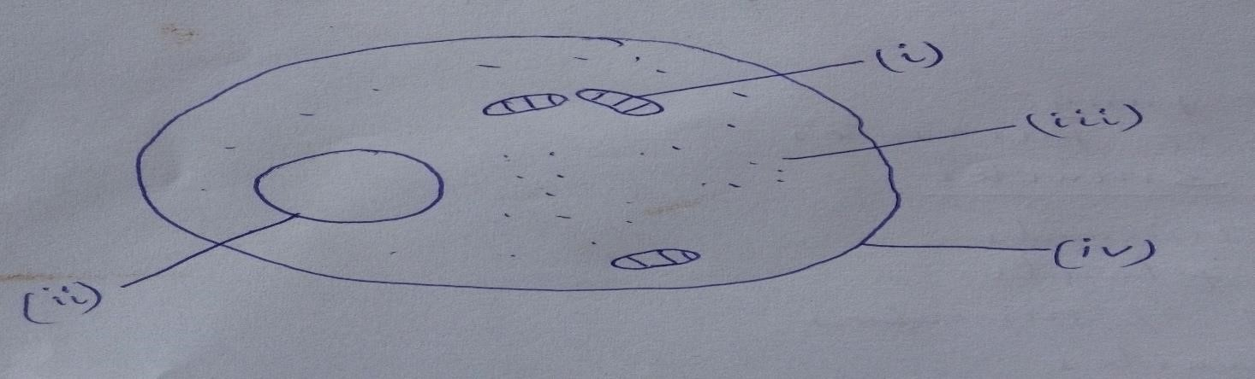
Diagram 04 Marks
Parts 2@=8 Marks

