PRESIDENT’S OFFICE
REGIONAL ADMINISTRATION AND LOCAL GOVERNMENT
ARUSHA REGION TERMINAL EXAMINATIONS
FORM THREE LITERATURE IN ENGLISH 2020
CODE: 024. TIME: 3HRS
INSTRUCTIONS:
- This paper consists of section A, B and C.
- Answer questions as instructed
SECTION A: (15 MARKS)
Theories of Literature.
Answer any two questions from this section.
- For each of the item (i-x)choose the correct answer from among the given alternatives and write its letter beside the item number in the answer sheet provided;
- is a process of choosing characters artistically and give them some roles to perform in a literary work
- Stock character
- Antagonist character
- Character
- Characterization
- Protagonist character
- ------------is the figure of speech that involves the use of something which stands for another,
- Symbolism
- Symbol
- Imagery
- Imagination
- Personification

- “Sepetu is an angel”Jocate said. Which stylistic device did Jocate employed?
- Metaphor
- Simile
- Personification
- Litotes
- Act
- If you read a play and become sad, what type of drama would you have read?
- Melodrama
- Soliloquy
- Tragedy
- Paradox
- Play
- What technique will you use when you want to refer to a literary work from history of an important person for more clarification?
- Satire
- Coincidence
- Flashback
- Straight forward
- Coincidence
- The privilege of a poet or poetess to break grammatical rules is
- Poetic license
- Poetic drama
- Poetic anaphora
- Poetic diction
- Poetic devices
- An act of practicing in preparation for a public performance whether a concert,play or speech is called
- Drama
- Stage
- Novel
- Rehearsal
- Plot

- The following are the genres of literature except
- Play
- Plot
- Novel
- Poetry
- A question asked in order to create dramatic effect.
- Irony
- Hyperbole
- Rhetorical question
- Euphemism
- Rhetorical criticism
- The creativity of composing the work of literature and skillful use of language
- Content
- Form
- Art
- Techniques
- Theme

- Match the item in column A with those in Column B to make the meaningful sentences by writing the letter of the correct response below the corresponding item in the table provided,

 | LIST A |  | LIST B
I | The most intense point in a plot | A | myth
II | The short and well known sentences for imparting moral lesson | B | Folk tale
III | Parents narrate stories to their children and they are passed over generations. | C | legend
IV | Stories about famous events or people | D | Resolution
V | Explains early history of people | E | proverb

SECTION B (40 MARKS)
- Briefly explain the differences between the following literary terms;
- Sarcasm and satire
- Novel and novella
- Plot and style
- Imagery and symbolism
- Fiction and non-fiction
- With examples differentiate the following literary terms
- Sarcasm and satire
- Poet and persona
- Linking and paradox
- Soliloquy and mime
- Prologue and aside
- Which literary term is being described by each of the following characteristics?
(a.) You and your friends were watching a performance. At the end of the performance you ended up laughing and became very happy.
(b). Last week our grandfather told us a short story about a here and hyena. He told us the story teaches that we should not be greedy.
(c). Regina is the tallest girl in the class but our class teacher calls her the dwarf one.
(d). Ngasa is hyena
(e.) Turning point of narrative work like novels
- Write short notes on the following literary concepts
a) Elegy
b) Sonnet
c) Lyric poem
d) Tragedy drama
e) Literary criticism

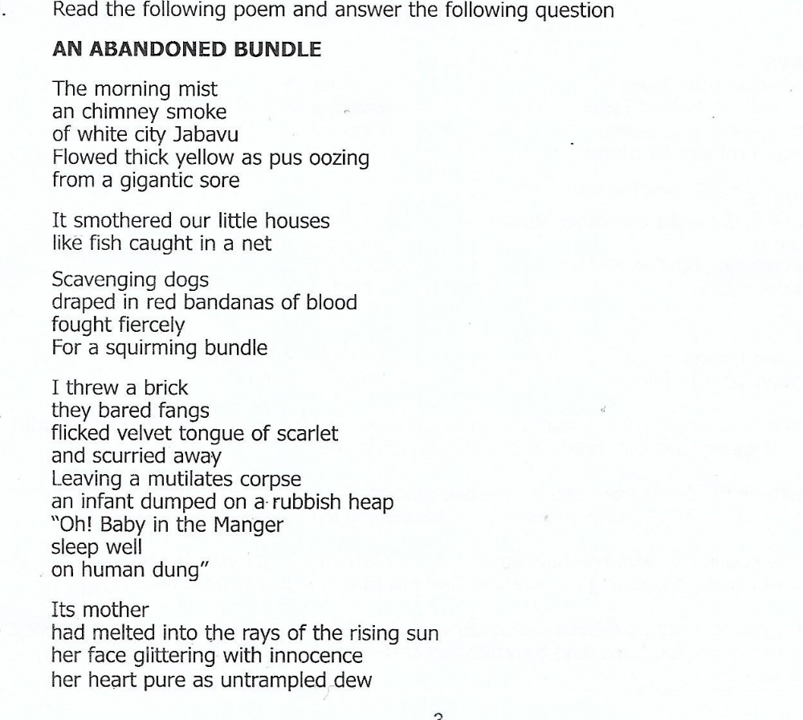

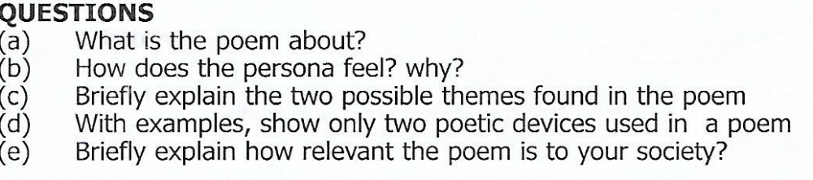

SECTION C (45 MARKS)
Answer three questions from this section
Answer question no 7 and

LIST OF READINGS
PLAYS
The Lion and the Jewel - Soyinka, W.
The Trials of Brother Jero - Soyinka, W.
The Dilemma of a Ghost - Aidoo, A.A.
The Government Inspector - Gogol, N.
NOVELS
A Walk in the Night and Other Stories - La Guma, A.
Houseboy - Oyono, F.
The Old Man and the Medal - Oyono, F
The Concubine - Amadi, E.
POETRY
Selected poetry - Institute of Education
Growing up with poetry -David Rubadil
- Literary works bring to light a variety of issues pertaining to the society. Since the issues are derived from the society, they are always relevant to the society. Discuss by referring to two poems of your choice.(give four points from each poem)
- Choose any two characters from the novel of your choice name them and show their positive contribution to the society (six points).
- Give three points from each of the two readings of your choice to support the argument that”Tittles of the novels give views of what happens in our contemporary society.
- Conflicts are inevitable in our societies. Support this statement with six causes of conflicts from two plays of your choice.

