PRIME MINISTER’S OFFICE
REGIONAL ADMINISTRATION AND LOCAL GOVERNMENT ARUSHA REGION

FORM THREE TERMINAL EXAMINATION
CODE:061 COMMERCE
TIME: 3: 00 HRS 28th May, 2026 INSTRUCTIONS
- This paper consists three sections; A, B and C with a total of eleven (11) questions.
- Answer all questions in sections A and B and two (2) questions from section C.
- Write your Full name on every page of your answer sheet provided.
- All drawings must be in pencil only and must be neat.

SECTION A (16 Marks)
Answer all questions in this section
1. For each of the following items (i) - (x) choose the correct answer from among the given alternatives and writes its letter beside the item number in the answer booklet provided.
- Mr. Dennis is a large scale local rice producer who invested a capital of shs. 250 million in production. The name of the reward he deserve is:-
  - Large scale retailer D. Interest
  - Small scale retailer E. Wholesaler
  - Profit
- Maulid bought 100 units of a certain commodity from carline and Co. ltd. The gross price is shs. 100 per item and trade discount allowed is 20%. If he settle the debts within 30 days he will be allowed a cash discount of 4% he intend to pay immediately. How much should he pay?
  - Sh. 5000 D. Sh. 8940
  - Sh. 3950 E. Sh. 7680
  - Sh. 4500
- A business man wants to find out the opinion, views, likes and dislikes of the customers for a particular product is likely to use which method?
  - Advertising D. Market promotion
  - Communication E. Market research
  - Sales promotion
- Mr. Ben is an income earner who receives Tsh 100,000 per month and pays 6% of his income as an income tax, on the other side Khamis is an income earner who received Tsh 150,000 per month and pay 5% of his income .What is the tax system applied?
  - Progressive tax system D. Direct tax system
  - Regressive tax system E. Indirect tax system
  - Proportional tax system
- Suppose you are working in a bonded warehouse and one of the customer’s needs to collect his car from the warehouse. Which tax would you require the customer to pay before releasing the car.

- Mark wants to deliver his products to his customers on door to door basis. Suggest the
A.

Property tax

B.

Customer’s duty

C.

Customs duty

D.

Exe
rcise duty

E.

Value added tax

suitable mode of transport he must use.

A.

Railway transport

B.

Sea transport

C.

Water transport

D.

Air transp
ort

E.

Road transport

)
vii
(

If you are going in the supermarket and hypermarket which feature may look alike:
-

A.

Size of the area

B.

Items bavailable

C.

Offer of transport for bulk buying customer

D.

Provision of purchasing facilities

E.

Self
-
service

)
(
viii

Discouraging imports so as to serve the country against the negative effects of
international trade can be attained by the use of;

A.

Remove quota system

B.

Imposing high tariffs on imports

C.

Remove total ban

D.

Encourage free trade

E.

High tax

on domestic product

ix
)
(

Which type of bank account would you recommend to a lower income earner?

A.

Current account

B.

Fixed deposit account

C.

Deposit and Current
account

D.

Saving account

E.

Exchequer account

(
x
)

Mr.
kalumanzila is an entrepreneur who owns a retail shop at city Centre where there are
so many retail shop. He succeeded in his business because he believes in himself and his
ability to achieve the goals set. We can simply explain him as:
-

A.

Hard working

B.

Goal setter

C.

Long
-
term
commitment person

D.

He is confident

E.

Innovator

Page 2 of 4

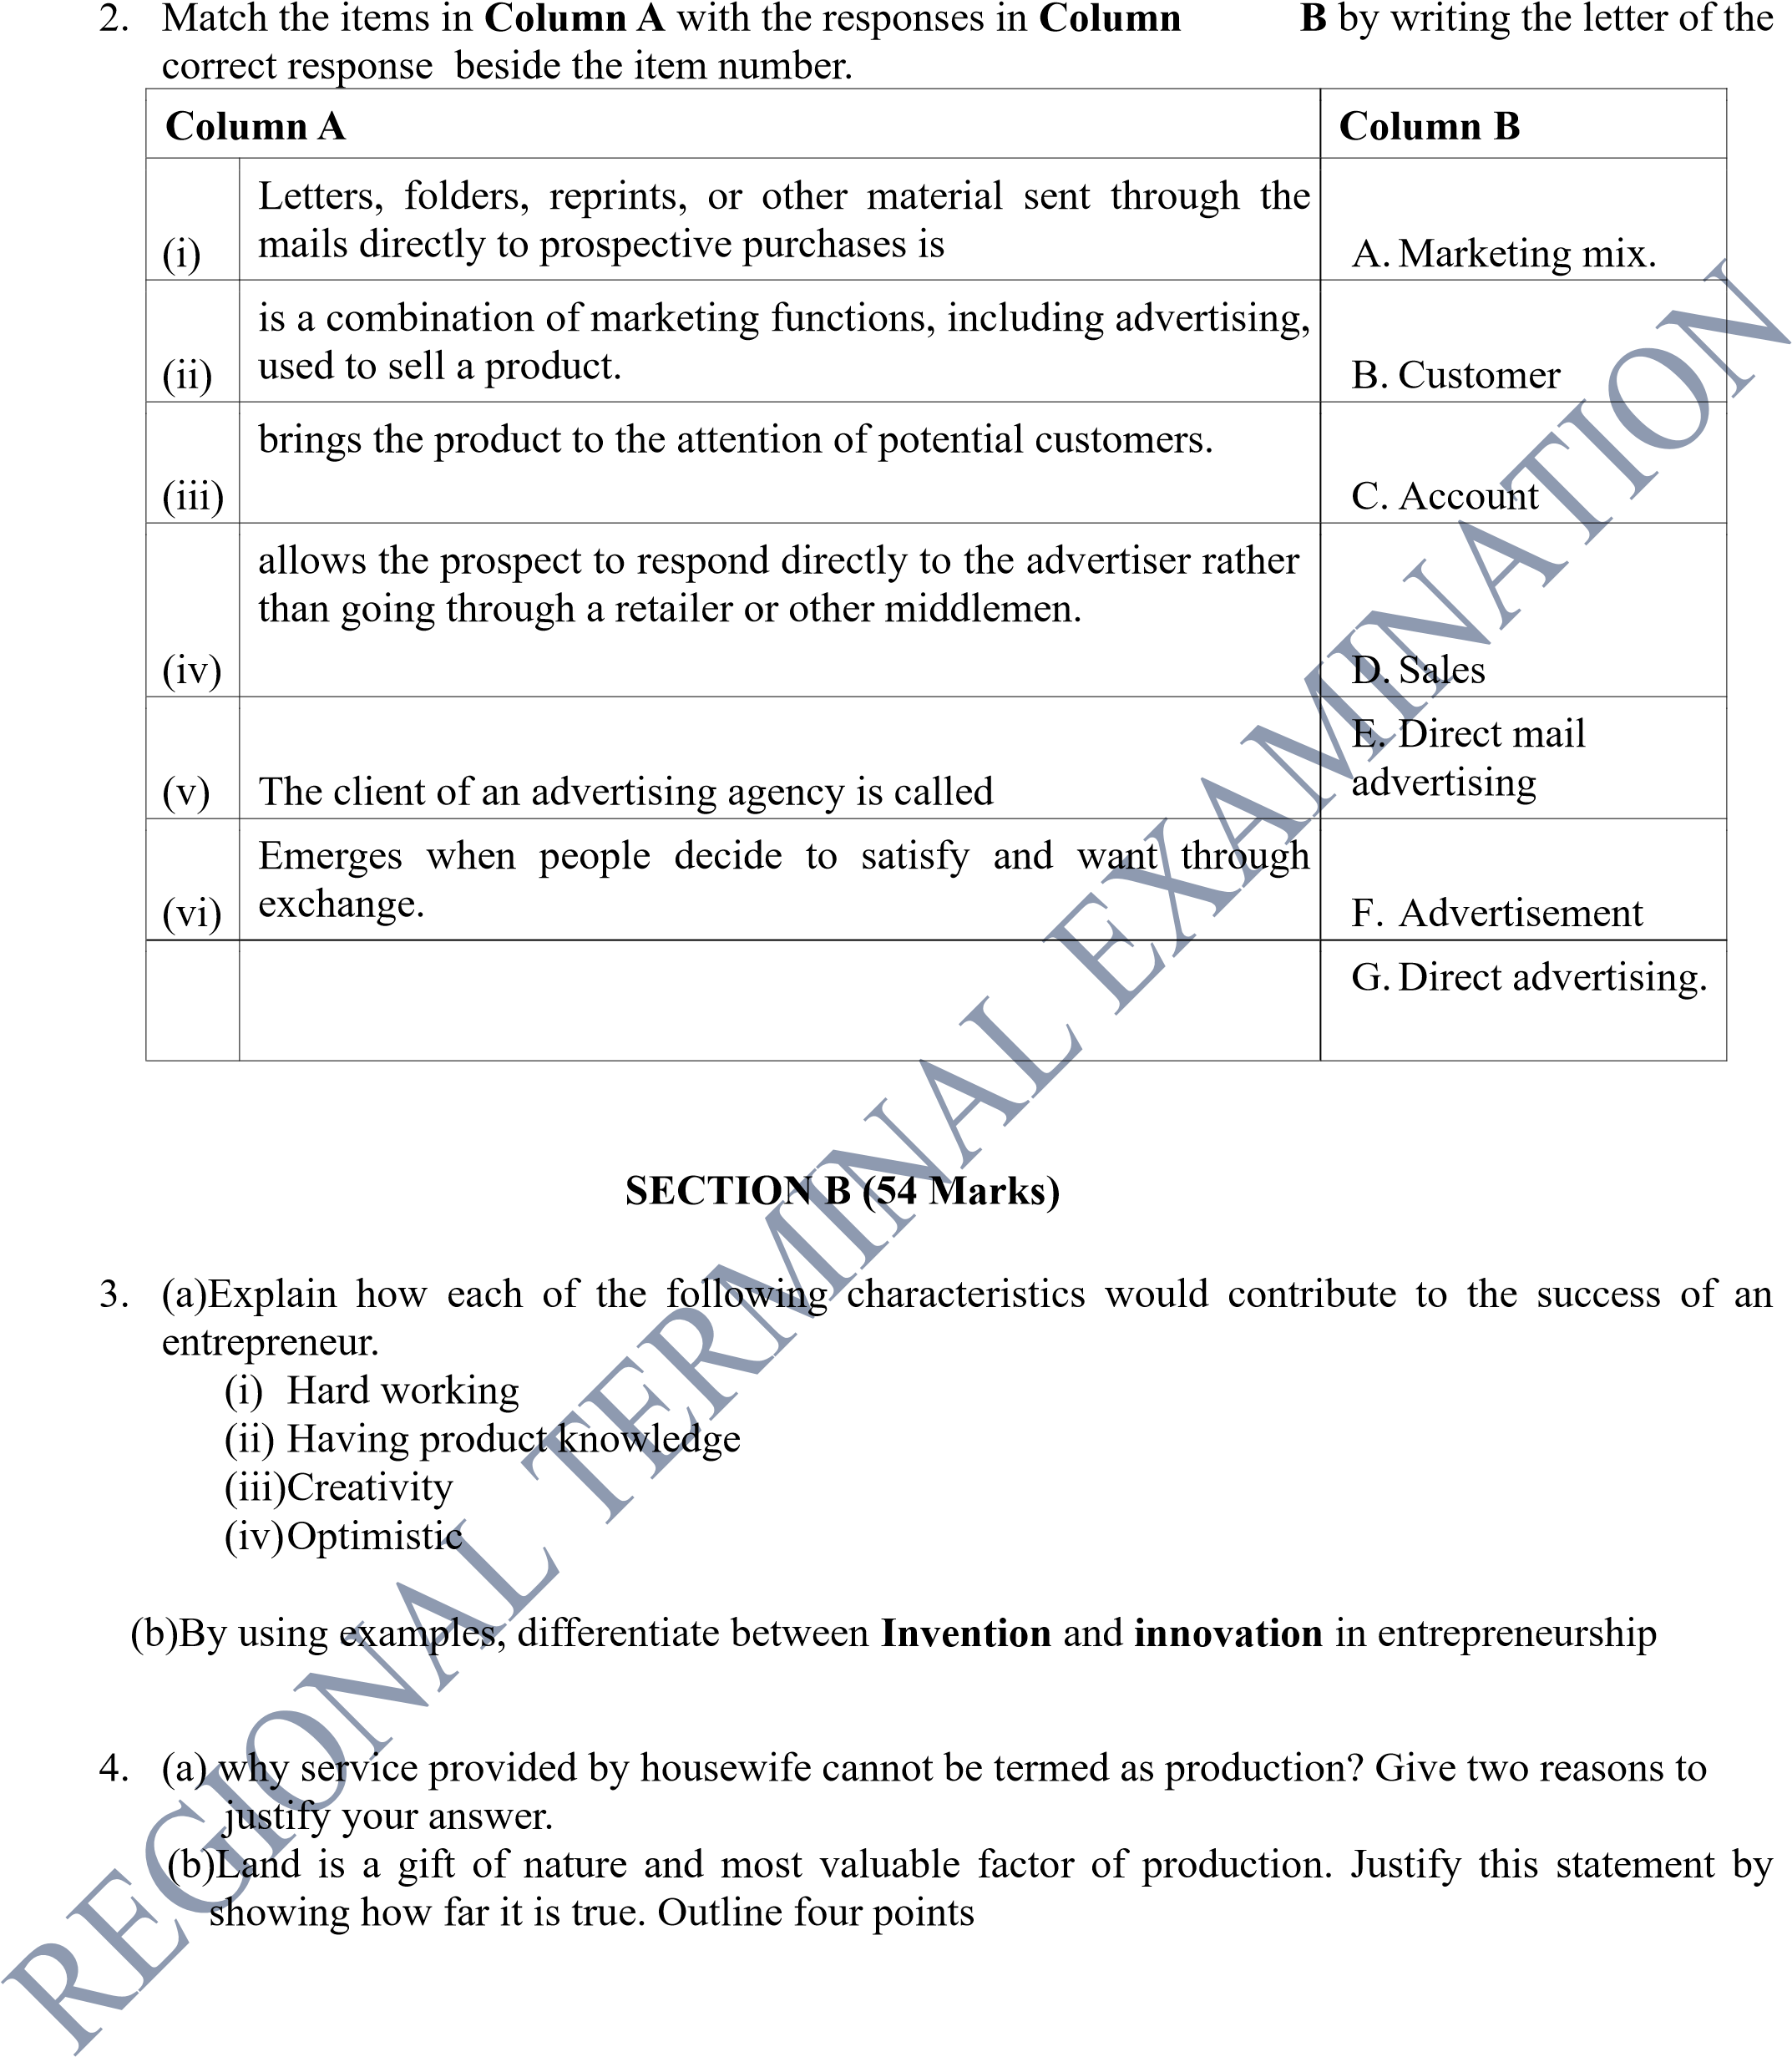5. Technology becomes more and more a part of our lives, there are seemingly even increasing methods of communication instantaneously with friends, family, business partners and strangers around the world.
(a)Describe three ways through which the internet has revolutionized business communication
in Tanzania.

(b) By using examples, explain other three electronic means of communication apart from internet.

Page 3 of 4

- At different points of times, traders are required to move goods from one place to another, i.e from their suppliers’ premises to their business premises. Always, they have to make sure that goods should reach the destination point safely, and this depends much on their decision about the mode of transport to adopt. Clearly elaborate five (05) factors that determines the effectiveness of transport.

- Is anything which is generally accepted by any society to be used as a medium of exchange and means of paying debts, “It is basic feature is acceptability” Explain any other six (6)qualities of good money.

8.

As a proprietor of a newly established business consultancy firm, you have been approached by
a client who is seeking assistance on how to improve their sales volume and market share. Present
five ways in

which your client can achieve their objective

SECTION C (30 marks)

Answer two questions from this section

9.

Mrs.Kashinde is a retail trader who believes that business location and capital are the basic
qualities for a successful retailer. Prove that Mr
s.kashinde’s belief is wrong by providing six
justifiable qualifications of the successful retailers.

10.

One of the form four students argue that “Business is most likely to collapse in future if there is
no good business communication” Support this argument by analyzing six roles of business
communication

11.

Mr Mwakalobo is the businessman and has a current
account at CRDB bank and is allowed to
operate this account through e
-
banking, explain the benefits that he will enjoy by using this
service.

Page 4 of 4

