THE PRESIDENT’S OFFICE
REGIONAL ADMINISTRATION AND LOCAL GOVERNMENT
FORM TWO JOINT EXAMINATION FOR GOVERNMENT SCHOOLS – JEGOS


PRE-MOCK EXAMINATION
031 PHYSICS
MARKING SCHEME 2024

SECTION A

C | C | B | B | B | B | B | C | D | B
- arks@ = total 10 marks

G | F | H | D | E
01marks @ =total 05 marks

SECTION B
- (a) Momentum is conserved. The lump of plasticine increases the mass of the trolley, but has no momentum in the direction of the trolley. The momentum mv, remains constant, and since mass has increased the velocity reduces. 04 marks
- By illustration
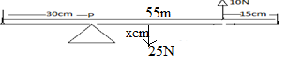
From
Sum of clockwise moment = sum of anticlockwise moment …………. 02 marks
$25N×xcm=10N×55cm$ …………………………………………. 02 marks
$25x=550$
$x=22cm$
Therefore the centre of gravity is 22cm from the pivot …………… 02 marks

- (a) Since speed is how fast something moves, may be the same at different points but the velocity will be different in those points because of different directions. 04 marks
- Data given
Mass of first body = 8kg
Mass of second body = 4kg
Initial velocity of the first body = 20m/s
Initial velocity of second body = -10m/s
Final velocity of first body = 15m/s
From
Total momentum before collision = total momentum after collision …. 01 marks
$m_{1}u_{1}+ m_{2}u_{2}= m_{1}v_{1}+m_{2}v_{2}$ …………………………………... 01 marks
$8×20+4×\left(-10\right)=8×15+4×v$ ………………………………. 01 marks
$160-40=120+v$
$120=120+v$ ……………………………………………………… 01 marks
Collect like terms
V = 120 – 120 = 0m/s ……………………………………………… 01 marks
Therefore, the velocity of 4kg body after collision is 0m/s ………… 01 marks

- (a) The electroscope is positively charged. Initially, the negative charge on the rod repels negative charges to the leaf causing the leaf to collapse. When brought very close to the cap, more negative charges move to the leaf causing divergence since the rod has a greater charge. 04 marks
- Data given
Side of cube (s) = 5cm
Mass of cube (m) = 306g
Density of glass = 2.55g/cm³
From
Volume of cube = $s^{3}=5^{3}{cm}^{3}=125{cm}^{3}$ …………………………..… 02 marks
Then
$density= \frac{mass}{volume}$ ………………………… …………………….. 01 marks
$volume= \frac{mass}{density}$
$volume= \frac{306}{2.55}=120{cm}^{3}$ ………………………..…………………. 01 marks
$volume of cavity=125-120=5{cm}^{3}$ …………………………… 01 marks
$therefore the volume of cavity=5{cm}^{3}$ …………..……………… 01 marks

- (a) The vibrations stop because energy is used in overcoming air resistance; also The vibrations stop because energy is used in overcoming forces opposing relative motion of the parts of the spring. 03 marks

- Data given
Mass of hydrometer (m) = 27g
Height of stem (h) = 4cm
Cross-sectional area (A) = 0.75${cm}^{2}$
From
Total volume = volume of bulb +volume of steam ………………01 marks
Total volume = $Ah+\frac{m}{ρ}$
$V_{T}=0.75×4+\frac{27}{1}$ …………………………………………… 01 marks
$V_{T}=3+27=30{cm}^{3}$
Therefore total volume = $30{cm}^{3}$ …………………………… 01 marks
- From
$density= \frac{mass}{volume}$
$density= \frac{27}{30}=\frac{0.9g}{{cm}^{3}}$ ………………………………………… 01 marks
$RD=\frac{density of liquid}{density of water}$ ………………………………………… 01 marks
$RD=\frac{0.9g/{cm}^{3}}{1g/{cm}^{3}}=0.9$ ……………………………………… 01 marks
$therefore, the relative density of liquid=0.9$ ………… 01 marks

- (a) This is because cannot be focused onto a screen; the rays only appear to originate from a common point behind the mirror. 04 marks
    - Centre of gravity of irregular object can be determined by using plumbline method
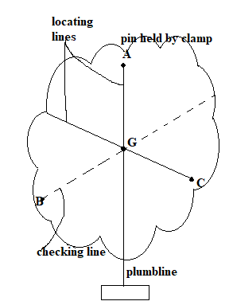
Steps
- Make three small holes at well-spaced intervals round the edge of the card
- Put a stout pin through one of the holes and held firmly by a clamp and stands so that the card can swing freely on it.
- The card will come to rest with its centre of gravity G vertically below point of support
- The vertical line through the support will be located by means of a plumbline.
- Thus, When a body is freely suspended by a string and is at rest the force of gravity on acting vertically downwards, is balanced by an equal and opposite force or tension in the string 06 marks
- (a) So as to use less effort since the angle of incline will be smaller hence it is easier to go up the hill 04 marks
    - Data given
Number of gallon = 200gallon
Density of soup = 1.15g/cm³
Mass of tins = 400g
Number of tins = ?
From
Volume = $πr^{2}h$ …………………………………………………… 01 marks
Volume = $π×{0.6}^{2}×0.67=0.757368m^{3}$ ………………………….… 01 marks
Then
Mass of soup = density $×volume$ = 1150$×0.757368=870.9732kg$ .. 01 marks
But
Number of tins = $\frac{mass of soup}{mass of tins}$ …………………………………… 01 marks
Number of tins = $\frac{870.9732}{0.4}$ = 2177.433 ………………………….... 01 marks
Therefore, the number of tins that can be filled with soup = 2177 …. 01 marks
- (a) Bulbs connected in parallel are brighter because the total resistance decrease, but in series the total resistance increase. 04 marks
    - (i) velocity-time graph of the motion
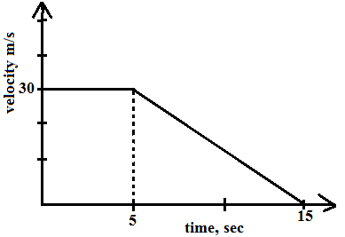
Diagram 03 marks
      - Total distance travelled, s = ? From: S = Ta ……….….. 01 marks
S = (30 x 5) + (30 x 10)/2 S = 150 + 300/2 ……………………….. 01 marks
S = 150 + 150
S = 300 m …………………………………………………….. 01 marks

SECTION C
- (a) Consider the figure below

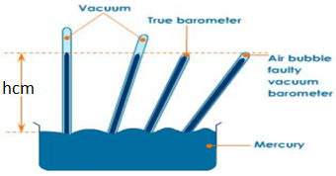
Diagram 02 marks
Procedures
- Take a 1m tube full of mercury and insert it upside down into a container containing mercury as seen above (01mark)
- Indicate the level of mercury reached when the tube is upright (hcm). 01 marks
- Tilt the tube until its top end is in the level of mercury (hcm) when the tube is upright
(01 mark)
Observation
- If the tube is completely filled with mercury, then the empty space is vacuum.
(01mark)
- If the empty space could still exist on top of the tube, then the empty space is not vacuum and hence the simple barometer could be regarded as being not accurate because could give wrong values of atmospheric pressure of a place. (01 marks)

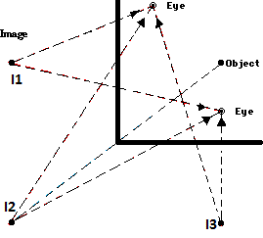
Diagram and labeling 04 marks
From
Number of image = $\frac{360}{∅}-1$ ……………………………………….. 01 marks
$number of image= \frac{360}{90}-1$ ………………………….....……… 01 marks
$n=4-1=3$ …………………………………………………… 01 marks
Therefore, number of image will be 3 image ……………………01 marks

