THE PRESIDENT’S OFFICE
REGINAL ADMINISTRATION AND LOCAL GOVERNMENT
ITILIMA DISTRICT COUNCIL
FORM TWO MOCK EXAMINATION: AUGUST 2020
031 PHYSICS
Time: 2:30 hrs Friday 7th August, 2020 am
Instructions
- This paper consist of two section A and B
- Answer all questions in both sections
- Write your examination number on each page of your answer sheet

SECTION A: 30 MARKS
- For each of the items (i)-(x) choose the correct answer from the given alternatives and write its letter beside the item numbers
- Archimedes’ principle deal with:
A. floating a body B. Motion of a body C. Sinking of a body D. real weight of a body
- A wheel barrow is a ____ class lever.
A. First B. Third C. Fourth D. Second
- Which instrument is used to measure the potential difference________
G
V
A

- B. C.
D.

- F=M$\left(\frac{∆v}{t}\right)$. This is:
A. the Newton’s 2nd law of motion B.The Newton’s 3rd law of motion C. Law of inertia D. change of momentum
- The number of images formed by multiple mirrors ______ on _______ the angle between mirrors.
A. Increase, decreasing B. Decrease , decreasing C. Increase, increasing D. decrease, increasing
- The following is not example of force.
A, Torsional B. repulsion C. Newton’s D. Gravity
- The capacitance total across TP is T P
2$μF 4μF 5μF$
A.0.95 $μF$ B. 1.05$μF$ C. 1.05$μF$ D. 1.59$μF$
- A vernier caliper is used to measure
A. distance of a car B. Distance of wire C. Diameter of a wire D. Volume of water
- Which one is strongly magnetized when placed in magnetic field.
A. Aluminum B. Lead C. cobalt D. Zinc
- One of the following is not a safety rule in a physics laboratory
A. To follow instruction B. Handling apparatus C. to wear shoes with hard soles D. To sit on a stool

- Match each of the statements given in list B with appropriate words given in list A. Write its letter beside the item number
List A | List B
- Irregular and regular reflection of light  - Hydrometer  - Can be transformed  - Attraction occurs when  - Moment  - Gold leaf electroscope  - Unstable  - Three pulley  - Displacement | - NM  - Power  - Energy  - g/m³  - Kg/m³  - Measure of force  - Measure of P.D  - N-N  - N-S  - Ohms  - Capacitor  - Detect charges  - High center of gravity  - V.R=3  - Rate of change of distance in specific direction  - Reflection of light  - Low center of gravity

- Fill the space provide
- Mass, length and time………………………………..
- Water boils at 100$℃$ as………………………….
- Like pole repel and unlike pole attract each other.This refers to______
- Pressure in solid depends on_______________
- Attraction force between molecules of different substance is called______
SECTION B
ANSWER ALL QUESTIONS.
- (a) Define measurement
(b) Draw and label micrometer screw gauge
(c)What is the reading in the figure below
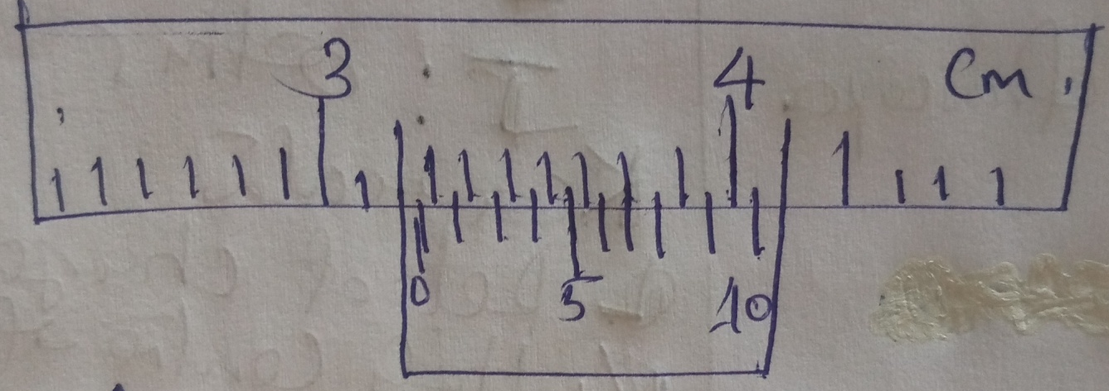

Main scale is _______cm
Vernier scale is______cm
Total reading is______cm
- (a)What is
- Load
- (ii) effort
(iii)Velocity ratio as applied in simple machine
(b) A hydraulic press has effort and load pistons with areas 0.02m² and 0.3m² respectively. A force of 550N is required to lift a car with a mass of 680kg. What is the efficiency of the press.
- (a) Distinguish between:
(i)Distance and displacement
(ii) Speed and velocity
(b) An object travelling at 10m/s accelerates at 4m/s² for 8s, calculate:
(i) Final velocity
(ii) How far does it travel for 8s
- (a) State the ohms law
(b) State the SI unit for:
(i) Voltage
(ii)Resistance
(iii) Current
(c)Below is an electric circuit with 3v supply

A

2 Ω

2 Ω
2 Ω
Calculate the current passing through the circuit
- (a)What is sustainable source of energy
(b) List five (5) sustainable source of energy
- (a)What is
(i)Center of gravity
(ii) Centre of mass
(b) State two factors that affect the stability of a body
(c) Calculate the distance X in the diagram below

120cm x

20g
2
50g

- (a) What is capacitance
(b) Determine the effective capacitance of the capacitor below

3V

0.3µ

0.6µ

(c) What is the value of the charges stored?

