PRESIDENT’S OFFICE REGIONAL ADMINISTRATION AND LOCAL GOVERNMENT
KASULU TOWN COUNCIL
FORM TWO DISTRICT MOCK EXAMINATION 2019
PHYSICS
CODE: 031 TIME 2.30HRS
INSTRUCTIONS
- This paper consists of sections A, B and C
- Answer all questions in each section
- Write your examination number at the top right corner of every page
- Show your work clearly
- All diagrams should be drawn in pencil
- Where necessary the following constants may be used:
- Acceleration due to gravity (g) = 10M/S²
- Density of water = 1g/cm³

SECTION A: 30 Marks
1. Write the letter of the most correct answer in the table below
- The study of matter in relation to energy is called ……………….
- Chemistry
- Physicists ( )
- Biology
- Physics
- The force which causes tear and wear between the machine parts is known as
- Friction
- Torsional
- Repulsive ( )
- Magnetic
- Ferry – boat floats in sea water because its density is ………………
- Greater than that of water
- Smaller than that of water ( )
- The same as its weight
- Greater than its weight
- Which of the following is not sustainable source of energy
- Sun
- Generator ( )
- Wind
- Sea water
- A temperature of 68⁰C is equivalent to
- 29F
- 45⁰E
- 154.4F ( )
- 90.4⁰C
- A beam balance is used to measure ………………….
- Weight
- Mass
- Heat
- Density

- Which of the following is not a form of energy
- Chemical
- Heat ( )
- Nuclear
- Joule
- The ability of the material to return to its original shape and size after being stretched is called
- Plasticity
- Plastic deformation ( )
- Elastic deformation
- Elasticity
- An instrument used to store electric charges is called
- Capacitance
- Capacitor
- Resistor ( )
- Inductor
- The point of support about which a bar or lever turns is referred to as
- Point
- Load arm
- Fulcrum ( )
- Pulley
- The state of balance of a body is known as
- Equilibrium
- Static equilibrium
- Dynamic equilibrium ( )
- Neutral equilibrium
- Water is unsuitable as thermometric liquid because it:-
- Boils at 80⁰C
- Freeze at -112⁰C
- Wets glass ( )
- Does not wet glass
- The energy which is obtained from hot rocks underground is known as
- Geothermal energy
- Solar energy ( )
- Water energy
- Wind energy
- Ability of a man to walk properly along a road is one of the application of
- Stable equilibrium
- Unstable equilibrium ( )
- Neutral equilibrium
- Neutral and stable equilibrium
- When a body of mass M is lifted through height “h” it possesses the energy known as
- Kinetic energy
- Chemical energy ( )
- Light energy
- Potential energy
- If the angle between two plane mirror is 60⁰C, then the number of images will be……………
- 2
- 3
- 4 ( )
- 5

- The presence of charge in a material can be demonstrated by
- Electrophorus
- Earth wire ( )
- Gold leaf
- Electroscope
- Figure 1 shows a ruler balanced by placing the loads at its ends. What is the weight X?
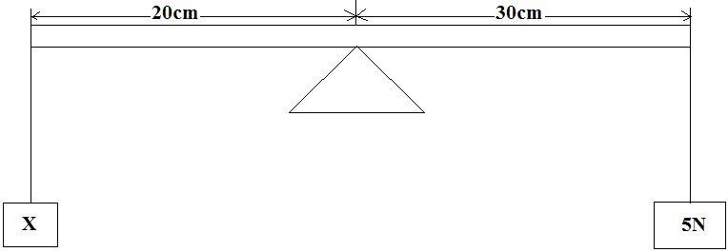
- 100N
- 7.5N ( )
- 200N
- 5N
- A hydrometer is an instrument used to measure
- The volume of liquids
- The density of liquids ( )
- The density of solids
- The volume of solids
- The following instruments are used to measure length except
- Hydrometer
- Meter rule ( )
- Micrometer screw gauge
- Vernier caliper

2. Match the item in List A with the correct response in List B by writing the correct response below the number of the corresponding item in List A in the table provided

LIST A | LIST B
- Constant speed  - A speed of 72km/h  - Force  - Displacement  - Acceleration  - Constant acceleration  - Deceleration  - Time  - Velocity  - Distance | - Mass x Acceleration  - 7200 m/s  - An interval between two events  - A slope of velocity – time events  - The rate of change of velocity is constant  - 20m/s  - Momentum  - An interval between two points measured in meters.  - Covers equal distance at equal time interval  - Distance by an object in a specific direction  - Negative acceleration  - Mass x velocity  - Displacement per unit time

Answers
LIST A | i | ii | iii | iv | v | vi | vii | viii | ix | x
LIST B

SECTION B: (50 MARKS)
Answer all questions in this section
3(i) Device for storing charges is called ………………..
(ii) The S.I unit of density is known as…………………….
(iii) Attractive force between the molecules of different substances is called ………………….
(iv) The tendency of an object to remain on the surface of the fluid due to the force exerted by the fluid is called ……………………
(v) The number of images (n) formed between mirrors placed at θ⁰C is given by formula n = …………………
4. (a) What do you understand by the following terms
(i) Work ……………………………………………………………………………………………………………………………………………………
………………………………………………………………………………………………………………………………………………………………….
(ii) Energy ………………………………………………………………………………………………………………………………………………….
………………………………………………………………………………………………………………………………………………………………….
(iii) Power …………………………………………………………………………………………………………………………………………………
………………………………………………………………………………………………………………………………………………………………….
(b) Calculate the power of pump which can lift 2000 kg of water through a vertical height of 6m in 10 seconds.
5. (a) Observe the following diagram and answer questions below
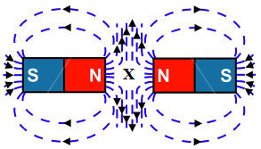

(i) Mention property of a magnetic shown
(ii) What does “X” represent……………
(iii) What is the meaning of “X”………………..
(b) Draw the diagram to show
(i) Regular reflection of light rays
(ii) Irregular reflection of light rays
6 (a) What do you understand by the following term
(i) Velocity …………………………………………………………………………………………………………………………………………….
………………………………………………………………………………………………………………………………………………………………….
(ii) Mechanical advantage ………………………………………………………………………………………………………………………
………………………………………………………………………………………………………………………………………………………………….
(iii) Efficiency of machine …………………………………………………………………………………………………………………………
………………………………………………………………………………………………………………………………………………………………….
(b) A box with weight of 1120N is pulled along an inclined plane of the length 40M and 10M high with a force of 140N. Calculate
(i) The mechanical advantage of the plane
(ii) The velocity ratio of the plane
(iii) The efficiency of the plane
7 (a) Define the following terms as applied in physics
(i) Real weight …………………………………………………………………………………………………………………………………………
………………………………………………………………………………………………………………………………………………………………….
(ii) Up thrust ……………………………………………………………………………………………………………………………………………
………………………………………………………………………………………………………………………………………………………………….
(b) (i) State Archimedes principle …………………………………………………………………………………………………………….
………………………………………………………………………………………………………………………………………………………………….
(ii) Why when a body is immersed in liquid its weight tends to be reduced?
(c)When an object is totally immersed in water its weight is recorded as 4N. If its weight in air is 5.1N. Calculate
(i) The relative density of an object
(ii) The density of an object

SECTION C (20 MARKS)
Answer all questions in this section
8 (a) Define pressure and state its SI unit

(b) Explain why it is easier to cut a piece of meat by using a sharp knife than a blunt knife?

(c)A rectangular box whose dimensions are 1.2M by 0.5M by 2M has a density of 25kg/m3. Calculate the maximum pressure which can be exerted when placed on a flat ground.

9 (a) State Newton’s laws of motion

(b) A body of a mass 32kg moving with a velocity of 40m/s collides with another body of mass 16kg moving with a velocity of 20m/s in the same direction. If the two bodies tends to stick together after the collision. Calculate the common velocity shared by two bodies.

