PRESIDENT’S OFFICE-RALG
LONGIDO DISTRICT EXAMINATION SYNDICATE
PHYSICS FORM TWO EXAMINTION AUGUST 2020
TIME: 2:30 HOURS
INSTRUCTIONS:
- This paper consists of section A, B and C
- Answer all questions in section A, B and two question in section c
- Show clearly your calculation step
- Calculator and cellular phone are not allowed in examination
- Write your examination number in every page of your answer sheet
- Where necessary the following constants may be used
- Acceleration due to gravity (g)=10m/s² or 10N/Kg
- Density of water = 1g/cm³ or 1000Kg/M³
SECTION A (30 MARKS)
- For each of the items i-xx choose the correct answer among the given alternatives and write its letter in the box provided
- Which instrument will you use to measure accurately the inside diameter of a bottle neck?
- Tape measure
- Micrometer screw gauge
- Metre rule
- Vernier callipers
- When a body of mass M is lifted through a height h, it possesses the energy known as
- Kinetic energy
- Chemical energy
- Light energy
- Potential energy
- If the angle between two plane mirrors is 60⁰ what will be the number of images?
- 2
- 3
- 4
- 5
- The process of removing magnetism from magnet is known as
- Polarization
- Demagnetization
- Magnetization
- Magnetizing
- The units of the basic physical quantities are
- Mass, Length, Time
- Newton, Metre, Time
- Kilogram, Metre and Second
- Second, Mass and Time
- Pond skaters and mosquito are able to walk on the surface of water because of the
- Up thrust
- Plasticity
- Surface tension
- Water Mass
- The force which cause tear and wear between machine parts is known as
- Friction
- Torsional
- Repulsive
- Magnetic
- From the Archimedes principle the up thrust acting on a body is equal to
- Apparent loss in weight
- Apparent weight
- Weight of a body in air
- Weight of a body in water
- Which of the following is a safety precaution in physics laboratory?
- Doing experiment in the laboratory
- Handling of apparatus in the laboratory
- Use equipment which are in the laboratory
- Do anything in the laboratory
- A hydrometer is an instrument used to measure
- The volume of liquid
- Density of liquid
- Relative density of liquid
- The volume of solid
- Why an atom is electrically neutral?
- It consists of equal number of elections
- It consists of equal number of Proton and Electron
- It consists of equal number of Electron and Neutron
- It consists of equal number of Proton and Neutron
- Measurement in physics is the process of
- Calculating and measuring
- Beam balancing
- Using a spring balance
- Assigning numbers to observation
- When charging body by rubbishing with either fur or silk the particles which are transferred are
- Proton and electron
- Proton
- Electron
- Nuclei
- An area under a velocity time graph represent
- Acceleration
- Distance covered
- Speed
- Velocity
- Path of light is always in a
- Bent path
- Straight line
- Convergent path
- Divergent path
- Apiece of metal of volume 0.23cm² and a mass of 0.72g has relative density of
- 3.0g/cm³
- 3.0kg/m³
- 0.3
- 3.0
- The figure 1 shows a ruler balanced by placing the loads at its end. What is the weight x?
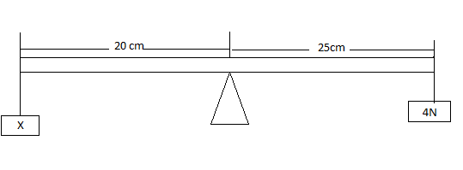
Figure 1
- 5N
- 0.5N
- 100N
- 200N
- Which of the following best illustrate Newton’s third law of motion?
- Inertia
- Rocket propulsion
- Momentum
- Circular motion
- The temperature of a body -40⁰c in kelvin (k) scales is
- 313k
- 233k
- 273k
- -40k
- When fire hazards from an electric fault erupts in a home
- Cut off all connecting wire
- Switch off the main switch
- Break the main switch
- Switch off the switch socket
- Match the item in LIST A with correct response in LIST B by writing a letter of a correct response below the corresponding item number in the table provided
LIST A | LIST B
- An instrument that used for magnifying very small objects  - An instrument that measure volume of liquid.  - An instrument used to demonstrate thermal expansion.  - An instrument that transfer specific amount of liquid from one container to another.  - An instrument used for holding experiment. | - Ball and ring apparatus  - Vernier caliper  - Flask  - Measuring cylinder  - Bar breaking apparatus  - Microscope  - pipette

LIST A | I | II | III | IV | V
LIST B
- Complete each of the following statement by writing the correct answer in the space provide
- Basic physical proportions of measurement which cannot be obtained from any other proportions by either multiplication or division are called…………
- Staircases winding roads uphill, wedges, screw are physical examples of……
- Resistance of a body to change its state of rest is called…………………
- Object which emit light when they are hot are called…………………………
- Materials which do not obey Hook`s law are known as…………………………
SECTION B (50Marks)
- Define the following terms and give their SI unit
- Work
- Energy
- Power
(b). A man lifts a load of 20kg through a height of 4M in 10seconds calculate
- Work done
- Power developed by a man
(C). A 1000kg car is travelling down the road at a speed of 15m/s how much kinetic energy does it have

- i. Briefly explain the motion of an object under gravity by taking an example of a ball thrown straight up into the air
ii. a car with velocity 60m/s is uniformly retarded and brought to the rest after 10seconds. Calculate its acceleration
(b)i. Distinguish between distance and displacement
ii. What mass will be given to a body with an acceleration of 7m/s² by a force of 3N
- (a)Define the following terms
- Magnetic material
- Magnetization
(b)State the law of polarity and illustrate this by using the large clear diagram
(c) i. state Pascal`s principle of pressure
ii. Calculate the area of the object if the pressure exerted is 0.2N/M² and its force is 2N
7. (a)Define electrostatics
(b)Draw the diagram of gold leaf electroscope and label the following parts
- Brass cap
- Insulator
- Earthed metal case
- Gold leaf
- Brass plate
- Brass road
(c)mention three ways of charging bodies
(d)Capacitors of 1mf, 4mf, and 2mf are connected in
- Series
- Parallel
- (a)State the principle of moment
(b) What does it mean by the “centre of gravity”
(c) A metre rule is pivoted about a point 0 as shown in the figure below and it is balanced by a load of 0.2N
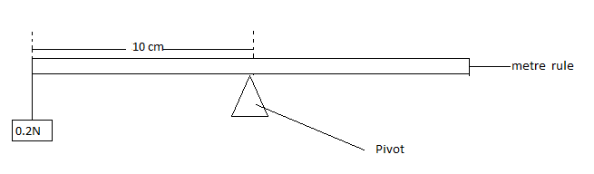

SECTION C (20marks)
9. (a)List down the factors affecting resistance of a conductor
(b)Study the diagram below and then answers the questions that follows

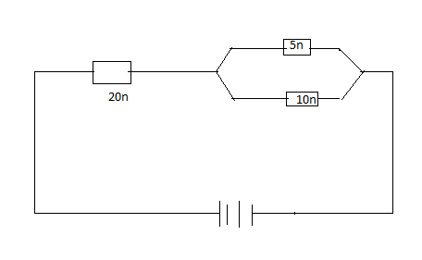

If the current flowing through 5Ω resistor is 2A. Calculate
- current flowing in 10Ω
- Potential difference (PD) across the 20Ω resistor
(c) In verification of ohm`s law the following circuit was used during experiment

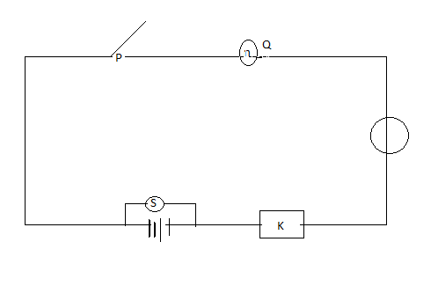
- P represent……………
- Q represent……………….
- S represent…………………...
- K represent………………..
- T represent……………………..
10. (a) Distinguish between speed and velocity
(b) what is acceleration
(c)A car starts from the rest and acceleration uniformly with a speed of 20m/s for 5seconds. It then maintain a constant speed for 20seconds and then breaks are applied and a car comes to rest in the next 5seconds sketch the velocity time graph to represent this motion and from the graph calculate
- Total distance covered
- Acceleration of a car
- Deceleration of a car
11. (a)State the law of floatation
(b) A body has mass of 120g and the volume of 100cm³ will the body sink or float?
(c)i. List two factors that pressure in liquid depend on
ii. Explain why elephant manage to walk comfortably in mad soil without sinking while human being may sink easily?
(d) Rectangular tank which measures 5m by 4m contains water to a height of 10m find
i. pressure at the base
ii. thrust on the base

