
THE PRESIDENT’S OFFICE
REGIONAL ADMINISTRATION AND LOCAL GOVERNMENT
ARUSHA CITY COUNCIL
FORM ONE MID-TERMEXAMINATION, SEPTEMBER 2019

GEOGRAPHY

INSTRUCTIONS: Time: 2 $\frac{1}{2}$Hours
- This paper consist of section A and B
- Answer ALL questions in both sections
- All writing must be in blue or black ink
- All answers should be written in the space given in this paper
SECTION A (70 Marks)
- Read the following statement carefully and write the letter of the correct answer in the space provided.
- Wind blows form

- Highlands to lowlands
- Low lands to highlands

- Low pressure areas to high pressure areas
- High pressure area to low pressure areas
- Identify the incorrect association in the following pairs

- Isobar and sunshine
- Isobar and pressure
- Isohyet and rainfall
- Isotherm and temperate

- The side of the mountain facing the direction of wind is

- Windward side
- Fore side
- Backward side
- Leeward side

- The time recorded along the same meridian is called

- Local mean time
- Greenwich mean time
- Great mean time
- Standard time

- In Geography the term rotation means
- The movement of the sun
- The movement of one body around another
- The spinning of a body on its axis
- The rise of the moon in the west
- The four seasons of the year which occur on the earth’s surface are the result of:

- Rotation of the earth
- Ferrell’s law
- The tilting of the earth on its axis
- Revolution of the earth

- Fold Mountains are formed by

- Compressional force
- Tension force
- Earthquakes
- Faulting

- Kilimanjaro is located in the East of the International Date Line (IDL) and Mbuyuni is in the West. If someone from Mbuyuni crosses the line to Kilimanjaro he/she:

- Loses a day
- Gains and loses a day at the same time
- Reducing a day
- Gains a day

- Dodoma at 800 meters above the sea level has a temperature reading of 28⁰C. Determine the temperature of Magugu which is located at 1400 metres above sea level.

- 31.6⁰C
- 24⁰C
- 3.6⁰C
- 24.4⁰C
- If it is 3:00pm at Mwanza 33⁰E in Tanzania, what will be the time at Tehran 50⁰E in Iran?

- 10:00am
- 1:52pm
- 4.08pm
- 10:08am

QUESTIONS | i | ii | iii | iv | v | vi | vii | Viii | ix | x
ANSWERS

- Math the items in column A with those in column B and writing letter of the correct response in the space provided.
COLUMN A | COLUMN B
- The wind which blows from the sea to land  - Weather  - Imaginary line that divides the earth into two halves from North to South  - It occurs when the Earth’s is far away from the sun  - Maximum and minimum temperature  - Partial shadow of the solar eclipse  - Equator and all longitudes  - Land that is completely surrounded by water  - Depression containing water found in the desert  - A piece of hard matter falling from outer space | - Penumbra  - Perihelion  - Island  - Great circle  - Six’s thermometer  - Sea breeze  - The condition of atmosphere which occurs at a specific place and period of time  - Oasis  - Land breeze  - Meteors  - Aphelion  - Ocean ridge  - Basin  - Greenwich  - Equinoxes  - Equator

QUESTIONS | i | ii | iii | iv | v | vi | vii | Viii | ix | x
ANSWERS
- Write TRUE if the statement is correct and FALSE if the statement is wrong.
- The Earth rotates from West to East ……………………….
- The Stevenson screen is painted white to reflect light from the moon ………..
- Rising and falling in the level of water in the Ocean is called current ………..
- Lines of longitude are sometimes called Meridians …………….
- Snow refers to tiny water droplets suspended immediately above the ground ……………
- Mount Elgon, the Himalaya’s and Ruwenzori ranges are good examples of volcanic mountain ………………………
- Circumnavigation of the earth is the evidence to prove that the earth is sphere …………………
- The sun is the source of all energy on the Earth ……………….
- Distributaries are found in the river mouth …………………….
- Trenches and ocean deeps are the same relief features of the river basin …………………..
Questions | i | ii | iii | iv | v | vi | vii | Viii | ix | x
Answers

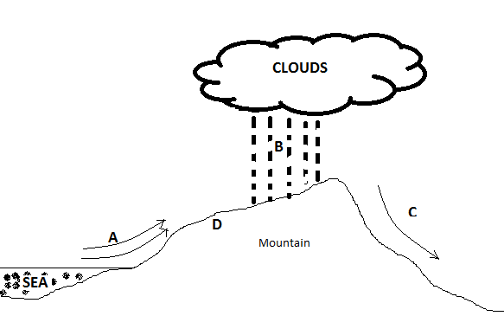
- Study carefully the diagram below then answer the question that follows.

E

- Name the type of rainfall labeled B ……………….
- A stand for …………………….
- C stand for …………………….
- D stand for …………………….
- E stand for ……………………..
- Define the following geographical terms
- Climate………………………………………………………………………………………………………………………………………………………………………..
- Solar energy…………………………………………………………………………
………………………………………………………………………………………….
- Longitude…………………………………………………………………………….
………………………………………………………………………………………….
- Ocean current……………………………………………………………………….
…………………………………………………………………………………………
- Precipitation ………………………………………………………………………..
………………………………………………………………………………………….
- Assign the instruments which are used to measure the following weather elements.
- Temperature …………………………………………………………………….
- Wind speed ………………………………………………………………………
- Sunshine …………………………………………………………………………
- Rainfall ……………………………………………………………………………
- Humidity ………………………………………………………………………….
- (a)State two types of rainfall
- …………………………………………………………………………………..
- …………………………………………………………………………………..
(b)Mention three factors that affect temperature of a place
(i) ………………………………………………………………………………………..
(ii)…………………………………………………………………………………………
(iii)…………………………………………………………………………………………
(c)If the time of place Z (45⁰E) is 10:00AM, what will be the time of a place y (45⁰W?)
……………………………………………………………………………………………………………………………………………………………………………………………………………………………………………………………………………………………………………………………………………………………………………………………………………………………………………………………………………………………………………………………………………………………………………………………………………………………………………………………………………………………………………………………………………………………………………………………………………………………………………………………………………………………………………………………………………………………………………………………………………………………………………………………………………………………………………………………………………………………………………………………………………….

SECTION B (30 Marks)
- (a) Mention any five(5) evidences which proved that the Earth is spherical in shape
- ………………………………………………………………………………………..
- ………………………………………………………………………………………..
- ………………………………………………………………………………………..
- ………………………………………………………………………………………..
- ………………………………………………………………………………………..
(b)List down first five continents in the world arrange according to size.
(i) …………………………………………. (ii) ……………………………………………..
(iii)………………………………………….. (iv)……………………………………………….
(v)……………………………………………..
- (a) Define lunar eclipse ………………………………………………………………………..
………………………………………………………………………………………………….
(b)Draw a well labeled diagram to show lunar eclipse ………………………………..
…………………………………………………………………………………………………..

The End

