THE UNITED REPUBLIC OF TANZANIA
THE PRESIDENT’S OFFICE
REGIONAL ADMINISTRATION AND LOCAL GOVERNMENT

NAMANGA FORM ONE PRE-MIDTERM EXAMINATION

GEOGRAPHY
MARKING SCHEME AUGUST 2024

SECTION A (15 MARKS)
- Multiple choice
i | ii | iii | iv | v | vi | vii | viii | ix | x
D | D | A | A | D | A | D | B | B | C

- Matching items
COLUMN A | i | ii | iii | iv | v
COLUMN B | C | E | G | F | A

SECTION B (70 MARKS)

- Solar system
- Characteristics of the sun @1mark
- It is the hottest star
- It is the brightest star
- It is the biggest star
- It is the only star that produce light and heat
- It is made up of heavy element
- Difference between the sun and planets @1marks
- Planets revolves around the sun while the sun is stationary
- Planets does not produce light and heat while the sun produce light and heat
- The sun is bigger than the planets
- The sun is very hot compared to planets
- The sun can not support life but the planet like earth supports life

- Structure of the earth
- Mountains these are elevated lands of the earth’s surface rising above 300m 3marks
- The two forces that operates are @1marks
- Tensional forces
- Compressional forces
- Roles of mountains @1marks
- It encourages the formation of rainfall
- It is a good site for agricultural activities
- They are used for settlement
- They are good sites for mining activities
- They encourage the growth of tourism

- Student should explain the concept of solar eclipse. 10 MARKS
THE SOLAR ECLIPSE
- This occurs when the moon passes between the earth and the sun, thus casting its shadow over the earth.
- The solar eclipse is also known as the eclipse of the sun.
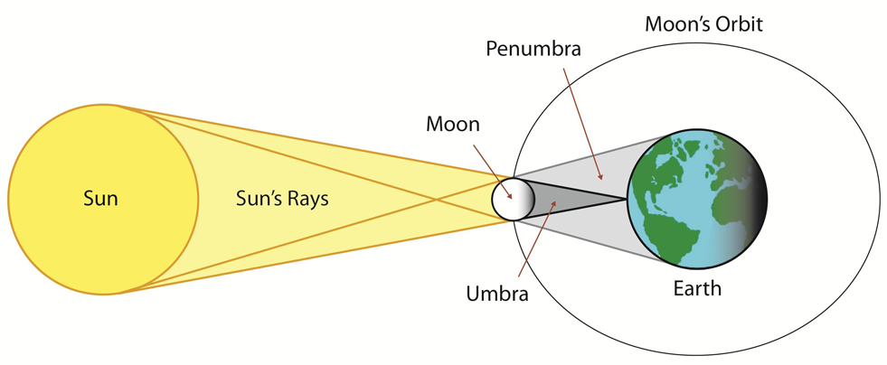

- Solar system @2.5marks
- Asteroid these are planet like bodies which revolve around the sun while comets these are solid objects with leading heads and bright tails
- Galaxy this is the group of stars while constellation this is the arrangement of stars in a pattern
- Aphelion this is the furthest position of the earth from the sun (152 million km) and perihelion is the nearest position of the earth from the sun (147 million km)
- Parallels these are lines that runs from east to west while meridians these are the lines which runs from north to south pole
- The concept of geography
- Geography is the study of man and his environment 3marks
- Importance of geography@1marks
- It enables us to appreciate nature
- It enables us to know how landforms are created
- It enables us to know our national heritages
- It enables us to gain skills for environmental conservation
- It enables us to enter into future careers like geology
- It enables us to identify social problems and solve them
- It enables us to know the relationship between one country and another

- Four components of the sun. 10 MARKS
The sun is made up of several layer;
  - CORONAIs the outermost layer of the sun’s atmosphere.
  - CHROMOSPHEREIs the outer layer of the sun’s atmosphere.
  - PHOTOSPHEREIs the bright surface of the sun.
  - COREIs the central part of the sun.
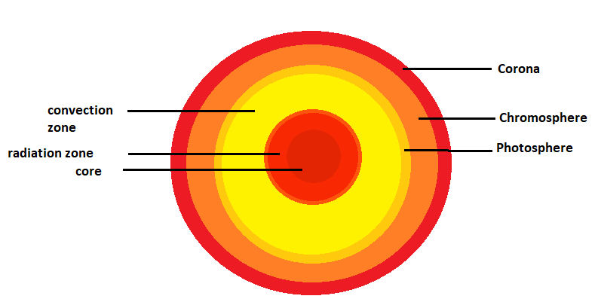

- 10 MARKS
Seasons Is the four periods of the year separated from each other by different temperature conditions. The seasons are summer, autumn, winter and spring. They are more pronounced between 23⁰c and 66⁰c of latitudes. At the equator the year is divided between hot and wet seasons while at the poles is very cold all the year around and the season cannot be identified easily.

(b)Explain the main seasons of the year and their respective month in the southern hemisphere.
- Spring is the beginning of the cycle. New vegetation grows, and the weather is generally warm and sunny. Sometimes it rains in spring. It’s the time when the plants and animals come alive and out of hibernation. Is the season soon after winter but before summerIn spring the weather usually turns warmer, trees begin to grow their leaves, plants start to flower and young animals such as chicks and lambs are born. Spring starts from AUGUST, SEPTEMBER AND OCTOBER.

- Summer is the hot weather season. Temperatures run highest in summer, accompanied by, depending on the location, extreme humidity or dryness. It is also a time for heat waves and droughts, and even forest fires in some areas. Summer is a time for long days. Is the season after spring but before autumn. In summer the weather is usually hot and trees have full green leaves. Summer starts from NOVEMBER, DECEMBER AND JANUARY.

- Autumn marks the beginning of cool weather. It is the time when leaves turn yellow/brown, and animals begin preparations because “winter is coming”. It is also harvesting season, which is a cause for celebration in most cultures. Is the season soon after summer but before winter. In autumn the weather turns colder and often rains. The leaves start to change colour and fall off the trees. Deciduous trees lose their leaves. Sseasons months in the Southern Hemisphere are: Fall (autumn) starts from FEBRUARY, MARCH AND APRIL.

- Winter is the coldest period of the year. The time when animals hibernate, and vegetation decreases. The days are shortest in winter. Is the season soon after Autumn but before springIn winter the weather is cold and we sometimes get snow and frost. The trees have no leaves. Sseasons months in the Southern Hemisphere are: Winter starts from MAY, JUNE AND JULY.

SECTION C (15 MARKS)
- 15 MARKS
Evidences which prove that earth is spherical.
There are some several evidences which are used to prove that the earth is sphere like structure, some of them are shown in the following: -
- Sunrise and sunset.
- Circumnavigation of the earth.
- Aerial photographs.
- Ship’s visibility.
- Lunar eclipse.

(i) SUNRISE AND SUNSET
- The sun riseS and sets at different times at different places of the earth.People in the east see the sun earlier than the people in the west due to earth’s rotation from west to east. If the earth was flat the whole world would have sunrise and sunset at the same time.
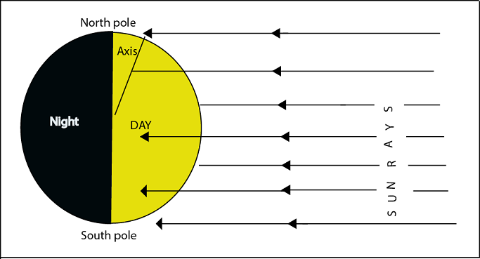

(ii) AERIAL PHOTOGRAPHS
- Photographs taken by satellites or aeroplane from the air show that the earth has a curved or round shape. They show the curvature of the earth.

(iii CIRCUMNAVIGATION OF THE EARTH
- If traveling from a certain point of the earth and you go straight around the earth you will come to the point of origin. The first traveler around the world named Magellan in 1519-1522 proved this, image did not encounter abrupt edge over the world in his voyage.

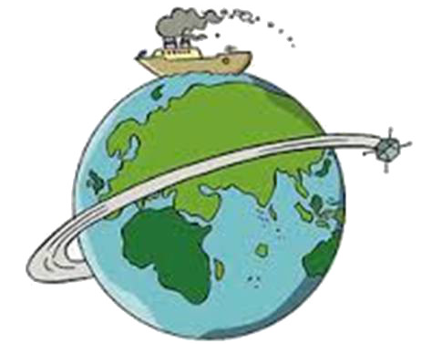

(iv) SHIP’S VISIBILITY
- If you are in the coast viewing a ship which is very far you will see the soot, then the pipe and eventually the whole ship as it comes closer to the coast.When the ship moves away it gradually disappears. If the earth were flat the ship would have been seen all at once.
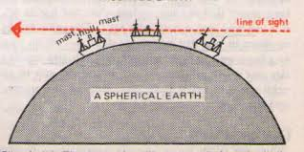

(v) LUNAR ECLIPSE
- The shadow of the earth thrown to the moon during lunar eclipse is always round. Only a spherical object can give a circular shadow.This prove tjhe earth is spherical in shape.

