THE UNITED REPUBLIC OF TANZANIA
THE PRESIDENT’S OFFICE
REGIONAL ADMINISTRATION AND LOCAL GOVERNMENT
LONGIDO DISTRICT
ANNUAL JOINT EXAMINATION

FORM ONE
013 GEOGRAPHY
MARKING SCHEME NOVEMBER 2024
SECTION A
- choosing the correct answer 10 MARKS
i | ii | iii | iv | v | vi | vii | viii | ix | x
D | D | B | A | C | D | A | C | A | C

- Matching the items 05MARKS
COLUMN A
COLUMN B | D | E | F | G | H

SECTION: B
- Five distinctive characteristics of Natura region M 10 MARKS @2
The Mediterranean climate has the following characteristics:
- Temperatures range from 21 ºC in summer to 10 ºC in winter.
- Winters are rainy and mildly, and at times can cause floods. Onshore western winds bring cyclonic rainfall. The annual rainfall ranges from 500 mm to 760 mm
- Summers are hot and dry, the sky is cloudless and humidity is low.
- Off-shore trade winds blow in summer. These winds are dry and give no rain.
- The vegetation of this climate is evergreen with open woodlands coupled with scattered trees.

- Relief features found on the earth surface, that form irregularities of the earth surface. 10 MARKS @2
- Plains are continuous stretches of comparatively flat land and not rising much above the sea level. Many extensive plains are a result of down warping of the earth’s crust for example, Siberia in Asia, North European plains, Indo-Gangetic plain and the Great central plains of North America.
- Plateaus Is an extensive high-altitude area with more or less uniform summit levels of usually consisting of relatively flat terrain(altitude) with one or more sides with steep slopes.
- Mountain Is a large and elevated part of the earth’s surface rising to greater height than ordinary hills. Nearly 27% of the world’s land surface is covered by mountains.
- A BASINIs a form of natural or artificial depression or (hollow) varying in size in the earth’s surface. When basin is occupied by water, they form lake, river, and oceans. Example Lake Victoria.
- HILL

- Student should explain the concept of solar eclipse. 10 MARKS
THE SOLAR ECLIPSE
- This occurs when the moon passes between the earth and the sun, thus casting its shadow over the earth.
- The solar eclipse is also known as the eclipse of the sun.
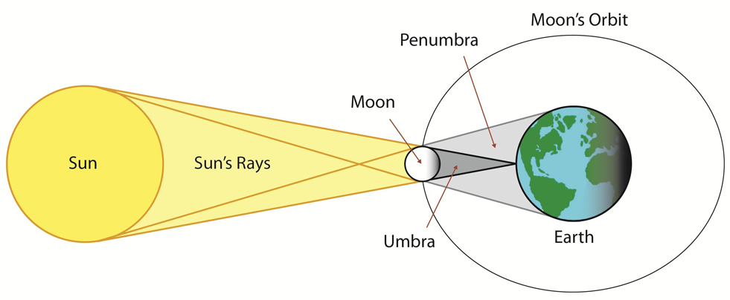

- If the time recorded at Kibaha ,45⁰ E was 9:00 A.M. What could be the longitude of Canada at 3:00 A.M. Show all steps and its procedures. 10 MARKS
Solution
- Data given
Longitude Time
Kibaha 45⁰E 9:00 A.M
Canada x 3:00A.M

- Since we have two time, we have to find difference in time
9:00-3:00= 6hrs

Since $\frac{1 hr°}{6hrs}=\frac{15°}{x}$

$$\frac{15°x6hrs}{1hr}=\frac{1hrx}{1hr}$$

X=90⁰
- Difference in degree is 90⁰ - 45⁰=45⁰

- Since canada town is ahead in time,hence it is located at Longitude 45⁰W

- Contribution of solar energy to the emancipation of women in Tanzania. 10 MARKS @2
- Solar energy can provide reliable, clean electricity to households and communities, which can improve women’s quality of life and reduce their workload. For example, solar lighting can replace the need for women to collect firewood for lighting and cooking, which can be time-consuming and physically demanding.
- Solar energy can also improve women’s safety by providing a safe and reliable source of light for homes, streets, and public spaces. This can reduce the risk of violence and accidents, particularly in areas where women and girls are at higher risk due to a lack of safe and reliable lighting.
- Solar energy can help to empower women by providing them with new skills and opportunities to learn and work in the renewable energy sector. For example, women can be trained in solar panel installation and maintenance, which can provide them with new income-generating opportunities.
- Solar energy can provide a more affordable and reliable source of electricity for women-led businesses and enterprises, which can help to increase their competitiveness and profitability. This can also create new opportunities for women to start their own businesses or expand existing ones.
- Solar energy can help to reduce greenhouse gas emissions, which can contribute to a cleaner and healthier environment for women and their families. This can help to reduce the burden of respiratory and other health problems caused by air pollution, which disproportionately affects women and children.
- Solar energy can reduce the need for women to rely on expensive and polluting sources of energy such as kerosene or diesel, which can be costly and harmful to health. This can help to improve women’s financial security and well-being.
- Solar energy can help to improve access to education for women and girls, particularly in rural and remote areas where electricity is often scarce or non-existent. Solar-powered lighting and computer systems can provide a more conducive and safer environment for learning, which can help to improve girls’ education and increase their opportunities in life.
- Solar energy can help to reduce water scarcity and improve access to clean water for women and their families. Solar-powered pumps and water treatment systems can help to provide a reliable and affordable source of clean water, which can help to reduce the burden of collecting water and improve women’s health and well-being.
- Solar energy can help to reduce the impact of climate change on women and their communities. For example, solar energy can help to reduce the risk of natural disasters and extreme weather events, which disproportionately affect women and their families due to their higher vulnerability and lower levels of resilience.
- Solar energy can help to reduce poverty and inequality for women and their families by providing a reliable and affordable source of electricity and energy. This can help to improve living standards and create new opportunities for women to thrive and succeed.

- (a)Ways of showing position on the map 10 MARKS @1
- By place naming
- By using latitude and longitude
- By using grid reference
- By bearing and directions
(b)What compass bearing is given for the following compass directions?
- ESE .............................112.5
- WNW..........................292.5
- NNW...........................337.5
(c)State the compass direction for each of the following compass bearings:
- 275° ...........................SW
- 135° ...........................SE
- 45°.............................NE

- (a)What is season? 10 MARKS @2
Seasons Is the four periods of the year separated from each other by different temperature conditions. The seasons are summer, autumn, winter and spring. They are more pronounced between 23⁰c and 66⁰c of latitudes. At the equator the year is divided between hot and wet seasons while at the poles is very cold all the year around and the season cannot be identified easily.

(b)Explain the main seasons of the year and their respective month in the southern hemisphere.
- Spring is the beginning of the cycle. New vegetation grows, and the weather is generally warm and sunny. Sometimes it rains in spring. It’s the time when the plants and animals come alive and out of hibernation. Is the season soon after winter but before summerIn spring the weather usually turns warmer, trees begin to grow their leaves, plants start to flower and young animals such as chicks and lambs are born. Spring starts from AUGUST, SEPTEMBER AND OCTOBER.

- Summer is the hot weather season. Temperatures run highest in summer, accompanied by, depending on the location, extreme humidity or dryness. It is also a time for heat waves and droughts, and even forest fires in some areas. Summer is a time for long days. Is the season after spring but before autumn. In summer the weather is usually hot and trees have full green leaves. Summer starts from NOVEMBER, DECEMBER AND JANUARY.

- Autumn marks the beginning of cool weather. It is the time when leaves turn yellow/brown, and animals begin preparations because “winter is coming”. It is also harvesting season, which is a cause for celebration in most cultures. Is the season soon after summer but before winter. In autumn the weather turns colder and often rains. The leaves start to change colour and fall off the trees. Deciduous trees lose their leaves. Sseasons months in the Southern Hemisphere are: Fall (autumn) starts from FEBRUARY, MARCH AND APRIL.

- Winter is the coldest period of the year. The time when animals hibernate, and vegetation decreases. The days are shortest in winter. Is the season soon after Autumn but before springIn winter the weather is cold and we sometimes get snow and frost. The trees have no leaves. Sseasons months in the Southern Hemisphere are: Winter starts from MAY, JUNE AND JULY.

SECTION C 10 MARKS @3
- Evidences that prove that earth is spherical.
There are some several evidences that are used to prove that the earth is sphere like structure, some of them are shown in the following: -
- Sunrise and sunset.
- Circumnavigation of the earth.
- Aerial photographs.
- Ship’s visibility.
- Lunar eclipse.

(i) SUNRISE AND SUNSET
- The sun riseS and sets at different times at different places of the earth.People in the east see the sun earlier than the people in the west due to earth’s rotation from west to east. If the earth was flat the whole world would have sunrise and sunset at the same time.
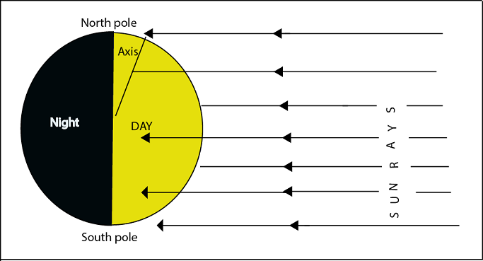

(ii) AERIAL PHOTOGRAPHS
- Photographs taken by satellites or aeroplane from the air show that the earth has a curved or round shape. They show the curvature of the earth.

(iii CIRCUMNAVIGATION OF THE EARTH
- If traveling from a certain point of the earth and you go straight around the earth you will come to the point of origin. The first traveler around the world named Magellan in 1519-1522 proved this, image did not encounter abrupt edge over the world in his voyage.

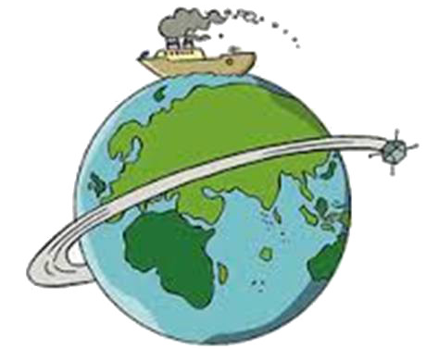

(iv) SHIP’S VISIBILITY
- If you are in the coast viewing a ship which is very far you will see the soot, then the pipe and eventually the whole ship as it comes closer to the coast.When the ship moves away it gradually disappears. If the earth were flat the ship would have been seen all at once.
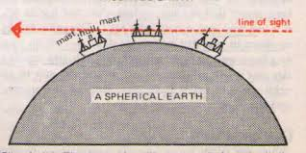

(v) LUNAR ECLIPSE
- The shadow of the earth thrown to the moon during lunar eclipse is always round. Only a spherical object can give a circular shadow.This prove tjhe earth is spherical in shape.

