PRESIDENT’S OFFICE
REGIONAL ADMINISTRATION AND LOCAL GOVERNMENT
LONGIDO DISTRICT COUNCIL
MID-TERM EXAMINATION
GEOGRAPHY FORM ONE

TIME 2:30HRS MARCH 2024

INSTRUCTION:
- This paper consist of section A and B
- Answer all questions in section A and two (2) question from section B
- All writing must be in blue or black ink except diagrams should be in pencil
- Write your examination number on every page of your answer sheet
- Any unauthorized material are not allowed in examination room
- All communication devices are not allowed in the examination room

SECTION A
- For each of the following items (i-x) choose the most correct answer from the given alternatives and write its letter in the box provided
- The study of the interrelationship between human being and the environment over time and space
- Biology
- Geography
- Solar system
- Agriculture
- The main source of heat and light in solar system
- The sun
- The moon
- The planet
- Electricity
- The path used by the earth and other planet when going around the sun is known as
- Revolution
- Rotation
- Axis
- Orbit
- Places on the east of Greenwich experience sunrise before places on the west because the earth
- Rotate from west to east
- Revolution around the sun
- Rotates from east to west
- Very close to the sun
- Spinning of a body on its own axis is known as
- Revolution
- Tilting
- Rotation
- Axis
- If the time recorded in Accra 0⁰was 05:00pm what will be the time at Bujumbura 30⁰e?
- 07.00pm
- 07:00am
- 02:00pm
- 02:00am
- Are visible in the sky during night as moving object with leading heads and bright tail
- Comet
- Meteors
- Asteroid
- Stars
- Which of the following is not true about earth rotation
- 1⁰ to 4minutes
- 15⁰ to 60minutes
- 15⁰ to 24hours
- 360⁰to 24hours
- When the moon’s shadow is cast over the earth’s surface the phenomenon is known as
- Lunar eclipse
- Solar eclipse
- Equinox
- Summer solistice
- Which of the following is the evidence of the earth’s sphere?
- The ship comes from far away
- The ocean water conceals the ship
- The earth revolve around the sun
- The ship visibility in the ocean change with distance
i | ii | Iii | iv | v | vi | vii | viii | ix | x

- Match the items in list A with a correct responses in list B and write its letter
List A | List B
- Is needed everywhere in our lives  - Imaginary line joining north pole and south pole  - The furthest position of the earth to the sun  - Light from sun are completely blocked  - Avoid bush fire, plant trees, avoid pollution, recycle wastes  - Equator and all meridians  - Imaginary lines parallel to the equator joining all places at equal angular distance  - The sun overhead in tropics  - A stretch of land where the standard time is accepted  - The light from the sun partially blocked form the shadow | - Aphelion  - Axis  - International date line  - Perihelion  - Water  - Solar energy  - Umbra  - Environment conservation  - Africa  - Great circle  - Latitude  - Longitude  - Solstice  - Equinox  - Great circle  - Penumbra  - Time zones

i | ii | iii | iv | v | vi | vii | viii | ix | X

- (a) What is an International Date Line?
________________________________________________________________________________________________________________________________________________
- What happens if someone crosses the International Date Line;
- From West to East
_______________________________________________________________
- From East to West
_______________________________________________________________
- Outline three important latitudes with their degrees
- _______________________________________________________________
- _______________________________________________________________
- _______________________________________________________________
- Asha is a standard six pupil, she heard that earth are always in motion. She don’t know about it, as you are a form one student make her to know by
- Explaining types of earth’s motions to her
- ______________________________________________
- ______________________________________________
- Give the evidence of the earth’s movements explained in (i) above
- Four (4) evidence of earth rotation
- _________________________________________________________
- _________________________________________________________
- _________________________________________________________
- _________________________________________________________
- Four (4) effects of earth revolution
- _________________________________________________________
- _________________________________________________________
- _________________________________________________________
- _________________________________________________________
- Study carefully the following diagram and answer the questions that follow.
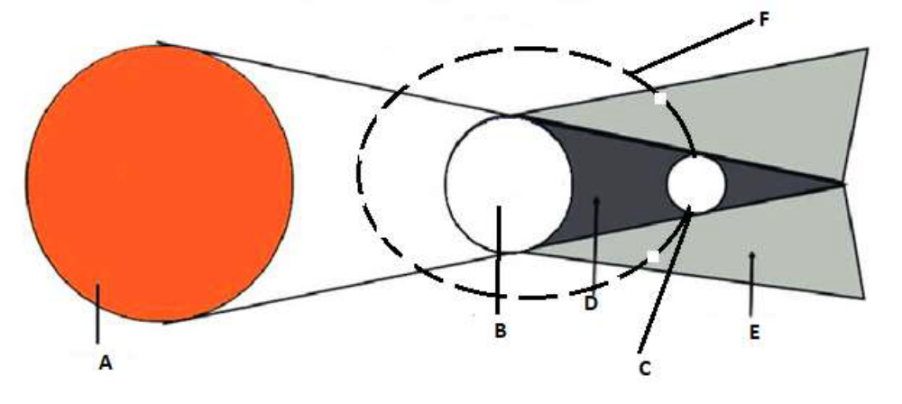

- Which geographical event does the diagram represents
__________________________________________________________________________________________________________________________________________
- What do the following letters stand for?
A--------------------------
B--------------------------
C--------------------------
D--------------------------
E--------------------------
- What will happen if object C moves between objects A and B?
______________________________________________________________________________________________________________________________________________________

SECTION B
Answer only two (2) questions from this section
- There was a debate on the shape of the earth. As you are a geography expert give the evidence of the earth’s shape. Five (5) points
- ---------------------------------------------------------------------------------------------------
- ---------------------------------------------------------------------------------------------------
- ---------------------------------------------------------------------------------------------------
- ---------------------------------------------------------------------------------------------------
- ---------------------------------------------------------------------------------------------------
- Tanzania government are insisting the use of solar energy to the people. Many people do not know why the government are insisting this. As you are a form one students who study geography. Describe to them FIVE (5) reasons of government
- ---------------------------------------------------------------------------------------------------
- ---------------------------------------------------------------------------------------------------
- ---------------------------------------------------------------------------------------------------
- ---------------------------------------------------------------------------------------------------
- ---------------------------------------------------------------------------------------------------
- Your parents wants you not to study geography subject and study science subjects only because they don’t know the necessities of the subject. As you are a form one student studying geography educate your parents so that they can know.
- ---------------------------------------------------------------------------------------------------
- ---------------------------------------------------------------------------------------------------
- ---------------------------------------------------------------------------------------------------
- ---------------------------------------------------------------------------------------------------
- ---------------------------------------------------------------------------------------------------

