THE UNITED REPUBLIC OF TANZANIA
PRESIDENT’S OFFICE
REGIONAL ADMINISTRATION AND LOCAL GOVERNMENT
NAMANGA SECONDARY SCHOOL
FORM ONE TERMINAL EXAMINATION
GEOGRAPHY
MARKING SCHEME 2024
SECTION A
Qn. 1 (10 Marks)
 |  |  |  |  |  |  | viii | ix | x
B | C | C | D | A | C | C | A | B | C

Qn. 2 (05 Marks)
i | ii | iii | iv | v
E | D | A | C | B

SECTION B
Qn. 3
- Meteors are pierces of hard matter falling from outer space (3 marks)
- Solar system is the arrangement of the planets and solid objects in the space in relation to the position from the sun (3 marks)
- planets are bodies that revolve around the sun (3 marks)
Qn. 4
- An ocean is large body of water that surrounds landmasses of the earth (1 marks)
- i. the Pacific Ocean (2 marks)
ii. the Atlantic Ocean (2 marks)
iii. the Indian ocean (2 marks)
iv. the arctic ocean (2 marks)
v. the Southern Ocean (2 marks)
Qn. 5
- occurrence of day and night (2 marks)
- ocean tides (2 marks)
- deflection of wind and ocean currents (2 marks)
- the difference of one hour for every 15⁰ longitudes (2 marks)
Qn. 6
  - Eclipse is the total or partial cutting off of light received by one space body from another by interception of third space body passing between the other two (2 marks)
  - i. eclipse of the sun/ solar eclipse (1 marks)
ii. eclipse of the moon/ lunar ellipse (1 marks)

  - drawing of lunar Eclipse (8 marks)
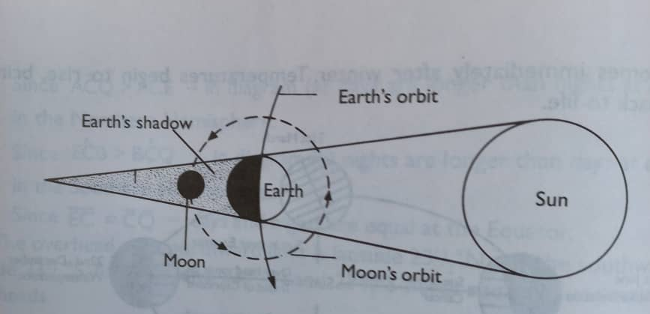

Qn. 7
- A continent is the major land masses rising from the ocean floors (3 marks)

  - Asian (1 marks)
  - Africa (1 marks)
  - South America (1 marks)
  - North America (1 marks)
  - Australia (1 marks)
  - Europe (1 marks)
  - Antarctica (1 marks)

Qn 8.
- 0⁰ (2 marks)
- 23½^{O}S (2 marks)
- 23½^{O}N (2 marks)
- 90⁰N (2 marks)
- 90⁰S (2 marks)
Qn.9
- circumnavigation of the earth (2 marks)
- sunrise and sunset (2 marks)
- Aerial photographs (2 marks)
- lunar eclipse (2 marks)
- ship visibility (2 marks)

Qn.10
- it is used for domestic purpose e.g. drying clothes, grains fruits (2 marks)
- it is used by plants to manufacture their own food (2 marks)
- it is used for making solar cooker (2 marks)
- it provides vitamin D for human being (2 marks)
- it is used in the evaporation of water for rain formation (2 marks)
- it is used for making electricity (2 marks)
Introduction: to define solar energy (2 marks)
Solar energy is the energy produced by the sun
Conclusion: (1 marks)
NB: points should be explained in essay form

