NAMANGA SECONDARY SCHOOL
ORIENTATION EXAMINATION
FOR FORM ONE - GEOGRAPHY
Time 1:30 hours
INSTRUCTIONS
Answer all questions
READING PRACTICE
- Read the story below and answer the following questions
MWAKIFUNA THE MOTORIST

- Whats is Mwakifuna nationality?
- What were the nationalities of the two friends that mwakifuna sought help from?
- How did the officers find out the passangers nationality?
- Do you think the passangers was African or European?

- SPEAKING PRACTICE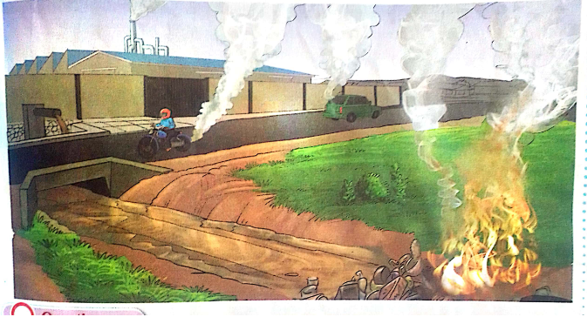

Study the picture and answer the questions that follow
- What do you see?
- Why do vehicles and industries produce smoke?
- What does this smoke do to the atmosphere?
- What should we do to save the earth?

VOCABULARY PRACTICE
- Read appropriately the words in COLOMN A and match them with their corresponding meaning in COLOMN B

LIST A |  | LIST B
- Bush fire  - Conserve  - Deforestation  - Degradation  - Environment |  | A.) A process through which the natural environment is endangered in some way.It reduces biological diversity and the gerneral health of the environment.  B. )Grassland fires frequently occuring after good period of rainfall which result in abundant growth of grass that dries out in hot weather  C.)co nvert(waste) into reusable material.  D.)Protect something important especially environment or culture from harm or destruction.  E. )The decrease in forest areas. A forest can be lost because of the human activities such as agricultural croplands, urbanisation, or mining  F. )The surroundings or conditions in which a person, animal, or plant lives or operates.
LIST A | I |  | II | III | IV | V
LIST B

4. Make a correct word from the following group of jumbled letters
i. elecry………………………………………………
ii. ctofary ……………………………………….
iii. tsawe…………………………………………
iv. teproct……………………………………….
v. ipnta……………………………………………….

