Candidate’s name……………………………….......

SECTION A (50 Marks)
- Read the following statements carefully and write the letter of the correct answer on the space provided.

- A nation is; …………
- A group of Tanzanians who speak Kiswahili
- People who speak Kiswahili and English
- A group of people who share the same government, culture, economy and history
- A community of people who live together.

- Some components of a nation are……….
- People, territory, government and torch
- Territory, sovereignty, people and flag
- Government, country, sovereignty and people
- Peace, national language, common traditions and history

- National symbols are ………
- Ivory, mount Kilimanjaro, uhuru torch and minerals
- Things which identify a nation, such as the national flag and a coat of arms
- The national anthem, national language, territory and the constitution only
- The land that is under the control of a particular government.

- Some of the national symbols of Tanzania are…………..
- The national anthem, national parks and the coat of arms
- The coat of arms, national parks and mount Kilimanjaro
- The uhuru torch, the national anthem and the national flag
- The national flag, the uhuru torch and national history.

- The people of a particular country or state are called………..
- Members
- Country
- Citizens
- Leaders

- The system of communication in speech and writing that is used by the people of a particular country is called…………
- Custom
- Language
- Citizen
- Culture

- The customs and beliefs of a particular group of people are called………
- Language
- History
- Nation
- Culture

- The events that happened in the past are called……..
- History
- Customs
- Beliefs
- Culture

- The national …………is the official song of a nation.
- Anthem
- Currency
- Game
- History

- A sign that represent something is called…………
- Custom
- Symbol
- Language
- Government

- The Tanzanian currency is the………….
- Coins
- Notes
- Shilling
- Dollar

- Tanzania uses a system of laws and basic principles called a…………
- Constitution
- Currency
- Government
- Coat of arms

- The official seal or stamp of the government of Tanzania is called the……….
- Presidential standard
- National currency
- Coat of arms
- Government anthem.

- The national anthem is sang when…………
- There is wedding
- The Prime Minister is about to address the nation
- The regional commissioner visits school
- The President is about to inspect a guard of honour.

- The head of government in Tanzania is called the………
- President
- Prime Minister
- Speaker
- Vice President

- One of the following is an example of a religious festival ……..
- Independence day
- Easter
- Union day
- Workers’ day

- One of the following colours is not on our national flag ……….
- Blue
- Green
- Red
- Yellow

- ………… Is the freedom that a country has to govern itself.
- Internal sovereignty
- External sovereignty
- Sovereignty
- Government

- The components of our coat of arms are ………
- Two human figures and history
- National flag and red band on the shield
- Sea wave and culture
- Language and peak of mount Kilimanjaro

- Which of the following pictures represents the national flag of Tanzania…….....

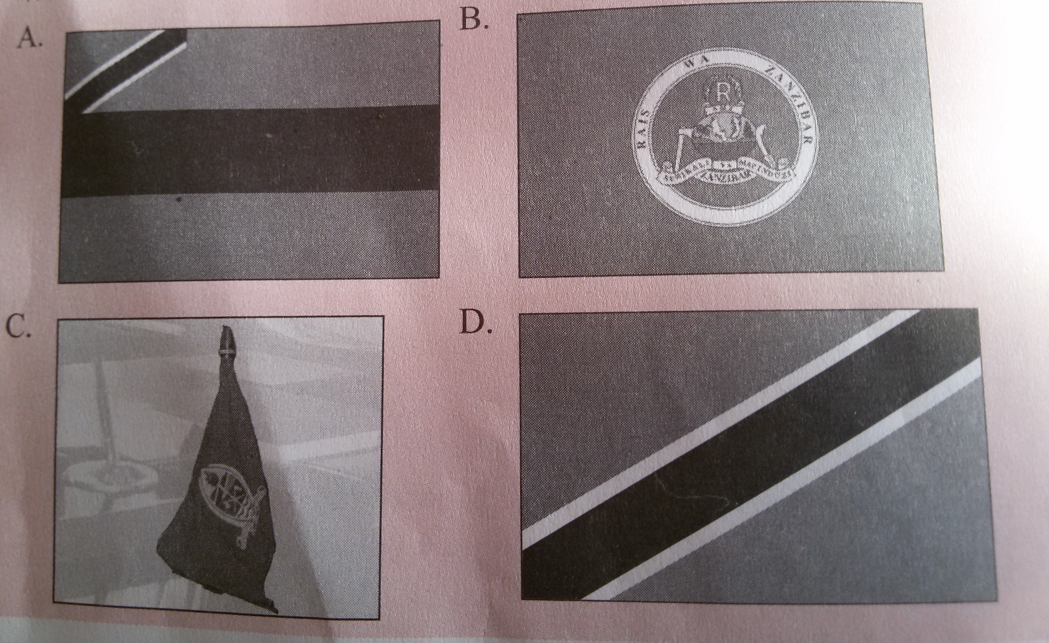
- Match the items in List A with those in List B, by writing the letter of the correct response against each number in the table provided.
LIST A | LIST B
- Culture  - Country  - Sovereignty  - Government  - National flag  - 9th December 1961  - 26th December  - Presidential standard  - 25th December  - Citizen | - Is the situation where by a country has the freedom to govern itself  - Refers to the customs and beliefs of a particular group of people  - Is the group of people who are responsible for controlling a country or state  - Is an area of land that has boundaries and is under the control of a government  - Tanganyika got its independence  - Blue, yellow, black and green  - Suffering and death of Jesus Christ  - The state symbol of the president  - Good Friday  - Independence day  - Christmas day  - Boxing day  - Maulid day  - A person who belongs to a particular country

ANSWERS
LIST A
LIST B

- The following statements are either correct on not correct. Write TRUE if the statement is correct or FALSE if the statement is not correct.
- Language is not a component of a nation ……………………..
- Tanganyika united with Zanzibar in 1963 as a result of the history of these two countries……………………
- Tanzania, Kenya and Uganda are nations ………………...
- The national anthem is sang when the school flag is being hoisted ……………….
- The Independence Torch was first lit on top of Mount Meru …………………..
- The national flag has four colours ………………….
- The coat of arms has more than ten components …………………..

