KISWAHILI KIDATO CHA KWANZA MUHULA WA KWANZA 2025
MWONGOZO WA USAHIHISHAJI
1. 10marks @01mark
SWALI | i | ii | iii | iv | v | vi | vii | viii | ix | x
MAJIBU | A | C | C | B | C | B | B | A | B | A

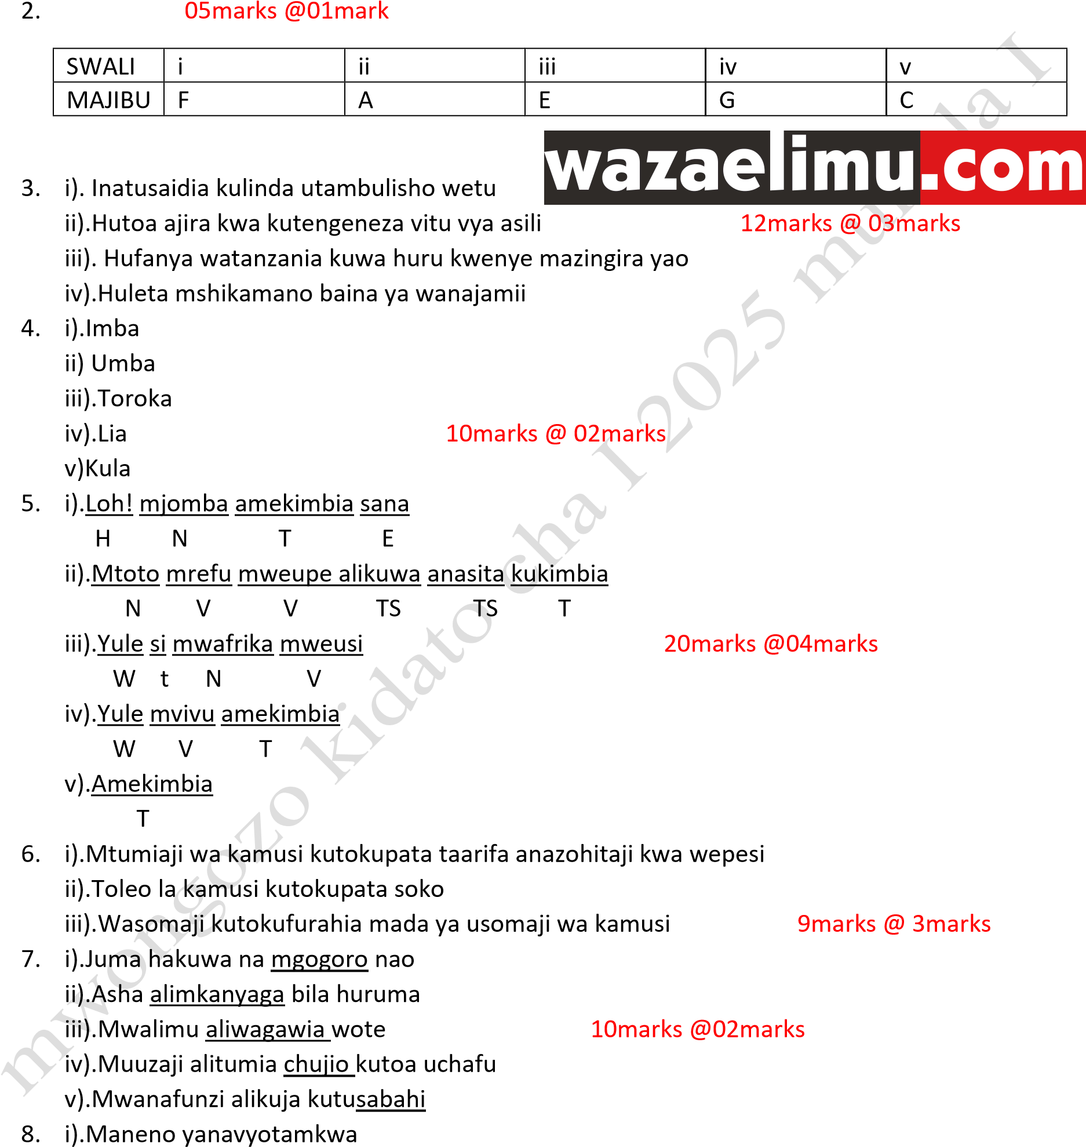
ii).Aina za maneno
iii).Umoja na wingi wa maneno 12marks @03marks iv).Asili ya neon
9. i).Hapendi ii).Thamani iii).Karibu iv).Ametembelea 12marks @03marks
Page 1 of 1

