THE UNITED REPUBLIC OF TANZANIA
PRESIDENT’S OFFICE
REGIONAL ADMINISTRATION AND LOCAL GOVERNMENT
NAMANGA SECONDARY SCHOOL
FORM ONE TERMINAL EXAMINATION
ENGLISH LANGUAGE
TIME: 2:30 Hours 2024
INSTRUCTIONS
- This paper consists of sections A, B and C with a total of TEN (10) questions.
- Answer all questions in the spaces provided.
- Section A and C carry fifteen (15) marks each and section B carries seventy (70) marks.
- All writings must be in Black or blue pen
- All communication devices and any unauthorised materials are not allowed in the assessment room
- Write your Assessment number at the top right corner of every page

SECTION A (15 Marks)
Answer ALL questions in this section.
      - For each of the items (i) – (x), choose the most correct answer from among the given alternatives and write its letter beside the item number in the answer booklet provided.
- Anna was speaking angrily and the teacher told her to …………

- Go down
- Came down.
- Slow down.
- Calm down.
- Come down.

- My hen usually …………. two eggs everyday
- lay
- lie
- Lies.
- layers
- lays

        - ………………… Tanzania is CORONA free, while developed countries are still suffering from the pandemic.

- Despite
- In spite of
- Notwithstanding
- Strange as it may seem
- Nevertheless

        - “It might rain this afternoon.” The auxiliary might has been used to show …
- Intention
- Obligation
- Necessity
- Permission
- Possibility

        - I was reading a grammar book in the national library then I came across this question. Which word is in plural? How would you help me to make the correct pick?

- News
- Books
- Mathematics
- Politics
- Economics

        - Elijah was walking past the cemetery at night, heard some voices from one end of the grave yard. He cast a glance in that direction and he saw …

- A team of robbers.
- A company of robbers.
- A gang of robbers.
- A staff of robbers.
- A troop of robbers

            - Our teachers are very ……………………. our class since we are the most disciplined class in the whole school.

- Proud about.
- Proud of.
- Proud for.
- Proud with.
- Proud at.

            - The boys ……….. the tree and some ripe mangoes fell onto the ground. Choose the correct form of the verb to fill in the blank.
        - Will Shake
        - Shaken
        - Shaking
        - Shook
        - Had Shake

            - Our mother told us to wear the new dresses which she ………… for us the day before.

      - Brings
      - Have brought
      - Has bring
d) Had Bring
e) Had brought

            - My daughter is learning the spellings, but more often she writes the words with wrong spellings. Which of the words below did she write with wrong spellings?
        - Pronoun
        - Conjuction
        - Interjection
        - Preposition
        - Adverb

      - Match the italicised pronouns in List A with the correct kind of pronoun in List B by writing its letter beside the corresponding number in the boxes provided below.

LIST A | LIST B
- Sam and Ney love each other.  - We need to take care of ourselves  - Those are going to be destroyed.  - He lost his pen so I gave him mine.  - The author whom you criticised in your review has written a reply. | - Demonstrative pronoun  - Relative pronoun  - Possessive pronoun  - Reflexive pronoun  - Reciprocal pronoun  - Interrogative pronoun  - Personal pronoun

LIST A | i | ii | iii | iv | v
LIST B

SECTION B (70 Marks)
Answer all questions in this section

      - (a) In English language, gender comes in four categories. Give ONE example of a word for each of the following categories of gender. (21mark =4)
- Masculine gender. ………...…………………………..
- Feminine gender. …..…………………………………
- Common gender. …..…………………………………
- Neuter gender. ..………………………………………

            - Answer the questions according to the instructions given after each. (@2mrks =06)
- has this he houses a lot city of in. (re-arrange the jumbled words to make a meaningful sentence.
…………………………………………………………………………………………
- He slaughtered a ram on Christmas day. (Use the opposite of the underlined word)
………………………………………………………………………………………….

- I asked him who he was. (Change into direct speech)
…………………………………………………………………………………………...

      - Check whether you know the meaning of the words in the box and then decide which one fits best into the sentences below. (@1 mark =10)

Machine, organization, instrument, act, substance, device, state, process, container, tool, feeling, quality.

- A vat is a large________________________ for holding liquids.
- A stethoscope is an ______________________that a doctor uses to listen to somebody’s heart and breathing.
- A chisel is a _________________________used for shaping wood, stone or metal.
- A blender is an electric _______________________for mixing soft food or liquid.
- Desalination is the_________________________ of removing salt from sea water.
- Horror is a _______________________of great shock, fear or disgust.
- Wealth is the _________________________of being rich.
- A union is an ________________________of workers that exists to protect their interests.
- Ambush is the_________________________ of making a surprise attack on someone.
- Beauty is the _________________________ of being pleasing to the senses or to the mind

      - Study the dictionary extract below and then answer the questions that follow
Agree water

Agree /əˈgri:/v. to have the same opinion as sb; to say that you have the same opinion. When he said that, I had to agree. OPP disagree SYN approve
Amerasian/əmereɪʃn ;- reɪʒn/ n. a person with one parent from Asia and one parent from the US. Amerasian adj
Babbitt/bæbɪt/n a person who is satisfied with a narrow set of values and thinks mainly about possessions and making money. ORIGIN From the name of the main character in the novel Babbitt by Sinclair Lewis.
Casa•nova/ˌkæsəˈnəʊvə/n BrE a man who has sex with a lot of women ORIGIN From Giovanni Jacopo Casanova, an Italian man in the 18th century who was famous for having sex with many women.
Chancy /ˈtʃɑːnsi/ adj. involving risks and uncertainty SYNrisky.
Convenient /kənˈviːniənt/ adj. useful, easy or quick to do, not causing problems. OPP INCONVENIENT
Debate/dɪˈbeɪt/n [C,U] 1. a formal discussion of an issue at a public meeting or in a parliament. 2. An argument or discussion expressing different opinions.
Deathless/ˈdeθləs/ adj. never dying or forgotten SYNIMMORTAL
difference/ˈdɪfrəns/ n. [C,U] (between A & B) the way in which two people or things are not like each other; the way in which sb has changed. OPPSIMILARITY
fuck/fʌk/ v (taboo, sl) 1. to have sex with sb. 2. a swear word that many people find offensive that is used to express anger, disgust or surprise. IDM fuck me! used to express surprise. Eg. Fuck me! Have you seen how much this costs?
game /geɪm/n.[C] (pl games). an activity or a sport with rules in which people or teams compete against each other. E.g. we are going to the ball game.
goose / gu:s /n, (pl. geese)[C] a bird like a large duck with a long neck.
keep / ki:p/ v. (kept, kept). to stay in a particular condition or position; to make sb do this.
uninspired /ˌʌnɪnˈspaɪəd/adj. not original or exciting SYN DULLOPP INSPIRED
water /ˈwɔːtə(r)/ n, v. [U] a liquid without colour, smell or taste that falls as rain, is in lakes fivers and sees and is used for drinking, washing etc.

By citing examples from the extract above, show the meaning or uses of the following words and symbols. (@1 mark = 10)
- SYN __________________________________________.
- OPP___________________________________________.
- [C]_____________________________________________
- [U] _________________________________________.
- Show two guidewords. ___________________________
- Sb __________________________________________
- / / ___________________________________________
- Sl ______________________________________________
- IDM _____________________________________________
- Pl ________________________________________________

      - Study the following diagram of a family tree showing the relationship between the members of Marwa’s family then answer the questions that follow after it.

Marwa’s Family Tree

NEEMA
MARWA

ELISHA
ELINA
ESTER
ELIYA

EVA
ENOCH
ELIZA
EVODIA
EVAN

EMMY
EMMA

EMIL
ERICK

KEY
FEMALE
MALE
ELIEZA
ENEL

Marwa is married to Neema and they have two children Eliya and Elina. Eliya is married to Ester and they have two children Enoch and Eliza. Enoch got married to Eva and they got only one child called Emmy. Emmy got married to Emma and they were blessed to get a daughter named Enel and a son named Elieza.

Elina on her side got married to Elisha and begot only one son named Evan who got married to Evodia and God blessed them with two cherubs Erick and Emil.

Now answer the following questions. (@ 1 mark =10)

Show the family relations of the following members
- How do Enel and Elieza call Marwa? ___________________
- How do Eliza and Enoch call Elina? ____________________
- Ester and Elina are ______________________________
- Emma, Emmy, Erick and Emil are the ____________of Mr. & Mrs. Marwa
- Enoch and Eva are _________ to Emma and ____________ to Elieza and Enel
- Mention the names of all grandfathers, ___________________
- Mention the names of all grandchildren __________________
- Mention the names of all wives ________________________
- Eliza is a ________________________ of Evan
      - Last Friday there was a football match between form one and form three. Being among the spectators, make five sentences to tell your friend who did not watch that match, what happened using the following words. (@ 2marks =10)
- Jersey
____________________________________________________________________
- Referee
_____________________________________________________________________
- Spectators
_____________________________________________________________________
- Team
_____________________________________________________________________
- Guest of honour
_____________________________________________________________________

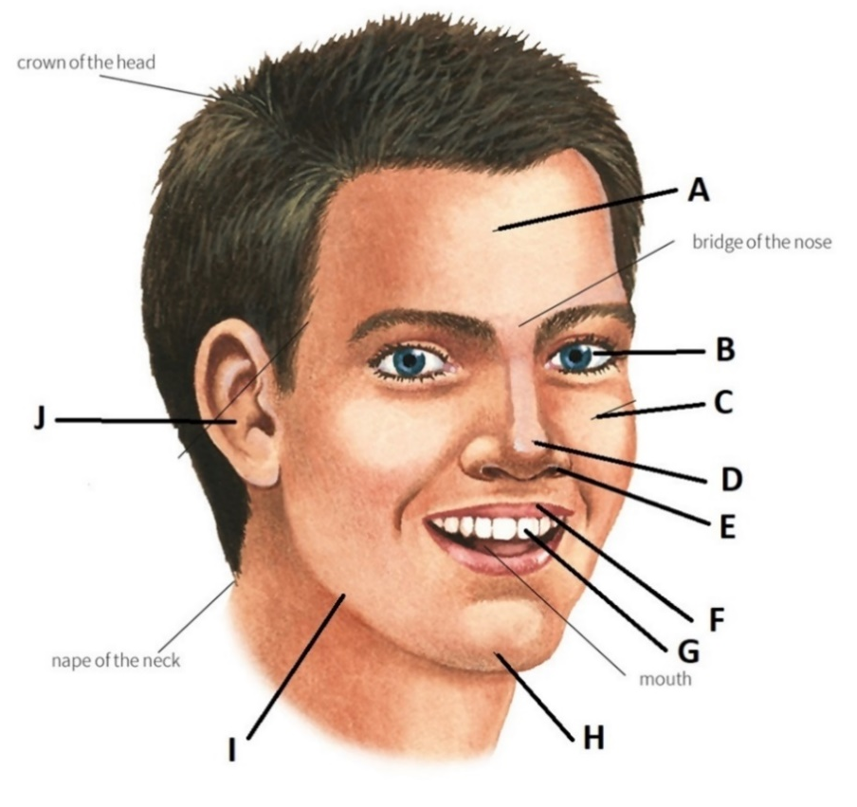
      - Look at the following human face and label the parts indicated (A - J) (@1 MARK =10)
- A _______________________
- B _______________________
- C _______________________
- D _______________________
- E _______________________
- F _______________________
- G _______________________
- H _______________________
- I ________________________
- J ________________________
      - Study the map in the next page carefully, then direct a visitor who wants to go to the bus station from where you are via PINE STREET. Choose the correct word from among the given alternatives to fill in the blanks.

Giving direction (@ 1 MARK = 10)
Move straight ahead (i) ________________ (along/between) the Second Avenue to the first cross junction. On your (ii)_____________________ (left/right) there is a bank. Then turn (iii) _________________ (left/right) and walk along the PINE STREET. On your (iv) ___________ (left / right) there is a central park. Keep walking and after crossing the bank you will see the playground on your (v) _______________(left/right). Move past the playground and you will come to the second cross junction. Turn left and move along the (vi) ______________(SECOND AVENUE/THIRD AVENUE). On your right you will see the Internet café (vii) _____________ (between/among) the drug store and the restaurant. Move straight to the third cross junction. After crossing you will see the Library on your (viii) __________________ (left/right). Go past the library, (ix) ________________ (next/behind) to it there is a Gym. Thereafter you will come to another cross junction. Cross it and turn (x) _________________right/left and you will be facing the bus station. I wish you all the best.

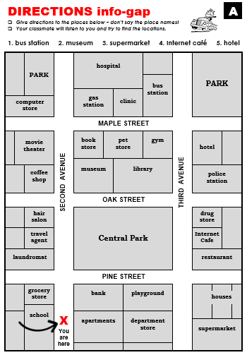

SECTION C (15 marks)
      - Imagine that you have completed your final examinations and your father has arranged for you a trip to Arusha to visit your aunt. Write a letter to your friend requesting him/her to spend one week with you at your aunt’s place. Sign your name as Mazoea Mengi.
……………………………………………………………………………………………………………………………………………………………………………………………………………………………………………………………………………………………………………………………………………………………………………………………………………………………………………………………………………………………………………………………………………………………………………………………………………………………………………………………………………………………………………………………………………………………………………………………………………………………………………………………………………………………………………………………………………………………………………………………………………………………………………………………………………………………………………………………………………………………………………………………………………………………………………………………………………………………………………………………………………………………………………………………………………………………………………………………………………………………………………………………………………………………………………………………………………………………………………………………………………………………………………………………………………………………………………………………………………………………………………………………………………………………………………………………………………………………………………………………………………………………………………………….……………………………………………………………………………………………………………………………………………………………………………………………………………………………………………………………………………………………………………………………………………………………………………………………………………………………………………………………………………………………………………………………………………………………………………………………………………………………………………………………………………………………………………………………………………………………………….……………………………………………………………………………………………………………………………………………………………………………………………………………………………………………………………………………………………………………………………………………………………………………………………………………………………………………………………………………………………………………………………………………………………………………………………………………………………………………………………………………………………………………………………………………………………………….…………………………………………………………………………………………………………………………………………….………………………………………………………………………………………………………………………………………………………………………………………………………………………………………………………………………………………………………………………………………………………………………………………………………………………………………………………………………………………………………………………………………………………………………………………………………………………………………………………………………………………………………………………………………………………………………………

