PRIME MINISTER’S OFFICE
REGIONAL ADMINISTRATION AND LOCAL GOVERNMENT ARUSHA REGION

FORM THREE TERMINAL EXAMINATION
CODE:062 BOOK-KEEPING
TIME: 3: 00 HRS 2026
INSTRUCTIONS
- This paper consists of sections A, B and C with a total of nine questions.
- Answer all questions.
- Sections A carries fifteen marks and B carries forty marks and Section C carries forty-five marks.
- All writings must be in blue or black ink.
- All answers must be written in the spaces provided.
- Cellular phones and any unauthorized materials are not allowed in examination room.

SECTION A (15 MARKS)
Answer all questions in this Section

- For each of the items (i) – (x) , choose the most correct answer from among the given alternatives and write its letter beside the item number in the answer sheets(s) provided
  - Which of the following errors are corrected through the suspense account?
    - Posting a wrong figure to an account
    - Errors of complete reversal entries
    - Error of omission
    - Errors of principle
    - Compensating errors

  - If an accumulated provision for depreciation account is in use, the entries for the year`s depreciation would be:
    - Debit asset account, Credit profit and loss account
    - Credit provision for depreciation account, Debit profit and loss account C. Credit assets account, Debit profit provision for depreciation account
D. Credit profit and loss account, Debit provision for depreciation account E. Debit profit and loss account, Credit assets account

  - Blue Mellow Company is a registered manufacturing firm dealing with Producing and supplying clothing. During 2021, a company bought a motor van for TZS 6,000,000/=. It was estimated to be used for four years, then be sold at a scrap value of TZS 2,000,000/=. What was the annual amount of depreciation if the straight line method is used?
    - TZS 1,500,000/= D. TZS 6,000,000/=
    - TZS 2,500,000/= E. TZS 1,000,000/=
    - TZS 8,000,000/=

  - Seypalm, a sole proprietor, took out goods worth TZS 30,000/= from his business for private use. What would be a double entry transaction of this transaction?
    - Debit Cash account, Credit Drawings account
    - Debit Drawings account, Credit purchases account
    - Debit Cash account, Credit Capital account
    - Debit Drawings, Credit Bank account
    - Debit Drawings account, Credit Cash account

  - When the financial statements are prepared, the bad debts account is closed by being transferred to:
    - Statement of financial position
    - Income statement
    - Trading account
    - Suspense account
    - Provision for doubtful debts account

  - Baraka bought 5 items of TZS 800 each, and was given allowance of 25% trade discount and 5% cash discount; if he could settle within the agreed credit period, how much was paid?
    - TZS 2,850 D. TZS 4,000
    - TZS 2,800 E. TZS 3,000
    - TZS 2,600

  - On 20th October, 2022, Bright, a sole trader, purchased a machinery paying TZS 3,500,000/= by cheque. What would be a double entry for this transaction?
    - Debit: Cash account, Credit: Machinery account
    - Debit: Purchases account, Credit: Machinery
    - Debit: machinery account, Credit: Bank account
    - Debit: Purchases account, Credit: Bank account
    - Debit: Machinery account, Credit: Cash account

  - During 2022, the following information was available in the books of Julius Stores, a solely owned business: Premises TZS 120,000/=, Inventory TZS 85,000/=, Loan from NBC TZS 46,000/=, Cash in hand TZS 40,000/=, Accounts payable TZS 30,000/=. What was the amount of capital for a business?
    - TZS. 245,000/= D. TZS 85,000/=
    - TZS. 169,000/= E. TZS. 120,000/=
    - TZS. 76,000/=

  - Which of the following is treated as current assets in the preparation of statement of financial position?
    - Prepaid income D. Depreciation
    - Accrued expenses E. Bad debts
    - Accrued revenue

  - A business has the cost of goods sold worth Tsh 150,000 and the mark-up of 40%. Calculate the amount of sales for the business
    - Tshs 102,000 D. Tshs 210,000
    - Tshs 60,000 E. Tshs 150,000
    - Tshs 90,000

- Match the explanation in column A with the corresponding names in column B by writing the letter of the correct responses in your exercise book.
COLUMN A COLUMN B
    - These are expenses paid for but not yet incurred. A. Accrue concept
    - These are revenue received in advance before it is earned. B. Accrued expenses
    - This is where the company has provided the service but have C. Revenue expenditure
not yet received the income from the customer. D. Accrued income
    - This concept requires an accountant to recognize revenue E. Prepaid income when is earned and not when it is received; expenses when F. Prepaid expenses
incurred, not when they are paid for. G. Capital expenditure
    - These are expenses not yet paid but have been incurred.

SECTION B (40 MARKS)
Answer all questions in this section
- (a) What is accounting cycle?
(b) State eight procedures to be followed when preparing financial statements.

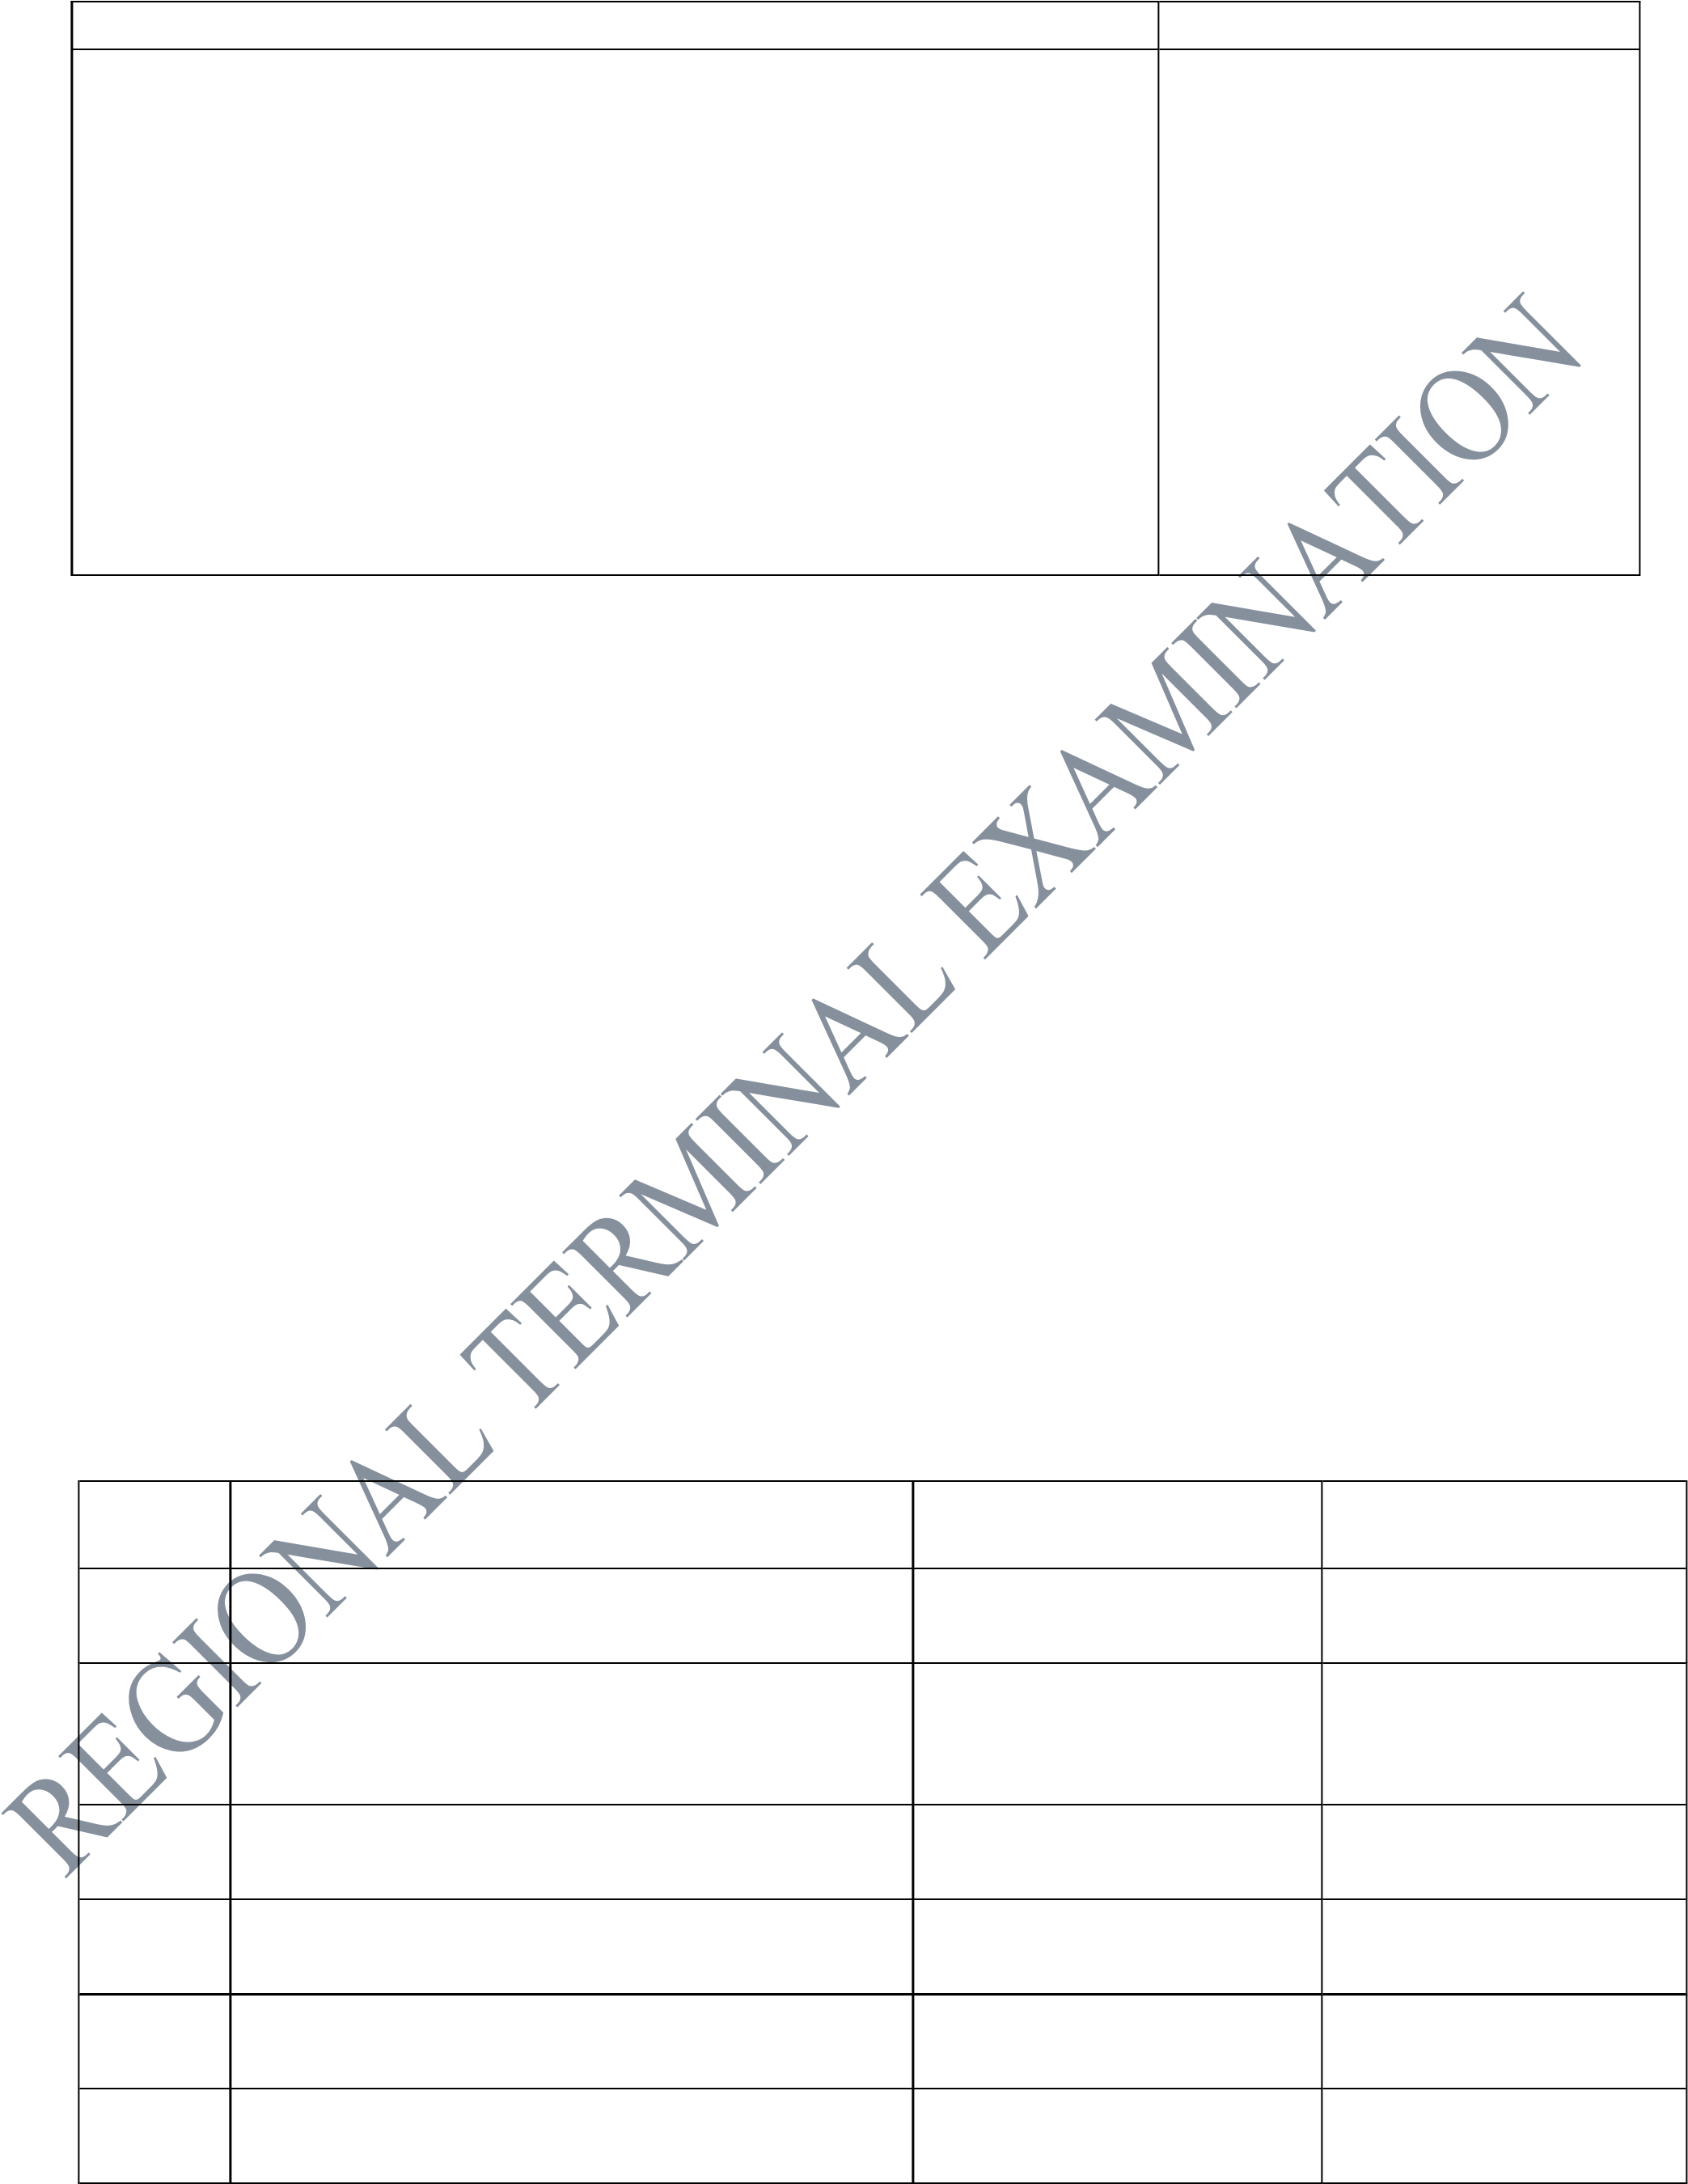
- (a) In 2025 Mr. Zuberi bought a motor car for the cost value of TZS 8,000,000/= with the aim of assisting him in business. But three years later he decided to dispose it for a book value of TZS 6,700,00/=. Mention five reasons that could be the causes for him to dispose the car for less than the cost value.
(b) The following information relate with transactions from the books of Shedrack Enterprises on the date shown:
1st Jan 2021 31st Dec. 2021
Rent outstanding 420,000 320,000
Rent paid in advance 550,000 120,000
A total of TZS. 1,870,000 cash were paid for rent during the year.
You are required to prepare Rent account showing amount to be transferred to income statement.

- Identify the effect of transaction on components of accounting equations.
S/N TRANSACTIONS EFFECT ACTION

      - Bought a van paying by cheque Increase asset of van Debit van account
Decrease asset of bank Credit bank account
      - Sold some equipment that was not
needed at cost of 1,100 on credit to Jose
      - Returned some of the equipment costing 2,300 to house suppliers.
      - Jose pays the firm the amount owing
1,100 by cheque.
      - Bought another van paying by cheque
4,300
      - Paid 9,700 to house supplier by cheque.

- On 31st December 2021, Brigitha’s bank balance as shown by the cash book was TZS 64,000. On receipt of bank statement, it was found that: - (i) The bank statement balance was 69,470.
    - A cheque of TZS 7,500 drawn in a favour of a supplier on 28th December 2021 had not been presented to the Bank payment.
    - The bank had credited TZS 8,200 on 30th December 2021, in respect of dividend collected, the information not having yet been received.
    - A cheque of TZS 9,500 deposited into a bank on 30th December 2021 had been credited to the bank statement on 4th January 2022.
    - The bank had debited TZS 230 bank charges on 30th December 2021 but not entered in the cash book.
    - During December, the Bank had paid TZS 500 for a yearly contribution of Brigitha, made to Lindi Press Club, as per her standing order. This amount appeared in the Bank Statement only. Required: Prepare bank reconciliation statement start with balance as per cash book.

SECTION C (45 MARKS)
Answer all questions in this section.
- Write up a petty cash book of Lobilo Hardware with analysis columns for cleaning expenses, office expenses, wages and motor expenses on 1st March 2022. The cash float is TZS 3,000,000 and the maximum amount in any petty cash voucher is TZS 500,000. The amount spent is reimbursed on 31st March 2022.
TZS
1/03/2022 Paid wages 90,000
2/03/2022 Bought paper reams 205,000
3/03/2022 Paid motor repair 335,000
4/03/2022 Bought cleaning materials 20,000
5/03/2022 Paid for large envelopes 55,000
9/03/2022 Paid petrol 170,000
12/03/2022 Paid wages 80,000
13/03/2022 Paid cleaner 40,000
14/03/2022 Bought staple pins 15,000
15/03/2022 Paid for diesel 95,000
17/03/2022 Bought staple machines 50,000
20/03/2022 Paid petrol 185,000
23/03/2022 Paid motor insurance 475,000
25/03/2022 Paid wages 330,000
26/03/2022 Paid window cleaner 70,000
28/03/2022 Bought a motor pump for water 415,000

- Kafuku Company with the financial year ending on 31st December bought two motor vans on 1st January 2011, No 1 for TZS 18,000,000 and No 2 for TZS 15,000,000. It also buys another van, No. 3 on 1st July 2012, for TZS 19,000,000 and another No 4 on 1st October, 2013 for TZS
17,200,000 the van No 1 was sold for TZS 6,290,000 on 30th September 2014. It is a company’s policy to charge depreciation at 15% per annum using a Diminishing balance method on full year basis, and no depreciation is charged on the year of disposal.
Required: Prepare for the year ended 31st December, 2011, 2012, 2013 and 2014.
  - Motor van account
  - Accumulated Provision for depreciation account (c) Motor van disposal account.

- Miss Janerosa owns a business which deals with electronic devices. One of her accountants prepared the following trial balance, which did not agree.
Janerosa trial balance as at 31st December 2024.
