THE UNITED REPUBLIC OF TANZANIA
THE PRESIDENT’S OFFICE
REGIONAL ADMINISTRATION AND LOCAL GOVERNMENT
LONGIDO DISTRICT
ANNUAL JOINT EXAMINATION

FORM THREE
BASIC MATHEMATICS
MARKING SCHEME NOVEMBER 2024
SECTION A
- (a) i. ${1 109}^{2}=1 229 881$........................................................................................$00\frac{1}{2}$ mark
$\sqrt{841}=±29$.......................................................................................................$00\frac{1}{2}$ mark
The least or lowest sum $=1 229 881-29=1 229 852$....................................$00\frac{1}{2}$ mark
$1 229 852=$ One million, two hundred twenty nine thousand, eight hundred fifty two.$00\frac{1}{2}$ mark
ii. $0.454545…=0.\overline{45}$
Let $0.\overline{45 }be y$
$y=0.\overline{45}$........................................................................................................equation 1
$y×100=0.\overline{4545}×100=45.45$
$100y=45.45$ .......................................................................................................equation2
Subtract equation 1 from equation 2
$-\left|\begin{matrix}100y=45.45 \\ y=0.45\end{matrix}\right.$
$99y=45$
$\frac{99y}{99}=\frac{45}{99} y=\frac{45÷9}{99÷9}=\frac{5}{11}$.........................................................................................01 mark.
Fraction for girls $=1-\frac{5}{11}=\frac{6}{11}$...............................................................................01 mark
(b) i. $0.0607879≈0.061$ ii. $0.0607879≈0.0608$ ................................................02 marks

- (a) ${100}^{\sqrt{x}}=\sqrt{{1 000}^{x}}$
${10}^{2\sqrt{x}}=\sqrt{{10}^{3x}}$
${10}^{2\sqrt{x}}={\left({10}^{3x}\right)}^{\frac{1}{2} }$
${10}^{2\sqrt{x}}={10}^{\frac{3x}{2}}$
$2\sqrt{x}=\frac{3x}{2}$......................................................................................................01 mark
${\left(2\sqrt{x}\right)}^{2}={\left(\frac{3x}{2}\right)}^{2}$
$4x=\frac{{9x}^{2}}{4}$....................................................................................................01 mark
$\frac{{9x}^{2}}{4}-4x=0$
$x\left(\frac{9x}{4}-4\right)=0$
Either $x=0 or \frac{9x}{4}-4=0$
Therefore,$x=0 or x=\frac{16}{9}$......................................................................................01 mark

(b) i. $M=\log_{2}\left(\left(x+3\right)\left(x-3\right)\right)$
$=\log_{2}\left(x^{2}-9\right)$
$2^{M}=x^{2}-9$..............................................................................................$00\frac{1}{2}$ mark.
$x^{2}=2^{M}+9$
$x=±\sqrt{2^{M}+9}$ ............................................................................................01 mark
$ii$. From $M=4 , x=±\sqrt{2^{4}+9}$
$=±\sqrt{16+9}$
$=±\sqrt{25}$..........................................................................$00\frac{1}{2}$ mark
$=±5$
$x=5,x≥0$ ........................................................................01 mark

- (a) $n\left(U\right)=20,$
$n\left(A∪B\right)=n\left(A\right)+n\left(B\right)-n\left(A∩B\right)$
$n\left(A∩B\right)=n\left(A\right)+n\left(B\right)-n\left(A∪B\right)$
$=10+11-18$
$=3$
From Venn diagram:
7

3

8

2

A

B

U

00½ mark

00½ mark

00½ mark

00½ mark

$n{\left(A∩B\right)}^{'}=7+2+8=17$...........................................................................01 mark
(b) Number of subsets in a set is given by $2^{n}$..........................................$00\frac{1}{2}$ mark
$2^{n}=128$..............................................................................................$00\frac{1}{2}$ mark
$2^{n}=2^{7}$....................................................................................................01 mark
$n=7$
Therefore, there are 7 elements...................................................................01 mark
- (a) i. Solve for $y$ from $2x-3y+7=0$
$3y=2x+7$..........................................................01 mark
$\frac{3y}{3}=\frac{2x+7}{3}$...................................................................01 mark.
$y=\frac{2x}{3}+\frac{7}{3}$.................................................................01 mark
ii. Gradient or slope $=m=\frac{2}{3}$...................................................................................01 mark
iii. $y-$ Intercept $=c=\frac{7}{3}$.........................................................................................01 mark

(b) $m=\frac{y_{2}-y_{1}}{x_{2}-x_{1}}$..........................................................................................$00\frac{1}{2}$ mark
$2=\frac{4-2}{4-x}$ .......................................................................................$00\frac{1}{2}$ mark
$2\left(4-x\right)=2$
$8-2x=2$...........................................................................................$00\frac{1}{2}$ mark
$8-2=2x$
$6=2x$..........................................................................................$00\frac{1}{2}$ mark
$\frac{2x}{2}=\frac{6}{2}$
$x=3$................................................................................................01 mark
- (a) $\overline{BF}=\overline{CE}$ ( given side)........................................................................................$00\frac{1}{2}$ mark
$∠BEC=∠BFC={90}^{°}$ (given angle)..................................................................$00\frac{1}{2}$ mark
$\overline{BC}$ is common side( hypotenuse).......................................................................01 mark
Therefore $\overline{CF}=\overline{BE}$ by RHS postulate...........................................................01 mark
(b) Extend line $\overline{AB} to E$
A
D
B
C
$${54}^{o}$$

${64}^{o}$ − $x$

E

${54}^{o}$

$$x$$

$$y$$

$$x$$

$∠DCB=∠EBC \left(\overline{AB}∥\overline{DC} alternate interior angles\right)$.......................$00\frac{1}{2}$ mark
$∠ADB= ∠ABD\left(Base angles of isoscless triangle\right)$ .....................$00\frac{1}{2}$ mark
Let $∠DBC be y and ∠ABD be x$
$x+y+{54}^{°}={180}^{°}$ (Straight-line angle)
$x+y={180}^{°}-{54}^{°}$
$x+y={126}^{°}$ .....equation 1 ..............................................................$00\frac{1}{2}$ mark
$∠BDC={64}^{°}-x$
m${64}^{°}-x+{54}^{°}+y={180}^{°}$
$y-x={180}^{°}-\left({64}^{°}+{54}^{°}\right)$
$y-x={62}^{°}$........equation 2........................................................$00\frac{1}{2}$ mark
Solve equation 1 and 2 by elimination method
$+\left|\begin{matrix}y+x={126}^{°} \\ y-x={62}^{°}\end{matrix}\right.$
$2y={188}^{°}$.....................................................................................$00\frac{1}{2}$ mark
$\frac{2y}{2}=\frac{{188}^{°}}{2}$
$y=∠DBC={94}^{°}$..........................................................................$00\frac{1}{2}$ mark

- (a) 59 dag$=590 g$......................................................................................01 mark
$-\left|\begin{matrix}112 kg 70 g \\ 35 kg 590 g\end{matrix}\right.$ ....................................................................01 mark
- $kg 480 g$
Therefore the mother weighs 76 kg 480 g...............................................01 mark
(b) Let Seypalm’s speed be $x km\left| hr and Jonathan^{'}s speed be y km\right|hr$
From time = $\frac{distance}{speed}$ , then
$\frac{30 }{x }$ −$\frac{30}{y}$= 2.......equation 1 ...............................................................$00\frac{1}{2}$ mark
$\frac{30}{y}-\frac{30}{2x}$ = 1.........equation 2.................................................................$00\frac{1}{2}$ mark
Solve equation 1 and 2 by elimination method
$\frac{30}{x}-\frac{30}{2x}$= 3............................................................................................$00\frac{1}{2}$ mark.
$x\left(\frac{30}{x}-\frac{30}{2x}=3\right)$
$30-15=3x$
$3x=15$..........................................................................................$00\frac{1}{2}$ mark
$\frac{3x}{3}=\frac{15}{3}$
$x=5$
Therefore, Seypalm’s speed is 5 km|hr ..............................................01 mark

- (a)$\frac{x}{y}=\frac{0.04}{1.5}=\frac{4}{150}=\frac{2}{75}$..............................................................................01 mark
$=\frac{y-x}{x+y}=\frac{\frac{y}{y}-\frac{x}{y}}{\frac{x}{y}+\frac{y}{y}}$................................................................................$00\frac{1}{2}$ mark
= $\frac{1-\frac{x}{y}}{\frac{x}{y}+1}=\frac{1-\frac{2}{75}}{1+\frac{2}{75}}$.................................................................................$00\frac{1}{2}$ mark
= $\frac{\frac{75-2}{75}}{\frac{77}{75}}=\frac{\frac{73}{75}}{\frac{77}{75}}$
= $\frac{73}{75}×\frac{75}{77}=\frac{73}{77}$.................................................................................01 mark.
(b) THE TRIAL BALANCE OF SEYPALM CO BUSINESS
Name of account | Debit | Credit
Capital |  | 30 000
Furniture | 25 000
Motor vehicle | 45 000
Sales |  | 68 000
Purchases | 54 000
Creditor |  | 76 000
Debtor | 15 000
Insurance | 3 000
Cash | 18 000
Discount received |  | 7 000
Discount allowed | 4 000
Drawing | 12 000
Electricity | 5 000
 | 181 000 | 181 000...............03 marks

- (a) Let 5 arithmetic mean numbers be $a, b c, d. e$
$A_{1}=17$
$A_{2}=A_{1}+d=a, A_{3}=A_{1}+2d=b, A_{4}=A_{1}+3d=c$
$A_{5}=A_{1}+4d=d , A_{6}=A_{1}+5d=e, A_{7}=A_{1}+6d=53$
From $A_{7}=A_{1}+6d=53$ but $A_{1}=17 17+6d=53$
$6d=53-17=36$
$\frac{6d}{6}=\frac{36}{6} , d=6$........................................................................$00\frac{1}{2}$ mark
$A_{2}=a=17+6=23$..............................................................$00\frac{1}{2}$ mark
$A_{3}=b=17+2×6=17+12=29$.....................................$00\frac{1}{2}$ mark
$A_{4}=c=17+3×6=35$........................................................$00\frac{1}{2}$ mark
$A_{5}=d=17+4×6=41$........................................................$00\frac{1}{2}$ mark
$A_{6}=e=17+5×6=47$.........................................................$00\frac{1}{2}$ mark
Therefore, the 5 arithmetic mean between 17 and 53 are 23, 29, 35, 41, and 47
(b) $G_{1}=p-2, G_{2}=p-1, G_{3}=3p-5$
$r=\frac{G_{3}}{G_{2}}=\frac{G_{2}}{G_{1} }$
$r=\frac{3p-5}{p-1}=\frac{p-1}{p-2}$
$\left(3p-5\right)\left(p-2\right)=\left(p-1\right)\left(p-1\right)$
${3p}^{2}-6p-5p+10=p^{2}-2p+1$
${3p}^{2}-p^{2}-11p+2p+10-1=0$
${2p}^{2}-9p+9=0$............................................................01 mark
Solve the equation by general formula
$p=\frac{-b±\sqrt{b^{2}-4ac}}{2a} , where, a=2, b=-9, c=9$
$=\frac{9±\sqrt{9^{2}-4×2×9}}{2×2}$
$=\frac{9±\sqrt{81-72}}{4}$
$=\frac{9±\sqrt{9}}{4}=\frac{9±3}{4}$
$=\frac{9+3}{4} or \frac{9-3}{4}$
$=\frac{12}{4} or \frac{6}{4}$
$=3 or \frac{3}{2}$......................................................................................................02 marks

- (a) i. Sin $x=\frac{2y}{4y}=\frac{1}{2}$........................................................................................01 mark
$x=\sin^{-1}\left(\frac{1}{2}\right)$
$={30}^{°}$.............................................................................................01 mark
ii. From triangle PQR
$$x$$

P

R

Q

1

2

$$y$$

01 mark

$y=\sqrt{2^{2}-1^{2}}=\sqrt{4-1}=\sqrt{3 } .$................ ..........................................01 mark
$tanx=\frac{1}{\sqrt{3}}=\frac{1}{\sqrt{3}}×\frac{\sqrt{3}}{\sqrt{3}}$
$=\frac{\sqrt{3}}{3}$....................................................................................................01 mark
(b) $diagonal=\sqrt{{side\left(s\right)}^{2}+{side \left(s\right)}^{2}}$
$=\sqrt{{\left(9 cm\right)}^{2}+{\left(9 cm\right)}^{2}}$..............................................................$00\frac{1}{2}$ mark.
$=\sqrt{{81 cm}^{2}+{81 cm}^{2}}$..................................................................$00\frac{1}{2}$ mark
$=\sqrt{{162 cm}^{2}}$...................................................................................01 mark
$=\left(9\sqrt{2}\right) cm$...................................................................................01 mark

- (a) i. $\frac{{\left(67.542\right)}^{2}-{\left(32.458\right)}^{2}}{75.458-40.374}=\frac{\left(67.542-32.458\right)\left(67.542+32.458\right)}{34.718}$.......................$00\frac{1}{2}$ mark
$=\frac{35.084×100}{35.084}$....................................................$00\frac{1}{2}$ mark
$=100$............................................................$00\frac{1}{2}$ mark
- $\frac{2x}{1+\frac{1}{1+\frac{x}{1-x}}}$= 1
$\frac{2x}{1+\frac{1}{\frac{x+1-x}{1-x}}}=1$

$\frac{2x}{1+\frac{1}{\frac{1}{1-x}}}$ =1

$\frac{2x}{1+1-x}$=1

$\frac{2x}{2-x}$ = 1...............................................................................$00\frac{1}{2}$ mark

$2x=2-x$
$2x+x=2$
$3x=2$..................................................................................$00\frac{1}{2}$ mark
$\frac{3x}{3}=\frac{2}{3}$
$x=\frac{2}{3}$...................................................................................$00\frac{1}{2}$ mark
(b) $\left(2p-1\right)\left(p+1\right)=2\left(2p+2\right)$
${2p}^{2}+2p-p-1=4p+4$
${2p}^{2}+2p-p-4p-1-4=0$
${2p}^{2}-3p-5=0$..............................................................01 mark
Solve the equation by method of factorization
Product is $-10$ and factors are $\left(-5 , 2\right)$............................................01 mark
${2p}^{2}-5p+2p-5=0$
$p\left(2p-5\right)1\left(2p-5\right)=0$
Either $\left(p+1\right)=0 or \left(2p-5\right)=0$
$p=-1 or p=\frac{5}{2}$....................................................01 mark

SECTION B
- (a) So $=x-2, OQ=OP=x \left(radii\right)$.....................................$00\frac{1}{2}$ mark
${OP}^{2}={OS}^{2}+{SP}^{2}$
$x^{2}={\left(x-2\right)}^{2}+6^{2}$...............................................................$00\frac{1}{2}$ mark
$x^{2}=x^{2}-4x+4+36$
$4x=40$....................................................................................01 mark
$\frac{4x}{4}=\frac{40}{4}$
$x=10$ ...................................................................................01 mark
(b)
Class interval | cf | f | cf | Class mark$\left(x\right)$ | $${fx}_{i}$$ | Upper real class limit
$$125-130$$ | 5 | 5 | 5 | 127.5 | 635.5 | 130.5
$$131-136$$ | 13 | 8 | 13 | 132.5 | 1 060 | 136.5
$$137-142$$ | 25 | 12 | 25 | 137 .5 | 1 650 | 142.5
$$143-148$$ | 29 | 4 | 29 | 142.5 | 570 | 148.5
$$149-154$$ | 30 | 1 | 30 | 147. 5 | 147.5 | 154.5
Total |  | 30
 |  | ...$00\frac{1}{2}$ | $00\frac{1}{2}$ mark | ..$00\frac{1}{2}$ mark | $$Σfx_{i}=4 063…01 mark$$ | ..$00\frac{1}{2}$ mark

- $\overline{x}=\frac{Σfx_{i}}{Σf_{i}}=\frac{4 063}{30}$.............................................................$00\frac{1}{2}$ mark
$=135.43$................................................................. ..$00\frac{1}{2}$ mark
- Modal class $137-142$
$Mode=l+\left(+\frac{t_{1}}{t_{1}+t_{2}}\right)i$
$=136.5+\left(\frac{12-8}{\left(12-8\right)+\left(12-4\right)}\right)5$
$=136.5+\left(\frac{4}{4+8}\right)5$......................................................................$00\frac{1}{2}$ mark
$=136.5+\frac{4}{12}×5$
$=136.5+1.66666..$
$=138.17$......................................................................................$00\frac{1}{2}$ mark
- Ogive graph or curve

$$y$$

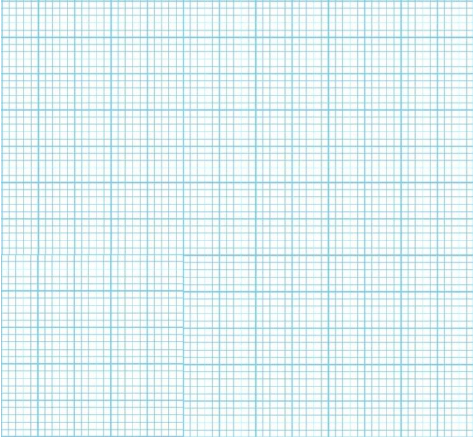
3

6

9

12

15

21

30

27

24

18

Cumulative frequency

$00\frac{1}{2}$ Marks

$$x$$

142.5

148.5

136.5

130.5

124.5

Upper real class limit

Median position $={\left(\frac{n}{2}\right)}^{th }={\left(\frac{30}{2}\right)}^{th}=$15th
$=\frac{6}{10}×2=1.2$
$=136.5+1.2$
$=137.7$
Therefore, estimated median is 137.7 cm.......................................$00\frac{1}{2}$ mark

- (a) Angular distance $={39}^{°}-{33}^{°}=6^{°}$........................................................01 mark.
Since latitudes are constant, therefore the points are on the small circle
Distance in nautical miles $=6^{°}×{60}^{'}cos6^{°}$ ……………………………… 01 mark
$=358.028 nm$ ....................................................01 mark
$t=\frac{ distance }{speed}$
= $\frac{{358.028}^{'}}{20nautical miles per hour}$ ………………….01 mark
$=17.9 hours$
Therefore, it will reach at point B after 17.9 hours ......................................01 mark
(b) Diagram ……………………………………………………………05 marks
-2

-1

0

2

1

0

1

2

4

3

Squared

A

B

- (a) The rotation of point Q (3, 2) through ${270}^{°}$ clockwise about the origin is shown in the following figure
$$x$$

Q’ (-2, 3)

Q (3, 2)

270º

$$y$$

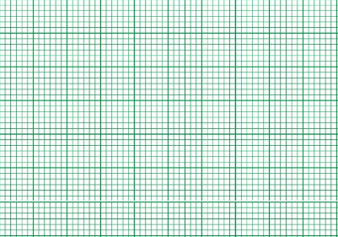
01 mark

01 mark

02 marks

From the figure above $R_{{270}^{°}}\left(3 , 2\right)=(-2 , 3)$....................................................01 mark
Generally, the rotation of a point through${ 270}^{°}$ clockwise about the origin is given by $R_{{270}^{°}}\left(x, y\right)=\left(-x , y\right)$
(b) Principal (p) $=5 000 000$ shillings
Amount (A)$=10 000 000$ shillings
Number of times interest is compounded per year (n) $=2$
Rate (r) $=5.5\%$
Required : time (t)
$A_{t}={p\left(1+\frac{r}{100n}\right)}^{nt}$
$10 000 000=5 000 000{\left(1+\frac{5.5}{200}\right)}^{2t}$
$\frac{10 000 000}{5 000 000}=\frac{5 000 000}{5 000 000}{\left(1.0275\right)}^{2t}$............................................................$00\frac{1}{2}$ mark
$2={\left(1.0275\right)}^{2t}$ introduce log both sides.....................................01 mark
$\log{2}=\log{{\left(1.0275\right)}^{2t}}$....................................................................$00\frac{1}{2}$ mark
$2t=\frac{\log{2}}{\log{1.0275}}$................................................................................01 mark
$t=\frac{1}{2}\left(25.55035862…\right)=12.775..≈13$ years.......................01 mark
Therefore, it will double after 13 years.......................................................01 mark
- (a) $y=-3 for=…-4, -3, -2$
$y=1 for x=-2, -1, 0 , 1$
$y=4 for x=1 , 2 , 3 , …$

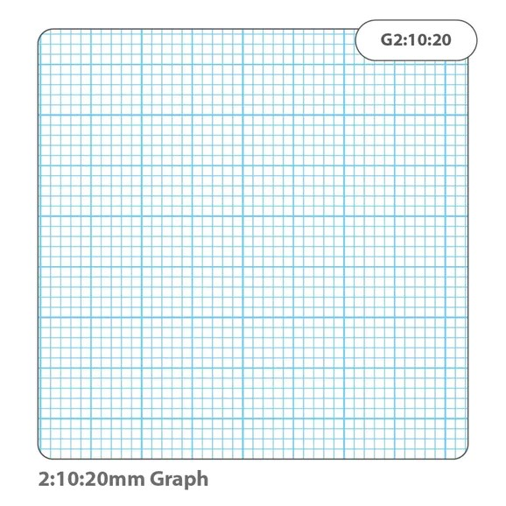
-2

-3

-1

1

0

-4

1

-1

-2

-3

2

3

2

3

4

5

4

5

$$y$$

$$x$$

........................................................$02 mark$s

- Domain $=\left\{All real numbers\right\}$.....................................................$01 mark$s
- $Range=\{-3, 1, 4\}$.......................................................................$01 mark$s
- It is not one to one function………………………………………………………01 mark

(b) Table of values

$$x$$ | ... | $$-3$$ | $$-2$$ | $$-1$$ | 0 | 1 | 2 | 3 | ...
$$y={-x}^{2}+2$$ | ... | $$-7$$ | $$-2$$ | 1 | 2 | 1 | $$-2$$ | $$-7$$ | ...
............................................................................................................$02 marks$
Domain$=\{all real numbers\}$..........................................................$00\frac{1}{2} mark$
Range$=\{y:y≤2\}$.............................................................................$00\frac{1}{2} mark$
$$y$$

$$x$$

$$y={-x}^{2}+2$$

-7

-6

-5

-4

-3

-1

2

1

0

-2

-8

1

2

3

4

-1

-2

-3

$02$ Marks

