MKALAMA DISTRICT COUNCIL
FORM THREE TERMINAL EXAMINATION, MAY 2025
BASIC MATHEMATICS-MARKING SCHEME
1. a) Deposited amount - 360,000/= Bank charges per withdrawal =1000/=
She withdraw 106,000/= two times
Total amount deducted= 106,000x2+1000x2=214000/= 1.5 marks
Remaining amount of money= Tsh 360000-Tsh 214000=Tsh.146, 000/=
1.5marks b) Let x=2.43̇ --------------------i
Multiply by 10 both side
10x=2.43̇ × 10
10x=24.33̈ ……………………ii 1mark
Subtract equation ii from equation i
10x-x=24.33̈ – 2.43̇............................................0.5 mark
9𝑥 21.9 10 219

= × = ........................1mark
𝑥 9 10 90
2.433333………..=219/90 =2¹³ ......... 0.5 mark
30
2. a) 4 log 5 − log 16 + 6 log 2.
= 4 log 5 − log 2 + 6 log 2.
= 4 log 5 − 2 log 2 + 6 log 2. (3 marks) = 4 log 5 + 4 log 2. = 4(log(5 × 2)
= 4(log(10))
= 4

b) 5x+32x−3 = 1 25
5x+3
4x−6 = 1
5
5^{𝑥+3−(4𝑥−6)} =1

5^{−3𝑥+9} =5⁰ (3marks)
−3𝑥+9=0
3𝑥=9
𝑥=3

of
3. (a) Total number of students, μ=100 Students studying physics subject; n (P) =45,
Students studying chemistry n(C) = 40
Students studying both physics and chemistry n (P∩C) = 5
Required: number of students studying none of these subjects
From (𝑃 ∪ 𝐶)′ = 𝑛(𝜇) − 𝑛(𝑃 ∪ 𝐶)
𝑛(𝑃 ∪ 𝐶)′ = 𝑛(𝜇) − (𝑛(𝑃) + 𝑛(𝐶) − 𝑛(𝑃 ∩ 𝐶)
(𝑃 ∪ 𝐶)′ = 100 − (45 + 40 − 5) (03marks)
n(𝑃 ∪ 𝐶)′ = 100 − (80
(𝑃 ∪ 𝐶)′ = 20

There are 20 students studying none of these subjects
(b) Three fifth of students in form three class are male and the rest are female. If there are 36 female students, how many male students are in this class?
let x = Total number of students
3x
Male =
5
3x 2x
Female = x − = = 36 (03marks)
5 5 x = 90

Male students = 90 − 36 = 54
4. a) Given equation y=3x-p Points (6, 10) and (q, 22)
From y=3x-p
p=3x-y, substitute (6, 10) 0.5 mark P=3x6-10=18-10=8
p=8 1mark
Substitute (q, 22) in y=3x-8
22=3q-8 0.5 mark
22+8=3q
30=3q 30/3=q q=10 1mark The value of p=8, q=10 b) Given m=3/4, point (-1, 2)
∆𝑦 𝑦−2
From m= =
∆𝑥 𝑥−−1

But m=3/4= ^{𝑦−2} 1mark
𝑥−−1
3x+3=4y-8
4y=3x+11
3𝑥 11
The equation is 𝑦= + 2mark
4 4
- a)
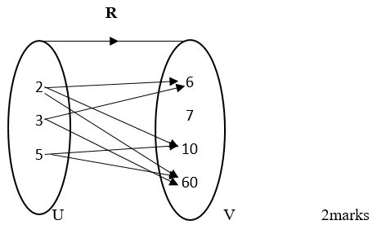 b) Given x+y≤2, x+y=2 Table value x+y=2=y=2-x

x | -2 | -1 | 0 | 1 | 2
y | 4 | 3 | 2 | 1 | 0
1/2mark
Given y≤ 2 = 𝑦 = 2 1/2mark
Graph................ (2marks)

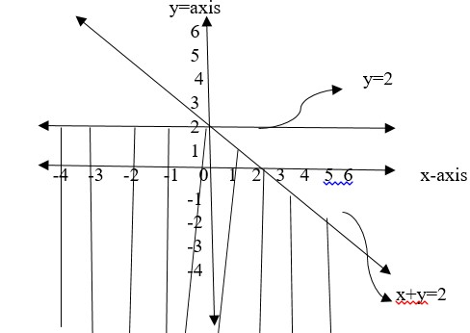
Domain{x: x∈ 𝑅} 1/2mark
Range {y: y≤ 2} 1/2mark
- a) Consider the figure below
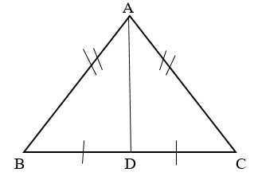
Proof
AD is common side (s) 0.5mark
AB=AC Given sides (s) 0.5mark
BD=DC Given sides (s) 0.5mark
∆𝐴𝐵𝐷 ≅ ∆𝐴𝐶𝐷 𝑏𝑦 𝑠𝑠𝑠 𝑟𝑢𝑙𝑒 0.5marks b) Consider the figure below
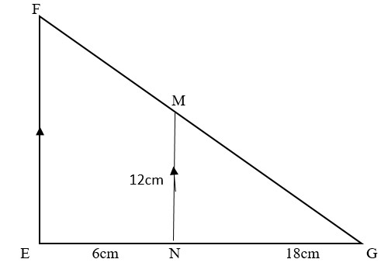

FE//MN Given side (s) 0.5mark
EG//NG Given side (s) 0.5mark
FG//MG Given side (s) 0.5mark
The pairs of similar triangles are ∆𝐹𝐸𝐺 𝑎𝑛𝑑 ∆𝑀𝑁𝐺 From the ratio of corresponding sides
𝐹𝐸 𝐸𝐺 𝐹𝐺
= = 0.5mark
𝑀𝑁 𝑁𝐺 𝑀𝐺
𝐹𝐸 6𝑐𝑚+18𝑐𝑚
= 1mark
12𝑐𝑚 18𝑐𝑚
𝐹𝐸 24𝑐𝑚
=
12𝑐𝑚 18𝑐𝑚
24𝑐𝑚𝑥12𝑐𝑚
FE=
18𝑐𝑚
288𝑐𝑚2
FE= = 16𝑐𝑚
18𝑐𝑚
The length ̅𝐹𝐸̅̅̅̅ is 16cm 01mark

7. a) x∞2𝑦 + 7 0.5mark
Given x1=5 y1=4 X2=6 y2=?
𝑥 2𝑦 + 7
= 𝑘 ( )
2𝑦 + 7 2𝑦 + 7
𝑥
k= 0.5mark
2𝑦+7
𝑥1 𝑥2
=
2𝑦1 + 7 2𝑦2 + 7
5 6
=
2(4) + 7 2𝑦2 + 7
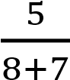 = 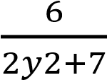
⁵ = ⁶
15 2𝑦2+7
5(2y2+7)=6(15)
10y2+35=90 10y2=90-35
10y2=55
Divide by 10 both side 10y2/10=55/10=5.5 y2=5.5
The value of y=5.5 2marks

b) 𝑊 𝛼 ¹ℎ 𝑎𝑛𝑑 𝑊𝛼 𝑑¹
Where by w=workers h= hours d= days
Joint variation
𝑤 = ℎ^{𝑘}𝑑 k=whd
w1h1d1=w2h2d2 0.5marks d1=52 , h1=8 ,w1=9 w2=13 and h2=6 d2=?
d2= 𝑤𝑤1ℎ12ℎ2𝑑1 d2=^{9×8×52} = 48𝑑𝑎𝑦𝑠 13×6
It will complete 48days 2marks

8. (a) from nth term=2^{𝑛−1}
5th term=2⁴
10th term=2⁹
Sum=16+512=528
(b) 1985, 1986, 1987... 2000
𝑓𝑟𝑜𝑚 𝐴𝑛 = 𝐴1 + (𝑛 − 1) (1.5 marks)
2000 = 1985 + (𝑛 − 1) × 1
𝑛 = 16
Coconut produced 10+13+16+19+......
From _{𝑛} = ^{𝑛}₂ (2𝐴1 + (𝑛 − 1)𝑑
𝑆16 = 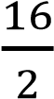 (2 × 10 + (16 − 1) × 3) (1.5 marks)
𝑆16 = 520

Coconuts produced from 1985 to 2000 is 520 coconuts

9. a) Given function f(x)=x²+6x-7 a=1 , b=6 , c=-7
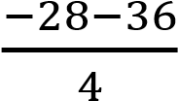
  - AxB of symmetry X=-b/2a=-6/2=-3 1mark 4𝑎𝑐−𝑏²
  - 𝑦 = = = −16 (2marks)
4𝑎
Maximum value is -16

(b) 𝑥² + 6𝑥 − 7 = 0
𝑥² + 6𝑥 = 7
(𝑥 + 3)² − 9 = 7 (1.5 marks)
(𝑥 + 3)² = 16
By applying square root both sides

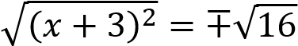
𝑥 + 3 = ∓4 (1.5 marks)

𝐸𝑖𝑡ℎ𝑒 = −7 𝑜𝑟 𝑥 = 1




10. (a)
7
m

4
m

h

𝑓𝑟𝑜𝑚 𝑎² + 𝑏² = 𝑐² (03marks)
4² + ℎ² = 7²

ℎ = √33𝑚 ℎ ≈ 5.74𝑚

The point where the ladder meets the wall is approximately 5.74 m high above the floor

b)
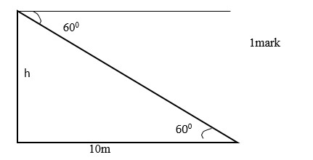
From tan 60⁰=opposite/adjacent 0.5mark
Tan 60⁰=h/10m 0.5mark
h=tan60⁰x10m
h=10mx1.732 =17.32m 0.5mark
The lower is 17.32m 0.5mark

- a) given A=34.5
Intervals | f | x | d=x-A | fd
0-9 | 3 | 4.5 | -30 | -90
10-19 | 4 | 14.5 | -20 | -80
20-29 | 6 | 24.5 | -10 | -60
30-39 | 8 | 34.5 | 0 | 0
40-49 | 3 | 44.5 | 10 | 30
50-59 | 5 | 54.5 | 20 | 100
60-69 | 3 | 64.5 | 30 | 90
70-79 | 2 | 74.5 | 40 | 80
80-89 | 1 | 84.5 | 50 | 50
4mark
𝜀𝑓 = 35 𝑎𝑛𝑑 𝜀𝑓𝑑 = 120
𝑁
−𝑁𝑏
  - Median =L+ ( ² )𝑖 1mark
𝑁𝑤
L=29.5
N=35 Nb=13 i=10
Nw=8
Median=29.5+(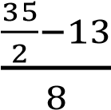)10
29.5+5.625=35.125=35.13
The median =35.13 2marks
𝜀𝑓𝑑
  - Mean=A+ 1mark
𝜀𝑓
34.5+120/35
34.5+3.4285=37.93
The mean =37.93 2marks

- i) Drawn graph
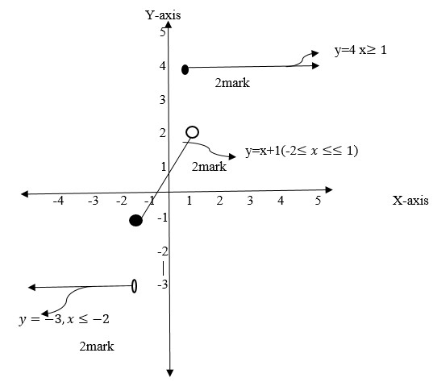
y=x-1 Table value
x | -2 | -1 | 0 | 2
y | -1 | 0 | 1 | 2
1mark ii)g(-5)=-3 1mark g(10)=4 1mark
i) Domain={x:x∈ 𝑅} 1/2mark
Range={y:y=-3,-1,0,1,2,4} 1/2mark
13. a)Require to factorize p²-q² By using different of two squares
p²-q²= (p+q)(p-q)
Then p²-q²= (p+q)(p-q) 3mark b) From 12a above p²-q²= (p+q)(p-q)
Then 1024-64=32²-8² 1mark
Since p²-q²=(p+q)(p-q)
32²-8²=(32+8)(32-8) 2mark
=(40)(24)=960 Then 1024-64=960 1mark c) Given 6x²-11xy-y² Find factors of 60 from
6x²-11xy-10y² 1mark
Factors are -15 and 4 then
6x²-15xy+4xy-10y² 1mark
(6x²-15xy)+(4xy-10y²)
3x(2x-5y)+2y(2x-5y) 1mark
(3x+2y)(2x-5)
6x²-11xy-10y²=(3x+2y)(2x-5y) 1mark
14. a) y>x
- The ordered pairs belong to relation R={X,Y:Y>X} are
(1,2) ,(-3,4) ,(-5,0), (-8,-3) 1mark
- Domain= {1,-3,-5,-8} 2marks
Range ={2,4,0,-3} 2marks
b) Rate of growth of seedling A
5cm/10days=0.5cm/day 2marks
Rate of growth of seedling B
8cm/12days=0.67cm/day 2marks
The growth rate of seedling B was greater than seedling A hence seedling B was growing more quickly than the seedling A 1mark

