PRESIDENT’S OFFICE
REGIONAL ADMINISTRATION AND LOCAL GOVERNMENT
MOROGORO MUNICIPAL COUNCIL

FORM THREE TERMINAL JOINT EXAMINATION
CODE: 041 BASIC MATHEMATICS
TIME: 3HRS MAY, 2025

INSTRUCTIONS:
1. This paper consists of section A and B with a total of fourteen (14) questions 2. Answer all questions
- Each question in section A caries six (6) marks while each question in section B carries ten (10) marks
- All necessary working and answer for each question must be shown clearly
- NECTA mathematical tables and non- programmable calculators may be used
- All communication devices and any unauthorized material are not allowed in the Examination room
- Write your examination Number on every page of your answer booklet(s)

SECTION A (60 MARKS)
Answer all questions in this section.
- (a) Round off
i. 9.67 to ones ii. 0.205 to one decimal place iii. 0.0197 to two decimal places
Hence use the results to estimate the value of ( write your answer in
mathematics notation).

  - Three bells are set to ring at intervals of 12 minutes, 15 minutes and 24 minutes. If they started together at 2:00 p.m, then find at what time will the bells ring together for the second time.
- (a) Given that , determine .
  - (i) Given that: =1, find the values of x and y.
(ii) Given that 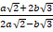=3 .Show that 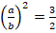
- (a) There are 60 people at the meeting.35 are business persons,32 are employees and 15 are both business persons and employees.
    - How many are business persons or employees ii) How many are neither business persons nor employees? (b) A line through points A (2, -k) and B (4, 3) has a gradient 2. Find; i) The value of k
    - The equation of a line AB

- (a) The average mass of 50 students is 48kg.When Alvin is absent the mass of the class is 47kg. Calculate Alvin’s mass.
  - A bus leaves the bus station at 06:43am and it takes 2hours and 48 minutes to reach the destination. What is the arrival time in 24 hours clock system?

- (a) Find the image of the point after a rotation through about the origin in the anticlockwise direction by using xy-plane
  - The perimeter of a Triangle ABC is ,

if
. Find the value of , hence

and
calculate the actual length of
,

and

- (a) A lorry carries 7.2 tonnes of sand from the mining area to the industrial site.On the way 230kg of sand either fall off or blow away. What mass of sand will remain by the end of the journey? Give the answer in tonnes.
  - The number of tablets given to a patient was found to be directly proportional to the weight of the patient. If patient with 36 kg was given 9 tablets, Find how many tablet would be given to a patient whole weight is 48 kg

- (a) An alloy consists of three metals A, B and C in the proportions and .Calculate the proportion .
  - Teacher Andrew sell an article for Tsh 480/= and make a profit of 30 %. What would be his percentage loss if he sold the article for Tsh 288/=.?

- (a) Find the first term and common difference of an arithmetic progression whose 5th term is 21 and 8th term is 30
  - The sum of three consecutive terms of an Arithmetic Progression is 21, their product is 280. Find:
i. The three consecutive terms. ii. Their common difference.

- (a) If, Find the value of .
  - Find the Length of the ladder which is supposed to reach the top of the vertical wall which is 15m high from the ground. If the ladder foot is to be set 6m away from the wall.
- (a) Juma went to the market with 3,000Tsh to buy oranges and mangoes. He bought 20 oranges and 5 mangoes. If Asha went to the same market with 2,000 Tsh and bought 10 oranges and 5 mangoes, What is the price of one mango and one orange?
(b). Solve the equation by completing the square.

SECTION B (40 Marks)
Answer all questions in this section.
- The masses of 40 students joined Form Five 2017 Togolani Secondary school in Tanga were recorded as follows:-

60 | 64 | 63 | 67 | 66 | 68 | 59 | 58 | 59 | 60
64 | 66 | 65 | 60 | 73 | 70 | 63 | 69 | 70 | 60
66 | 70 | 74 | 69 | 63 | 69 | 59 | 65 | 64 | 65
73 | 61 | 62 | 64 | 61 | 61 | 62 | 63 | 68 | 73
From the data above :
- Tabulate as a frequency distribution using intervals 50-59, 60-69, etc.
- Calculate :
  - The mean score if the assumed mean is obtained from the mid mark of the modal class.
  - The median.
  - The size of class interval
- Draw a histogram and frequency polygon on the same diagram.

12. (a) Use the following figure to find the values of x and y

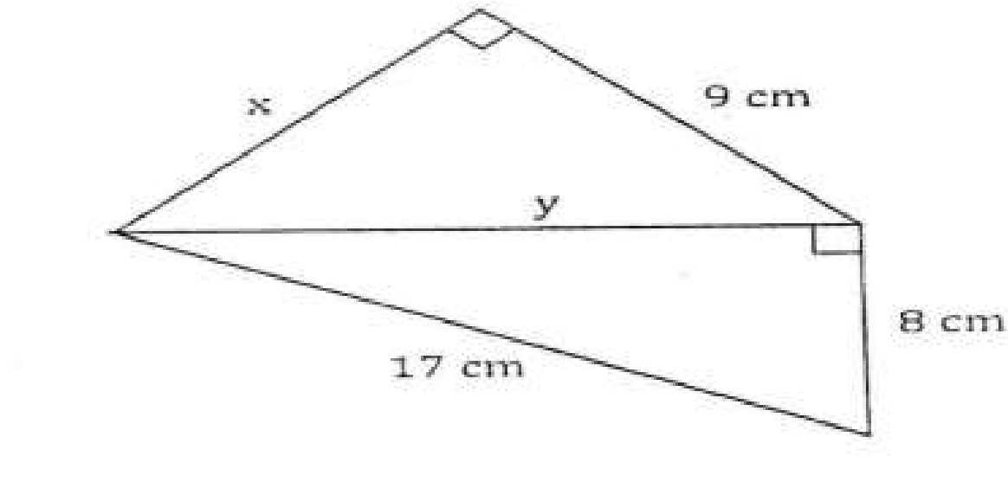
(b) Winifrida was given Tsh. 80 000 by her father. She spent 25% of the money to pay for examination fee, Tsh. 10 000 to buy a pair of shoes and ½ of the remaining money as transport fare to school. How much money remained?

13 (a) Study carefully the grid square given below

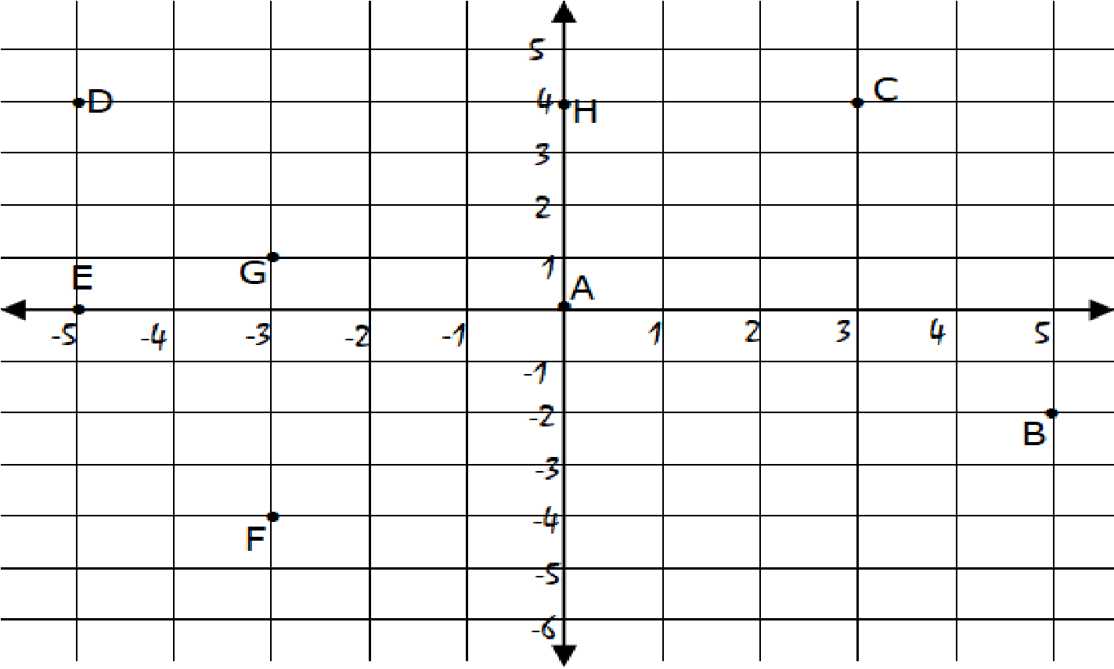

- On the figure, label the axes.
- Give the coordinates of each point.
A [ ] ,B [ ], C [ ], D [ ], E [ ], F [ ], G [ ], H [ ]
- On the grid, join the points A, E, C and D; give the name of the resulting figure.
(b) A regular polygon has an interior angle of 120˚. Find
- The number of sides
- The sum of interior angle of the polygon
14. (a) Draw the graph of the relation and hence state
its domain and range.
(b) A function is defined by and is another function of such that
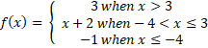

. Find

(
c) Given that:
- Sketch the graph of .
- Find .
- State the domain and range of

