PRESIDENT’S OFFICE
REGIONAL ADMINISTRATION AND LOCAL GOVERNMENT
NAMANGA SECONDARY SCHOOL
FORM THREE MID-TERM EXAMINATIONS
BASIC MATHEMATICS
TIME: 3:00HRS AUGUST, 2025

INSTRUCTIONS
- This paper consists of section A and B making a total of fourteen (14) questions.
- Answer all questions in section A and B.
- Each question in section A carries six (06) marks while each question in section B carries ten (10) marks.
- All communication devices, programmable calculator and any unauthorized materials are not allowed in the examination room.
- Write your examination names on every page of your answer sheet (s) provided.

SECTION A: (60 MARKS)
- (a) Mwajuma deposited Tsh.360, 000 in a bank account. The bank charges Tsh.1, 000 for every withdrawal. How much money remained in her account if she withdraws Tsh.106, 000 two times?
  - Write 2.4333333333....as a mixed fraction.
- (a) Without using table evaluate 4 log 5 − log 16 + 6 log 2

  - Find the value of x given that : $\frac{5^{x+1}}{{25}^{2x-3}}$=1

- (a) In a class of 100 students, 45 students study physics subject, 40 students study chemistry and 5 students study both physics and chemistry. How many students study none of these subjects?

  - Three fifth of students in form three class are male and the rest are female. If there are 36 female students, how many male students are in this class?

- (a) If the line whose equation is 𝑦 = 3𝑥 – passes through the point (6,10) and(𝑞, 22) find value of 𝑝 and 𝑞 where 𝑝 and 𝑞 are integers.
  - A line has a gradient of ¾ and passes through point(−1, 2) find its equation.
- (a) Let 𝑈 = { 2,3, 5 } and 𝑉 = { 6,7, 10, 60}. Draw a pictorial diagram between 𝑈 and 𝑉 to illustrate the relation ‘’ is a factor of ‘’
(b) If 𝑅 = {(𝑥, 𝑦): 𝑥 + 𝑦 ≤ 2 𝑎𝑛𝑑 𝑦 ≤ 2} is a relation of real numbers. Draw a graph of 𝑅 and state the domain and range.
- (a) Triangle ABC is isosceles triangle in which ̅𝐴𝐵̅̅̅ and ̅𝐴𝐶̅̅̅ are equal. If D is the midpoint of ̅𝐵𝐶̅̅̅, Prove that ∆𝐴𝐵𝐷 ≅ ∆𝐴𝐶𝐷
of
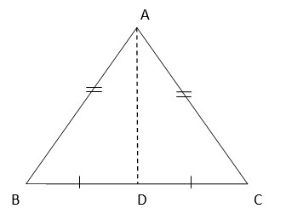

  - State with reasons, the pair of similar triangles hence determine the length of side 𝐹𝐸. In the figure below

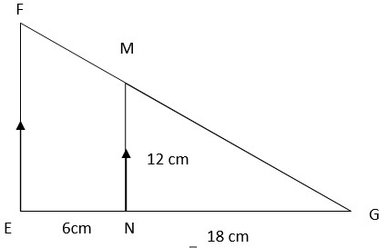

- (a) If x varies direct as 2y +7 and x = 5, when y = 4, find the value of y when x = 6.
  - Nine workers work 8 hours a day to complete a piece of work in 52 days, how long will it take 13 workers to complete the same job by working 6 hours a day?

- (a) The n^{th} term of a certain sequence is 2^{𝑛−1}, find the sum of 5th and 10th terms.
  - Each year a coconut tree produces 3 more coconut than it did the previous year. If it produced 10 coconuts in 1985, find a total number of coconuts produced from 1985 to 2000.
- (a) Given (𝑥) = 𝑥² + 6𝑥 − 7, find; (i) The axis of symmetry.
(ii) Maximum or minimum value.
  - Solve the equation n 𝑥² + 6𝑥 − 7 = 0 by completing the square
- (a) A ladder 7m long leans against a vertical wall with its foot 4m away from the wall on a horizontal floor. How high above the floor the point is where the ladder meets the wall?
(b) From the top of the tower, the angle of depression of a point on the ground 10𝑚 away from the base of the tower is 60°. How high is the tower?

SECTION B: (40 MARKS)
11. The following were scores of 35 students in a mathematics mock examination.
7 19, 78 53 43 67 12
54 27 22 33 80 23 58
50 36 65 33 16 19 34
20 55 27 37 41 04 32 48 28 70 31 61 08 35.
- Prepare a frequency distribution table using the class size of 10 and start with a class interval of 0 − 9.
- Calculate median
- Calculate mean using assumed mean method (use assume mean A=34.5)

12. Given that; -3 𝑖𝑓 𝑥 < −2

g(x) = x+1 if 2 ≤ 𝑥 < 1

4 𝑖𝑓 𝑥 ≥ 1

- Sketch the graph of 𝑔(𝑥)
- Compute 𝑔(−5) and 𝑔(10)
- State the domain and range of 𝑔(𝑥)

13. (a) A student has two plants seedlings, she measured the rate at which the seedlings were growing. Seedling A grew 5𝑐𝑚 in 10 days and seedling B grew 8𝑐𝑚 in 12 days, which seedling was growing more quickly?
(b)Given the following ordered pairs; (1,2), (2,1), (-3,4), (-3,-5), (2,2), (-5,0),(-8,-3)
(i) Which ordered pairs belong to the relation R= $\left\{\left(x,y\right):y>x\right\}$
(ii) State domain and range.

14(a) A and B are two points on latitude 70°N. Their longitudes are 62°W and 118°E respectively. Calculate the distance in kilometers from A to B if the Earth’s diameter is 12,800km along a parallel of latitude.

(b) Find the value of angle x, in the figure below
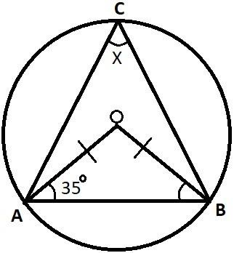
of

