NAMANGA SECONDARY SCHOOL
MIDTERM EXAMINATIONS AUGUST 2023
MATHEMATICS FORM THREE
Instructions: Answer all questions
- Use blue or black pen

SECTION A (60 MARKS)
Answer all questions in this section.

- (a)In a water inspection at school assembly on Friday, three form one students were given a number 16, 20,
and 32 for coming with water. Find the least number that can be given to all the students at once. Give
your answer as a product of its prime factors.

  - Copy and complete the table of equivalent below.

Fraction | Decimal | Percentage
1/10
 | 0 . 0 6̇ 2̇
 |  | 30%

2
(3√2)
2
– (2√3)

- (a) Rationalize the denominator the expression
3√2 + 2√3 .

  - Find the value x if (1/3) = √81^{–1} .
x

9804 × 23 . 19

  - Use mathematical tables, calculate the value table of logarithms below.
Numbers | Standard Form | Logarithms
9804 | 9.804 × 10³  2.319 × 10¹ | 1.3653
Numerator
41750 | 8.6 × 10^{–2} | 2 .9345
Denominator
Numerator
Denominator
 |  | 1.8016

0 . 086 × 41750 by completing the

- (a) In a year group of 113 students, 60 liked Hockey, 45 liked Rugby and 18 liked neither. Use a Venn diagram, calculate the number of students who:
- liked both Hockey and Rugby.
- liked only Hockey.
(b) Find the coordinates of the image of the point A(3,4) after a reflection in the line y = x. Draw a sketch
to show the point and its image.

- (a) Record the following transactions below in the cash book. Post to the ledger and then construct a trial balance to check mathematical accuracy of entries.
On $1^{st}$ February, James started business with a capital in cash of sh.60,000
February 2 Purchased goods for cash 50,000
February 3 Paid cash for transport sh. 10,000
February 10 Sold goods for cash sh.90,000
February 20 Bought furniture for cash sh. 30,000
February 28 Paid cash for carriage sh.5000

(b) Prepare a trading account for the year ended $31^{st}December 2010.$
Stock at end ……………………………… sh. 100,000
Purchases ……………………………….... sh. 600,000
Carriage inwards ………………………… sh. 30,000
Return outwards ………………………..... sh. 12,000
Return inwards …………………………… sh. 10,000
Sales ……………………………………… sh. 980,000
Stock at first ……………………………… sh. 200,000

- (a) Plot the points P(−1, −2), Q(−1,6), R(3,6) and S(3, −2) on the graph. Hence find the equation of the line that joining the point S and point Q in the form of y = mx + c.

(b) Find the inverse of the relation R = {(x , y) : y = 2x + 1} and hence, state its domain and range.

- The diagram below shows a triangle ABC with a line XY drawn parallel to BC. Angle BCA = 45º and angle BYC = 70º. Given that the line XY bisexts the angle AYB.

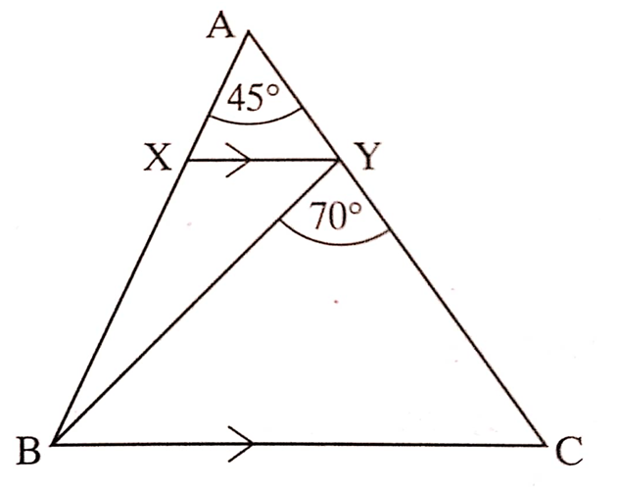
- Calculate the sizes of the angles:
  - angle AYX and angle AXY.
  - angle YCB and angle ABY.

- (i) Write down the letters of the three points which form an isoceles triangle in the diagram.

(ii) Name the equal sides of this triangle.

- (a) A family on holiday in France exchanged Pound £480 for Franc when the exchange rate was 10.70 Franc to the Pound. They spent 3700 Francs and then changed the rest into Tanzanian shillings, by which time the exchange rate had become 2500 Tanzanian shillings to the Franc. How much did the holiday cost?

(b)Given that y varies directly as x and inversely as 𝑧. If y = 10 when x = 8 and 𝑧 = 5, find the equation
connecting x, y and 𝑧. Hence, calculate the value of y when x = 6 and 𝑧 = 2.5.

- (a) Wanjunu invests sh.122,500 in a business for 6 months. Kimemia invests sh.220,500 in the same business for 2 months.
- In what proportional should they share the profits of the business?
- How much should Wanjunu get if the first six month’s profits come to sh.50,960
(b) Alfred bought a second-hand car for 4 700 000 Tanzanian shillings and spent 600 000 Tanzanian shillings on its repair. If he sold the car for 5 600 000 Tanzanian shillings, what was his percentage profit or loss?

- 9. (a) If the n^{th} term of a certain sequence is 3n – 5. Write the series corresponding to the sequence
- and hence, find the sum of the first three terms.

(b) Sketch the graph of g(𝑥) = 1 − | 𝑥 − 2 | and give its domain and range.

- (a) In the figure below, find the value of 𝑥.

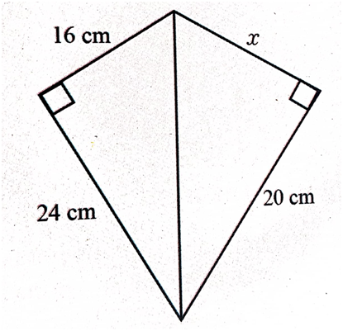

√3 cos 30° – 2 tan 45°

(b) Without using tables evaluate
3
2 sin 30°
+ cos 0° .

SECTION B (40 MARKS)
Answer all questions in this section.

- The solutions of the quadratic equation 𝑎𝑥² + 𝑏𝑥 + 𝑐 = 0 are given by the formula

𝑥 = –b±√b2–4ac
2a
. Use the formula only after trying and failing to factorize, solve the following

quadratic equations:
(a) 𝑥² + 2𝑥 − 3 = 0

(b) 5𝑥² − 6𝑥 − 1 = 0

- The mass of 42 athletes were recorded in kilograms as shown in table below.

Mass (kg) | 40 – 44 | 45 – 49 | 50 – 54 | 55 – 59 | 60 – 64 | 65 – 69
Frequency | 7 | 8 | 11 | 10 | 4 | 2

- Use the formula 𝑥 = 52 + Z , calculate the mean mass of the athletes.
N
- Find the mass of athletes that occur mostly in above set of data and use it to interpret the data.
- Draw a histogran of the distribution.

- (a) Given a quadratic function defined by (𝑥) = 4 − 6𝑥 − 3𝑥². Find:
- the maximum or minimum value of f (x).
- the attaining point of the function.
- the domain and range of the function.

(b) A spider can walk at a certain speed and run at another speed. If she walks for 2 seconds and run for 3 seconds, she travels 18 meters. If she walks for 3 seconds and runs for 1 second she travels 5 meters. Formulate the system of simultaneous equations and use graphical method to find her speeds of walking and running.

- A function f (x) is defined by the rule f (x) = {

- Sketch the graph of f (x).
5 if 𝑥 ≥ 1
1 − 𝑥 if −1 ≤ 𝑥 < 1
𝑥 if 𝑥 < −1

- Use a graph, state domain and range f (x).
- Find the value f (x) at x = −5 and x = 0.

(b) Let R be a relation on real numbers given by R = {(x,y) : x + y ≥ 1 and y ≤ – 3}.
- Draw the graph of R.
- State domain and range of R.

