PRIME MINISTER’S OFFICE REGIONAL ADMINISTRATION AND LOCAL GOVERNMENT ARUSHA REGION


FORM ONE TERMINAL EXAMINATION CODE: 065 BUSINESS STUDIES TIME: 2: 30 HRS 29th May, 2026

SECTION A (15MARKS)

- Give the correct answer to the corresponding question that follows below

(i) According to your knowledge of business studies what do you think one of the following is not among the business processes?
    - Production C. Goods and services
    - Exchange D. Consumption

(ii) Mr.Kamwendo transported timber and woods from Njombe Region to Dar es Salaam for production of furnitures. What process does Kamwendo applied?
    - Exchange C. Production
    - Distribution D. Consumption

(iii)Mr. Mathayo own's a retail shop where he sells different goods. What kind of business is Mathayo's retail shop found?
    - Large business C. Small business
    - Retail shop D. Medium business

  - Mwanaidi has designed the school uniform for the final consumption or to the student, this process is called?
    - Exchange C. Distribution
    - Consumption D. Production

  - Baraka has saved some money and is thinking about how to use it. He can either invest in a small business venture or put the money in a saving account. If he chooses to start the business, he will have to give up the interest, he would have earned in the saving account. What business concept does this illustrated?
    - Opportunity cost C. Needs and wants
    - Scarcity D. Consumption

  - Mrs. Juma visited the market and takes some money to the seller for school uniform what does this process is?
    - Production C. Consumption
    - Exchange D. Distribution

  - Why resources are scarce?
    - Because of buying and selling of goods and services
    - Because of creation of goods and services
    - Because all human needs and wants are unlimited in number D. Because of the selection of best alternative

  - Wajihi chooses to save money rather than to purchase clothes, the process done by himself it is called?
    - Resources C. Scarcity
    - Goods and services D. Opportunity cost

  - Mr. Kabula own a supermarket and mobile phone company he sells different products and phones at large quantity. What kind of business does Kabula owns?
    - Large business C. Medium business
    - Small business D. Retail shop

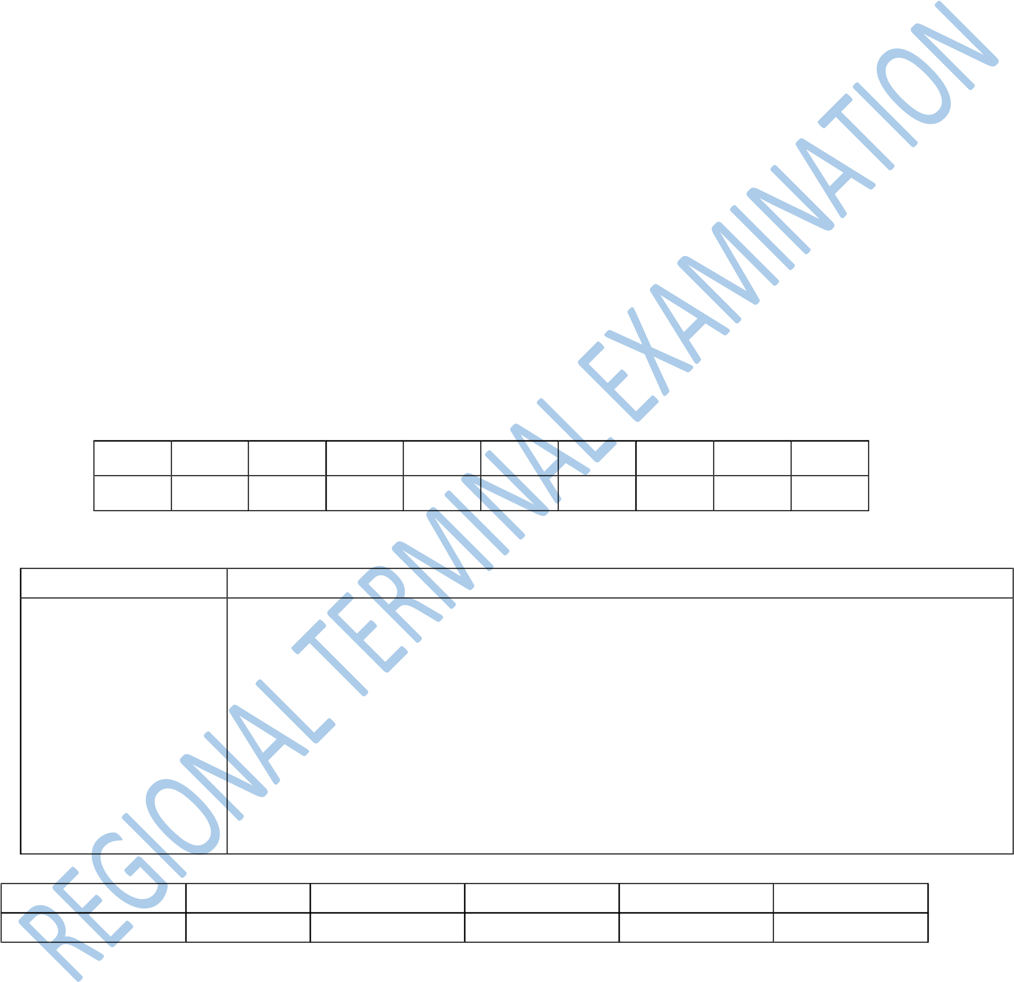
  - Monalisa required to give a type of good provided by being asked that " A type of good that stay over a short period and long period of time. You as a student with knowledge what kind of goods is applied?
    - Consumer and producer goods C. Merit and demerit goods
    - Perishable and durable goods D. Free and economic goods

i ii iii iv v vi Vii viii ix X

- Match the terms in column A with their correct definition in column B

COLUMN A COLUMN B
- Production A. The act of using goods and services to satisfy human needs and wants. B. Shortage in supply of resources or goods and services.
- Distribution C. Involves buying and selling of goods and services between two parties.
D. The process of transporting raw materials
(iii)Exchange E. into finished products to satisfy human needs
F. and wants
- Consumption G. This is the process of moving goods and
H. services from the area where they are
- Scarcity I. produced to where they are needed for consumption.

COLUMN A COLUMN B

SECTION B (40 MARKS)
- Define the following terms used in business studies
  - Scarcity ……………………………………………………………..............................................
……………………………………………………………………………………………………
  - Business ………………………………………………………………………………………......
…………………………………………………………………………………………………… (iii)Entrepreneurship
……………………………………………………………………………………………………
……………………………………………………………………………………………………
(iv) Production ……………………………………………………………………………………….
…………………………………………………………………………………………………… (v) Opportunity cost ……………………………………………………………………………..............
……………………………………………………………………………………………………....

- With examples differentiate the following
  - Needs and wants
……………………………………………………………………………………………………
……………………………………………………………………………………………………
……………………………………………………………………………………………………
  - Economic and free goods
…………………………………………………………………………………………………… ……………………………………………………………………………………………………
…………………………………………………………………………………………………….
(iii)Perishable and durable goods
…………………………………………………………………………………………………… ……………………………………………………………………………………………………
……………………………………………………………………………………………………
  - Merits and demerits goods
……………………………………………………………………………………………...………
……………………………………………………………………………………………………
…………………………………………………………………………………………………
  - Consumer and producer goods …………………………………………………………………………............................................
…………………………………………………………………………………………………………
…………………………………………………………………………………………………....

- Sir Mwakalila prepared the lesson of business processes for form one students. Help sir Mwakalila to explain four business processes that take place in business activities
………………………………………………………………………………………………………… …………………………………………………………………………………………………………
…………………………………………………………………………………………………………
…………………………………………………………………………………………………………
…………………………………………………………………………………………………………
………………………………………………………………………………………………………… ………………………………………………………………………………………………………… …………………………………………………………………………………………………………
…………………………………………………………………………………………………………
…………………………………………………………………………………………………………
…………………………………………………………………………………………………………
………………………………………………………………………………………………………… ………………………………………………………………………………………………………… …………………………………………………………………………………………………………
…………………………………………………………………………………………………………
…………………………………………………………………………………………………………
…………………………………………………………………………………………………………
…………………………………………………………………………………………………………
………………………………………………………………………………………………………… …………………………………………………………………………………………………………
…………………………………………………………………………………………………………

6. Outline main four purposes of business
(i) …………………………………………………………………………………………. (ii) ………………………………………………………………………………………….
(iii)………………………………………………………………………………………….
(iv) …………………………………………………………………………………………..

SECTION C (45 MARKS)

7. Briefly explain the importance of studying business studies in peoples’ daily life. (Six points)
……………………………………………………………………………………………………………
……………………………………………………………………………………………………………
……………………………………………………………………………………………………………
……………………………………………………………………………………………………………
……………………………………………………………………………………………………………
…………………………………………………………………………………………………………… …………………………………………………………………………………………………………… ……………………………………………………………………………………………………………
……………………………………………………………………………………………………………
……………………………………………………………………………………………………………
……………………………………………………………………………………………………………
…………………………………………………………………………………………………………… …………………………………………………………………………………………………………… ……………………………………………………………………………………………………………
……………………………………………………………………………………………………………
……………………………………………………………………………………………………………
……………………………………………………………………………………………………………
…………………………………………………………………………………………………………… …………………………………………………………………………………………………………… ……………………………………………………………………………………………………………
……………………………………………………………………………………………………………
……………………………………………………................................................................……………
…………………………………………………………………………………………………………… …………………………………………………………………………………………………………… ……………………………………………………………………………………………………………
……………………………………………………………………………………………………………
……………………………………………………………………………………………………………
……………………………………………………………………………………………………………
……………………………………………………………………………………………………………
……………………………………………………………………………………………………………
……………………………………………...………………………………………………………………
……………………………………………………………………………………………………………
……………………………………………………………………………………………………………
……………………………………………………………………………………………………………
……………………………………………………………………………………………………………
…………………………………………………………………………………………………………… …………………………………………………………………………………………………………… …………………………………………………………………………………………………………… ………………………………………………………………………………………………………...……

8. Business studies is a combination of various fields of study. Justify the statement (Six points)
…………………………………………………………………………………………………………
…………………………………………………………………………………………………………
…………………………………………………………………………………………………………
…………………………………………………………………………………………………………
…………………………………………………………………………………………………………
…………………………………………………………………………………………………………
………………………………………………………………………………………………………… ………………………………………………………………………………………………………… …………………………………………………………………………………………………………
…………………………………………………………………………………………………………
…………………………………………………………………………………………………………
…………………………………………………………………………………………………………
………………………………………………………………………………………………………… ………………………………………………………………………………………………………… …………………………………………………………………………………………………………
…………………………………………………………………………………………………………
…………………………………………………………………………………………………………
…………………………………………………………………………………………………………
…………………………………………………………………………………………………………
………………………………………………………………………………………………………… ………………………………………………………………………………………………………… …………………………………………………………………………………………………………
…………………………………………………………………………………………………………
…………………………………………………………………………………………………………
…………………………………………………………………………………………………………
………………………………………………………………………………………………………… ………………………………………………………………………………………………………… ………………………………………………………………………………………………………… ………………………………………………………………………………………………………... …………………………………………………………………………………………………………
…………………………………………………………………………………………………………
………………………………………………………………………………………………………… ………………………………………………………………………………………………………… …………………………………………………………………………………………………………
…………………………………………………………………………………………………………
…………………………………………………………………………………………………………
………………………………………………………………………………………………………… ………………………………………………………………………………………………………… ………………………………………………………………………………………………………… ………………………....……………………………………………………………………………… …………………………………………………………………………………………………………
…………………………………………………………………………………………………………
…………………………………………………………………………………………………………
…………………………………………………………………………………………………………
………………………………………………………………………………………………………… ………………………………………………………………………………………………………… ………………………………………………………………………………………………………… …………………………………………………………………………………………………………
…………………………………………………………………………………………………………

9. People working in the field of education have special characteristics that enable them to carry out their duties and responsibilities effectively. The same applies to lawyers, doctors and in other professions. How is this statement correct to an entrepreneur? (Six points)
…………………………………………………………………………………………………………
…………………………………………………………………………………………………………
…………………………………………………………………………………………………………
…………………………………………………………………………………………………………
…………………………………………………………………………………………………………
………………………………………………………………………………………………………… ………………………………………………………………………………………………………… …………………………………………………………………………………………………………
…………………………………………………………………………………………………………
…………………………………………………………………………………………………………
…………………………………………………………………………………………………………
………………………………………………………………………………………………………… ………………………………………………………………………………………………………… …………………………………………………………………………………………………………
…………………………………………………………………………………………………………
…………………………………………………………………………………………………………
…………………………………………………………………………………………………………
…………………………………………………………………………………………………………
………………………………………………………………………………………………………… ………………………………………………………………………………………………………… …………………………………………………………………………………………………………
…………………………………………………………………………………………………………
…………………………………………………………………………………………………………
………………………………………………………………………………………………………… ………………………………………………………………………………………………………… ………………………………………………………………………………………………………… …………………………………………………………………………………………………………
…………………………………………………………………………………………………………
…………………………………………………………………………………………………………
…………………………………………………………………………………………………………
…………………………………………………………………………………………………………
…………………………………………………………………………………………………………
…………………………………………………………………………………………………………
…………………………………………………………………………………………………………
…………………………………………………………………………………………………………
…………………………………………………………………………………………………………
…………………………………………………………………………………………………………
………………………………………………………………………………………………………… ………………………………………………………………………………………………………… ………………………………………………………………………………………………………… …………………………………………………………………………………………………………
…………………………………………………………………………………………………………
………………………………………………………………………………………………………… …………………………………………………………………………………………………………
……………………………………………………………………………………………………….…
…………………………………………………………………………………………………………
…………………………………………………………………………………………………………
…………………………………………………………………………………………………………

