PRESIDENT’S OFFICE
REGIONAL ADMINISTRATION AND LOCAL GOVERNMENT
NAMANGA SECONDARY
FORM THREE MID-TERM EXAMINATION - AUGUST 2023
PHYSICS
INSTRUCTIONS TIME 3HRS

- This paper consists of sections A, B and C with a total of eleven (11) questions
- Answer all questions in sections A and B and two (02) questions from section C
- Cell phones are not allowed in the examination room
- Write your examination number on every page of your answer booklet(s)
- Where necessary the following constants may be
Used;
Acceleration due to gravity, g = 10m/s2 or 10N/kg,
. specific heat capacity water is 4200J/kg.
.Linear expansivity of copper is 0.000017per kelvin

SECTION A (15 Marks)
Answer all questions in this section.
- For each of the items (i-x) choose the correct answer from among the given alternatives and write its letter beside the item number in the answer sheet(s) provided.
i Which pairs of instruments would you use to correctly measure the diameter of a small ball bearing?
  - Measuring tape and Vernier caliper
  - Slide rule and micrometer screw gauge C Vernier caliper and slide rule
D Micrometer screw gauge and Vernier caliper E Meter rule and micrometer screw gauge
ii Which phenomena is a result of the earth being exactly along the same line between the center of the sun and the moon?
A Lunar eclipse B Penumbra
C Solar eclipse D Umbra E reflection
- A body moved upward a distance of 20m. Calculate the time taken to reach the maximum height
A 2s B 5s C 10s D 15s E 11s

- The temperature of a certain liquid is measured to be 300k. What will be its temperature in degrees centigrade?
A 273⁰C B100⁰CC 57⁰C D 37⁰C E 27⁰C

v Which metals become strongly magnetized when subjected to a magnetic field?
A Nickel and copper B Zinc and aluminum C Cobalt and iron D Aluminum and lead
E Iron and zinc
Vi The mass of copper over the volume of copper is 8.9g/cm3. What volume of 89g of copper?
- 10m³
- 10cm³
- 1cm³
- 10⁻⁵m³
- 100cm³

- A white shawl wrapped around a baby keeps the baby warm because the shawl A Is a poor reflector B Is a poor radiator
C Has pockets of air trapped nit D Conducts heat to the baby E Stopsconvectioncurrents

- Two forces of 5N and 8N are acting at the same point and are inclined at an angle of 45⁰to each other. What will be their resultant force?
A 2N B 12N C 4N D 2N E 12N

- The attractive force between molecules of different substances is called
A | Osmosis | B | Restoring | C.
D | Adhesive force | E | Cohesive force |  | Magnetism

- Which of the following device works on light only?
A An electric bell B A vernier caliper
C A meter rule D A microscope E A beam balance
- Match the statements of the motion of bodies list A with the correct graph in list B by writing the letter of the correct response beside the item number. The response can be used more than one
LIST A | LIST B
- Distance-time graph represent a motion of a stone released from rest from a tall building.  - Distance-time graph represents a motion of a body moving with constant velocity  - Velocity-time graph representing a motion of a car retarding uniformly after application of a brake.  - Velocity-time graph for a body moving in a straight line with uniform velocity.  - Velocity time graph representing a motion of a body dropped freely vertical. | distance (m)  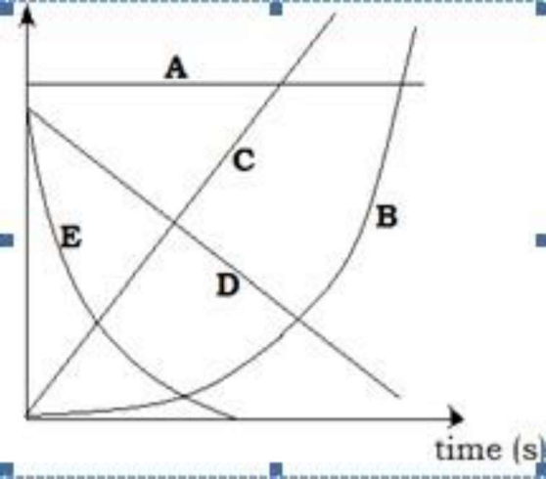

SECTION B (60 Marks)
Answer all questions in this section.
- (a) (i) What is meant by refraction of light?
(ii) Mention three points to be considered when drawing a ray diagram to show the
formation of images on a concave mirror.
(b). (i) Briefly explain why pout of the road ahead of a person apparently looks as if it has a pool of water on a sunny day?
(ii) A pin is at the bottom of a vessel 16cm deep. When the vessel is filled with water the pin appears to rise when viewed from above. Find the height to which the pin appears to rise.
- (a) Give two practical examples where impulse and momentum play an important role
(b) (i) Distinguish between elastic collision and inelastic collision.
(ii) A box of mass 50kg is raised vertically with a uniform acceleration "a" when a force of700 N is acting in a rope. Calculate the uniform acceleration
(c ). (i) What are the similarities and differences between speed and velocity?
- Sketch the diagram of a body which starts from rest and accelerate uniformly for sometimes to a constant velocity and then maintains this velocity for a certain period of time before decelerating uniformly to stop.

- (a) Give reasons for the following
(i)a gap is left between two successive rails
(Ii)a glass tumbler is break when hot liquid is poured into it
(b) mention three applications of thermal expansion in solids

- (a)Give two difference and similarities between scalar and vector quantities
(b)A moves with 30N towards east and then 40N towards north, determine result Force and direction of the car by using Pythagoras theorem and trigonometrical ratios

7. (a) what are the difference between boiling and evaporation (four points)
(b)how heat transferred through
(i) convection
(i) radiation
8(a) (i) Distinguish between camera and eye (2 points)
(ii)with the help of diagram explain how capacitor works
(b)Draw the following rays of light beam
(i) parallel rays
(ii) convergent rays
(iii) divergent rays

SECTION:C(25Marks)
Answer two (2) questions from this section.
9(a). What is meant by the following terms
(i)heat capacity
(ii) specific heat capacity
(b). A100g piece of metal at 100 degrees Celsius is placed into 120g of water at 16 degree Celsius of metal in the vessel of negligible heat capacity. If the final temperature is 28 degrees Celsius, calculate the specific heat capacity of metal.

- (a) (i) Why in case of liquids we distinguish between coefficients of apparent and real expansion whereas in case of gas not, Explain.
- The absolute expansivity of mercury is 0.0018 per kelvin. Find the apparent volume expansivity of mercury in glass given the linear expansivity of glass is 0.00009 per kelvin
- (I)Define linear expansivity of the substance
(ii)A copper rod has a length of 40cm on a day when the temperature is 22.3 degree Celsius. What will it's length be on a day when the temperature is 30 degree Celsius?

- (a) Why is it advised to connect bulb in parallel arrangement during installation of electricity in most building?
(b) Two resistors 5ohm and 2ohm are connected parallel and electromotive force applied was 12V.
( I) dwarf circuit to show the above information
( ii) determine effective resistance
(iii) determine current flowing through each resistor

