THE PRESIDENT’S OFFICE
REGIONAL ADMINISTRATION AND LOCAL GOVERNMENT
LONGIDO DISTRICT EXAMINATION SYNDCATE-AUGUST 2020
FORM THREE PRE-REGIONAL EXAMINATION
TIME 3 HOURS.
INSTRUCTIONS:
- This paper consists of sections A, B and C with total of eleven(11)questions
- Answer all questions in sections A and B and two (2) questions from section C.
- Cellular phones and any unauthorized materials are not allowed in the examination room.
- Write your examination number/name on every page of your answer sheet(s)
- Where necessary use the following constants.
- Acceleration due to gravity=10m/s or 10N/kg
- Density of water =1.0g/cm³
- Pie =3.14

SECTION A (15 MARKS)

- For each of the following items (i)-(x), choose the correct answer from among the given alternatives and write its letter beside the item number in the answer book provided.

- A body is said to be in equilibrium if;
- It moves with the same speed
- The net force acting on is zero
- The upward force and the downward forces are equal
- Its center of gravity is low positioned
- Its magnitude is less than gravity
- The device used to detect presence of charges on a body is known as
- Gold leaf
- Capacitor
- Resistor
- Battery
- Electroscope
- The temperature of a certain liquid is measured to be 300k.What will be its temperature in degree centigrade?
- 273
- 100
- 57
- 37
- 27
- Which metals become strongly magnetized when subjected to a magnetic field?
- Nickel and copper
- Zinc and alluminium
- Cobalt and iron
- Alluminium and lead
- Iron and zinc
- The SI unity of linear momentum is
- Kg/m
- Kgm/s
- Ns
- Kgms
- Kg
- A stone of mass 500g is lifted through a height of 20m.the potential energy gained by the stone is
- 10,000J
- 100J
- 70J
- 520J
- 10J
- …………………..is the ratio of sin r˚/sin r
- Snell’s low
- Critical angle
- Refractive index
- Law of refraction
- Critical angle
- A block and tackle system has 2 movable pulleys and 3 fixed pulleys. The velocity ratio of the system (V.R) is given as;
- 2/3
- 2
- 3
- 5
- 3.2
- A victim of electric shock is immediately helped by removing a person from the source by using
- A dry stick
- Metal rod
- Bare hands
- Wet hands
- Dry hands
- John wanted to measure the volume of stone with an irregular shape. Which pair of apparatus is useful in this practical work?
- Eureka can pipette
- Eureka can Beaker
- Stop watch and spatula
- Beaker and spring balance
- Stop watch and spatula
- Match the following items in list A with the responses in list B by writing the letter of the corresponding response beside the item number.
LIST A |  | LIST B
i | Relative motion | a | Angle of deviation
ii | Maximum value of static friction | b | Combining cells in series and parallel
iii | Rollers | c | Limiting friction
iv | Angle made between the incident ray and emergent ray from a triangular prism | d | Potential divider
v | A central line drawn through the pole and centre of | e | A method of reducing friction
 |  | f | Ratio of sine of angle of incident to sine of angle of refraction.
 |  | g | Principal axis
 |  | h | Principal focus
 |  | i | Motion of one object as viewed in relative to the motion of another
 |  | j | Skin friction

SECTION B (60) MARKS

- (a)i/state one factor which affects density of a gas
II/briefly explain how the above mentioned factor affects the gas density
(b) An alloy contains 30% by mass of lead (density =11.4g/cm³) and 70% by volume of tin (density=7.3g/cm³) find the density of the alloy.
(c) Briefly explain the following conditions
i/Ice floats on water
ii/a person can swim in sea water more easily than in fresh water.
- (a)the figure below shows a simple machine B which has to be used to pull the load of 2000N into a car by an effort of 1500N
I/Give the name of simple machine B
II/calculate the efficiency of machine B
III/briefly explain why the efficiency of machine B is less than 100%

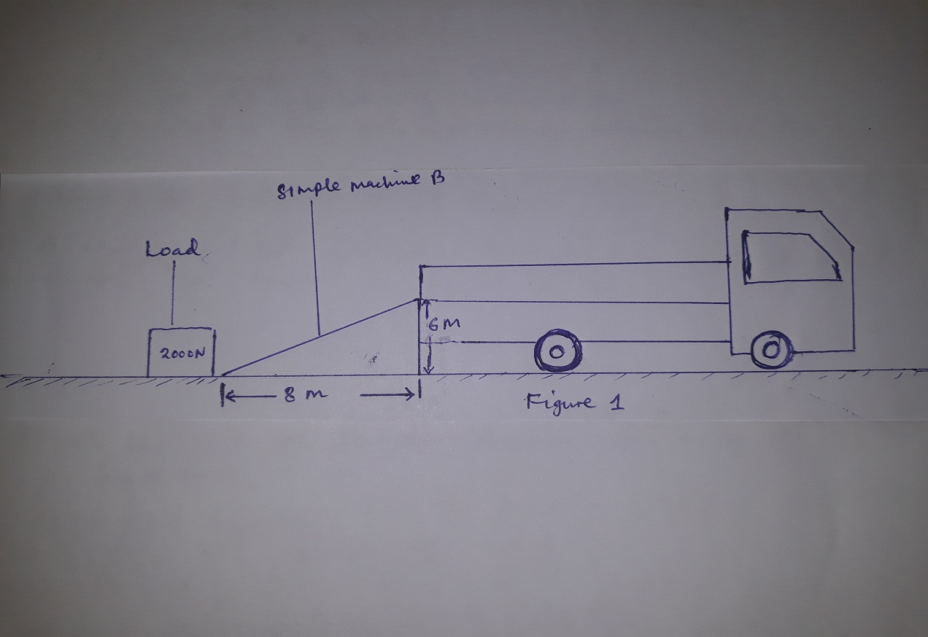
(b) With the aid of the diagram explain the mode of action of a hydrometer
- (a)Draw the symbol for the following electric circuits components and give the function of each
- Cell
- Bulb
- Ammeter
- Capacitor

(b) Briefly explain why it is advisable to connect bulb in parallel arrangement during installation of electricity in most building
(c) State what happens in the following conditions
i/an ebonite rod is rubbed with fur
ii/a negatively charged electroscope cap is touched with a positive glass rod.
- (a) i/ for which position of an object does a concave mirror produce an inverted, magnified and real image?
Ii/with the aid of the diagram show the above condition in 6(a) i
(b) Explain why driving mirrors are preferred to be convex mirror rather than plane mirror
(c) An object is placed 20cm in front of a concave mirror of a focal length 10cm.calculate
i/the image distance
ii/the magnification of the image
(d) Distinguish between concave and convex mirrors
- (a)i/state 2 laws of refraction
ii/give the name of the second law of refraction
iii/a fish in a pond appear to be at a position shallower than its actual depth. Explain this phenomenon.

(b) A ray of light travels through air into another medium as shown in figure 2 below.

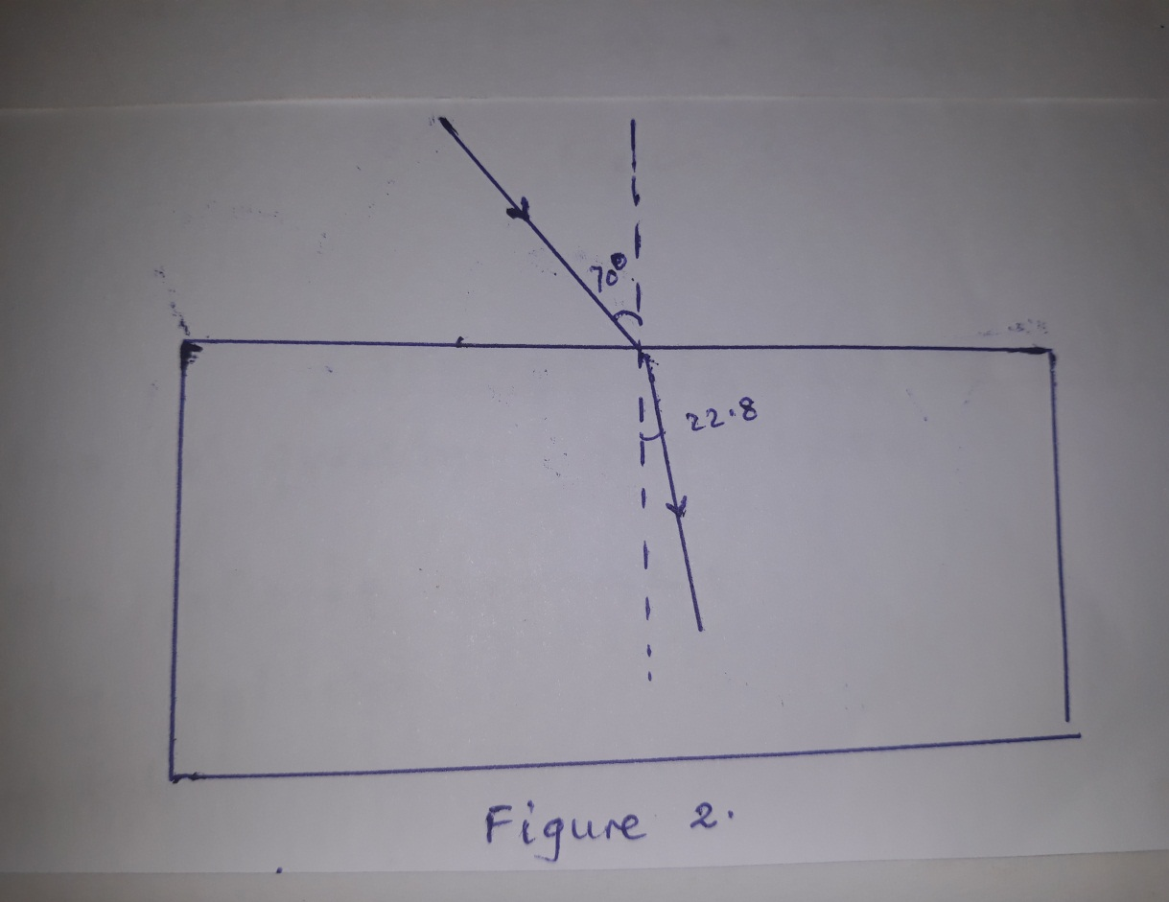

Its angle of incidence is 70 and angle of refraction is 22.8.calculate the critical angle for the medium.
(c) What colour would red t-shirt appear under these lights?
i/red light
ii/green light
- (a)i/state Newton’s second and third law of motion
ii/state the law of inertia
(b) Distinguish between speed and velocity
(c) A mass of 500g is placed in a straight sloping at an angle of 45˚ to the horizontal as shown in figure 3 below. Calculate
(i) The acceleration of the load as it slides down the slope.
(ii) The distance moved from rest in 2 seconds.

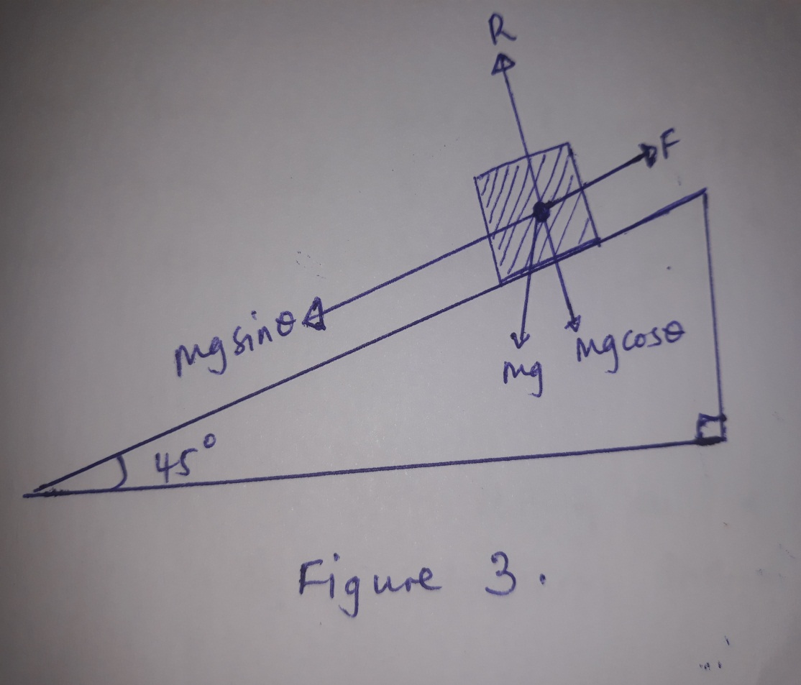

SECTION C
Answer two questions from section.
- (a)define the following apparatus
- Measuring sylinder
- Stop watch
- Thermometer
- Galvanometer
(b) What should you do in the laboratory in the event of the situations?
- Your partner is cut by glass during experiment
- You have some biscuits and your friend want to eat them
- Your class leader want to lock the laboratory door during experiment
(c) State three (3) importance of first aid
(d) Name five (5) items found in a first aid kit
- (a) State and explain with the aid of diagram, why the base of a Bunsen burner is heavily weighted and of a large base.

(b) A uniform rod has a weight of 30N with a force of 15N at one end, it balances at a point 1m from the same end. Determine the length of the rod.

(c) If the forward driving force acting on a car is 4000N and the car moves with a uniform speed through a distance of 30m.

I/what is the resistance force acting on the car? Give reason for your answer
ii/calculate the work done on the car by driving force.

- (a) During sunder storm the time between the flash of light and thunder is 10 seconds. Explain this condition
(b) Why bubbles of air increases in volume as it rise from the bottom of a pond of water to the surface?
(c) Explain two ways in which
- Camera differ from human eye
- Camera is similar to human eye

(d) Write the relationship of pressure in liquid and state each term.

