

THE PRIME MINISTER’S OFFICE
REGIONAL ADMINISTRATION AND LOCAL GOVERNMENT
LONGIDO DISTRICT MID TERM JOINT EXAMINATION

FORM THREE
031 PHYSICS 1
MARKING SCHEME AUGUST 2026

SECTION A

1.

C | D | D | B | E | B | E | C | E | D
01 marks@ = 10marks
2.
H | E | B | C | F | D
01 marks@ = 06 marks
SECTION B
- (a) (i) 1) Because: Energy is needed to lift the bottom pulley and the ropes. 01 mark

2) Friction between the moving parts of machine transform some of the energy into heat. 01 mark
(ii) V.R = 4

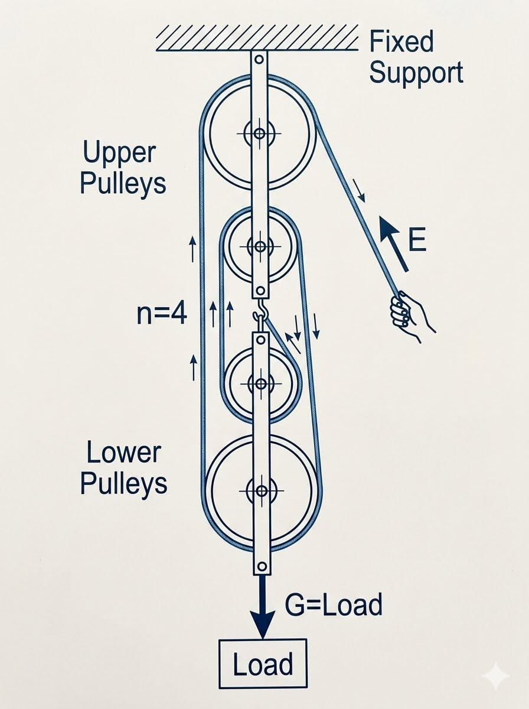

Effort 03 marks
(b) Data given

V.R =12

Total length = 2.5m.

But total length = EA + LA where EA = Effort arm

LA – Land arm

EA + LA = 2.5 (i) 01 mark

V .R  E A
LA

EA = V.R x LA

= 12 x LA

EA = 12LA (ii) 01 mark

Subst. eq. (ii) int (ii) EA+LA = 2.5
12LA+LA=2.5

13LA = 2.5

L  2.5
A 13

LA = 0.19m 01 mark

EA = 12LA

= 12 x 0.19

EA = 2.28m  2.3.n 01 mark

Therefore the effort applied at 2.3 m from fulcrum.

- (a) By observing smoke particles in random motion (Brownian motion) in a smoke cell, we can conclude that air particles are in random motion since they collide with the smoke particles, resulting in the random motion of the smoke particles. 05 marks
(b)
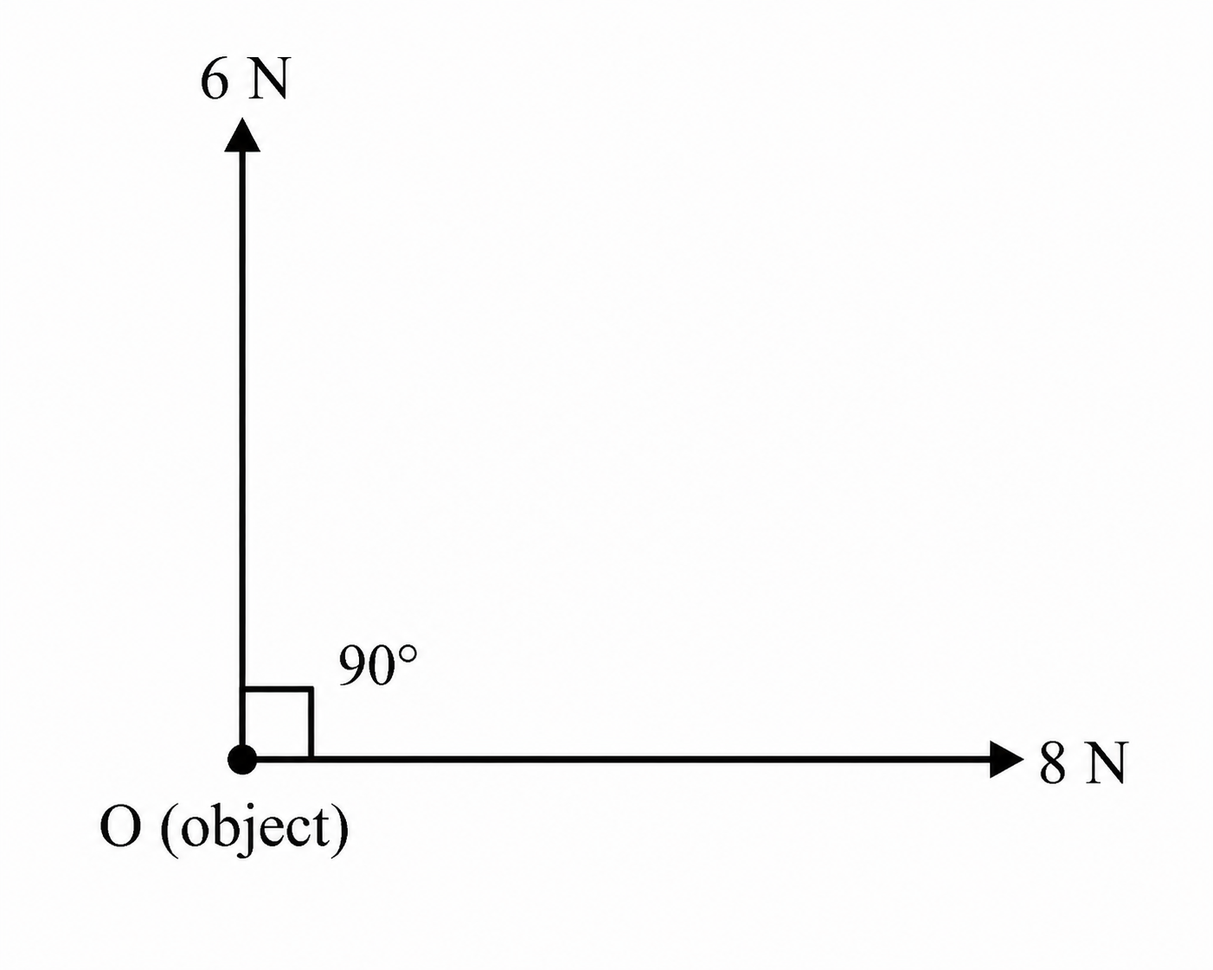
- A correct vector diagram showing the 6 N and 8 N forces perpendicular to each other. 1 mark

(ii) R=62+82​ R=36+64​ R=100​ R=10N​ 2 marks

- Solution:
Given Cross section area of stem, A = 0.5${cm}^{2}$
Height of stem, h = 18 cm
The volume of stem, V1 = Ah = 9 ${cm}^{3}$
Total volume, Vt = (9 + V2) ${cm}^{3}$
Minimum density, ρmn = 0.8 g/ ${cm}^{3}$
Maximum density, ρmx = 1.0 g/${cm}^{3}$
The volume of bulb, V2 =?
(a) The volume of bulb, V2 = ?
From:
$V_{bulb}= \frac{Ahρ_{min}}{ρ_{max}−ρ_{min}}$ ………………………………………………. 02 marks
$V_{bulb}=\frac{9×0.8}{1.0−0.8}=36{cm}^{3}$ ……………………………………… 02 marks
(b) What height, h2 of hydrometer when shifted to measure 0.9 g/${cm}^{3}$
From:
$V_{bulb}= \frac{Ahρ_{min}}{ρ_{max}−ρ_{min}}$ ……………………………………………….. 01 marks
$\frac{0.9×0.5×h}{1.0−0.9}=36{cm}^{3}$ ……………………………………………….. 02 marks
𝒉=𝟑𝟔×𝟎.𝟏𝟎.𝟓×𝟎.𝟗=8 𝑐𝑚 02 marks

- (a) Water has low density as compared to mercury. The liquid column would be too tall since atmospheric pressure pushes water to a height of about 10m. 04 marks

- Convex lens. (1 mark)
- The object should be placed between the optical centre and the principal focus of the lens. (1 mark)
- Any two:(2 marks)
- The image is virtual.
- The image is upright/erect.
- The image is magnified/enlarged.
- (a) Because of the scattering of the sun’s light when it enters the earth’s atmosphere. The blue light is scattered more than other colours due to the difference in their wavelength. While on the moon, the sky appears black because the moon has no atmosphere to scatter sunlight. 04 marks
- Data given
Least count = 0.01mm
Sleeve scale = 1.6cm =16mm
Thimble scale = 0.48mm
Zero error = -0.003cm = -0.03mm …………………………………………… 01 marks
From
Diameter of the rod = sleeve scale +thimble scale ……………………………… 01 marks
Diameter of the rod = 16mm + 0.48mm = 16.48mm ………………………… 01 marks
But
Correct diameter = 16.48mm + 0.03mm = 16.51mm ……………………… 01 marks
Therefore, correct diameter of the rod = 16.51mm ……………………… 01 marks

- (a) Testing for negative charge, the electroscope must be positively charged. Hence the leaf collapses if the negatively charged material is brought near the cap of the electroscope. Testing for positive charge, the electroscope must be negatively charged. Hence the leaf collapses if the positively charged material is brought near the cap of the electroscope 05 marks
- As you walk across a carpet your feet rub electrons off the carpet, leaving you with slightly negative static charge. When you reach for a doorknob you get a shock as electrons jump from you to the knob, which conducts electricity. OR
While walking on a carpet, you are sort of insulated hence high electrons accumulation. On the other hand, the door has excess of the opposite charges. This results in a mild electric shock. 04 marks
SECTION C
- (a)
(i) Conduction: Heat is transferred through a substance from the hotter region to the colder region without the bulk movement of the substance. It is especially important in solids. (1 mark)
(ii) Convection: Heat is transferred by the actual movement of a fluid. Warmer, less dense fluid rises while cooler, denser fluid sinks, producing convection currents. (1.5 marks)
(iii) Radiation: Heat is transferred in the form of electromagnetic waves and does not require a material medium. (1.5 marks)
- Iron contracts in the morning due to low temperature. This makes the nut to hold tightly onto the wheels. The reverse happens on a hot day. 05 marks
- Because water has a larger index of refraction than air does, the critical angle for the diamond-water interface is no longer 24.4° but increases to 33.3°. Therefore, this particular ray is no longer totally internally reflected. Only some of the right ray will be reflected back into the diamond, while the reminder escapes into the water. Consequently, less light exits from the top of the diamond, causing it to lose much of its sparkle 04 marks
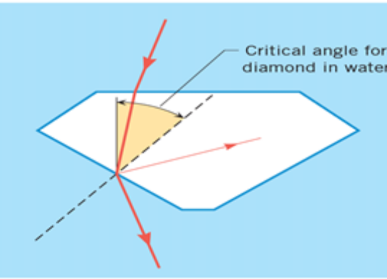
Diagram 02 marks
- (a) disadvantages of friction
- It causes wear and tear
- It produces heat in various machine parts causing efficiency to decrease
- Due to friction noise is produced in machine
- Causes loss of energy in form of heat and sound
- Causes motion of a body to slow down
- Heat produced by friction can cause appliance to burn
- It causes wounding, when skin wearing
Any five points @ 01 marks = total 05 marks

  - Polishing lowers the ability of material atoms to come closer (i.e. to bond each together) and thus reduce friction
- Polished surface is much frictionless than smooth surface. This is because for the smooth surfaces, atoms of both the materials come very closer to each other and the number of bonds between them increases and thus friction increases 05 marks
- Soln:
Given: m = 4 kg, $∅$ = 40⁰
Consider the fig below
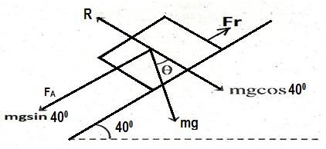
Diagram 01 marks
From:
𝑨𝒕 𝒄𝒐𝒏𝒔𝒕𝒂𝒏𝒕 𝒔𝒑𝒆𝒆𝒅 (𝒂 = 𝟎), 𝝁 = 𝒕𝒂𝒏𝜽 02 marks
∴ 𝝁 = 𝒕𝒂𝒏𝜽 = 𝒕𝒂𝒏𝟒𝟎 = 𝟎. 𝟖𝟒 02 marks

- (a) The following are the rules used to locate image in the curved mirror.
- A ray of light travelling to the mirror parallel to the principal axis, a ray is reflected through the principal focus
- A ray of light travelling to the mirror through the centre of curvature is reflected along its own path
- A ray of light travelling to the mirror through the principal focus is reflected parallel to the principal axis 01.5marks@ =04.5 marks
- Light rays before striking the air bubbles have to travel through water. These light rays which strike the air bubbles at an angle greater than critical angle for water air surface are totally reflected and it is because of these reflected rays that the air bubbles appear silvery. 04.5 marks
- Data given
u = 20 cm, f = 12 cm, v = v
From:
Therefore, v = 30 cm, A positive value of v means a real image is formed. Hence a real image is formed 30 cm away from the mirror on the same side as the object 06 marks

